Distribution System Analysis Subcommittee

4 Node Test Feeder

Experiences with the
Center-tapped Wye-Delta Transformer Test Case

Roger C. Dugan
Surya Santoso

June 30, 2004

IEEE 4 Node Test Feeder

Experiences with the
Center-tapped Wye-Delta Transformer Test Case

Introduction
THis describes one investigator’s experiences with the 4-wire Delta test case. This is based on a paper of the same title [1] delivered by Dr. Surya Santoso in the author’s absence at the IEEE PES General Meeting in Denver, June 2004. A more complete transformer model is provided for reader’s to compare with their individual results.
In recent IEEE PES meetings, the efforts of the Distribution System Analysis Subcommittee have focused on transformer modeling for distribution analysis (e.g., references 2 - 3). This extends that effort to one of the more interesting transformer connections found in the distribution system: the ungrounded wye-delta transformer bank with a center-tapped transformer in one leg of the delta secondary. This connection is also vaiously known as the "4-wire delta," “red leg,” or “crazy leg” connection. The center tap is grounded, which shifts the secondary side voltage reference to an unusual location for three-phase circuit analysis. One phase is significantly higher in voltage with respect to ground resulting in a “crazy” leg.
This transformer connection is employed in small- to medium-sized commercial loads that have three-phase motors as well as single-phase lighting and appliance load. It is an economical way to provide both 3-phase and single-phase service with one transformer bank.
While it is not necessary to model secondary circuits for most types of distribution system analysis, there are special cases where analysis of this particular connection is important:

- This connection results in unbalanced voltages and currents that can adversely affect 3-phase motors and overload the transformers.
- The transformer can backfeed certain fault conditions on the primary feeder.
- It can impact the ability to perform single-phase switching. High voltages can appear unexpectedly when switching the bank.

Besides these practical needs, the case presents a challenge to designers of three-phase distribution system analysis software. If an algorithm can handle this case without compromise, it is more likely to be sufficiently robust to handle other unusual circuit configurations.

The System Model
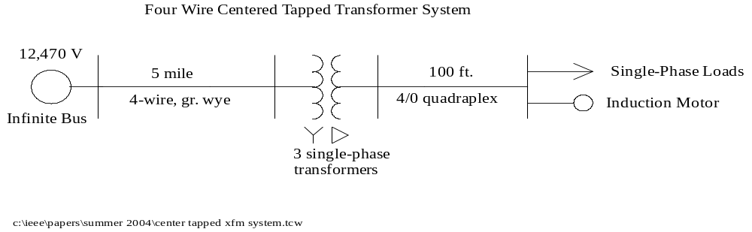 Figure 1. One-line diagram of Test Case

The test case system one-line diagram is shown in Figure 2. It consists of 5 miles of 556 MCM ACSR conductor with a 4/0 ACSR neutral supplying power at 12.47 kV to a bank of three single-phase transformers. The secondary circuit consists of 100 ft of 4/0 quadraplex to a service entrance panel where both single-phase loads and a 3-phase induction motor are connected.
A three-phase diagram showing the connections of the system is shown in Figure 3. Data values for the various parameters are given in the Appendix. Note that these values are expressed slightly differently than the Test Case description [4] due to the input requirements of the simulation tool used be the author.

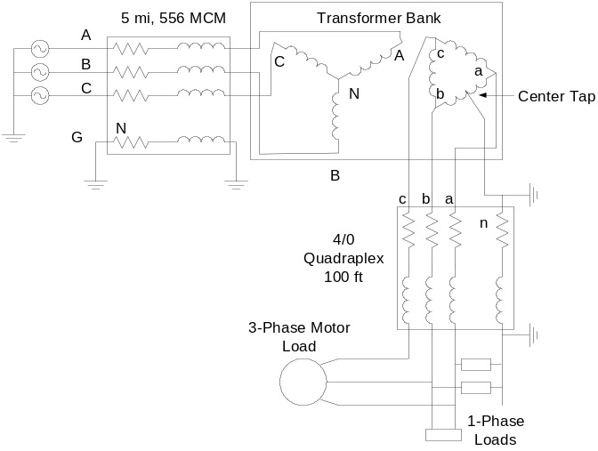
Figure 4. 3-Phase connection diagram for the Test Case.

Implementation Experience
A discussion of each element of the test system follows.

Source
The source was modeled as a wye-connected, ideal 3-phase voltage source is assumed with a value of 12.47 kV line-to-line. The neutral is assumed grounded (connected to the system voltage reference). The first phase, A, is 7200V line to neutral at an angle of 0°. The next two phases lag behind by 120°, yielding the standard ABC rotation.

Line Models
Both line models are specified by 4x4 impedance matrices. The neutral conductors are explicitly modeled in the Test Case and the currents in these conductors are given in the results. The same phase currents can be obtained by using a Kron reduction to eliminate the neutral conductors. However, it is an interesting test to determine if an algorithm is capable of modeling more than three phases.
Note that both ends of the neutrals are to be explicitly connected to ground (zero voltage reference) if modeled explicitly. (This is what the Kron reduction would imply.)
The computer program used is capable of accepting arbitrarily-sized impedance matrices for lines. The impedance matrices shown in the Appendix were entered directly in ohms per unit length and then multiplied by the appropriate length. The only atypical operation encountered in representing the lines was the explicit connection of both ends of the neutral wire to node 0, which is the default zero voltage reference used by the program. When a 3x3 matrix is used only the phase conductor connections need be specified. Both representations were tested with similar results.
The Test Case results were found to be somewhat sensitive to the precision used in the line impedances. However, it was relatively easy to obtain a match of 4 to 5 significant digits with the results obtained by Kersting.

Transformer Models
The two 2-winding “power” transformers used for the 3-phase load are identical. They have a single secondary winding rated 240V. The third transformer serves the single-phase loads as well as the 3-phase motor. It has a center-tapped 240V secondary winding (120V on each side). Thus, this transformer serves a 240V 3-phase motor as well as both 120Vand 240V single-phase lighting and appliance loads.
The center tap point is connected to ground, which is the reference for the single-phase loads. Thus, the opposite point on the delta winding is nominally 208V with respect to ground reference. This is atypical for a 3-phase power flow program because the neutral point for the 3-phase system differs from the voltage reference point on this side of the transformer.
In our model, the center-tapped transformer is treated like a three-winding transformer with one 7200V winding and two 120V windings. The impedances in the Appendix are expressed in terms more suitable for this kind of model than those in the Test Case description. The three-winding transformer model is developed from the short circuit impedances between each pair of windings as described in Ref. [5]. This technique allows the modeling of transformers with any number of windings.

Single-Phase Loads
These loads are treated as conventional power flow load models. That is, they are constant active (P) and reactive (Q) power loads for voltages within the standard range of nominal voltage.
This did not appear to present any difficulties to the solution. The loads consistently converged to the values specified within 4 iterations. The loads are represented as a Norton equivalent with the injection currents compensating for the nonlinear relationship of current to voltage. This is standard practice for many distribution system analysis programs.

Induction Motor Load
The Test Case description gives the motor impedances in ohms. It also provides an asymmetric impedance matrix representing the motor for the slip specified. Unfortunately, the program being used accepts neither of these forms directly. Instead, it uses a compensation-based model that is defined by per unit impedances.
The motor is rated 25 hp. Therefore, a base of 25 kVA was arbitrarily chosen and the ohmic impedances were converted to per unit on this base at 240V. These values are given in the Appendix.
A symmetrical component motor model was used, although some other transformation may work equally well. The induction machine model is iterative. First, it converts the phase voltages into sequence quantities. Then the positive-and negative-sequence currents are computed and converted back into phase quantities. The zero sequence current is set to zero to represent either an ungrounded wye or a delta connected stator.
Normally, this induction machine model seeks to find a slip that achieves a specified power output. The slip will vary slightly as the voltage varies and makes it difficult to match the Test Case results precisely. To match the Test Case, the motor model was set to keep the shaft speed constant at the slip value specified. This was the only modification made to the normal solution procedure to successfully represent the Test Case as it is specified.
Introducing the motor into the Test Case adds an interesting variable that might make matching the results difficult. The Test Case removes some variability by specifying a fixed slip, which results in a constant impedance model. However, this might still expose weaknesses in certain algorithms that are not capable of representing elements with different positive- and negative-sequence impedances. A simple R-L impedance load model will not give the proper answer.
Another issue that is tested with this example is the grounding of the machine winding model. The solution algorithm must be capable of modeling an ungrounded winding connection. Some 3-phase power flow models may use a grounded-wye connection because it is often easier to obtain convergence in difficult cases. Grounding the neutral of a wye-connected stator would connect it to the midpoint of one leg of the 3-phase supply, which would not yield the intended effect. Induction machines are seldom grounded although synchronous machines frequently are. We specified a delta winding connection.

The Transformer Model
The transformer model was developed following the procedures described in detail in Ref. [6]. A primitive admittance matrix is developed for each of the three single-phase transformers. The primitives are then summed into the overall system admittance matrix according to the nodes to which they are connected.
The two 10 kVA single-phase, two-winding transformer models are straightforward and the model impedances given in the Test Case description are used directly.
The three-winding transformer model is a bit more complicated. The starting ingredients for the modeling procedure are:

- The short circuit impedance between each pair of windings,
- The turns ratio or voltage ratings of the windings.

The Test Case description provides the voltage ratios without ambiguity, but shows the per unit and actual ohmic values of impedances inserted into the terminals of the individual windings of the transformer model. Therefore, the first step was to convert these values to the per unit short circuit impedances between each pair of windings. The results, in percent, are given in the Appendix.
The resulting primitive admittance matrix, Y = G + jB, for the three-winding, 25 kVA transformer is:

Primitive G matrix, siemens
0.0134
-0.0134 0.0134
-0.4009 0.4009 66.7839
0.4009 -0.4009 -66.7839 66.7839
-0.4009 0.4009 -42.7269 42.7269 66.7839
0.4009 -0.4009 42.7269 -42.7269 -66.7839 66.7839

Primitive B Matrix, siemens
-0.0189
0.0189 -0.0189
0.5680 -0.5680 -48.0685
-0.5680 0.5680 48.0684 -48.0684
0.5680 -0.5680 13.9877 -13.9877 -48.0685
-0.5680 0.5680 -13.9877 13.9877 48.0684 -48.0684

Note that these are actual values not per unit or percent.
The matrices are symmetrical with only the lower triangle shown. The sequence of elements in these matrices is the two terminals of the 7200V winding followed by each pair of identical 120V windings. The first terminal of each pair is the “polarity” terminal.
The only significant issue encountered with this model is that one has to be careful when defining the connections for the secondary windings to get the polarities correct. The polarity terminal of the second 120V winding is connected to the system ground reference. Power system analysts are not accustomed to doing this with 3-winding transformer models. Therefore, some algorithms may lack the flexibility to handle this connection. This is one of the reasons the center-tapped transformer connection is so interesting and why it has been added to the Radial Test Feeder cases.
The ungrounded neutral on the primary side of the bank can cause convergence problems in some of the Radial Test Feeder cases. However, this does not appear to be much of problem with this case.

Solving the System Model
The approach taken in this investigation of the Test Case was to build a primitive admittance matrix, Y_{prim}, for each element in the circuit. Each Y_{prim} is then merged with the others to form a system nodal admittance matrix, Y. The merging rule is quite simple and can be accomplished with remarkably little computer code. Given a particular Y_{prim,} each element is summed into Y :

Y_{ij} = Y_{ij} + Y_{prim, mn i, j ≠ 0} (1)

where,
Terminal m maps to Node i, and
Terminal n maps to Node j

In most cases for distribution system power flow analysis, the resulting nodal admittance equations can be solved by a simple fixed-point iteration:

0. Make initial guess at node voltages, V
1. Compute load injection currents, I
2. Compute new guess at voltage by solving:
I = Y V
(repeat 1 and 2 until converged)

For the Test Case, this procedure converges in 4 iterations to a voltage magnitude tolerance of 0.00002 per unit. The results matched the published results to 4 or 5 significant digits.
One question that frequently arises in ungrounded distribution transformer modeling is how to handle the singularity in Y_{prim} for the transformer when the windings are not connected to ground. This issue does not arise in the example with this solution method. Both sides of the transformer are connected to subsystems that have solid connections to the system voltage reference. Once the system Y matrix is formed, there is no problem with the solution.
The load elements are not modeled entirely by their primitive Y matrix. An admittance is entered that approximates the load impedance at some load value. Then compensating current injections are computed at each iteration to represent the actual load.

Reporting Powers
One interesting aspect of the Test Case concerns the reporting of the power flows. The technique used for this paper to solve the case uses only voltages and currents for the solution process. Powers are computed after the solution has converged. Thus, the algorithm is indifferent to the actual connections of elements and can even solve faulted systems.

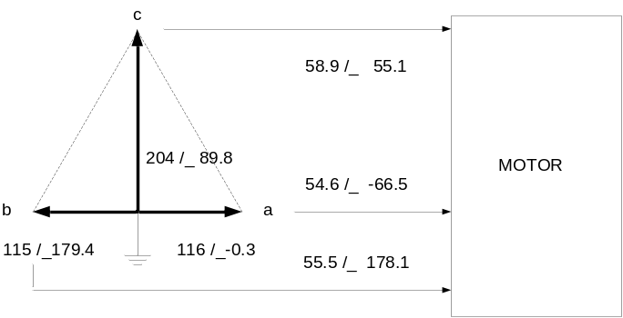
Figure 5. Phasor diagram for the secondary voltages with respect to ground and the motor currents.

Other algorithms for distribution power flow analysis use the powers for convergence. These algorithms usually depend on the voltage reference being near the neutral point of the three-phase system. The center-tapped transformer moves the usual voltage reference to the middle of one leg of the delta winding. This is illustrated in Figure 6.
If one were to measure the individual phase powers using ground as the reference voltage, the following result would be obtained.

Phase | P, kW | Q, kvar
a | 2.6 | 5.8
b | 6.4 | 0.1
c | 9.8 | 6.8
Total | 18.8 | 12.7

This appears quite unbalanced. Inspecting the motor phase currents shown in Figure 7, it is obvious that the currents are reasonably well-balanced. The negative sequence current is 4.7%. Thus, it is obviously the wrong reference frame to be reporting the power flow into the motors. This reference frame does, however, give the correct power flows into the single-phase loads. The total power into the motor is correct, corresponding to approximately 25 hp, but the individual phase powers with respect to ground voltage reference have no meaning by themselves.
The phase powers appear more balanced when the line-to-line voltages are used. This highlights the following points for this transformer connection:

- Two different voltage reference frames must be used at the same bus to report powers in a conventional manner.
- The total power into 3-phase loads is the more important issue in most cases and that is what should be reported.
- For rating devices in such unbalanced configurations, power flows can be confusing. It is usually more useful to know the currents than the individual phase powers as in the table below:

Transformer Winding | Current, A | % of rating
Primary (AN) | 2.75 | 79
Sec. (an) | 73.7 | 71
Sec (nb) | 91.6 | 88
Primary (BN) | 1.77 | 127
Primary (CN) | 1.61 | 116

The secondary windings of the BN and CN transformers have the same percent current as the primary.
It is interesting to note that although there is 18 kVA of single-phase load on the 25 kVA transformer in addition to the 3-phase motor load, the two 10 kVA transformers for the 3-phase load are the ones overloaded. Based on the 3-phase load alone, one might expect these two transformers to be approximately 80% loaded. This illustrates one reason why it is important to be able to model this configuration.

Acknowledgment
This panel summary describes work taking place in the Distribution Systems Analysis Subcommittee of the Power Systems Analysis, Computing and Economics Committee. The assistance of W. H. Kersting is gratefully acknowledged.

References
7 R. C. Dugan, "Experiences with the Center-tapped Wye-Delta Transformer Test Case," Component Models for Distribution Systems Analysis Panel, IEEE PES General Meeting Conference Proceedings , Denver, 2004.
8 R. C. Dugan, “A Perspective on Transformer Modeling for Distribution Systems Analysis,” IEEE PES General Meeting Conference Proceedings, Toronto, July 2003.
9 R. C. Dugan and S. Santoso, “An Example of 3-phase Transformer Modeling for Distribution System Analysis,” IEEE PES Transmission and Distribution Conference Proceedings, Dallas, September 2003.
10 W. H. Kersting, “Transformer Model Test System,” IEEE PES Transmission and Distribution Conference Proceedings, Dallas, September 2003.
11 Ray D. Zimmerman, Hsiao-Dong Chiang, and Karen Miu, “Transformer Modeling Using Line-to-Line Voltages in Ungrounded Distribution Systems,” IEEE PES Transmission and Distribution Conference Proceedings, Dallas, September 2003.
12 Karen Butler-Purry and H. Wang, “Computer Models of Internal Short Circuit and Incipient Faults in Transformers,” IEEE PES Transmission and Distribution Conference Proceedings, Dallas, September 2003.
13 W. H. Kersting, " Center-tapped Wye-Delta Transformer Test Case," Component Models for Distribution Systems Analysis Panel, IEEE PES General Meeting Conference Proceedings , Denver, 2004.

Appendix: Circuit Data
556 MCM Overhead line
556 MCM ACSR with 4/0 ACSR Neutral
(The neutral is explicitly modeled. Therefore, the matrices are 4x4, symmetrical.)

Resistance matrix (ABCN, lower triangle)
0.2812
0.0953 0.2812 (ohms per mile)
0.0953 0.0953 0.2812
0.0953 0.0953 0.0953 0.6873

Reactance matrix (ABCN, lower triangle)
1.38304
0.7266 1.38304 (ohms per mile)
0.85152 0.7802 1.38304 (60 Hz)
0.75244 0.7674 0.7864 1.54648

4/0 Quadraplex Secondary Cable
4/0 AA phase with 4/0 ACSR neutral.
(Neutral explicitly modeled.)

Resistance matrix (abcn, lower triangle)
0.011
0.0018 0.011 (ohms per 100 ft)
0.0018 0.0018 0.011
0.0018 0.0018 0.0018 0.013

Reactance matrix (abcn, lower triangle)
0.0278
0.0241 0.0278 (ohms per 100 ft)
0.0241 0.0241 0.0278 (60Hz)
0.0246 0.0232 0.0246 0.0293

Center-Tapped Transformer
3-windings: 7200V/120V/120V, 25 kVA
Short Circuit Reactances:
Windings | Reactance @ 25 kVA
Primary - Secondary 1 | 2.04%
Primary - Secondary 2 | 2.04%
Secondary 1 - Secondary 2 | 1.36%

Winding Resistances:
Winding | Resistance @ 25 kVA
Primary | 0.6%
Secondary 1 | 1.2%
Secondary 2 | 1.2%

Other Transformers (2)
2 windings: 7200V/240V, 10 kVA
Reactance: 1.4% @ 10 kVA
Resistance: 1.6% @ 10 kVA

Loads - single phase
120V San: 3 kVA, 0.95 PF
120V Sbn: 5 kVA, 0.85 PF
240V Sab: 10 kVA, 0.90 PF

3-Phase Induction Motor Load
Rated voltage: 240V
Per unit Impedances @ 25 kVA, 60 Hz:
Rs=.03359397
Xs=.07999132
Rr=.03940972
Xr=.07999132
Xm=2.1
Slip=0.035 (assumed fixed for analysis)
Connection: Assume ungrounded wye or delta (no zero sequence current).

Complete Transformer Model Details

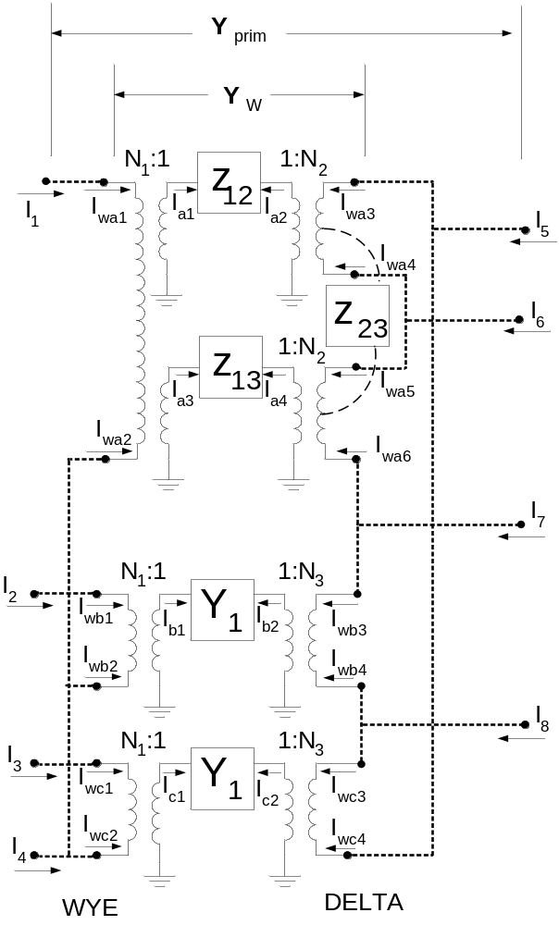
Resulting primitive Y matrix for the entire 3-phase transformer bank. In actual values (siemens). The dimension of the primitive admittance matrix is 8×8 since the transformer has 8 explicit terminals.

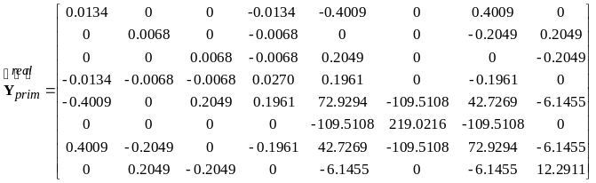(2) (conductance matrix)
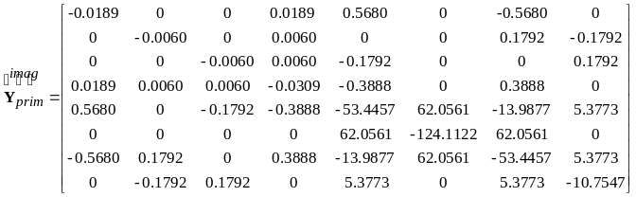(3 (susceptance matrix)

