Given a binary tree root, return the maximum sum of all keys of any sub-tree which is also a Binary Search Tree (BST).

Assume a BST is defined as follows:

The left subtree of a node contains only nodes with keys less than the node's key.

The right subtree of a node contains only nodes with keys greater than the node's key.

Both the left and right subtrees must also be binary search trees.

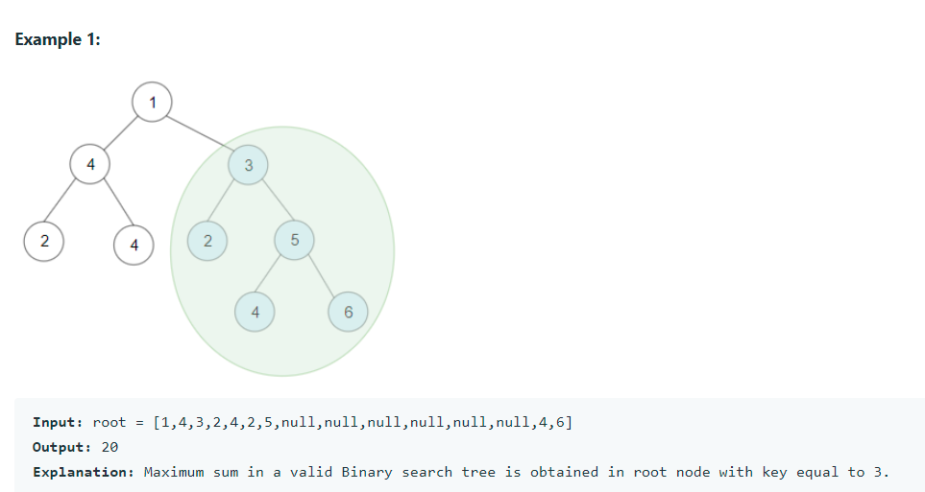

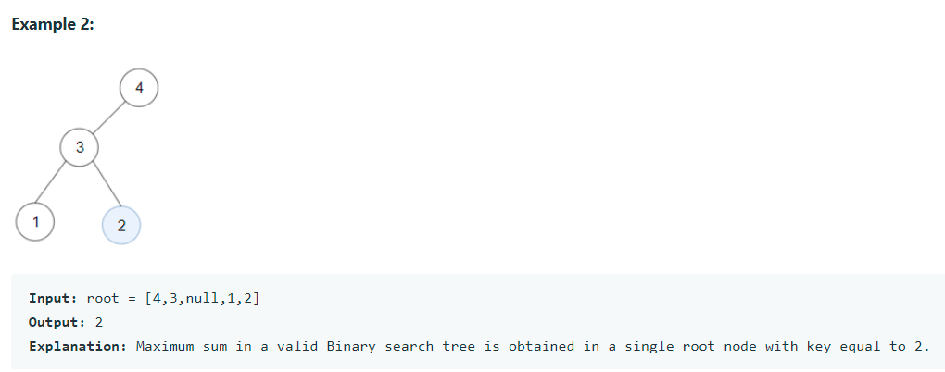

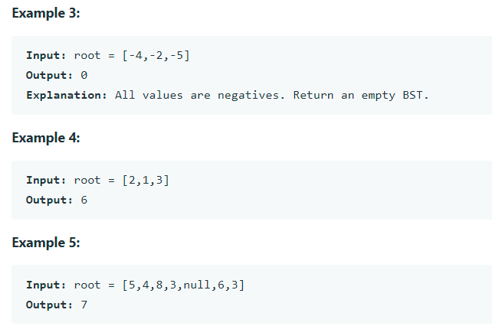

**Constraints:**

The number of nodes in the tree is in the range [1, 4 * 104].

-4 * 104 <= Node.val <= 4 * 104