Recruitment & Onboarding
Workflows
Priority Handling Logistics, Inc. • HRMS
Implementation reference • Updated 2026-09-20

Purpose: provide a single, implementation-aligned reference for applicant intake, recruitment decisions, interviews, notifications, hiring, temporary employee access, requirements, training, permanent access, and MFA.

Contents
- End-to-end recruitment overview
- Public application and resume validation
- Recruitment stages and safeguards
- Resume review and AI-assisted ranking
- Interview workflow
- Applicant notifications and tracking
- Hire and temporary-account creation
- Requirements and permanent-access promotion
- Authentication, MFA, and email responsibilities
- Route ownership and acceptance testing
Diagram colors: blue represents a user or HR action, green an automated success, amber a decision or validation, and red a blocked or terminal result.

1. End-to-end recruitment overview
The workflow begins with a published vacancy and ends when a successful candidate has permanent employee access and enters onboarding. Rejected and withdrawn applications retain their history for authorized review.
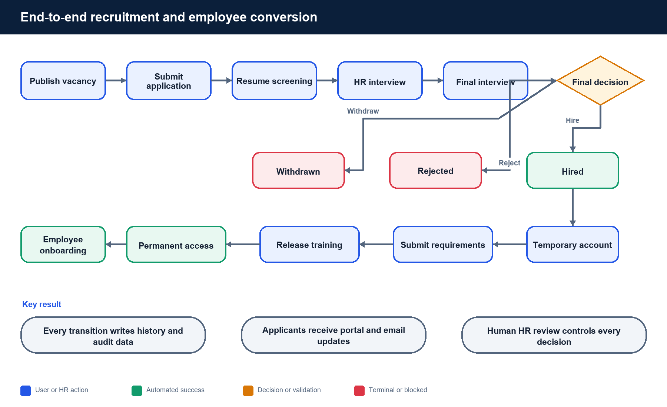
Figure 1. Complete recruitment-to-employee lifecycle

2. Public application and resume validation
The public form intentionally collects only the information required for initial screening: full name, phone, email, location, privacy consent, and a PDF resume.
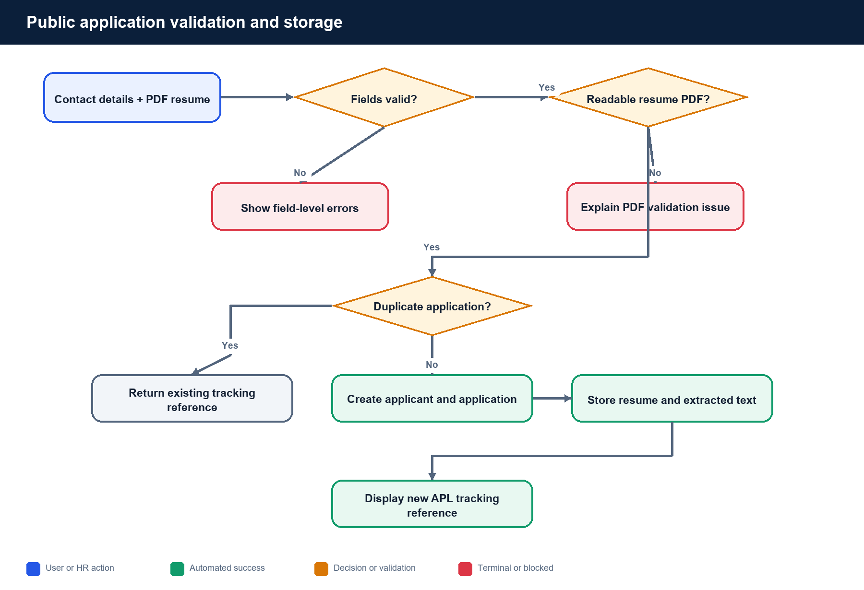
Figure 2. Application validation and data creation
Workflow point | Implemented rule
Phone | Accept 7 to 15 digits.
Resume format | Accept PDF only, up to 4 MB.
Resume integrity | Require a readable, searchable, unencrypted PDF with recognizable resume content.
Duplicates | Prevent the same applicant email from applying twice to one vacancy.
Tracking | Return an APL reference after a successful submission.

3. Recruitment stages and safeguards
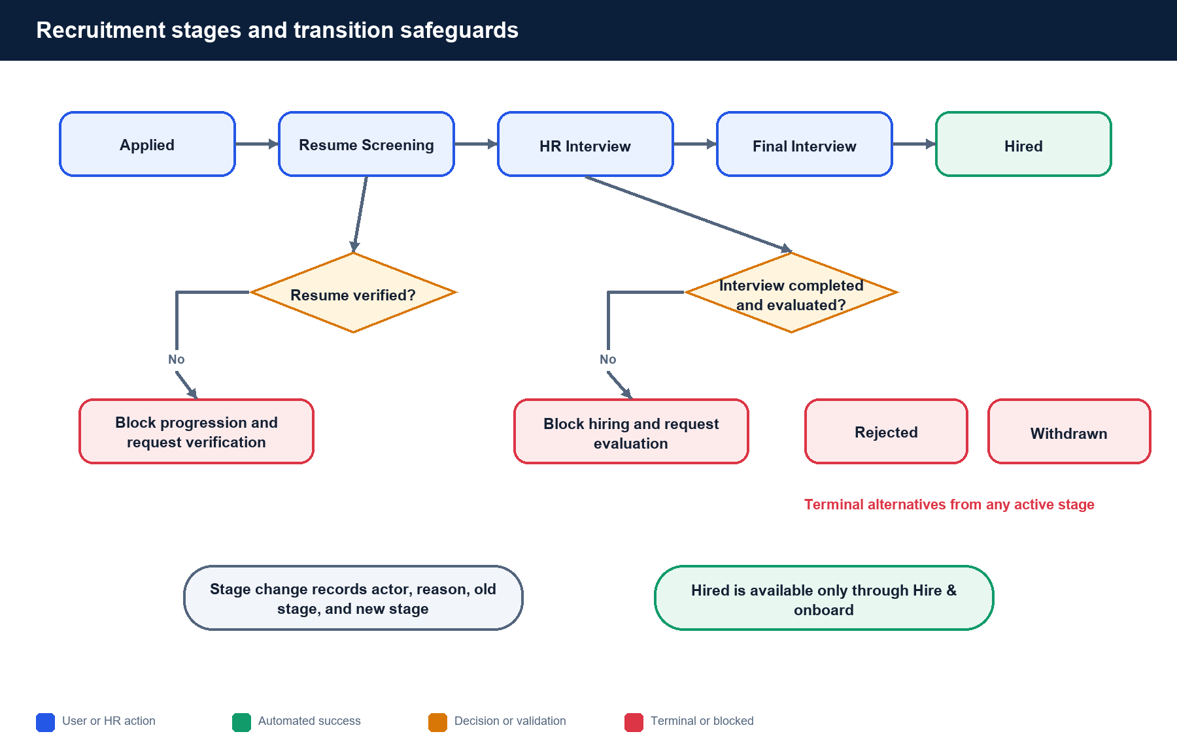
Figure 3. Active stages and protected transitions
Workflow point | Implemented rule
Applied | Assigned automatically after a successful application.
Resume Screening | HR verifies the submitted resume before further progression.
HR Interview | Scheduling is available only after resume verification.
Final Interview | HR records the final interview and evaluation.
Hired | Available only through Hire & onboard, not the ordinary stage selector.
Rejected / Withdrawn | Terminal outcomes with a recorded reason and stage history.

4. Resume review and AI-assisted ranking
HR may generate an explainable score from the vacancy criteria and extracted resume text. The output includes a 0–100 score, recommendation, strengths, concerns, and a summary. It is decision support only.
- Every applicant remains visible regardless of score.
- The system does not automatically reject or hire an applicant.
- An authorized reviewer records whether the guidance was accepted or overridden.
- Human review controls every recruitment-stage transition.

5. Interview workflow
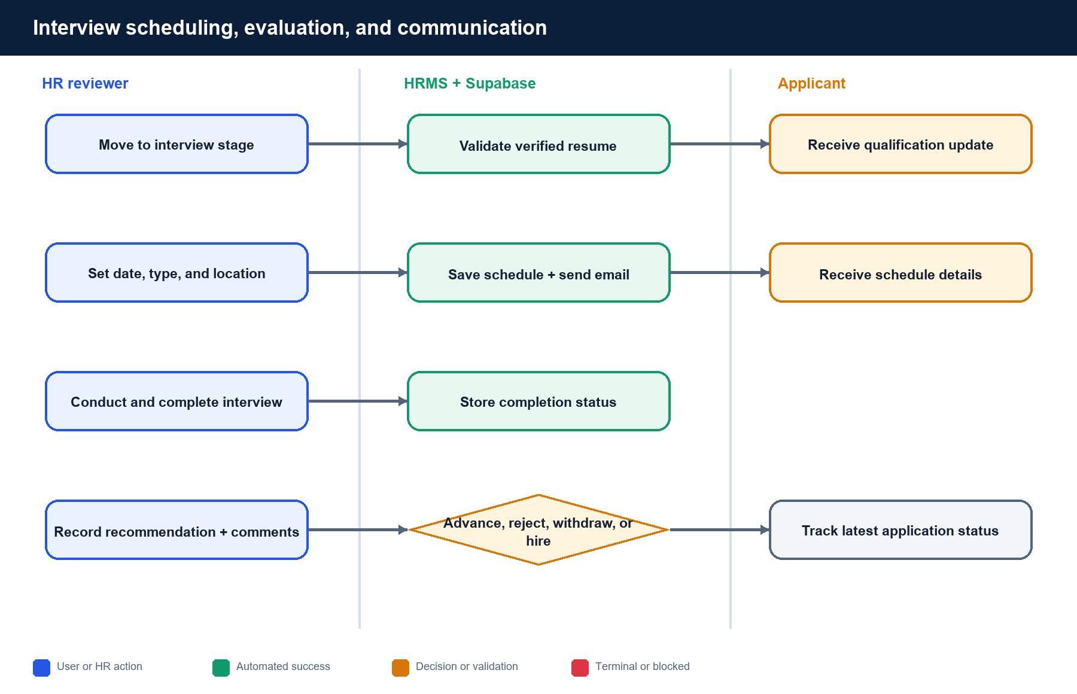
Figure 4. Interview scheduling, communication, and evaluation
- HR records interview type, start and end time, timezone, location, or meeting URL.
- The applicant receives qualification and scheduling updates when SMTP is available.
- HR can edit or cancel an interview before completion.
- A completed interview and saved evaluation are required before hiring.

6. Applicant notifications and tracking
Every supported recruitment event creates a portal notification. When Gmail SMTP is configured, the HRMS also creates an email-delivery record, sends the message, and stores the provider message ID or delivery error.
- Screening passed
- Qualified for interview
- Interview scheduled
- Rejected
- Hired
Applicants use /careers/track with the application reference and matching email to view the current stage and updates. Tracking remains available if external email fails.

7. Hire and temporary-account creation
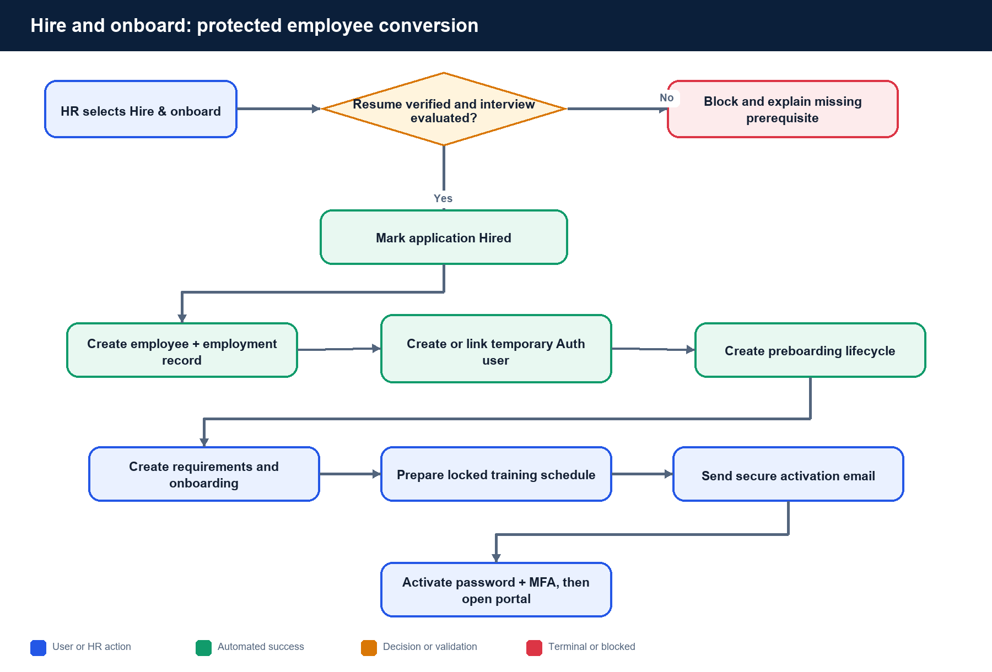
Figure 5. Protected Hire & onboard transaction
Workflow point | Implemented rule
Hiring prerequisites | Verified resume and a completed, evaluated interview.
Employee record | Create the employee and current position/department assignment.
Auth account | Create or link an employee-compatible Supabase Auth user.
Temporary role | Assign preboarding access, requirements, onboarding, and locked training.
Activation | Send a secure Supabase invitation through configured custom SMTP.

8. Requirements and permanent-access promotion
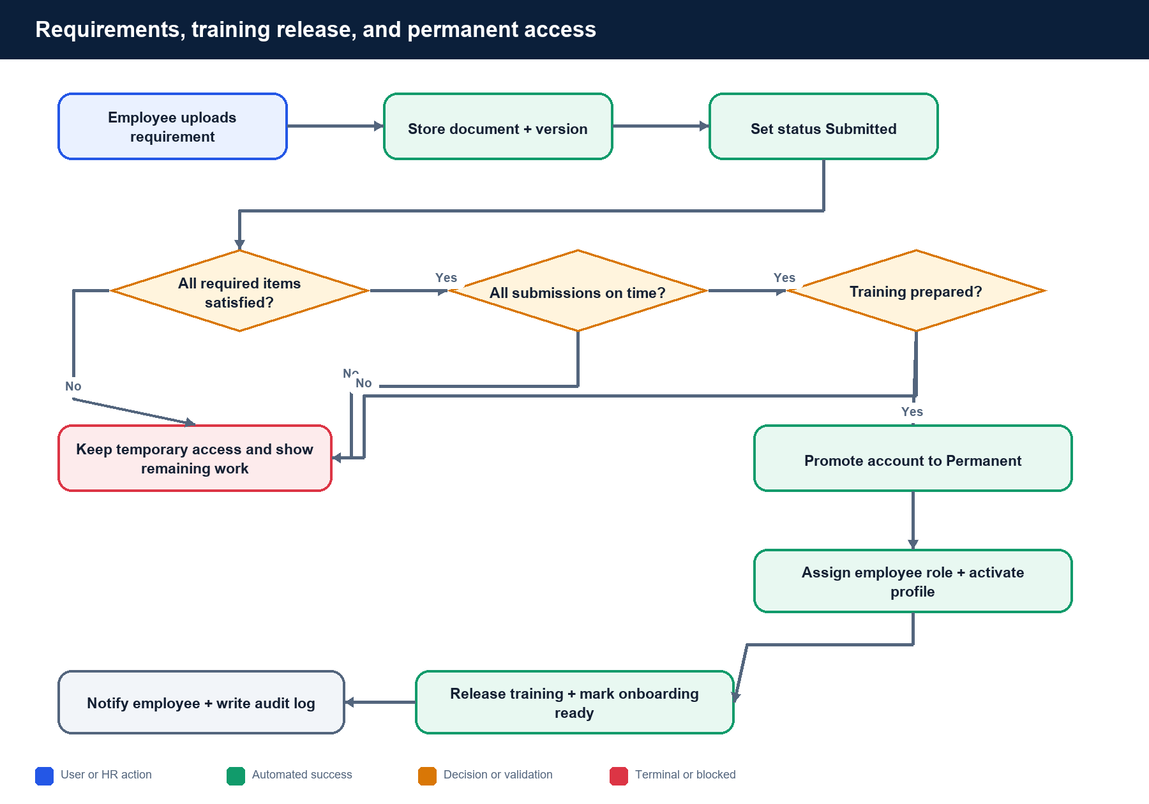
Figure 6. Automatic temporary-to-permanent access promotion

Requirement states
Pending → Submitted → Under review → Verified. HR may reject a submitted file, after which the employee uploads a replacement. HR may waive a requirement when no file is needed.
- Submitted, Under review, Verified, and Rejected states require an attached document.
- Replacement uploads create document versions.
- HR sees submissions in Preboarding and Employee records.
- The employee portal hides completed submissions while preserving HR records.

Promotion gate
Permanent access is granted when all required items were submitted on time and are not Pending or Rejected, or were waived, and at least one prepared training schedule exists. The system then assigns the employee role, activates the profile, releases training, marks onboarding ready, notifies the employee, and writes an audit record.

9. Authentication, MFA, and email responsibilities
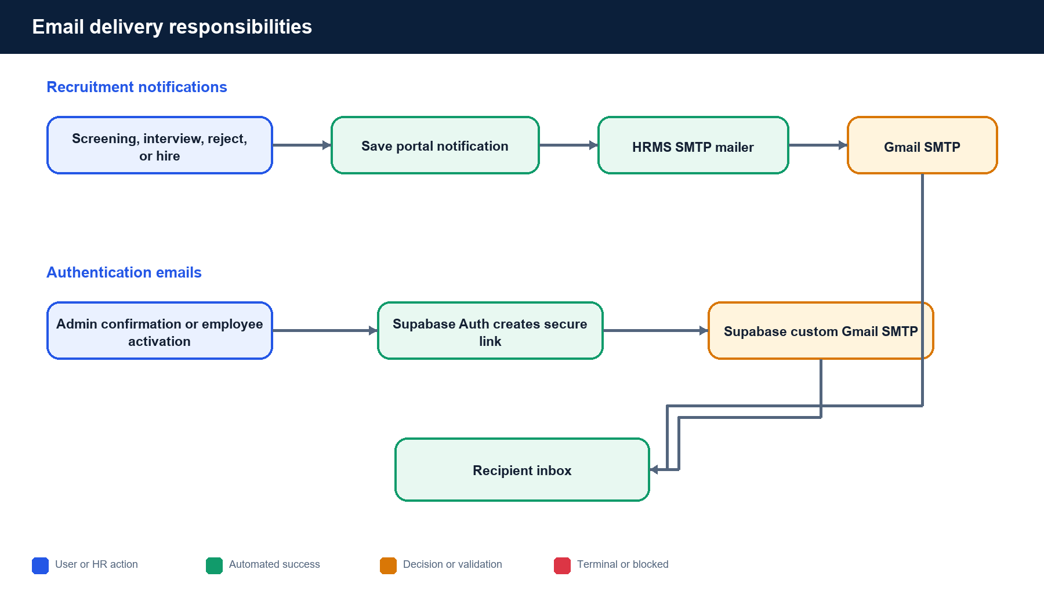
Figure 7. Separate application and Supabase Auth email channels
Workflow point | Implemented rule
Applicant updates | HRMS server sends through SMTP_* Gmail settings.
Admin confirmation | Supabase Auth sends through its custom Gmail SMTP settings.
Employee activation | Supabase Auth sends the invitation or activation link.
MFA | Protected HR and employee sessions proceed through enrollment or verification to AAL2.
Admin registration | Public first-administrator registration is disabled.

10. Route ownership and acceptance testing
Workflow point | Implemented rule
/careers | Browse published vacancies.
/careers/[vacancyId] | Submit a public application.
/careers/track | Track an application by reference and email.
/hr/recruitment/applicants | Review applicants and current stages.
Applicant detail | Verify resume, assess match, manage interviews, and decide outcome.
/hr/preboarding | Manage temporary accounts, requirements, training, and access.
/employee/onboarding | Submit employee documents and view unlocked training.
/hr/records | Review retained employee records and submitted files.

Recommended end-to-end acceptance test
- Publish a test vacancy and submit a valid searchable PDF resume.
- Use the returned reference in Track application.
- Verify the resume and generate the advisory match assessment.
- Advance to HR Interview and confirm the notification record.
- Schedule, complete, and evaluate the interview.
- Advance to Final Interview, then use Hire & onboard.
- Confirm employee, employment, Auth, lifecycle, requirement, training, and audit records.
- Activate the temporary account, complete MFA, and upload every requirement.
- Confirm HR can download and review each submission.
- Confirm on-time completion releases training and grants Permanent access.

End of workflow reference

