Using Get-SQL
Get-SQL makes it easier to use PowerShell to work with databases, using either ODBC or the SQL-Client for SQL Server.
It connects to databases and submits SQL Statements, either taking a prepared SQL statement or building one from multiple intellisense-enabled parameters.

Getting connected.
To start using Get-SQL you need to connect to a database as shown in the Figure 1 and Figure 3.
Get-SQL uses -Connection to specify a connection-string and -Session to name an instance of a link (if you don’t specify a session name, Get-SQL will name the session “default”). If a subsequent command provides connection information for a session which already exists, a new connection will only be made if the –ForceNew parameter is specified.
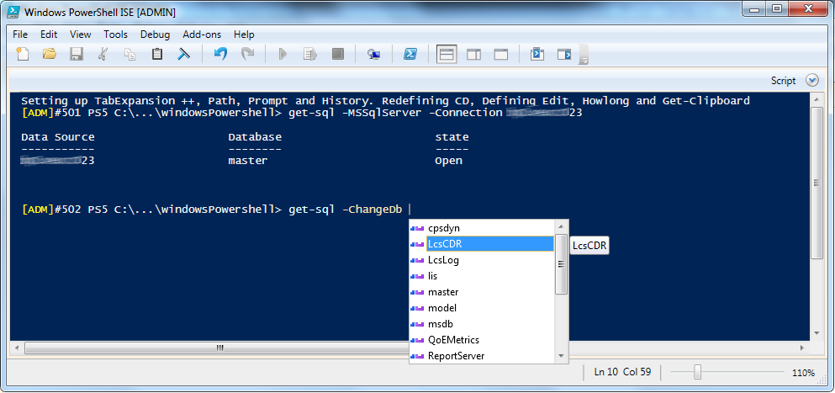
Figure 1 connecting the default session to SQL server
Figure 1 shows connecting to SQL server without naming the session, so it becomes the default session. -MSSQLServer tells Get-SQL to use the SQLClient driver. It interprets a –Connection parameter which does not contain an = sign, as a server name and builds a simple connection string. This string specifies a trusted connection and a timeout but it doesn’t include a database name, so the SQL server driver connects to the master database. The second line in Figure 1 shows switching databases - intellisense is available to complete the database name.
Figure 1 shows 64-bit PowerShell (the default), but 32-bit ODBC drivers provided with 32-bit Office, require 32-bit PowerShell – and the 64-bit drivers from 64-bit Office only work with 64-bit PowerShell. Office provides the drivers for the following local file types:
- Access (*.mdb, *.accdb) – even if Access itself is not installed
- dBASE / Foxpro (*.dbf, *.ndx, *.mdx)
- Excel (*.xls, *.xlsx, *.xlsm, *.xlsb)
- Paradox (*.db )
- Text (*.txt, *.csv) – the text driver treats a folder as a virtual “database” and files within it as tables.
The text driver appears to work only with Data Source Names (DSNs) created in the “Data sources (ODBC)” tool (the 32-bit version if using 32-bit Office) as in Figure 2, below.
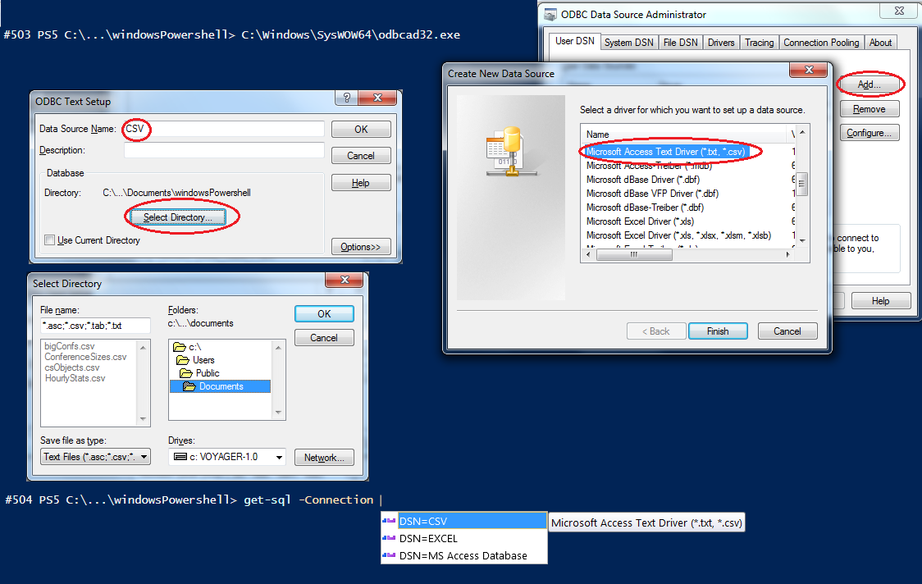
Figure 2 Setting up a text ODBC connection for CSV files
When specifying the -connection parameter it can be DSN= «Name» or a detailed connection string, like this:
'Driver={Microsoft Excel Driver (*.xls, *.xlsx, *.xlsm, *.xlsb)};DriverId=790;ReadOnly=0;Dbq «FileName»;'
To save having to set-up DSNs or write connection strings in full, there are –Excel and –Access switches to tell Get-SQL to treat the –Connection parameter as file name (as seen in Figure 3)
If you always use the same database, you can set $DefaultDBConnection in your profile to the value for the -Connection parameter (though if it is not an ODBC connection string, you may need to specify -SQLServer -Excel or -Access explicitly.)
Figure 3 32-bit PowerShell connecting a named session to an Excel database
In Figure 3 the Get-SQL session is named “Topology”; you access this database using
Get-SQL –Session Topology «command»
When Get-SQL connects to a database it defines a new PowerShell alias for itself, using the same name as the session. Calling it with the alias makes the same name the default session name so
Topology -ShowTables
is equivalent to Get-SQL –Session topology –ShowTables. When there is no command “SQL”, PowerShell will try adding “Get-” to the start of the command so SQL is an automatic alias for Get-SQL
-ShowTables returns a list of tables and is one of two parameters for discovering things about the database; the other is -Describe «tablename»
The –Close switch tells Get-SQL to disconnect from the database after running any command; some ODBC drivers lock files, so forgetting to close the file can prevent other programs from opening it. The opening or closing of a session can be combined with running a command - Figure 1 showed connecting to a server and changing database as two separate PowerShell commands, but it is possible to run commands together; Figure 4 combines the initial connection with a change DB command (using its alias of “-USE” to be closer to SQL Server) and the -ShowTables switch
Figure 4 Combing connecting, changing database and a query in one line

Running SQL Commands
Any SQL can be run sent by passing the it in the -SQL parameter, -SQL will accept the first unnamed parameter so the connection can be used like this so each of the following will run the same query:
- Get-SQL -Session LyncCDR -SQL "SELECT * From Users"
- LyncCDR -SQL "SELECT * From Users"
- LyncCDR "SELECT * From Users"
- "SELECT * From Users" | lynccdr | Select-Object -ExpandProperty userURI
Notice that SQL statements can be piped into Get-SQL; it also allows the -SQL parameter to contain multiple statements. Get-SQL also allows a complete query to come from the clipboard using -Paste
Figure 1 and Figure 2 showed that Get-SQL supports intellisense to provide ODBC DSNs and SQL server databases. It also uses intellisense to help to construct single-table Select, Update, Delete and Insert queries from the PowerShell command line. Figure 5 and Figure 6 show this in action.
Figure 5 Building Select and Update queries from the command line
The first command in Figure 5 shows another way to return all rows in the Users table:
LyncCDR -Table Users
Used without other parameters, -Table Users produces the query “Select * from Users”, but often we want to add more to end of the query, and the -SQL parameter can do that; written out in full it looks like this:
Get-SQL -Session LyncCDR -Table "Users" -SQL "where userUri like 'james%' "
and can be shortened to
LyncCDR -Table "Users" "where userUri like 'james%' "
Get-SQL also has a -Where parameter which can be populated by Intellisense. (PowerShell allows parameters to be entered in any order, but Intellisense requires the session to be identified to choose the table, and the table to be identified to choose fields).
So, -where could specify the userUri field, and the last part of query could be something like
"Between 'James.o' and 'james.p'" so the previous query could be built like this:
LyncCDR -Table "Users" -where "userUri" "like 'james%' "
But Get-SQL goes a little further and provides the same options as PowerShell’s Where-Object cmdlet, you can specify -
-EQ, -NE, -GE, -LE, GT, -LT, -LIKE or -NotLike so the command above could be:
LyncCDR -Table Users -where userUri -like james*
Notice there are no quote marks in the last example: PowerShell can often manage without them but when Get-SQL’s argument completers provide values for intellisense they are wrapped in quotes.
Notice also, that if -Like and -NotLike are used, Get-SQL converts the standard command-line wildcard “*” into the “%” sign that SQL uses. In other places or if you use the format "like 'James*'", the * will remain untouched, so you can search for an asterisk.
All the queries so far are expected to return data and Get-SQL writes a message to the console (not to standard output, ensuring that it doesn’t get mixed up with the data) saying how many rows were returned. This can be supressed with the -Quiet switch – it’s also often helpful to see the data in PowerShell’s grid view which can apply further sorting and filtering on the returned data to save typing | Out-GridView you can specify -G (or -Gridview in full). --GridView can also be used with -Describe
Get-SQL isn’t confined to the building Select queries.
Adding -Delete to the command line will transform the query from a Select into a Delete query (if the database driver supports it – Excel’s, for example, does not) and adding -Set «fieldname1 ,fieldname2» -values «value1,value2» turns it into an Update; the last command in Figure 5 does exactly this, and shows Get-SQL’s support for -Verbose, -WhatIf and -Confirm switches.
-Verbose displays the SQL string submitted to the database and if Get-SQL builds a connection string -Verbose will display that as well.
If -Delete or -Set is specified, GET-SQL will require confirmation (unless you specify -Confirm:$false), -Insert does not (unless you specify -Confirm) and -whatif will display the Delete, Insert or Update query which would be run.
There are additional options for Select queries which can be seen in Figure 6
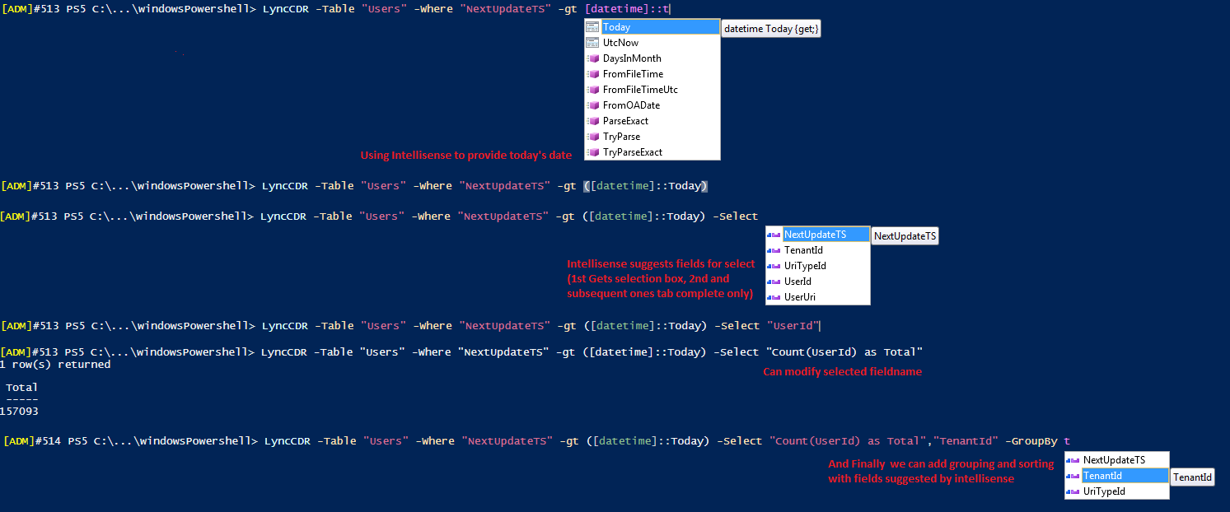
Figure 6 More options in Select queries
SQL date formatting can be problematic and Get-SQL will format datetime objects so they can be processed (for special cases the -dateformat parameter allows the format to be changed) – PowerShell’s Tab Expansion will put brackets around [datetime]::Today and you can use, for example, -LT ([datetime]::Today).AddDays(-7) for “more than one week ago”
Specifying -Table on its own runs a query as “Select *”, to choose specific fields Get-SQL has a -Select parameter – the fields can be completed by intellisense and it can be quicker to edit a field name populated that way than to type it; in Figure 6 you can see that "UserID" was filled in and then changed to "Count(UserID) as Total", and then a second field was added. Note that the separate field names in -Select become changed a single string holding a comma separated list in the final query so anything which legitimate in a Select clause can be used for example: -Select "TOP 5 *".
-GroupBy and -OrderBy parameters also modify how Select queries are built, and both support intellisense; fields for Order By can be modified to contain “DESC” so they sort in descending order. The last parameter which affects Select queries is -Distinct which changes the Select statement to a Select Distinct one
Get-SQL won’t check a Delete or Update query which is passed in the -SQL parameter – it allows any SQL and assumes database engine supports it and you intend to run it - but when asked to build such a query from parameters it requires that there is a Where condition (so a whole table isn’t deleted or overwritten by mistake). If -Select, -Distinct -Orderby or -GroupBy have been specified then the parameter definitions for GET-SQL won’t allow -Set ... -Values or -Delete
As well as building Select, Delete and Update queries, Get-SQL has an -INSERT parameter to allow it to add new rows. For all other kinds of queries the -SQL parameter contains either a complete SQL query or something to append to the end of query built from other parameters, with -Insert it must be one or more PSObjects or Hash Tables. With a PSobject the property names match column names in the table and the value of each goes in that column: with a hash table the Keys are column names.
So, an insert command might look like this
Get-SQL -Insert TestTable @{Name="File.ext";length=1024}
or this
dir *.ps1 | Select-object -property -Name, Length | Get-SQL -Insert TestTable
Passing an object through Select-Object -property is a quick way to create the required PSobject
Get-SQL has a lot of choices: Figure 7 shows each different type of operation (top to bottom) and the different groups of parameters which build up to create the command (left to right)
Figure 7 How the parameters fit together
One final parameter was added in version 1.2. When a table object is returned it is expanded into its rows and there are use cases where the table is needed -OutputVariable MyTable puts the table into a variable so that after Get-SQL has finished, the table can be accessed as $MyTable.

