$projectName = 'ServerAutomationDemo' *## common term used through set up*

$subscriptionName = 'XXXXXXXXXX'

$subscriptionId = 'XXXXXXXX'

$tenantId = 'XXXXXXX'

$region = 'XXXXXXX'

$resourceGroupName = $projectName

$azDevOpsOrgName = 'adbertram'

$GitHubAccountName = $azDevOpsOrgName

$localVMAdminPw = 'I like azure.' *## a single password for demo purposes*

$gitHubRepoUrl = "<https://github.com/$GitHubAccountName/$projectName>"

*#Login and pick the right subscription*

az login

az account set --subscription $subscriptionName

*#Set up a resource group for this demo*

az group create --location $region --name $resourceGroupName

*#Create a service principal - see screen shot for where this goes in the gui*

$spIdUri = "<http://$projectName>"

$sp = az ad sp create-for-rbac --name $spIdUri | ConvertFrom-Json

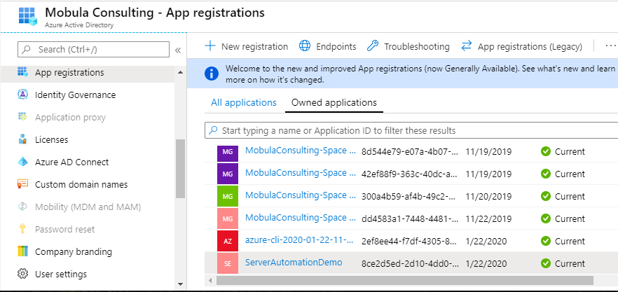

*#Create a keyvault in the the projects resource group*

$kvName = "$projectName-KV"

$keyVault = az keyvault create --location $region --name $kvName --resource-group $resourceGroupName   
 --enabled-for-template-deployment true | ConvertFrom-Json

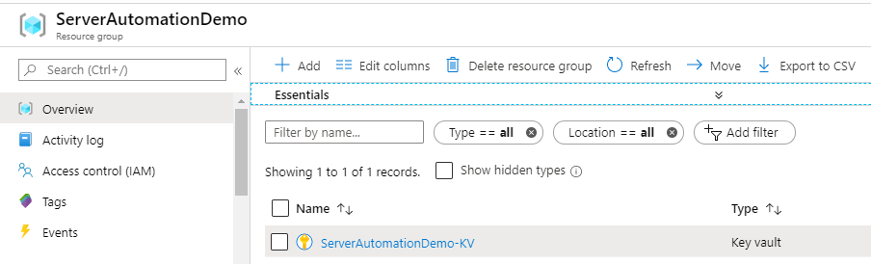

*# ## Create the key vault secrets*

az keyvault secret set --name "$projectName-AppPw" --value $sp.password --vault-name $kvName

az keyvault secret set --name StandardVmAdminPassword --value $localVMAdminPw --vault-name $kvName

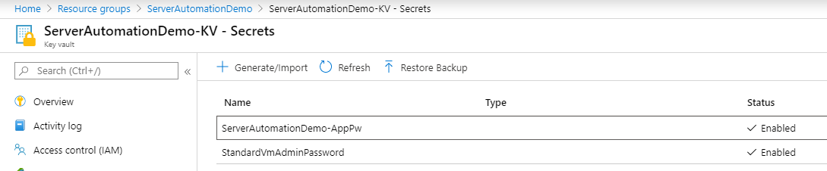

*#Create the Azure DevOps project*

az devops project create --name $projectName

az devops configure --defaults project=$projectName

#My AzDO organizations on the left, new AzDO project on the right

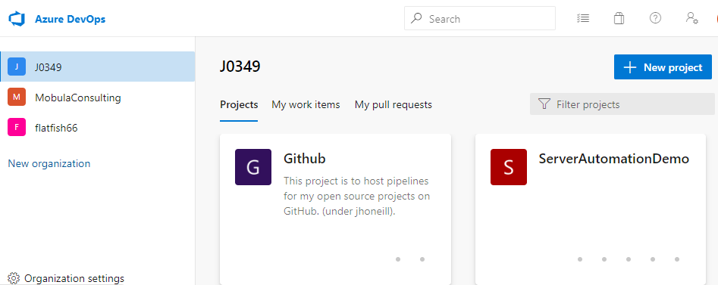

*#Create the Devops service connections*

*## Run $sp.password and copy it to the clipboard*

*## when prompted, use the value of $sp.password for the Azure RM service principal key*

$sp.Password

az devops service-endpoint azurerm create --azure-rm-service-principal-id $sp.appId --azure-rm-subscription-id  
 $subscriptionId --azure-rm-subscription-name $subscriptionName --azure-rm-tenant-id $tenantId --name 'ARM'

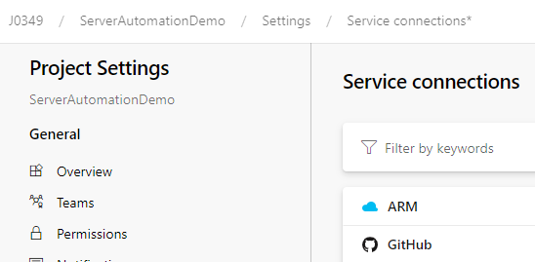

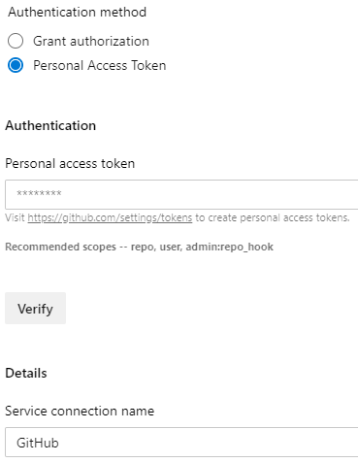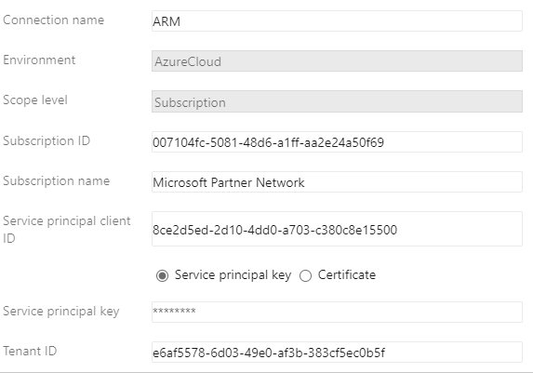

*#we have a Service Principal in Azure Ad for our tenant/Subscription with an id of 8ce2d5ed-2d10-4dd0-a703-c380c8e15500 , [above] it can connect to our key vault to read the secrets The project has this as one service connection named ARM. It needs another service connect for connecting to GitHub [right]*

*#Get a GitHub access token (under developer settings) and Paste that in when asked.*

*$gitHubServiceEndpoint = az devops service-endpoint github create --github-url $gitHubRepoUrl --name 'GitHub' |  
 ConvertFrom-Json*

*##ARM, our service connection, gives us a connection to the Azure key vault as the service principal.*

*‘Now we need a variable group which to deliver the secrets into the pipeline.   
## It needs a dummy variable because AZ cli won't allow creation without it then MANUALLY link the key vault*

$varGroup = az pipelines variable-group create --name $projectName --authorize true --variables foo=bar |   
 ConvertFrom-Json

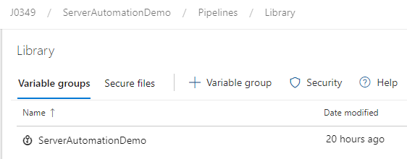

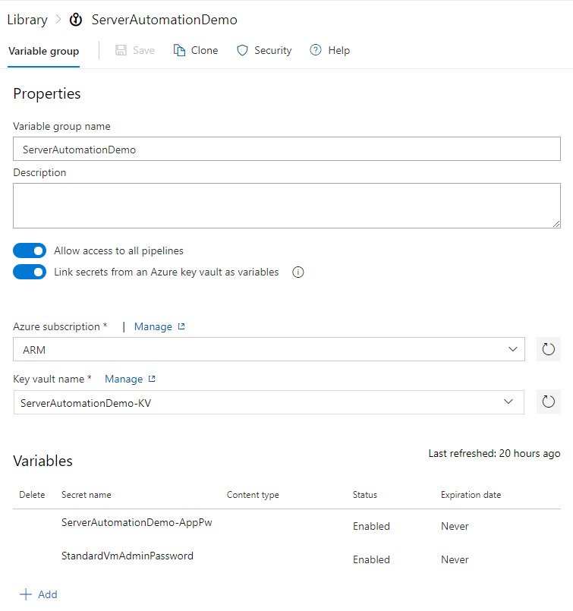

*# Add the pipeline*

az pipelines create --name $projectName --repository $gitHubRepoUrl --branch master --service-connection $gitHubServiceEndpoint.id --skip-run

trigger: *# what in the repo will trigger the pipeline*

branches:

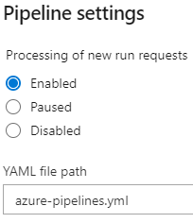 include:

- master

paths:

include:

- server.json

- server.parameters.json

pool:

vmImage: "ubuntu-latest"

variables:

- group: ServerAutomationDemo

- name: **azure_resource_group_name** *# resource group will have a suffix -123 based on build no.*

value: "ServerProvisionTesting-$(Build.BuildId)"

- name: **subscription_id** *# The others Could be secrets.*

value: "xxxxxxxx-xxxx-xxxx-xxxx-xxxxxxxxxxxx"

- name: **application_id**

value: "xxxxxxxx-xxxx-xxxx-xxxx-xxxxxxxxxxxx"

- name: **tenant_id**

value: "xxxxxxxx-xxxx-xxxx-xxxx-xxxxxxxxxxxx"

steps:

- task: PowerShell@2

inputs:

filePath: "connect-azure.ps1"

arguments: '-ServicePrincipalPassword "***$(ServerAutomationDemo-AppPw)***" -SubscriptionId $(subscription_id)   
 -ApplicationId $(**application_id**) -TenantId $(**tenant_id**)'

- task: PowerShell@2

inputs:

targetType: "inline"

script: New-AzResourceGroup -Name $(**azure_resource_group_name**) -Location uksouth -Force

- task: AzureResourceManagerTemplateDeployment@3

deploymentScope: "Resource Group"

azureResourceManagerConnection: "ARM"

subscriptionId: "$(subscription_id)"

action: "Create Or Update Resource Group"

resourceGroupName: **$(azure_resource_group_name)**

location: "UK South"

templateLocation: "Linked artifact"

csmFile: "server.json"

csmParametersFile: "server.parameters.json"

deploymentMode: "Incremental"

deploymentOutputs: "arm_output"

First task does   
 Install-Module -Name Az.Accounts, Az.Resources -Force -SkipPublisherCheck

Connect-AzAccount -ServicePrincipal -Tennant <<idfromvar>> -SubscriptionId <<idfromvar>>  
 -Credential <<from AppidVar & passwordsecret from library>>

Second task creates resource group

Third task looks like this in the portal

