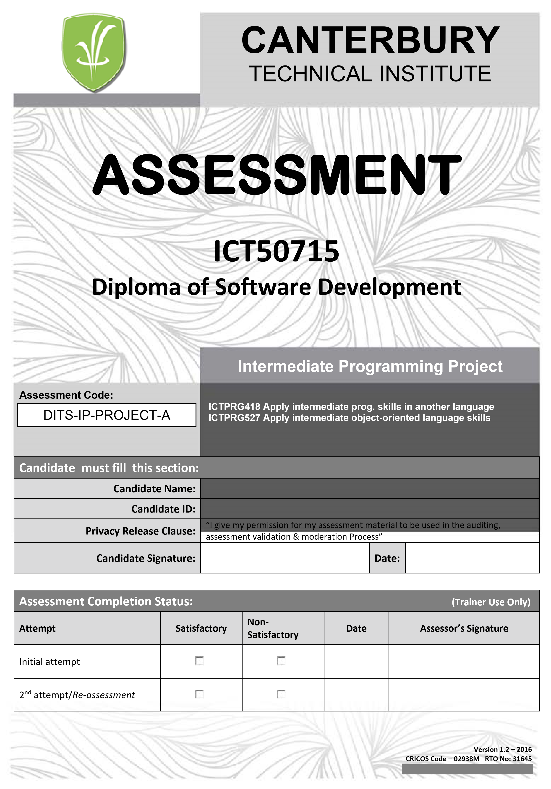

|  |
| --- |
| **Information for Candidate:** |
| * All work is to be entirely of the candidate.     **General Information for this assessment:**   * Read the instructions for each question very carefully. * Be sure to PRINT your FULL name & LAST name in every place that is provided. * Short questions must be answered in the spaces provided. * For those activities requesting extra evidence such as: research reports, ESSAY reports, etc. The student must attach its own work formatted in double space, Arial 12 pts. * All activities must be addressed correctly in order to obtain a competence for the unit of competency. * If the candidate doesn’t understand the assessment, they can request help from the assessor to interpret the assessment. |
| **Re-assessment of Result & Academic Appeal procedures:** |
| If a student at CTI is not happy with his/ her results, that student may appeal against their grade via a written letter, clearly stating the grounds of appeal to the Deputy Principal. This should be submitted after completion of the subject and within fourteen days of commencement of the new term.  **Re-assessment Process:**   * An appeal in writing is made to the Deputy Principal providing reasons for re-assessment /appeal. * Deputy Principal will delegate another faculty member of CTI to review the assessment. * The student will be advised of the review result done by another assessor. * If the student is still not satisfied and further challenges the decision, then a review panel is formed comprising the lecturer/trainer in charge, the Deputy Principal and the Director of Student Services OR if need be an external assessor. * The Institute will advise the student within 14 days from the submission date of the appeal. The decision of the panel will be deemed to be final. * If the student is still not satisfied with the result, the he / she has the right to seek independent advice or follow external mediation option with CTI’s nominated mediation agency. * Any student who fails a compulsory subject or appeals unsuccessfully will be required to re-enrol in that subject.     The cost of reassessment will be borne by the Institute. The external assessor will base his/her judgement based on principles of assessment. These principles require assessment to be reliable, fair, practical and valid.  **Academic Appeals**   * If you are dissatisfied with the outcome of the re-evaluation process, you have a right to appeal through CTI’s complaint / grievance protocol. * The notice of appeal should be in writing addressed to the Deputy Principal and submitted within seven days of notification of the outcome of the re-evaluation process. * If the appeal is not lodged in the specified time, the result will stand and you must re-enrol in the unit. * In emergency circumstances, such as in cases of serious illness or injury, you must forward a medical certificate in support of a deferred appeal.   The notice of appeal must be made within three working days of the concluding date shown on the medical certificate.   * The decision of Deputy Principal will be discussed with the PEO and will be final. * Student would then have the right to pursue the claim through an independent external body as detailed in the students’ complaint / grievance policy. |

|  |
| --- |
| **Feedback/Comments:** |
|  |

|  |  |  |  |  |  |  |  |
| --- | --- | --- | --- | --- | --- | --- | --- |
| **Acknowledgement** | | | | | | | |
| I understand all the above rules, guidelines and feedback for this assessment. | | | | | | | |
|  | **Full Name:** |  | **Signature:** |  | **Date:** |  |  |

|  |
| --- |
| **Submission Details:** |
| The assessment task is due on trainer provided date. Any variations to this arrangement must be approved in writing by your assessor. Submit this document with any required evidence attached. See specifications below for details  **Performance objective**  The candidate must demonstrate skills, knowledge and understanding and promote the use and implementation of innovative work practices to effect change, as states the units of competency **ICTPRG418,** **ICTPRG527**. Throughout this program you are to demonstrate knowledge in:     * Australian Computer Society Code of Ethics. * Federal and state or territory legislation and policy relevant to an IT environment relating to:   Access and equity, copyright and intellectual property and OHS.   * Privacy. * Organisational communication processes and procedures. * Organisational requirements for customer service.     And skills in:   * Communication skills to liaise with internal and external personnel on ethical and privacy, operational and business-related matters. * Learning skills to update personal ethical and privacy knowledge through professional development literacy skills to apply standards and legislation to policy and procedure development and monitoring. * Planning and organisational skills to plan, prioritise and monitor own work. * Research skills to gain and maintain current industry privacy and ethical information. * Technical skills to perform application and system security and storage management. |
| **Assessment description:** |
| You will undertake **computer based test** based on class lectures and activities in this Practical Activity. |
| **Procedure:** |
| 1. You will need to follow instructions below and address all activities required. 2. This is an individual activity where each candidate will be assessed individually; 3. Complete all activities and submit assessment evidence (including these papers) to your assessor the date specified above (see submission details). 4. Referencing : All findings from the internet or other sources must be referenced as per standards laid by APA referencing guide at: http://www.usq.edu.au/library/help/referencing/apa |
| **Specifications/Conditions:** |
| Your assessor will be looking for evidence of:   * Analyse legislation and standards relating to professional conduct and privacy in the IT industry * Contribute to the development of a code of ethics and monitor the workplace to ensure code of ethics is being applied and is appropriate * Contribute to the development of a privacy policy and monitor the workplace to ensure the policy is being applied and is appropriate. * Relevant organisational policies, legislation and standards documentation. * Industry codes of practice. |

**Assessment Details**

**Units covered in this project:**

ICTPRG418 Apply intermediate programming skills in another language ICTPRG527 Apply intermediate object‐oriented language skills ICTPRG501 Apply advanced object‐oriented language skills

ICTPRG523 Apply advanced programming skills in another language

ICTPRG505 Build advanced user interface

ICTPRG507 Implement security for applications **Project time-frame:**

Two (2) terms, eighteen (18) weeks divided into two (2) parts:

* **Part A** (Term 1, 8 weeks) – Intermediate Programming o (ICTPRG418, ICTPRG527).
* **Part B** (Term 2, 10 weeks) – Advanced Programming o (ICTPRG501, ICTPRG523, ICTPRG505, ICTPRG507)

**Problem Scenario**

|  |
| --- |
| A company named Logic Peripherals Australia (LPA) has decided to invest in a new computer software package to manage the sales and stock of their computer peripheral line to rollout across their corporate network an internet web site. The new system they require will be a customised application to manage the following:   * Stock (Computer Peripherals) * Sales & Invoicing * eCommerce web site store with payment gateway   The project will be divided into three sections with the following user interfaces:   * **Desktop application**    + This application will be used for internal intranet management of the system and will only be accessible on the corporate network or via VPN access. This interface will have full access to the system core with all features. * **Mobile Application**    + The mobile application will be used for external management of the system and will have limited access to only allow management of the stock, sales and invoicing, system administration level will not be available through this interface. * **eCommerce web site store**    + This is the end point interface for the customer to purchase products (computer peripherals) via the internet and will have no access to the system manage core.   All system data will need to be stored on a centralised database server that is accessible from all interfaces. Each section of the software package will need to be developed with a graphical user interface (GUI) and connect to the centralised database server.  A system administration section will be required to allow system administrators full access to the core system, only system administrators will have the required access level to manage system users and any other admin tasks available. |

# Development Schedule and tasks

The development schedule is divided into two (2) parts, intermediate and advanced. The intermediate part is the initial design of the core system; this is referred to as pre-alpha stage and will need to be completed by the end of term one (1).

**Pre-Alpha Phase Development Schedule:**

|  |  |  |
| --- | --- | --- |
| **Week** | **Tasks** | |
| **1** | ***A.***  ***B.***  • | ***Project Name:***  Select a suitable name for your project, it is recommended to use “LPA eComms” with development project name as “Lpaecomms”.  ***Web interface design for mobile application:***  Create the interface for the mobile application with the following requirements:   1. ~~User login page – consisting of the following:~~     * ~~a dialog window that is centered on the screen~~    * ~~a caption on the dialog title bar “User Login”~~    * ~~a user name label and text field within the user login dialog~~    * ~~a password label and text field with the text field masked within the user login dialog~~    * ~~a login button within the user login dialog~~ 2. ~~Main home page – consisting of the following:~~     * ~~a page header that is global to all pages~~    * ~~a menu system for navigation within the application except for the login page~~    * ~~a page body for main home page content~~    * ~~a page footer that is global to all pages~~ 3. Stock management page – consisting of the following:    * ~~a page header that is global to all pages~~    * ~~a menu system for navigation within the application except for the login page~~    * a page body for stock management page content with the following components:      + ~~stock id label and text field~~      + ~~stock item name label and text field~~      + ~~stock item description label and text field~~      + ~~stock item on-hand label and text field~~      + ~~stock item price label and text field~~      + ~~stock item status label and enabled/disabled radio button~~      + ~~a save button~~      + ~~a search button~~      + ~~a close button~~    * ~~a page footer that is global to all pages~~ |
| **2** |  | 4. Sales and Invoicing page – consisting of the following minimum components:   * ~~a page header that is global to all pages~~ * ~~a menu system for navigation within the application except for~~ the |

|  |  |
| --- | --- |
|  | login page   * ~~a page body for sales and invoicing page content with the following minimum components:~~    + ~~Search invoice record section with search label, text field and search button.~~   + ~~Search results list to display all invoices from sales after the search button has been clicked with a Date, Client and amount columns.~~   + ~~A total amount row at the bottom of the list that displays the sum of all invoice amounts in the list.~~ * ~~a page footer that is global to all pages~~ |
| **3** | 5. Sales and Invoicing page – consisting of the following minimum components:   * a page header that is global to all pages * ~~a menu system for navigation within the application except for the login page~~ * ~~a page body for sales and invoicing page content with the following minimum components:~~    + Search invoice record section with search label, text field and search button.   + Search results list to display all invoices from sales after the search button has been clicked with a Date, Client and amount columns.   + A total amount row at the bottom of the list that displays the sum of all invoice amounts in the list. * a page footer that is global to all pages |
| **4** | ***C. Desktop application interface design:***  • Create a desktop application interface in Java with the following requirements:  1. Application main parent JFrame with the following minimum components:   * Menu Bar fixed to the top of the frame and spanning full width from left to right. * Menu hierarchy on the menu bar as follows:   o Menu   * + - * Stock Management       * Sales and Invoicing         + Invoices         + Clients   + Separator line   + System Administration ➢ User Management.   + Separator line   + Exit o Help   + User Guide   + About   + Maximized main parent JFrame on application launch |

|  |  |  |
| --- | --- | --- |
|  | 1. Stock Management JInternalFrame with the same body content requirements as the mobile application stock management interface. 2. Sales and Invoicing JInternalFrame with the same body content requirements as the mobile application sales and invoicing interface. 3. User Management JInternalFrame with the minimum following components:    * a User ID label and text field    * a User name label and text field ➢ a First Name label and text field    * a Last Name label and text field    * a Group label and user, admin dropdown combo box options    * a Status label and Enabled, Disabled dropdown combo box options.    * dropdown combo box options    * a Save button    * a Find button    * a Close button | |
| **5** | ***D.***  • | ***Create centralised database:***  Using MySQL Database from a centralised server, create the following database and table structure:   1. Database name “LPA_eComms” 2. Create a database table in the “LPA_eComms” database named “lpa_stock” with the following fields:    * “lpa_stock_ID” with Type “VARCHAR”, length of 20 and set index to primary.    * “lpa_stock_name” with Type “VARCHAR”, length of 250.    * “lpa_stock_desc” with Type “TEXT”.    * “lpa_stock_onhand” with Type “VARCHAR”, length of 5.    * “lpa_stock_price” with Type “DECIMAL”, length of 7,2. ➢ “lpa_stock_status” with Type “CHAR”, length of 1. 3. Create a database table in the “LPA_eComms” database named “lpa_clients” with the following fields:    * “lpa_client_ID” with Type “VARCHAR”, length of 20 and set index to primary.    * “lpa_client_firstname” with Type “VARCHAR”, length of 50. ➢ “lpa_client_lastname” with Type “VARCHAR”, length of 50.    * “lpa_client_address” with Type “VARCHAR”, length of 250.    * “lpa_client_phone” with Type “VARCHAR”, length of 30. ➢ “lpa_client_status” with Type “CHAR”, length of 1. 4. Create a database table in the “LPA_eComms” database named “lpa_invoices” with the following fields:    * “lpa_inv_no” with Type “VARCHAR”, length of 20 and set index to primary.    * “lpa_inv_date” with Type “DATETIME”.    * “lpa_inv_client_ID” with Type “VARCHAR”, length of 20.    * “lpa_inv_client_name” with Type “VARCHAR”, length of 50.    * “lpa_inv_client_address” with Type “VARCHAR”, length of 250. |

|  |  |  |
| --- | --- | --- |
|  | ➢ “lpa_inv_amount” with Type “DECIMAL”, length of 8,2. ➢ “lpa_inv_status” with Type “CHAR”, length of 1.   1. Create a database table in the “LPA_eComms” database named “lpa_invoice_items” with the following fields:    * “lpa_invitem_no” with Type “VARCHAR”, length of 20 and set index to primary.    * “lpa_invitem_inv_no” with Type “VARCHAR” , length of 20.    * “lpa_invitem_stock_ID” with Type “VARCHAR”, length of 20.    * “lpa_invitem_stock_name” with Type “VARCHAR”, length of 250.    * “lpa_invitem_qty” with Type “VARCHAR”, length of 6.    * “lpa_invitem_stock_price” with Type “DECIMAL”, length of 7,2.    * “lpa_invitem_stock_amount” with Type “DECIMAL”, length of 7,2. ➢ “lpa_inv_status” with Type “CHAR”, length of 1. 2. Create a database table in the “LPA_eComms” database named “lpa_users” with the following fields:    * “lpa_user_ID” with Type “VARCHAR”, length of 20 and set index to primary.    * “lpa_user_username” with Type “VARCHAR” , length of 30.    * “lpa_user_password” with Type “VARCHAR”, length of 50.    * “lpa_user_firstname” with Type “VARCHAR”, length of 50.    * “lpa_user_lastname” with Type “VARCHAR”, length of 50.    * “lpa_user_group” with Type “VARCHAR”, length of 50.    * “lpa_inv_status” with Type “CHAR”, length of 1. | |
| **6** | ***E.*** • | ***Create database links and access to application interface:***  Establish a database link and access to the mobile web interface:  1. Create code to allow for storage and retrieval of data from each section of the mobile interface as follows:   * User to be authenticated from the login page by checking user information supplied from the “lpa_users” table against user input from the login page username and password fields. * User must not have access to any page except for login without authenticated access. * Once users have logged in access must be given to sections of the application based on group level, ie. Users in the user group only have read access while administrators have read/write access. * User management must not be made available to any user including administrators. * Users can only update their own account details, this includes administrators. |
| **7** | • | Establish a database link and access to the desktop application interface:  1. Create code to allow for storage and retrieval of data from each section of the desktop interface as follows:  ➢ User to be authenticated from a login JInternalFrame by checking user information supplied from the “lpa_users” table against user input from the login frame username and password fields. |
|  | * User must not have access to any section except for login without authenticated access. * Once users have logged in access must be given to sections of the application based on group level, ie. Users in the user group only have read access while administrators have read/write access. * User management must only be made available for administrators; all other users must NOT have access. * Users can only update their own account details, except for administrators which will have full management rights to all user accounts. | |
| 8 | 1. ***Entity relationship diagram (ERD):***   Draw an entity relationship diagram (ERD) and create a business logic layer for the Mobile and Desktop interfaces. This layer is mainly consisting of a set of code for data object that does basic interactions between the presentation layer and the data access layer.   1. ***Help and About Documentation:***   Create a dialog within the desktop application to show a brief help guide that demonstrates basic operation of the application including author and version control in an about dialog. | |

**Assessment Submission Details**

This assessment requires the following evidence:

* The assessment cover sheet (first two pages of the document) filled in with:

o Your Name o Student Number o Date

* All created documents/source code/reports for this assessment.
* A **zip** or **7z** compressed archive containing the completed cover sheet and all relevant assessment documentation for this assessment.

Submitted electronically via instructions from you assessor/instructor.