**Architecture**

The chat architecture between server and client is a 3 Tier architecture, composed of the following tier: Persistence configured with the MySQL database server, the tier of the business deployed with java development platform and the tier of the client deployed with the Java development platform.

This architecture allows the application to be deployed in 3 different machines, one for each tier.

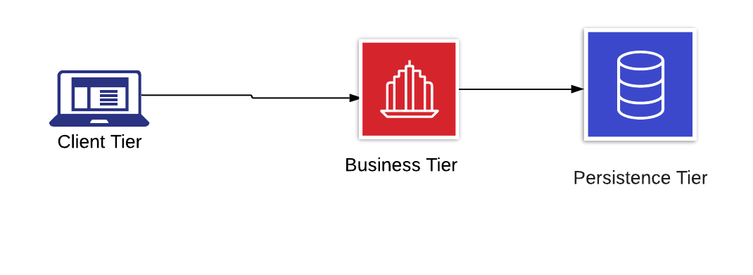

**How To AgaChat**

The application starts by initially deploying the database server, then the RMI chat server and finally the client. Now, the client, starting the application proceeds to log in, if the process is correct, a graphic interface is displayed to start the chat with the server, in the same way a graphic interface is displayed on the server. When you start the chat (Either server or client can start the chat). When sending the messages, they are encrypted with an AES algorithm and decrypted by the receiver. considering that AES is a symmetric algorithm, the key is generated by the server and shared by the client at the time of logging in.

All messages between client and server are stored in the database called AgaChat, so all users are registered in the database.

**Installation and configuration**

For this see the video attached

**Information technology**

Below is a list of the information technologies used for the development of the project:

|  |  |
| --- | --- |
| **Information Technology** | **Description** |
| Database engine | MySQL version 10.1.30 |
| Programming language | Java version 8 |
| Control Version Software | Git |