Computer Programming

Design a program that generates the general average of three grading systems. Display the remarks as
output, based on the following scale.

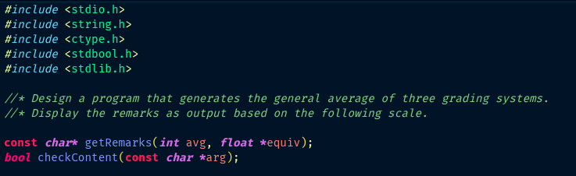  General Average | Equivalent Grade | Remarks
100 - 97 | 1.00 | Excellent
94 - 96 | 1.25 | Excellent
91 – 93 | 1.50 | Very Good
88 – 90 | 1.75 | Very Good
85 – 87 | 2.00 | Good
82 – 84 | 2.25 | Good
79 – 81 | 2.50 | Satisfactory
76 – 78 | 2.75 | Fair
75 | 3 | Passed
Below 75 | 5 | Failed
