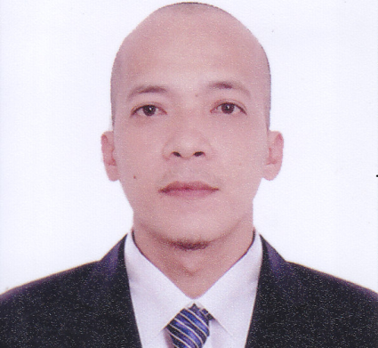

MACHINE OPERATOR

CURRICULUM VITAE

-Helper & Welder

TRIPLE A CONSTRUCTION

-Production Operator

2005-2007

ISABELO R. LUBIANO

Maribago, Lapu-Lapu City, Cebu Philippines

Contact #: 09473643740

Email add: mr_wonderer1@yahoo.com

Skype: mr_wonderer1

Objective:To findjob that is suitable for my skills and work experience where I can dedicate

Myself with utmost honesty and integrity. Able to cope up assigned duties with attention to details and

Accustomed to pressures of tight deadlines.

­­­­­­­­­­­­

Personal Data:

Age 33 years old

Date of birth May 3, 1986

Religion Roman Catholic

Citizenship Filipino

Weight 147lbs

Height 5’7”

Marital status Single

Place of birth Isabel Leyte

Language spoken Japanese, English, Tagalog and Cebuano

Educational Background:

High school Tipolo National High School

Production Technology

College Center for industrial technology and enterprise

2005-2006

2006-2007

.

Elementary Tipolo Elementary School

1998-1999

Trainings:

Right Click Diskless Training Center Golden Gateway International Agency

Nihongo & Japanese Culture, Work Values and Ethics

Computer Technician 101

Benedicto College Inc. Lear Automotive Corp

Shielded Metal Arc Welding NCII

Production Technology In-Plant Trainee

Work Experience:

Kokuryou Sangyou

Production Operator

Machine Operator

Lear Automotive Corp.

Kokuryou Sangyou

2014-2017

2008-2012

2008-2012

Routes and taping wires to form wire harness in accordance to work instruction

Starts and operate core molding machine

Operate over-head crane for loading sand and replacing die mold

Furnace, Cuts spouts and pouring holes in molds and sizes hardened cores by using needle file, saw

Sprays coat molds with compound to lubricate

Cleans, glues, and racks cores finished product for storage

Inspect molds for cracks or other defects and measures; weigh casting to ensure specifications met.

Removes casting from press

Select wires of specified color, marking, or length, and loop wires between guide pegs on harness board

Insert correct convolute into wire and apply specific kinds of taping and use the required to be used

Changing work instruction and covering bens and post that are needed

Cleaning area before and after operation and

Troubleshoot machinery, Repair and report any problem occurs

Timex Philippines

2018- 2019

Welder

Fabricate I-beam base for HVAC

-neutralize acidic liquid by mixing calcium carbonate powder

-repair water cooled chiller

-replace, repair defective motor pump

-dismantle production line for relocation

-plumbing

-installing emergency shower and eyewash

Assist regular employee

Re-place, fix and fabricate any defective, damage like metal bracket, gate, and pipe