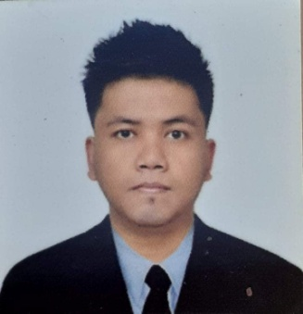**Marco Villaverde Dela Cruz**

**1368 P. Enriquez St., Sta.Barbara, Baliuag,**

**Bulacan 3006 Philippines**

**mobile: +63 943 828 2226**

**mdcvillaverde@yahoo.com**

**_____________________________________________________________________________________**

**CARREER OBJECTIVE:** Seeking the position that will give me the opportunity to train for further advancements. Can work with pressure.

**SUMMARY OF QUALIFICATIONS:**

Possesses creativity, credibility, and dedication to work.

Has excellent organizational and motivational skills.

Proficient in manipulating MS Word,MS Excel and MS Powerpoint

**EDUCATIONAL BACKGROUND:**

**TERTIARY** : **MICROLINK INSTITUTE of SCIENCE and TECHNOLOGY**

Baliuag, Bulacan

**Accounting Technology**

S.Y. 2012-2015

**SECONDARY**: **LICEO de PULILAN COLLEGES**

Longos, Pulilan, Bulacan

S.Y. 2006-2011

**PRIMARY** : **STA.BARBARA ELEMENTARY SCHOOL**

Sta.Barbara, Baliuag, Bulacan

S.Y. 2000-2006

**OTHER QUALIFICATION:**

Bookkeeping NCIII Certificate

_**PERSONAL INFORMATION:**

**Age**  : 26 years old

**Birthday** : August 09, 1993

**Birth Place** : Baliuag, Bulacan

**Gender**  : Male

**Height** : 172 cm.

**Weight**  : 80 kg.

**Civil Status** : Single

**Citizenship** : Filipino

**Religion** : Roman Catholic

**Father** : Vergilio Dela Cruz

**Mother**  : Patricia Villaverde

**WORK HISTORY:**

**Warehouse Clerk**

Baliwag Marketing Company Inc.

Barangay Sampaloc, San Rafael,

Bulacan, Philippines

November 2019 up to present

**Pump Machine Operator**

Amado Mango Farm

Sta. Barbara, Baliuag,

Bulacan, Philippines

October 2018 – November 2019

**Accounting Assistant**

CJ Philippines Inc.

Barangay Sampaloc, San Rafael,

Bulacan, Philippines

February 2017 to September 2018

**Pump Machine Attendant**

Filoil Gas Company Inc.

M.S Garcia, Cabanatuan City,

Nueva Ecija, Philippines

May to October 2013

**SEMINARS AND TRAININGS:**

BMRF Marshall Training

MacArthur Highway, Malolos, Bulacan

August 19, 2018

MDDPA Riding Safety Seminar

Tibagan, Bustos, Bulacan

July 23, 2018

Integrated Accounting using Quickbooks

MIST Baliwag Campus – Baliuag, Bulacan

December 12, 2013

**REFERENCES:**

Ms. Jocelyn Diacamos

Manager Acctg & Fin., CJ Philippines Inc.

Guiguinto, Bulacan

+63 905 271 5609

Mr. Bobby Felix

Station Manager, Filoil Gas Company Inc.

San Rafael, Bulacan

+63 915 572 1267

*I hereby certify that the above information given are true and correct as to the best of my knowledge.*

**Marco Villaverde Dela Cruz**