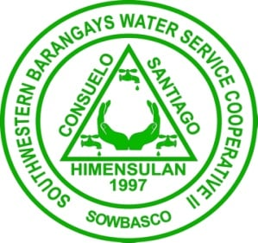

**Southwestern Barangays Water Service Cooperative II**

**(SOWBASCO)**

**Consuelo, San Francisco, Cebu**