Casos covid Ola1 mayo- junio

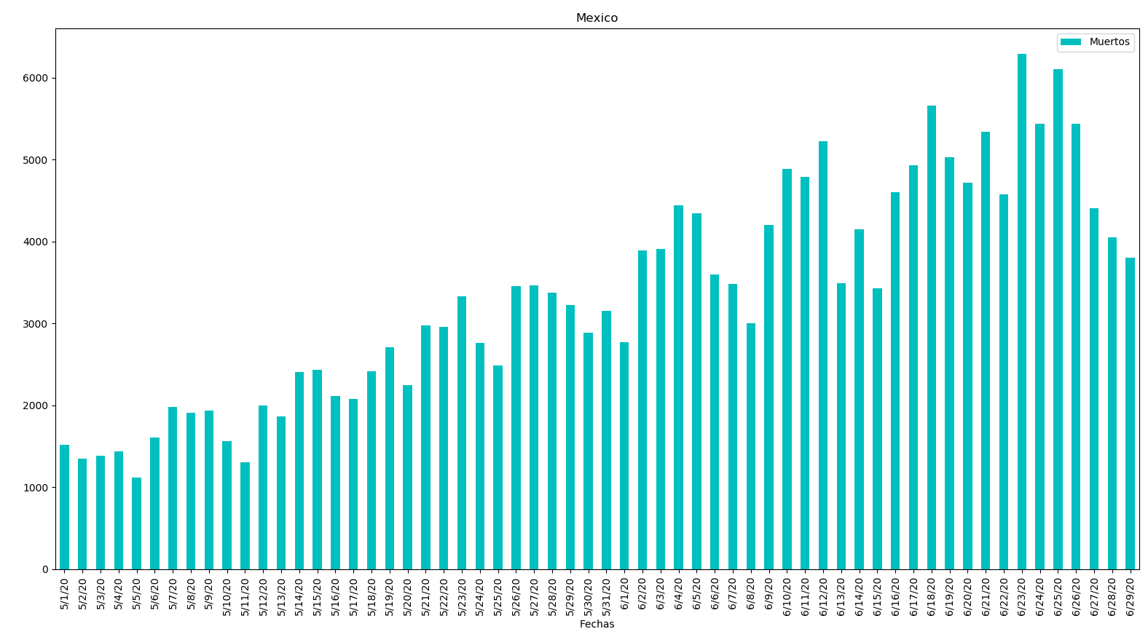

Fechas Casos

0 5/1/20 1515 27 5/28/20 3377 54 6/24/20 5437

1 5/2/20 1349 28 5/29/20 3227 55 6/25/20 6104

2 5/3/20 1383 29 5/30/20 2885 56 6/26/20 5441

3 5/4/20 1434 30 5/31/20 3152 57 6/27/20 4410

4 5/5/20 1120 31 6/1/20 2771 58 6/28/20 4050

5 5/6/20 1609 32 6/2/20 3891 59 6/29/20 3805

6 5/7/20 1982 33 6/3/20 3912

7 5/8/20 1906 34 6/4/20 4442

8 5/9/20 1938 35 6/5/20 4346

9 5/10/20 1562 36 6/6/20 3593

10 5/11/20 1305 37 6/7/20 3484

11 5/12/20 1997 38 6/8/20 2999

12 5/13/20 1862 39 6/9/20 4199

13 5/14/20 2409 40 6/10/20 4883

14 5/15/20 2437 41 6/11/20 4790

15 5/16/20 2112 42 6/12/20 5222

16 5/17/20 2075 43 6/13/20 3494

17 5/18/20 2414 44 6/14/20 4147

18 5/19/20 2713 45 6/15/20 3427

19 5/20/20 2248 46 6/16/20 4599

20 5/21/20 2973 47 6/17/20 4930

21 5/22/20 2960 48 6/18/20 5662

22 5/23/20 3329 49 6/19/20 5030

23 5/24/20 2764 50 6/20/20 4717

24 5/25/20 2485 51 6/21/20 5343

25 5/26/20 3455 52 6/22/20 4577

26 5/27/20 3463 53 6/23/20 6288

Casos Ola2 Octubre-Noviembre

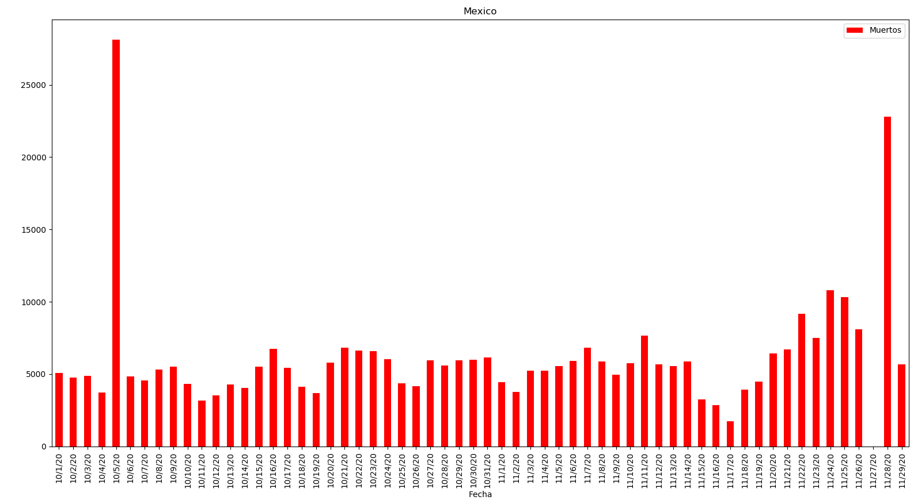

Fecha Casos

0 10/1/20 5099 26 10/27/20 5942 52 11/22/20 9187

1 10/2/20 4775 27 10/28/20 5595 53 11/23/20 7483

2 10/3/20 4863 28 10/29/20 5948 54 11/24/20 10794

3 10/4/20 3712 29 10/30/20 6000 55 11/25/20 10335

4 10/5/20 28115 30 10/31/20 6151 56 11/26/20 8107

5 10/6/20 4828 31 11/1/20 4430 57 11/27/20 0

6 10/7/20 4580 32 11/2/20 3763 58 11/28/20 22809

7 10/8/20 5300 33 11/3/20 5250 59 11/29/20 5668

8 10/9/20 5532 34 11/4/20 5225

9 10/10/20 4308 35 11/5/20 5567

10 10/11/20 3175 36 11/6/20 5931

11 10/12/20 3542 37 11/7/20 6810

12 10/13/20 4295 38 11/8/20 5887

13 10/14/20 4056 39 11/9/20 4960

14 10/15/20 5514 40 11/10/20 5746

15 10/16/20 6751 41 11/11/20 7646

16 10/17/20 5447 42 11/12/20 5658

17 10/18/20 4119 43 11/13/20 5558

18 10/19/20 3699 44 11/14/20 5860

19 10/20/20 5788 45 11/15/20 3269

20 10/21/20 6845 46 11/16/20 2874

21 10/22/20 6612 47 11/17/20 1757

22 10/23/20 6604 48 11/18/20 3918

23 10/24/20 6025 49 11/19/20 4472

24 10/25/20 4360 50 11/20/20 6426

25 10/26/20 4166 51 11/21/20 6719

Muertes covid Ola1 mayo- junio

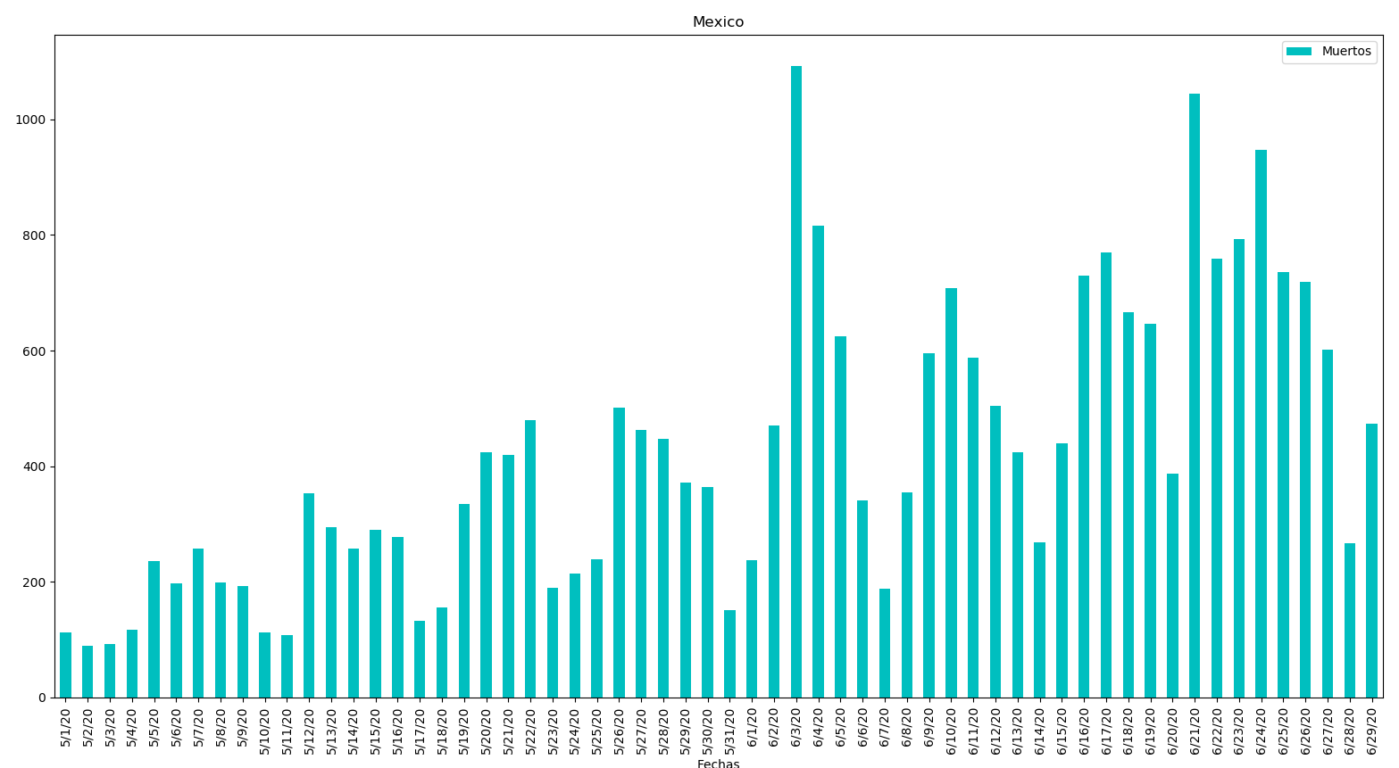

Fechas Muertos

0 5/1/20 113 28 5/29/20 371 56 6/26/20 719

1 5/2/20 89 29 5/30/20 364 57 6/27/20 602

2 5/3/20 93 30 5/31/20 151 58 6/28/20 267

3 5/4/20 117 31 6/1/20 237 59 6/29/20 473

4 5/5/20 236 32 6/2/20 470

5 5/6/20 197 33 6/3/20 1092

6 5/7/20 257 34 6/4/20 816

7 5/8/20 199 35 6/5/20 625

8 5/9/20 193 36 6/6/20 341

9 5/10/20 112 37 6/7/20 188

10 5/11/20 108 38 6/8/20 354

11 5/12/20 353 39 6/9/20 596

12 5/13/20 294 40 6/10/20 708

13 5/14/20 257 41 6/11/20 587

14 5/15/20 290 42 6/12/20 504

15 5/16/20 278 43 6/13/20 424

16 5/17/20 132 44 6/14/20 269

17 5/18/20 155 45 6/15/20 439

18 5/19/20 334 46 6/16/20 730

19 5/20/20 424 47 6/17/20 770

20 5/21/20 420 48 6/18/20 667

21 5/22/20 479 49 6/19/20 647

22 5/23/20 190 50 6/20/20 387

23 5/24/20 215 51 6/21/20 1044

24 5/25/20 239 52 6/22/20 759

25 5/26/20 501 53 6/23/20 793

26 5/27/20 463 54 6/24/20 947

27 5/28/20 447 55 6/25/20 736

Muertes Ola2 Octubre-Noviembre

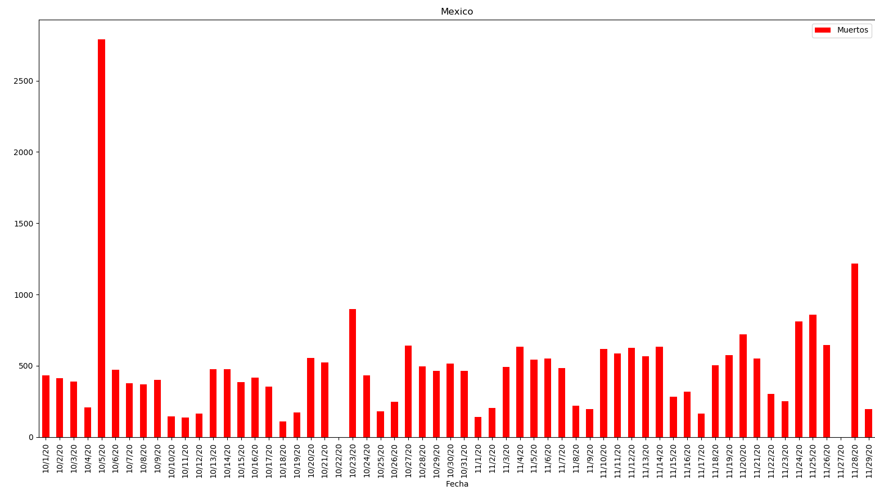

Fecha Muertos

0 10/1/20 432 27 10/28/20 495 54 11/24/20 813

1 10/2/20 414 28 10/29/20 464 55 11/25/20 858

2 10/3/20 388 29 10/30/20 516 56 11/26/20 645

3 10/4/20 208 30 10/31/20 464 57 11/27/20 0

4 10/5/20 2789 31 11/1/20 142 58 11/28/20 1217

5 10/6/20 471 32 11/2/20 205 59 11/29/20 196

6 10/7/20 378 33 11/3/20 493

7 10/8/20 370 34 11/4/20 635

8 10/9/20 401 35 11/5/20 544

9 10/10/20 145 36 11/6/20 551

10 10/11/20 139 37 11/7/20 485

11 10/12/20 164 38 11/8/20 219

12 10/13/20 475 39 11/9/20 198

13 10/14/20 478 40 11/10/20 617

14 10/15/20 387 41 11/11/20 588

15 10/16/20 419 42 11/12/20 626

16 10/17/20 355 43 11/13/20 568

17 10/18/20 108 44 11/14/20 635

18 10/19/20 171 45 11/15/20 283

19 10/20/20 555 46 11/16/20 319

20 10/21/20 522 47 11/17/20 165

21 10/22/20 0 48 11/18/20 502

22 10/23/20 897 49 11/19/20 576

23 10/24/20 431 50 11/20/20 719

24 10/25/20 181 51 11/21/20 550

25 10/26/20 247 52 11/22/20 303

26 10/27/20 643 53 11/23/20 250

Casos



Muertes

