CONNECTING TO MY FIRST EC IN AWS

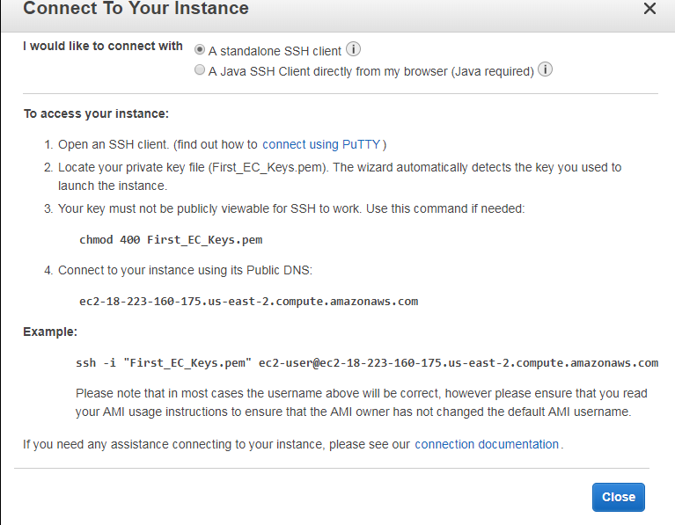
Location of private key
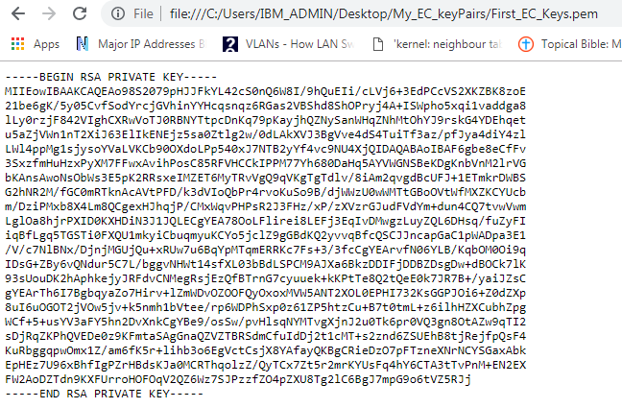
Connecting to an instance
https://docs.aws.amazon.com/AWSEC2/latest/UserGuide/putty.html?icmpid=docs_ec2_console

My instance profile

Instance ID: 1-023190172d00c7010
public DNS: ec2-18-223-160-175.us-east-2.compute.amazonaws.com
ipv4 public IP: 18.223.160.175
Qualified path to my key pair: file:///C:/Users/IBM_ADMIN/Desktop/My_EC_keyPairs/First_EC_Keys.pem

Ec2 user name: Sunny_EC1
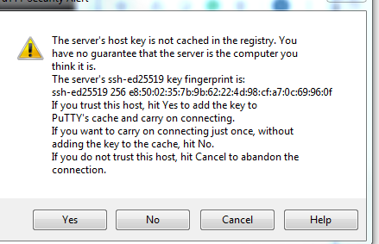

Extra
problem with write-protect on storage device
https://www.easeus.com/storage-media-recovery/remove-write-protection-in-windows-10-8-7.html

My_AWS_Proj

To get access to root
https://aws.amazon.com/premiumsupport/knowledge-center/set-change-root-linux/

logging in into my two instances
