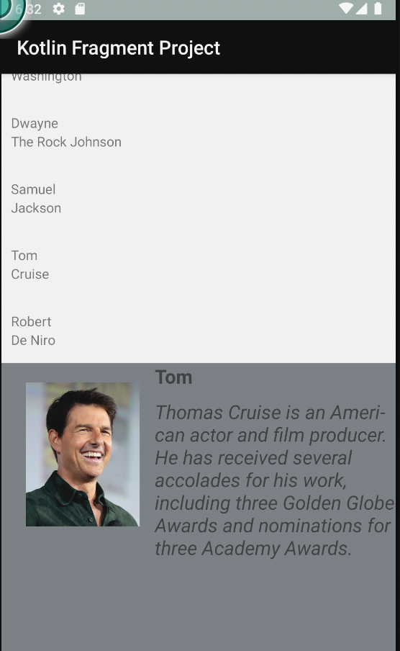

Directions:

Coding

Create a multi pane app (add two fragment to the activity in a sequence)

Fragment one should have a list of celebrity names.

Fragment two should have the detail of the celebrity selected.

-Fragment two should be updated on each list item clicked

-Celebrity detail should have at least a picture of the celebrity (you can save all the images in the drawable folder), short description. But be creative to add more if you like.

-Use different attributes to make the design better.

Questions:

1. What is static, inferred and dynamic typing?

Static-Type is assigned at during compilation

Dynamic-Type is assigned at runtime

Inferred-Programming language assigns type for you

2. How does string constant pools work in JAVA?

When a new string is declared the literal value it added to the string constant pool as memory is allocated for that string. All following declarations of the exact same are used with the value stored in the pool unless a new instance of the string is created, which will be stored in the memory heap.

3. What is functional Programming and how does it differ from pure object oriented?

Programming model focusing on evaluation of functions, uses immutable data, supports parallel programming, statements can be executed in any order

4. What is lambda function?

express instances of functional interfaces

5. What are some ways Kotlin achieves null safety?

? operator - "could be null"

?: operator - if expression on left is not null use it, otherwise use expression on right