LABORATORY EXERCISE 2

ENHANCING HTML STRUCTURE & CSS CREATIVITY WITH COLOR SCHEMES

Learning Objectives
By the end of this laboratory exercise, students should be able to:
- Enhance basic HTML structure by adding semantic elements (header, nav, main, section, footer)
- Apply CSS styling techniques including colors, fonts, spacing, and layout
- Select and implement a cohesive color scheme for a webpage
- Create a multi-section webpage with proper content organization
- Apply CSS box model concepts (padding, margin, border) effectively
- Use CSS flexbox for basic layout arrangements.

Prerequisite student experiences and knowledge
Before starting this exercise, students should have:
- Completed Laboratory Exercise 1
- Basic understanding of HTML tags (html, head, body, h1-h6, p, div, img)
- Familiarity with opening files via localhost and Live Server
- XAMPP and VS Code properly installed and configured.

Background
In Laboratory Exercise 1, you created your first HTML page, a simple document with basic structure and content. While functional, that page lacked visual appeal and proper content organization.
In real-world web development, websites are not just about presenting information; they need to be visually engaging, well-organized, and easy to navigate. This is where CSS (Cascading Style Sheets) becomes essential. CSS controls the presentation layer of your website, including colors, fonts, spacing, and layout.
A critical aspect of web design is the color scheme: a deliberate selection of colors that work harmoniously together. A well-chosen color scheme:
Creates visual hierarchy and guides user attention. Establishes brand identity and emotional tone. Improves readability and user experience. Makes your website look professional and polished
In this exercise, you will transform your basic HTML page into a visually appealing, well-structured webpage by adding semantic HTML elements and applying a carefully selected color scheme through CSS.

Materials/Resources
- Personal Computer with Internet Access (Windows, macOS, or Linux).
- XAMPP Installer (downloaded from apachefriends.org).
- Visual Studio Code (downloaded from code.visualstudio.com).
- Web Browser (Google Chrome is recommended).
- Github (https://github.com/)
- Color Scheme Resources (for reference):
  - Coolors.co Color palette generator
  - Adobe Color Color wheel and theme creator
  - ColorHunt Curated color palettes
THEORY / CONCEPTS
Semantic HTML Elements
Semantic HTML elements clearly describe their meaning to both the browser and the developer. They provide structure and context to your content:
Element | Purpose | Example Usage
<header> | Introductory content, site logo, navigation | Top of the page
<nav> | Navigation links | Main menu, sidebar links
<main> | Primary content of the page | Core article or information
<section> | Thematic grouping of content | Chapters, news sections, product features
<article> | Self-contained content | Blog posts, news articles
<aside> | Secondary/sidebar content | Related links, advertisements
<footer> | Footer of page or section | Copyright, contact info, links

CSS Fundamentals
CSS Syntax:
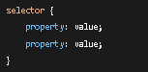
CSS Color Properties:
- color Sets text color
- background-color Sets background color
- border-color Sets border color

CSS Box Model:
Every HTML element is a box with:
- Content The actual text or media
- Padding Space inside the border
- Border Outline around padding
- Margin Space outside the border

Color Theory Basics
Color Harmony Schemes:
- Monochromatic Variations of one color (different shades and tints)
- Complementary Two colors opposite on the color wheel
- Analogous Three colors adjacent on the color wheel
- Triadic Three colors equally spaced on the color wheel

Color Properties
- Hue The pure color (red, blue, etc.)
- Saturation Intensity or purity of the color
- Brightness/Value Lightness or darkness of the color

Color Notation in CSS
- Hex: #FF5733
- RGB: rgb(255, 87, 51)
- RGBA: rgba(255, 87, 51, 0.5) with transparency
- HSL: hsl(9, 100%, 60%)
- Named Colors: red, blue, cornflowerblue

Laboratory Activity
Part 1: Selecting Your Color Scheme
Before writing any CSS code, you must select a color scheme that will define the visual identity of your webpage.
- Open your web browser and visit one of the color palette websites:
- Coolors.co
- Adobe Color
- ColorHunt
- Browse through existing palettes or generate a new one.
- Select or create a color scheme with 4-6 colors that work harmoniously together. Consider:
- Primary Color Main brand color (used for headers, navigation, buttons)
- Secondary Color Supporting color (used for accents, borders, highlights)
- Background Color Light/neutral color for page background
- Text Color Dark/readable color for main text
- Accent Color Bold color for emphasis and call-to-action elements
- Write down or copy the color codes (hex values) of your chosen colors. You will use these in your CSS.
Example Color Scheme (Ocean Blue Theme):

Color Name | Hex Code | Usage
Primary | #1a5276 | Headers, navigation
Secondary | #2980b9 | Accents, links
Background | #f0f3f5 | Page background
Text | #2c3e50 | Main text
Accent | #e67e22 | Buttons, highlights
Light Accent | #d4e6f1 | Section backgrounds

Part 2: Structuring Your HTML with Semantic Elements
- Open Visual Studio Code.
- Open your project folder from Laboratory Exercise 1: lab1_YourStudentID
- Create a new folder inside your lab folder called lab2_YourStudentID (e.g., lab2_20251234).
- Inside this new folder, create a new file named index.html.
- Type ! and press Tab to generate the HTML5 boilerplate.
- Modify the structure to include semantic elements. Your HTML should have this structure:
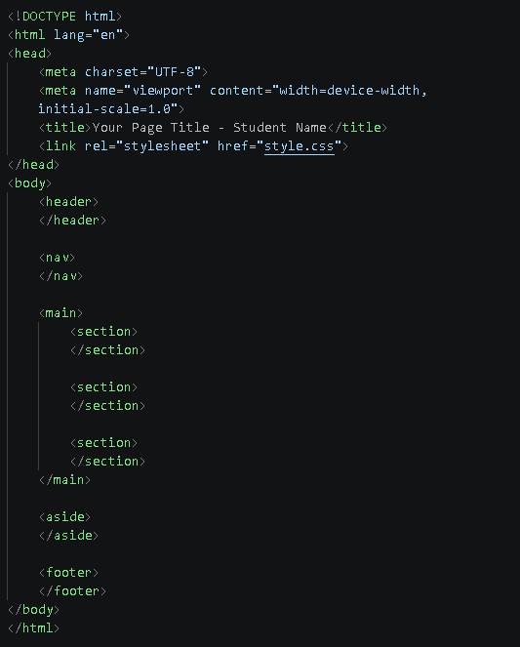
- Content Requirements for Your Page:
Header:
Your name as the site title (use <h1>)
A brief tagline or description

Navigation:
Create links for: Home, About, Skills, Projects, Contact
For now, use href="#" or href="#section-id" for internal links

Main Content Section 1 (About/Introduction):
<h2> heading
A paragraph about yourself
Include your course, year level, and interests

Main Content Section 2 (Skills or Services):
<h2> heading
List 3-5 skills using <ul> (unordered list)
Each skill should have a brief description

Main Content Section 3 (Projects or Portfolio):
<h2> heading
At least 3 project items using <div> or <article> elements
Each project should have a title and short description

Aside (Sidebar):
Quick facts or interesting information about you
A favorite quote
Fun fact or hobby

Footer:
Copyright notice (e.g., &copy; 2026 Your Name)
Contact email or social media links
Last updated date
- Write the complete HTML code in your index.html file. Save your file (Ctrl+S).

Part 3: Creating and Applying CSS Styles
- In VS Code, create a new file named style.css (same folder as index.html).

- Link your CSS file to your HTML. In the <head> section of your HTML, add:
<link rel="stylesheet" href="style.css">
- Write CSS code to style your webpage. Use the color scheme you selected in Part
Minimum CSS Requirements:
CSS Element | What to Style
body | Font family, background color, text color, margin, padding
header | Background color, padding, text color, text alignment
nav | Background color, padding, display (flex or inline)
nav a | Color, text decoration, padding, hover effect
h1, h2, h3 | Color, font size, margin, font weight
section | Background color (light variation), padding, margin, border-radius
aside | Background color, padding, border, margin
footer | Background color, text color, text alignment, padding
.class | Create custom classes for specific styling
ul, li | List styling (bullets, spacing)
a:hover | Hover effects for links
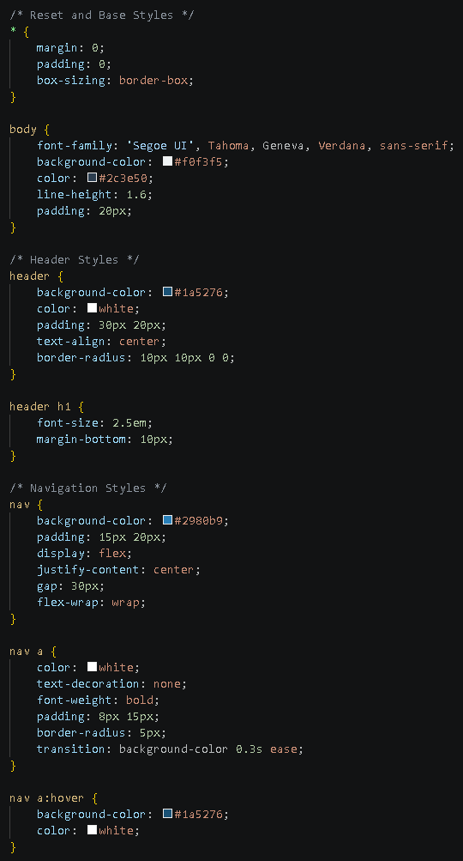
Sample CSS Code (Ocean Blue Theme):
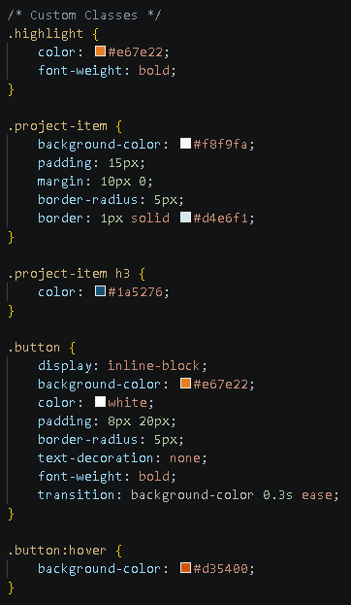
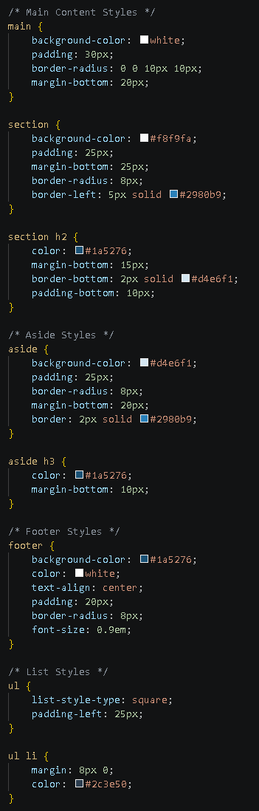
- Add at least 3 custom classes to your CSS and apply them to elements in your HTML.
- Add hover effects for navigation links and buttons.
- Apply your selected color scheme throughout your CSS:
- Header and footer should use your primary color
- Navigation should use your secondary color
- Sections should use light variations of your colors
- Accent elements should use your accent color
- Text should use your text color

Part 4: Testing and Viewing Your Page
Method 1: Using XAMPP (Localhost)
- Ensure Apache is running in XAMPP Control Panel.
- Open your web browser and navigate to:
http://localhost/lab2_YourStudentID/
(If using port 8080: http://localhost:8080/lab2_YourStudentID/)
- Verify that your page loads correctly with all styles applied.

Method 2: Using Live Server
- In VS Code, right-click on your index.html file.
- Select "Open with Live Server".
- Your browser will open with a live preview that auto-refreshes when you save changes.

Part 5: Push to GitHub
- Open your GitHub repository (created in Laboratory Exercise 1).
- Add your lab2_YourStudentID folder to the repository.
- Commit and push your changes with a meaningful commit message (e.g., "Added Laboratory Exercise 2 with CSS styling").
- Take a screenshot of your GitHub repository showing the new files.

Output / Results
Take a screenshot of the following outputs and paste them into your lab report document:
- Screenshot 1: VS Code editor showing your complete index.html code with semantic HTML structure
- Screenshot 2: VS Code editor showing your complete style.css code with your selected color scheme
- Screenshot 3: Your web browser displaying the fully styled HTML page with the URL visible in the address bar (showing either http://localhost or http://127.0.0.1:5500)
- Screenshot 4: Your GitHub repository showing the history of commits and the new lab2_YourStudentID folder
- Screenshot 5: A separate image or section showing the color palette/color scheme you selected (including hex codes)

Submission Guidelines
- Name the file as: Lab2_[YourStudentID]_[YourLastName].pdf (e.g., Lab2_20251234_Cruz.pdf).
- Submit the File to your instructor via the Learning Management System (LMS) provided before the start of the next laboratory session.

QUESTIONS:
- Explain the purpose and benefits of using semantic HTML elements (like <header>, <nav>, <main>, <section>, <footer>) instead of generic <div> elements. How do they improve web development?
Answer:
Honestly, <div> doesn't tell you anything — it's just a box. You could use it for literally anything, so when you're reading someone else's code (or your own code a week later), you have no idea what that div is actually for. Semantic tags like <header>, <nav>, <main>, <section>, and <footer> actually say what the content is, so the code is way easier to read and understand at a glance. It also helps with accessibility since screen readers can jump straight to the "nav" or "main content" instead of the user having to sit through the whole page. And search engines actually pay attention to tags like <main> and <article> when ranking pages, so it can help with SEO too. Basically it makes the structure make sense to both humans and machines.

- Describe the color scheme you selected for your webpage. What type of color harmony did you use (monochromatic, complementary, analogous, or triadic)? List your colors with their hex codes and explain why you chose this particular scheme.
Answer:
Gumamasa ako ng analogous color scheme, kaya nakatutok ito sa black, grey, at white tones na magkakatabi sa color wheel, plus dolphine/blue bilang accent color para maging litaw ang visual:

- What is the CSS box model? Explain the difference between margin, padding, and border, and provide an example of how you used each in your CSS code.
Answer:
Lahat ng element sa HTML ay maituturing na box na may 4 na parte: content, padding, border, at margin. Content ang mismong text o image. Padding ang espasyo sa pagitan ng content at border (space sa loob ng box). Border ang linya sa paligid ng padding. Margin naman ang espasyo sa labas ng border na naglalayo sa box sa iba pang elements.

- What is the difference between inline, internal, and external CSS? Why is external CSS (using a separate .css file) preferred for web development projects?
Answer:
Mas okay pa ang External CSS sa real projects kasi hiwalay ang content sa design, kaya malinis ang HTML. Pwede mo ring i-reuse yung iisang CSS file sa ibang pages para iwas copy-paste, at mas mabilis mag-load ang site kasi pwedeng i-cache ng browser yung file.

- How does the hover pseudo-class work in CSS? Provide an example of a hover effect you implemented in your webpage and explain how it improves user experience.
Answer:
Hover lets you style comething only while the mouse is on top of it, no JavaScript needed.
css
.site-nav a:hover {
background-color: var(--accent);
border-color: var(--accent);
color: var(--primary);
}
Naglalaman ito ng hover effect na nagpapabago ng kulay ng nav links papuntang gold kapag tinututukan ng mouse cursor. Maliit na detail lang ito pero mas nagiging interactive ang site, at agad nalalaman ng user na itong i-click imbes na manghula pa sila.

- Explain the difference between relative and absolute units in CSS. Give examples of when you would use each type.
Answer:
Ang absolute units (tulad ng px) ay fixed ang sukat—hindi ito nagbabago kahit magbago ang screen size o settings ng browser. Ginagamit ito kapag kailangan mo ng eksaktong sukat, tulad ng border-width: 1px o maliliit na icons.

Output / Results

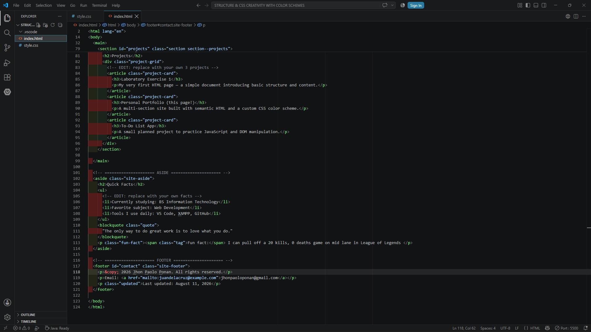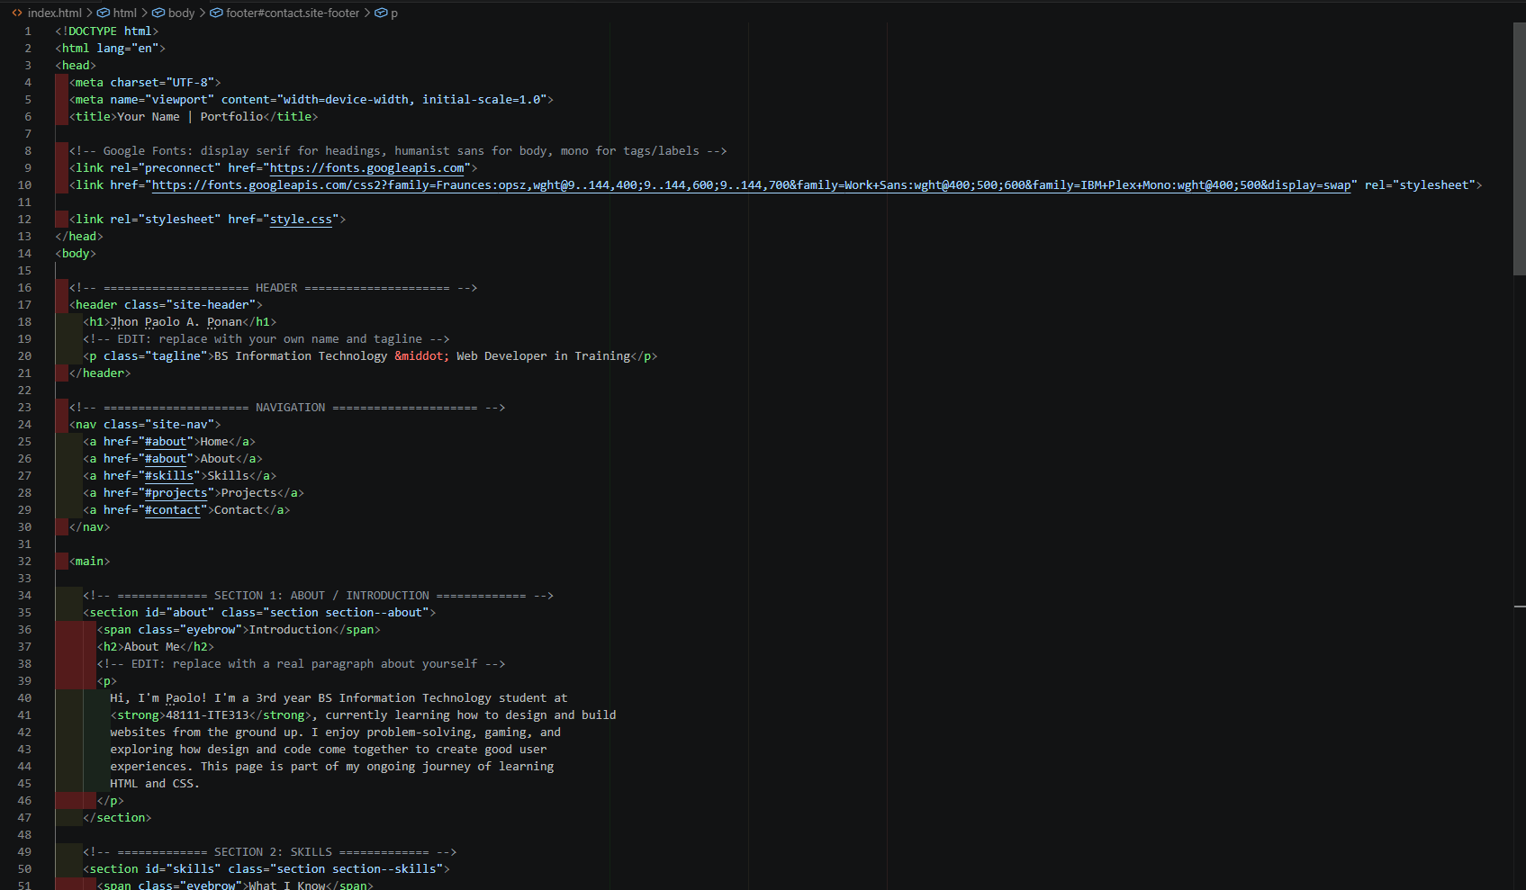

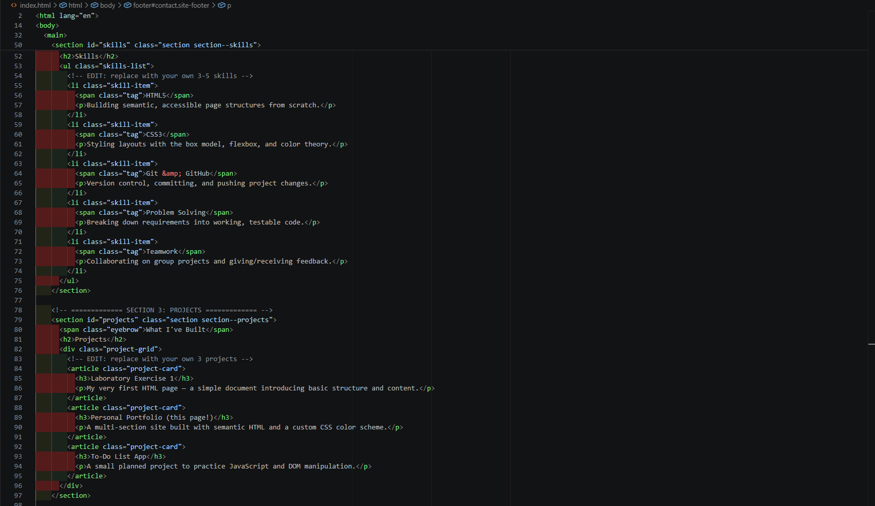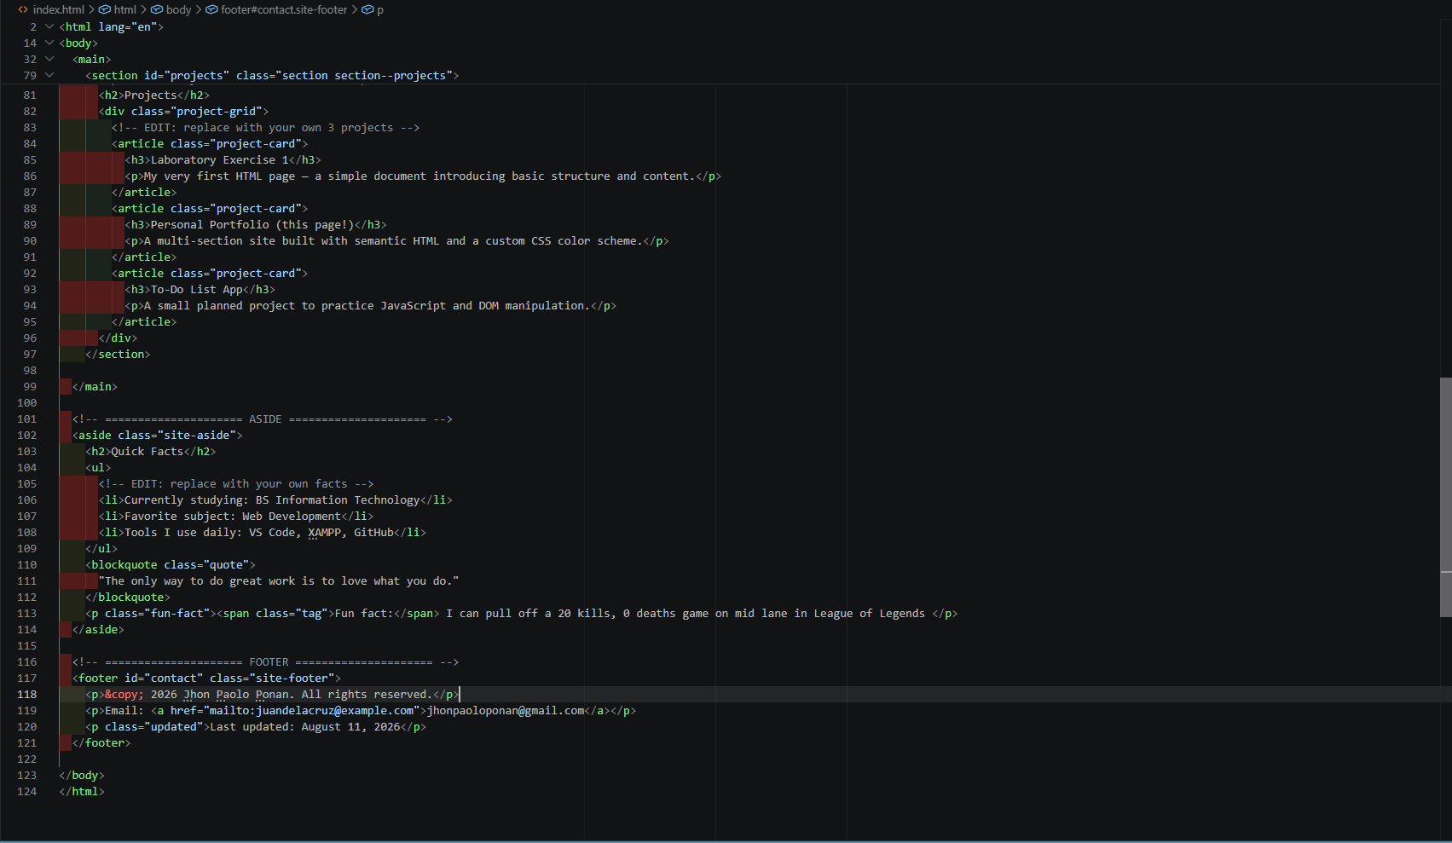
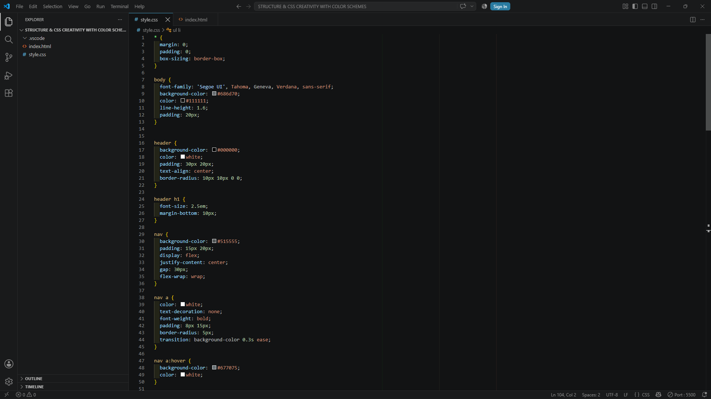
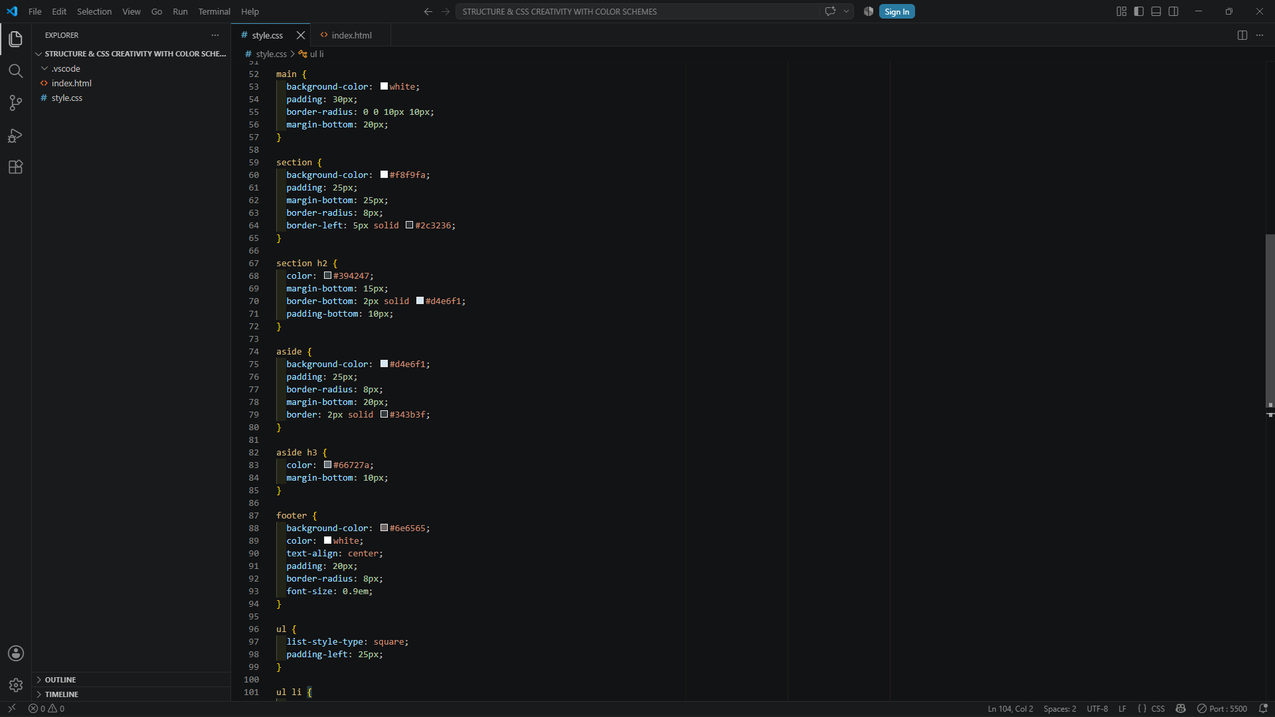
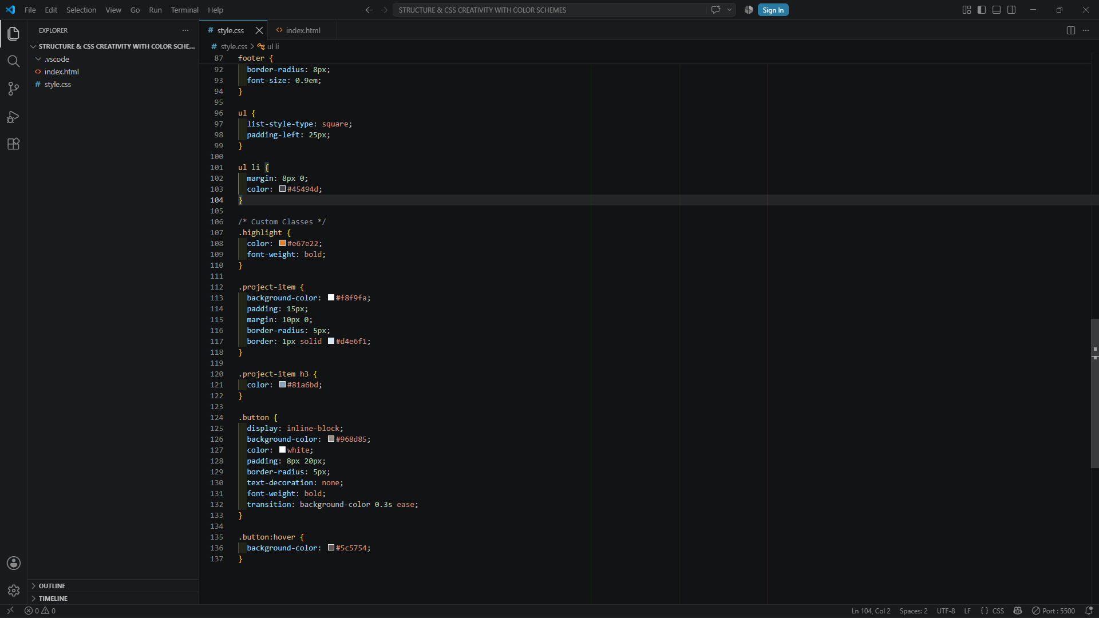
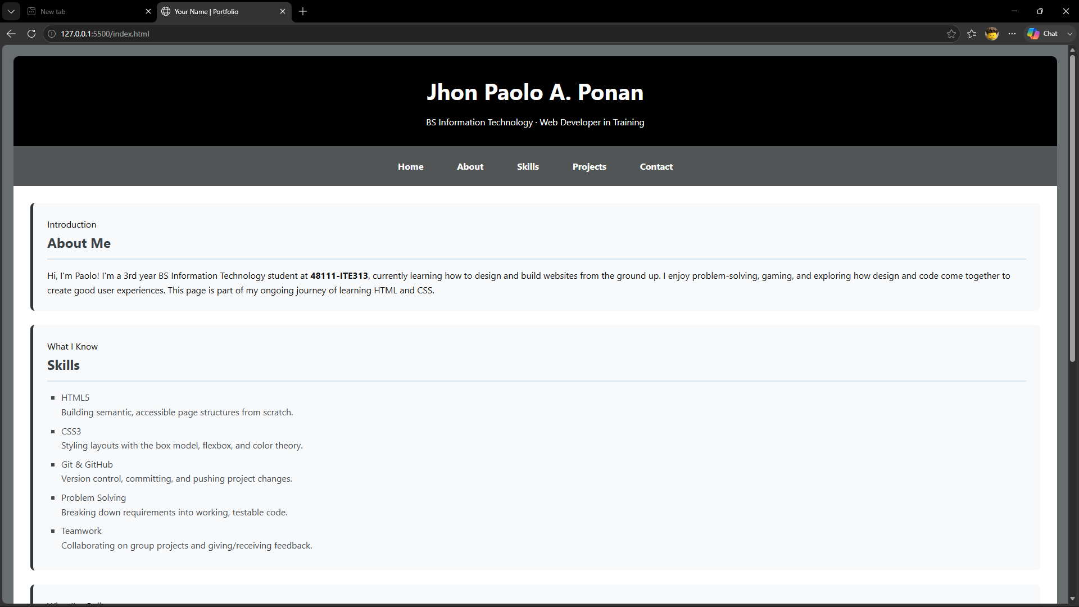

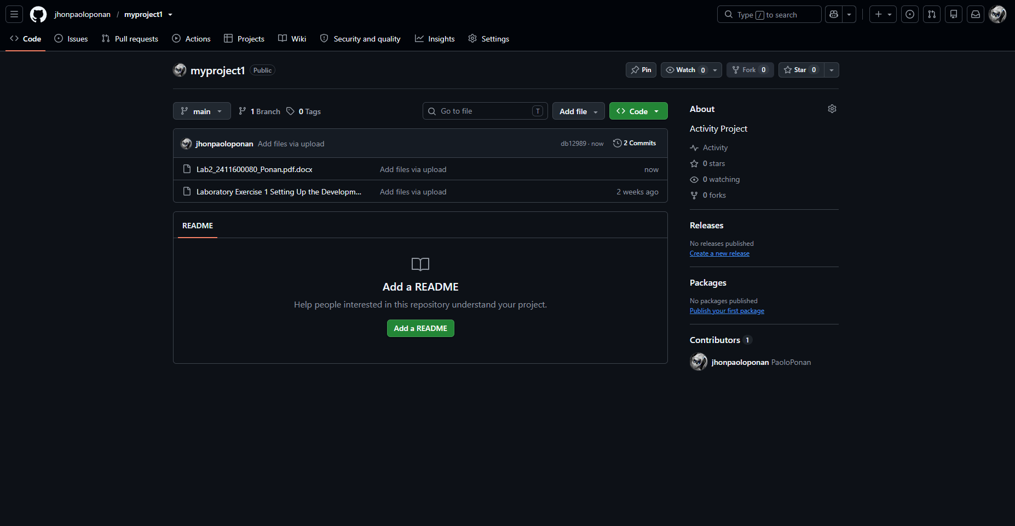

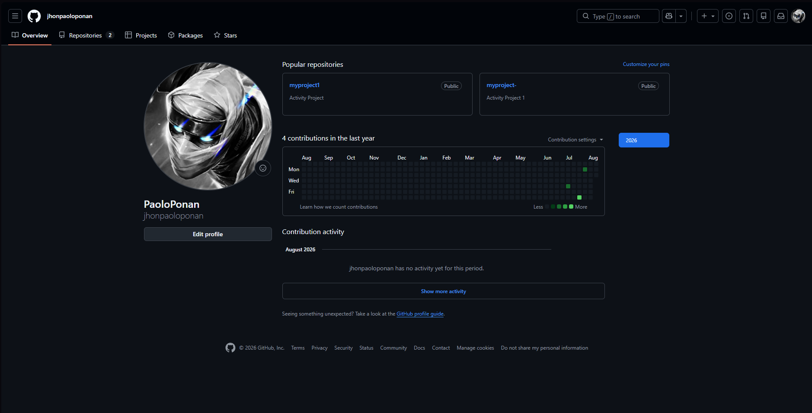

Conclusion
Sa activity na ito, gumawa ako ng personal portfolio web page gamit ang HTML5 at CSS3 kasunod ang "GreyScale" color scheme.
Gumamit ako ng semantic HTML tags tulad ng <header>, <nav>, <main>, <section>, <aside>, at <footer> para maging malinis at maayos ang pagkakahanay ng sections tulad ng About, Skills, Projects, at Quick Facts. Para sa styling, in-apply ko ang CSS box-model principles, Flexbox para sa navigation menu, Google Fonts para sa magandang typography, at hover effects para sa interactive elements.
Sa kabuuan, nagbigay ang project na ito ng hands-on practice sa pagsasama ng HTML structure at CSS styling para makabuo ng isang functional at maayos na web page.

