LABORATORY EXERCISE 1

SETTING UP THE DEVELOPMENT ENVIRONMENT & YOUR FIRST HTML PAGE

Learning Objectives
By the end of this laboratory exercise, students should be able to:
- Successfully install and configure XAMPP to run a local Apache web server.
- Install and set up Visual Studio Code (VS Code) as a code editor.
- Install the "Live Server" extension to streamline the development workflow.
- Create a structured project folder inside the server's document root (htdocs).
- Write a basic HTML5 document using the standard boilerplate structure.
- View their first webpage using both the localhost URL and the Live Server feature..

Prerequisite student experiences and knowledge
Before starting this exercise, students should have:
- None! This laboratory is designed for absolute beginners.
- Basic familiarity with using a computer (creating folders, downloading files, and navigating directories).
- Ability to use a web browser (Chrome, Firefox, or Edge).

Background
When you visit a website like facebook.com or youtube.com, your browser is actually requesting files from a remote computer called a web server. To practice web development, we don't need to rent a remote server. Instead, we install a local web server on our own PC.

XAMPP is a free software package that includes Apache (the web server). When you place your HTML files inside XAMPP's htdocs folder, Apache serves them to your browser via http://localhost. This perfectly simulates a live environment without needing the internet.

Visual Studio Code is a lightweight but powerful code editor. It provides syntax highlighting (color-coding your code) and extensions like "Live Server", which automatically refreshes your browser whenever you save your HTML file—saving you a huge amount of time.

In this exercise, you will set up both tools and write your very first HTML page from scratch.

Materials/Resources
- Personal Computer with Internet Access (Windows, macOS, or Linux).
- XAMPP Installer (downloaded from apachefriends.org).
- Visual Studio Code (downloaded from code.visualstudio.com).
- Web Browser (Google Chrome is recommended).
- Github (https://github.com/)

Laboratory Activity
Step 1: Install and Configure XAMPP
- Open your web browser and visit the official XAMPP website at apachefriends.org.
- Download the installer appropriate for your operating system (Windows, macOS, or Linux).
- Run the installer. If a security warning appears, click "Yes" or "Allow".
- During installation, when asked to "Select Components", ensure that Apache is checked. You may uncheck MySQL, FileZilla, and other components to save space (we won't need them for this lab).
- Important:
- For the installation directory, use the default location (e.g., C:\xampp on Windows) or install it directly in the root of your drive.
- Do not use spaces in the folder path (e.g., avoid "Program Files").
- Complete the installation and launch the XAMPP Control Panel.
- In the Control Panel, click the "Start" button next to Apache.
- Verify: The module's row should turn green, and the port number (usually 80) should appear.
TROUBLESHOOTING: Port 80 Conflict
- If Apache fails to start (the row stays red or orange), it means another program is already using Port 80. Common offenders include Skype, Microsoft Teams, or IIS (Internet Information Services). To fix this:
  - In the XAMPP Control Panel, click the "Config" button for Apache.
  - Select "Apache (httpd.conf)".
  - In the text file that opens, press Ctrl+F and search for Listen 80.
  - Change this line to Listen 8080 and save the File.
  - Now, click "Start" for Apache again. Your server will now run on http://localhost:8080.
  - Remember: Whenever this lab guide says http://localhost, you will type http://localhost:8080 instead.

Step 2: Install Visual Studio Code and Extensions
- Go to code.visualstudio.com and download the installer for your OS.
- Run the installer and follow the steps (keep all default settings).
- Launch Visual Studio Code.
- Click on the Extensions icon on the left sidebar (it looks like four squares) or press Ctrl+Shift+X (Cmd+Shift+X on macOS).
- In the search bar, type "Live Server" and install the extension made by Ritwick Dey.

Optional but helpful: Also install the "HTML CSS Support" extension for better auto-completion.

Step 3: Create the Project Folder Structure
- Open your File Explorer (Windows) or Finder (macOS).
- Navigate to your XAMPP installation directory (e.g., C:\xampp).
- Open the htdocs folder. This is the official "Document Root" where Apache looks for web files.
- Inside htdocs, create a new folder and name it exactly like this:
- lab1_YourStudentID (e.g., lab1_20251234).
- Open Visual Studio Code. Click File -> Open Folder... and select the lab1_YourStudentID folder you just created. This sets your project workspace.

Step 4: Create Your First HTML Page
- Inside VS Code, make sure your folder (lab1_...) is shown in the left sidebar (Explorer).
- Click the "New File" icon or press Ctrl+N (Cmd+N).
- Immediately save this File by pressing Ctrl+S (Cmd+S). Name it index.html.
- Pro Tip: Web servers automatically look for a file named index.html as the default homepage.
- In your newly created index.html File, type a single exclamation mark:! and then press the Tab key (or Enter).
- This uses an "Emmet" shortcut to generate the complete HTML5 boilerplate instantly.
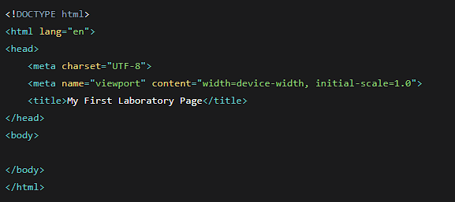
- Your code should now look like this:
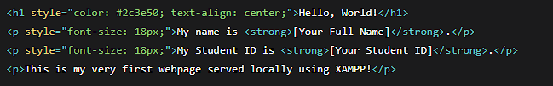
- Inside the <body> tags, add the following content (replace the bracketed information with your own):

Step 5: Run Your Web Page (Two Methods)
- Method A: Using Localhost (XAMPP)
  - Open your web browser.
  - In the address bar, type: http://localhost/lab1_YourStudentID/ (if you changed the port to 8080, use http://localhost:8080/lab1_YourStudentID/).
  - Press Enter. Your beautifully styled page should appear!
- Method B: Using Live Server (VS Code)
  - In VS Code, right-click anywhere inside your index.html file.
  - Select "Open with Live Server".
  - Your browser will automatically open with a URL like http://127.0.0.1:5500. This is an alternative way to preview your work instantly.

Step 6: Push Update Project to GitHub
- Take screenshots of your running program and GitHub repository.
- Insert them in your lab report under "Output/Results."

Output / Results
- Take a screenshot of the following outputs and paste them into your lab report document:
- Screenshot 1: The XAMPP Control Panel showing the Apache service running successfully (green highlight).
- Screenshot 2: The VS Code editor showing your complete index.html code.
- Screenshot 3: Your web browser displaying the rendered HTML page, with the http://localhost URL clearly visible in the address bar.
- Screenshot 4: Your repository that shows the history of commits of development.

Submission Guidelines
- Name the file as: Lab1_[YourStudentID]_[YourLastName].pdf (e.g., Lab1_20251234_Cruz.pdf).
- Submit the File to your instructor via the Learning Management System (LMS) provided before the start of the next laboratory session.

QUESTIONS:
- What is the main difference between opening an HTML file directly via file:/// and opening it via http://localhost? Why is localhost preferred in web development?
- What is the purpose of the htdocs folder in XAMPP, and what happens if you place your files outside of it?
- If Apache refuses to start because Port 80 is in use, name two programs that might be causing the conflict and explain the step you took to resolve it.
- What is the role of the <!DOCTYPE html> declaration at the very top of your HTML file?
- How does the "Live Server" extension in VS Code improve a developer's workflow compared to manually refreshing the browser?

1.If I use file:// to open an HTML file, then it is only going to read the file on my own computer. When I use http://localhost, then I am accessing my website via the local server which is much more preferable as I will be able to use all the PHP scripts.
2. The htdocs folder is where I keep all of my website files for XAMPP to be able to read them. If I store my files elsewhere, they will not load using localhost since Apache only loads files from the htdocs folder.
3. Applications such as Skype and IIS can run on Port 80 and thus prevent Apache from running. The solution to the problem was to close the application using that port or change the port on which Apache should run, such as Port 8080.
4. <!DOCTYPE html> is used to notify the browser that HTML5 is being used by the document. This ensures that the webpage displays accurately in all browsers.
5.Live Server is beneficial in web development since it updates the webpage every time I save the code. It helps me view any changes I make without the need to refresh the page manually.

Output / Results

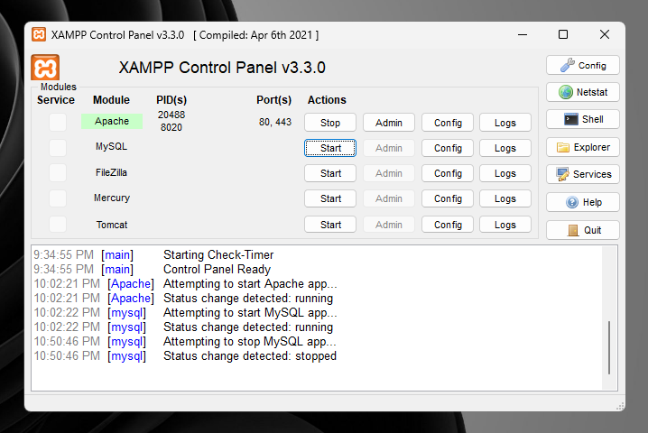

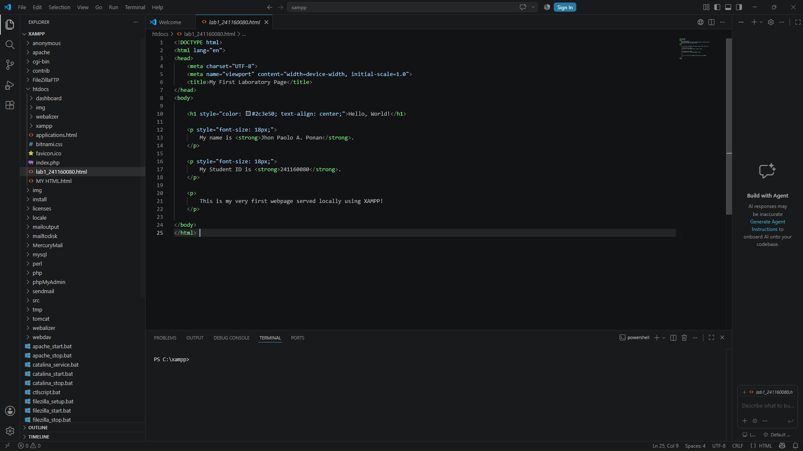

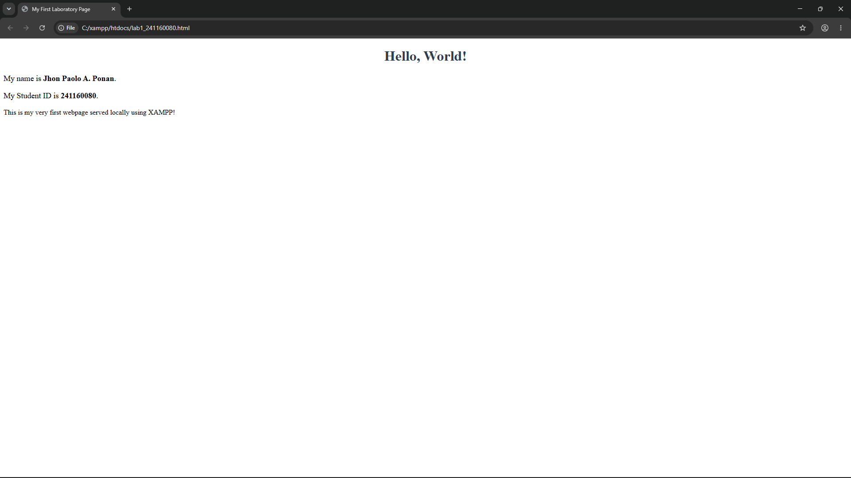

Conclusion

Through this laboratory experiment, I have been able to learn how to generate my first HTML page and be able to use XAMPP to run it in my computer acting as a local server. I have also been able to appreciate the significance of the htdocs folder, Apache and the use of localhost in testing my webpage instead of opening them from my browser. It was easy for me to type my HTML page through the use of Visual Studio Code and be able to test it using XAMPP.
