Excel Data Transfer and Storage System

Submitted by:
Jhon Patrick L. Tacio
Instructor:
Gerry Dacanay
Date:
August 14,2026

Table of Contents

Title Page --------------------------------------------------------------------------- 1
Table of Contents ----------------------------------------------------------------- 2
Project Information ---------------------------------------------------------------- 3
Program Design -------------------------------------------------------------------- 4
Program Code ---------------------------------------------------------------------- 5
Researcher’s Profile ----------------------------------------------------------------7

Project Name:
Excel Data Transfer and Storage System

Function:
The Excel Data Transfer and Storage System is designed to read and process data from an Excel file and transfer the extracted data into a MySQL database for storage and management. This system simplifies the process of manually entering data into a database and helps ensure that information from Excel can be stored in an organized and accessible format.

How It Will Help:
The system can help reduce the time and effort required to manually transfer data from Excel into a database.
It also provides a more efficient way of storing and managing large amounts of data in MySQL, making the information easier to access and process when needed.

APIs, Middleware, and Tools Used:
- Python – Used as the primary programming language to read and process the data from the Excel file and transfer it to the MySQL database.
- MySQL – Used as the database management system where the transferred data is stored.
- MySQL Workbench – Used to create, manage, and monitor the MySQL database.
- Visual Studio Code – Used as the development environment for writing, editing, and running the Python program.

Technology Used:
- Python
- MySQL
- MySQL Workbench
- Visual Studio Code
-Excel
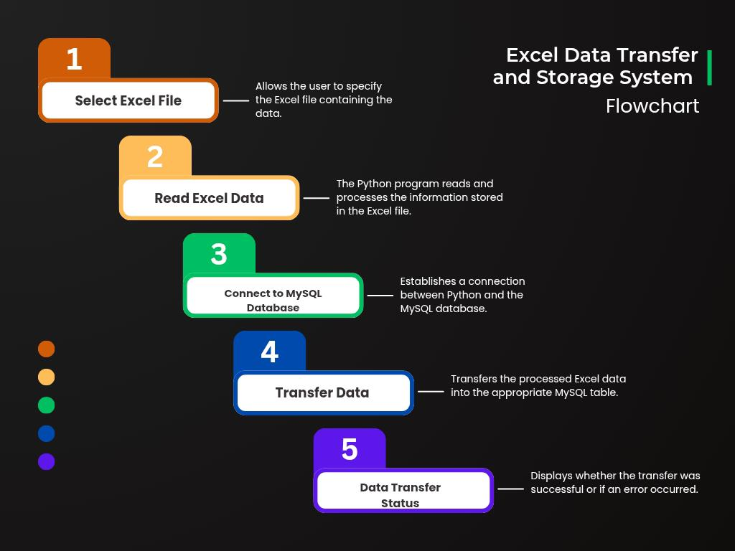
Program Design
Program Code
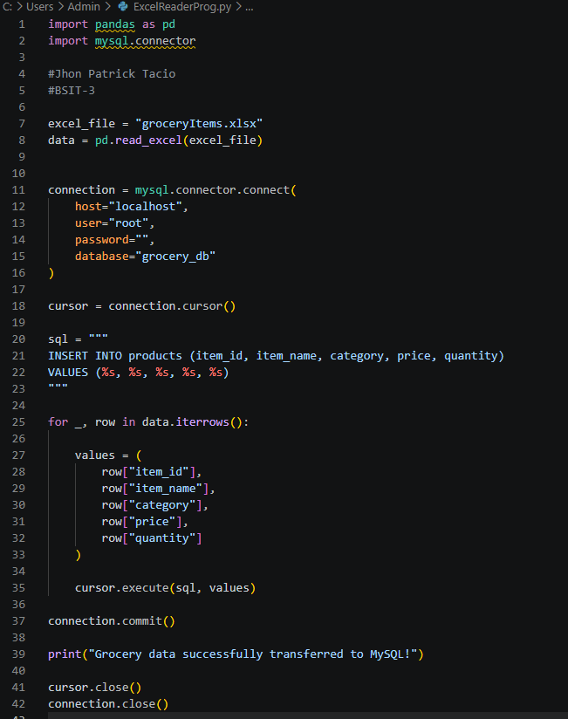

MySql Code:
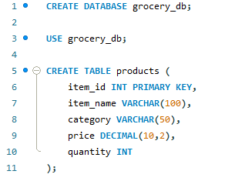


Researcher’s Profile

Personal Information
Name: Jhon Patrick Tacio
Age: 19
Gender: Male
Adress: Km. 4 Asin Road, Baguio City
Citizenship: Filipino
Date of Birth: September 17, 2006
Place of Birth: Baler Aurora
Contact Information: 09109732918
Mother’s Name: Shiela May Tacio
Father’s Name: Noel Tacio
Educational Background
Primary: Pacday Quiño Elementary School
Year Graduated: 2017-2018
Secondary: Joaquin Smith National High School
Year Graduated: 2022
Tertiary: Baguio College of Technology

