Create the virtual environment

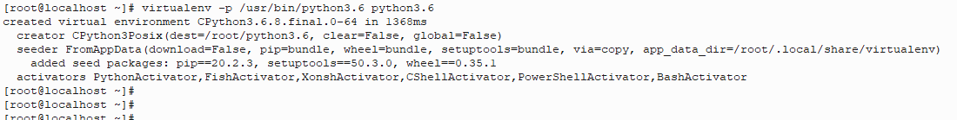

Activate the virtual environment

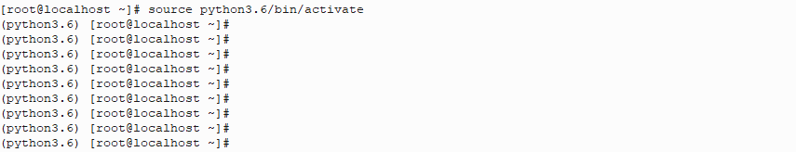

Install pandas/Matplotlib/ Numpy

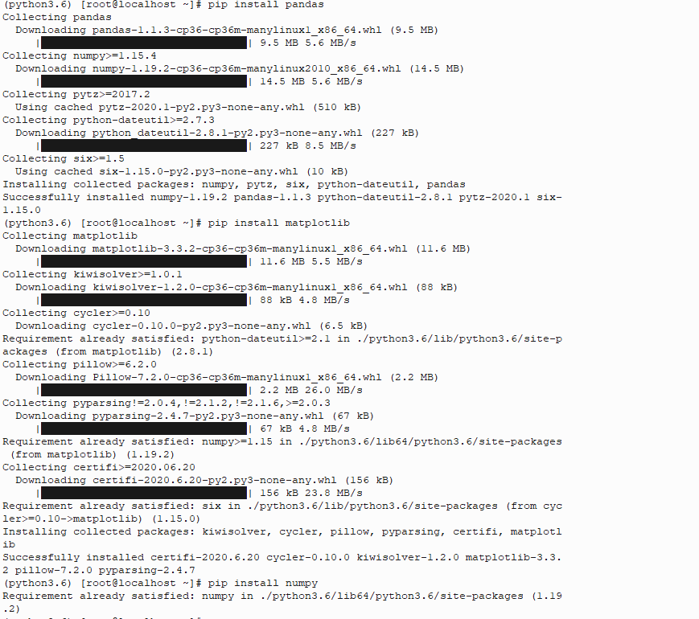

Uninstall python-dateutil

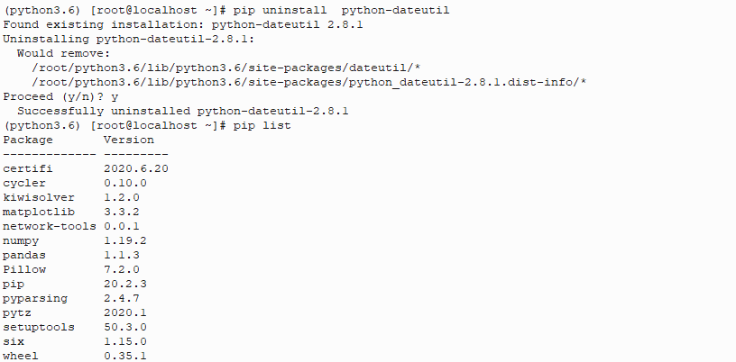

Creating the requirements.txt

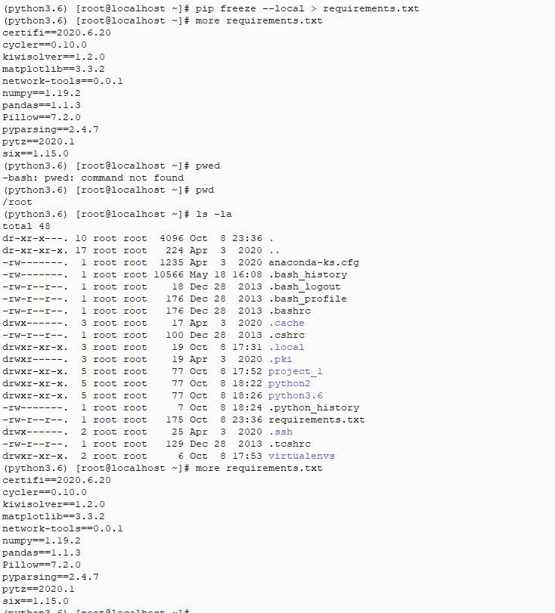



Deactivate and delete the virtual environment

