# **C20A - Clue Control GUI (Clue Pair)**

**Originally written by Mark Baldwin but revised by Michael Crews and Jhon Malagon.**

For this assignment you must install JavaFX 14 and JDK 14. **This takes at least 1 hour**. Please refer to this link on how do that: [https://openjfx.io/openjfx-docs](https://openjfx.io/openjfx-docs/)

**Purpose:**

* Layout the control panel GUI.

**Preparation:**

* Please review videos 1 through 14 of this JavaFX tutorial series found here: <https://www.youtube.com/watch?v=FLkOX4Eez6o&list=PL6gx4Cwl9DGBzfXLWLSYVy8EbTdpGbUIG>
* Please review the code on the following github link: <https://github.com/buckyroberts/Source-Code-from-Tutorials/tree/master/JavaFX>
* This assignment should be done with your Clue partner.
* Take a look at the layout coming up in the upcoming assignment to get an idea how this GUI will fit into the overall game.

The image below is from the Swing version of the Clue Game and will be updated with the JavaFX version when completed.

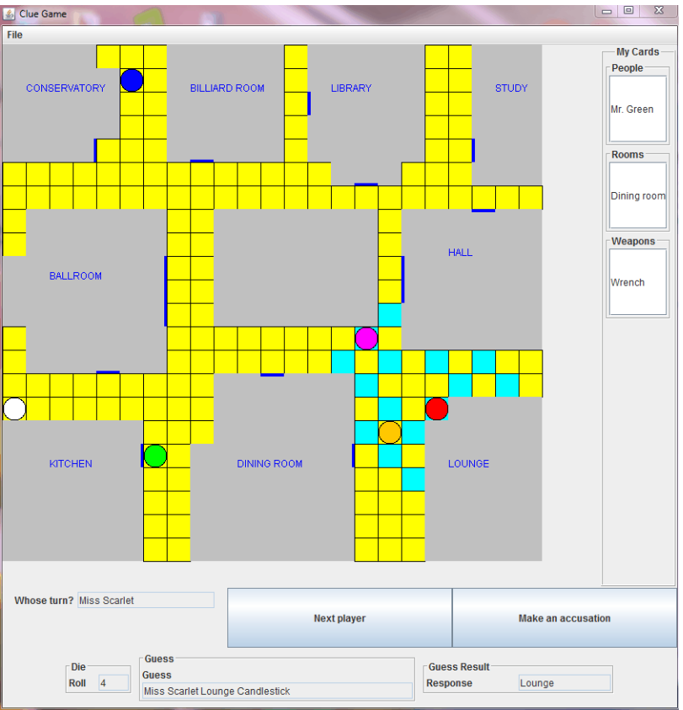

**Lesson**

This assignment doesn't test any game functionality, but it creates the layout for one panel that you will need (lower panel in above example). The Control panel will hold the game controls, and should include:

* button to move to the next player
* button to make an accusation
* display of the roll of the die
* display of whose turn it is
* display of guesses made by other players and the result

The figure below shows my control layout, yours may vary. Hints:

* Look at this document from Oracle if you are struggling to figure out which layout to use: <https://docs.oracle.com/javafx/2/layout/builtin_layouts.htm>
* To make buttons expand with the window, check out the following code found from this link: <https://docs.oracle.com/javase/8/javafx/api/javafx/scene/layout/HBox.html>

HBox hbox = new HBox();

Button button1 = new Button("Add");

Button button2 = new Button("Remove");

**HBox.setHgrow(button1, Priority.ALWAYS);**

**HBox.setHgrow(button2, Priority.ALWAYS);**

**button1.setMaxWidth(Double.MAX_VALUE);**

**button2.setMaxWidth(Double.MAX_VALUE);**

hbox.getChildren().addAll(button1, button2);

* To make the borders look pretty I used a lot of GridPanes but this is unnecessary to complete the assignment.
* Don’t forget to use the launch args command in main.
* It is NOT important for you to follow this layout exactly! Much better to play with the layout and come up with something that seems OK to you. Remember that mastering JavaFX layouts is NOT a focus of this course.

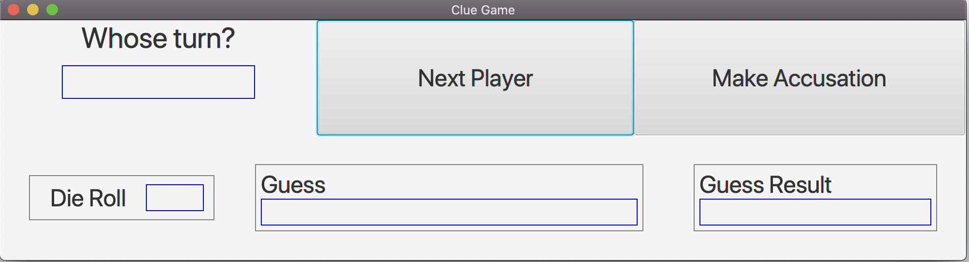

*Figure 1. Control Layout*

**Specific Requirements**

Ultimately you will include this panel in your clue game. All in the start method, you should create a scene, add your layout to the scene, set the size of the scene, set the default close operation, add the scene to the window, and show the window. Please refer to the links above for example JavaFX code.

This assignment is worth 50 points

* (40) Game Control GUI with buttons and fields
* (10) Main method to launch the JavaFX code

Submit

Zip your entire ClueGame project and submit here (just one per team, be sure to put team member's name in comments). The grader will simply run your Control GUI class (if your class is in another package or the name is not obvious, include a note in comments).