# **C22A - More GUI (Clue Pair)**

**Originally written by Mark Baldwin but revised by Michael Crews and Jhon Malagon.**

### Purpose:

* Add game functionality
* Continue using git

### Preparation:

* You may want to play some previous examples of Clue.  Note, these only run in Windows.
  + [ClueGame_CR.exe](https://elearning.mines.edu/courses/21501/files/1459963/download?wrap=1)
  + [ClueGame_RM.exe](https://elearning.mines.edu/courses/21501/files/1459962/download?wrap=1)
  + ClueGame_MW.exe

### Lesson:

In this lesson we'll add a splash screen that displays when the game starts and a display of the cards dealt to the human player.

### Splash Screen:

When the game starts, you should display a message such as the one shown below.

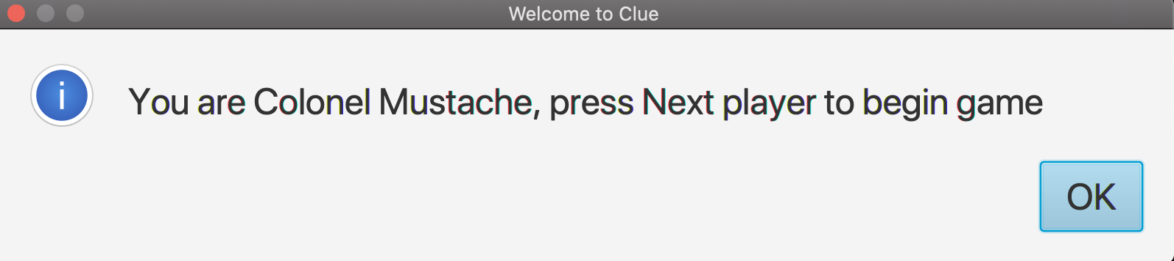

*Figure 1. Splash screen*

Hint:

* For the display message, it’s easiest to make another class that uses the Alert class from JavaFX. This link is helpful: <https://code.makery.ch/blog/javafx-dialogs-official/>

### Player Card Display

After cards are dealt, the human player needs to know what's in his or her hand. Add a display similar to the one below (right hand edge).

Hint: How will you know what cards to display? I just pass in the human player and use a getter for the player’s cards.

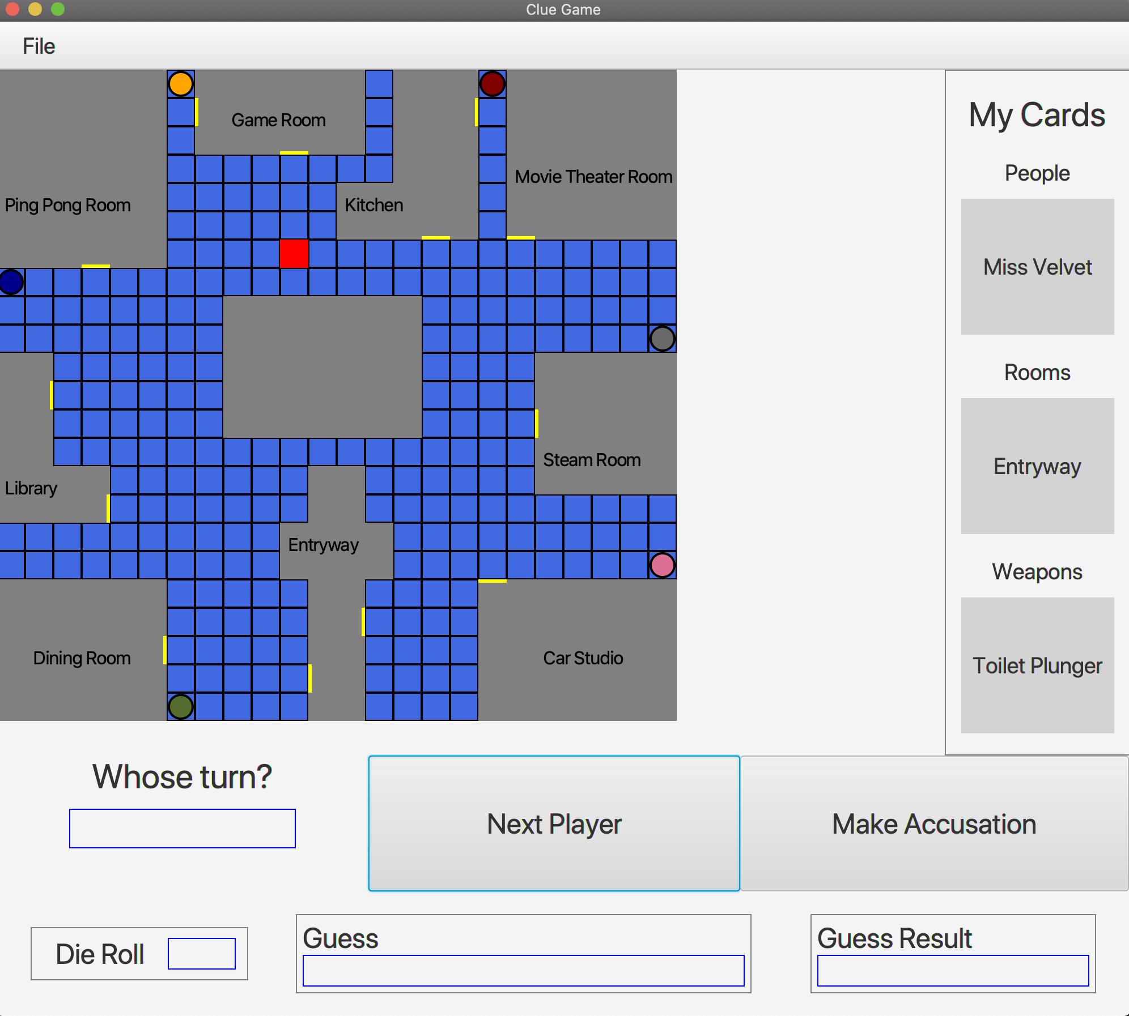

*Figure 2. Clue Game GUI*

### Specific Requirements

This lab is worth 50 points

Splash Screen

* (10) Prompt to start the game

#### Player Card Display

* (40) Display of cards dealt to human

#### Control Display

* (5) Add your control GUI to the program

Git

* (5) Git log showing work by all partners.

### Submit

Zip your project and submit.   Include your GIT log.