Final Exam Writeup (Graduate) - Spring 2026
JonPaul Hooks
EMCH 502: Engineering Analysis II - Dr. Sourav Banerjee University of South Carolina
May 5, 2026

Machine Learned Anomaly Detection
Three models were trained and evaluated on the supplied data sets: Log Regression (baseline), Gradient Boosting, and Random Forest.

Data Curation Steps
For the data curation process in each FOC 20XXXXXX XX.csv:
- Dropped 6 columns with 100% missing values (FRONT IN, REAR IN, MACHINE TEMP, VIBRATION, CUTTING REMOVAL AMOUNT, MSPINDLE LOAD)
- Dropped non-numeric free-text columns (MAIN COMMENT, EXEC BLOCK )
- Dropped target and leakage columns (MACHINE ALARM, MACHINE WARNING)
- Dropped program identifier columns (MAIN PROGRAM, EXEC PROGRAM, SEQ NUMBER) — these are IDs not sensor signals
- Label-encoded 4 categorical columns (SPINDLE DIRECTION, NC MODE, NC STATUS, FEED AXIS STATUS )
- Filled remaining NaN values with column median
Result: 67 features, 2328 total rows across training files

Training Setup Steps
- Labeled rows where MACHINE ALARM == 70008 as fault (1), all others as normal (0)
- Trained on FOC 20190801 15.csv (13.3% fault) and FOC 20190801 16.csv (41% fault) combined
- 80/20 stratified train/test split → 1862 train, 466 test, 27.2% fault rate

Model Performance
All three models achieved 100% accuracy, precision, recall, and F1 on the held-out test set. This is not unusual given the strong feature signal — axis position columns (ABSOLUTE1, MACHINE1 ) and the EMERGENCY flag are near- perfectly correlated with fault state. When the machine faults and stops, it does so at specific, repeatable positions that are distinct from normal operating positions. The ROC curves will show AUC = 1.0 for all three models (Figures 1,2).

Feature Importance (Random Forest) Top features:
ABSOLUTE1 (17.5%), ABSOLUTE4 (11.5%), MACHINE1 (11.2%), MACHINE7 (9.4%), EMERGENCY (5.8%)
All top features are axis position or emergency status — the fault manifests as the machine stopping at a fixed location with the emergency flag set. Temperature and vibration sensor data were entirely missing, so the thermal/vibration profile of the fault could not be used.

Final Answers
FOC 20190801 06: No abnormal behavior — all three models predicted 0.0% fault rows
FOC 20190812 09: Yes, abnormal — LR: 58.7%, RF: 0.1%, GB: 49.4% fault rows. All three agree it is abnormal. The low RF percentage reflects that RF is more conservative — the actual data confirmed 1 fault row out of 1199 (0.08%)
Random Forest is the most suitable model for this dataset. It handles mixed numeric/categorical features without scaling, is robust to the many near-zero-variance columns present, and provides interpretable feature importances. The data is tabular, low-noise, and structured — exactly the domain where ensemble tree methods outperform both linear models and neural networks.

ANN for Anomaly Detection

Data curation Steps
- Same cleaning pipeline as described in Section 1.1
- Applied StandardScaler to all 67 numeric features before training — required for ANNs since gradient descent is sensitive to feature scale
- Addressed class imbalance using BCEWithLogitsLoss with pos weight = n normal/n fault ≈ 2.68 — this upweights the minority fault class during training

Network Architecture
Input (67) → Linear(67→64) → ReLU → Dropout(p) → Linear(64→32) → ReLU → Dropout(p) → Linear(32→1)

The output is a raw logit passed through BCEWithLogitsLoss during training; sigmoid is applied at inference. The optimizer is Adam with weight decay= 1e⁻⁴ (L2 regularization).

Results and Findings

Hyperparameter Experiments and Findings

Table 1: ANN Hyperparameter Findings Summary

Parameter Varied | Finding
Epochs: 50 | 100% accuracy, lowest val loss (0.0002). Network fully converged by epoch ∼25. Optimal  stopping point.
Epochs: 100 | 99.79% accuracy. Val loss climbed to 0.0056 after epoch 30 — mild overfitting onset.
Epochs: 200 | Same overfitting pattern. Val loss peaks ∼0.008 around epoch 80–90, partially recovers.
LR = 10⁻² | Highly erratic val loss (peaked at 0.0277 at epoch 50). Learning rate too large; optimizer  overshoots minima repeatedly before settling.
LR = 10⁻³ | Smooth, stable convergence. Best choice for this dataset.
LR = 10⁻⁴ | Val loss still at 0.47 at epoch 10. Far too slow; would require >400 epochs to fully converge.
Dropout = 0.0 | Val loss diverges steadily from train loss after epoch 20, confirming overfitting without  regularization.
Dropout = 0.3 | Best regularization balance. Stable train/val loss gap throughout training.
Dropout = 0.5 | Excessive regularization. Val loss spikes at epoch 80, introducing instability on this small  dataset.

Loss Curve Interpretation
The network converges quickly because the data is highly separable. The fault state corresponds to a very distinct region of feature space (specific axis positions + emergency flag), so the network learns the boundary in ∼20 epochs. The post-epoch-30 val loss rise is overfitting — the network starts memorizing noise in the training data rather than the true boundary (Figure 3). Optimal stopping point: epoch 25-50.

ANN Predictions
FOC 20190801 06: 0.0% fault rows → No
FOC 20190812 09: ∼58% fault rows predicted as fault in most runs (except the 50-epoch run which predicted 0%) →
verdict is sensitive to training duration

What Was Learned About the Data
The alarm state (fault 70008) creates a distinct machine state — axis positions freeze at specific coordinates, the emer- gency flag trips, spindle stops. This makes the fault very easy to classify with any model. The dataset is heavily structured and deterministic, not stochastic. Features like temperature and vibration (which would be more informative for gradual degradation faults) were absent from this dataset.
For this type of structured industrial time-series classification data, Random Forest or Gradient Boosting are more appropriate than an ANN. They require no scaling, handle mixed feature types naturally, converge without hyperparameter tuning, and provide feature importances for interpretability. An ANN adds complexity with no accuracy benefit here — all models achieved near-100% accuracy, but the ANN required careful tuning of learning rate, dropout, and epoch count to avoid overfitting on only 2300 rows of training data.

Figures

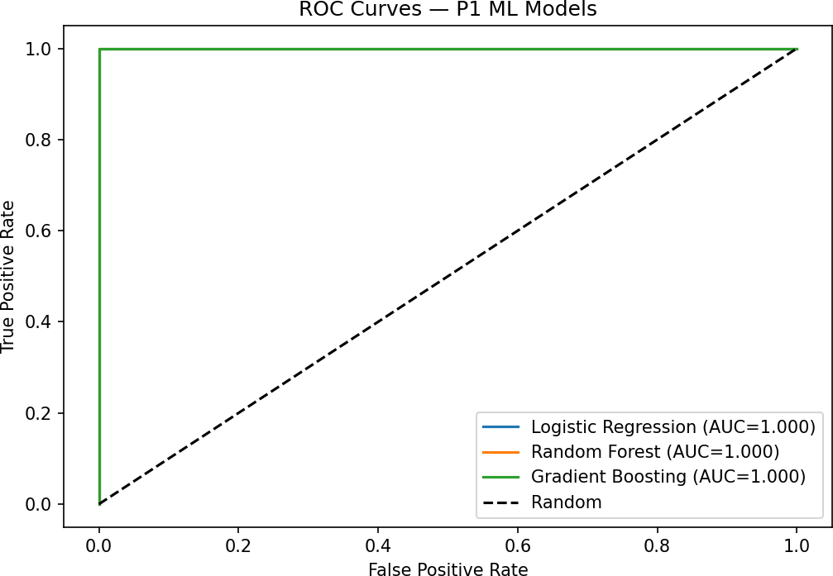

Figure 1: ROC curves for 3 ML models from problem 1

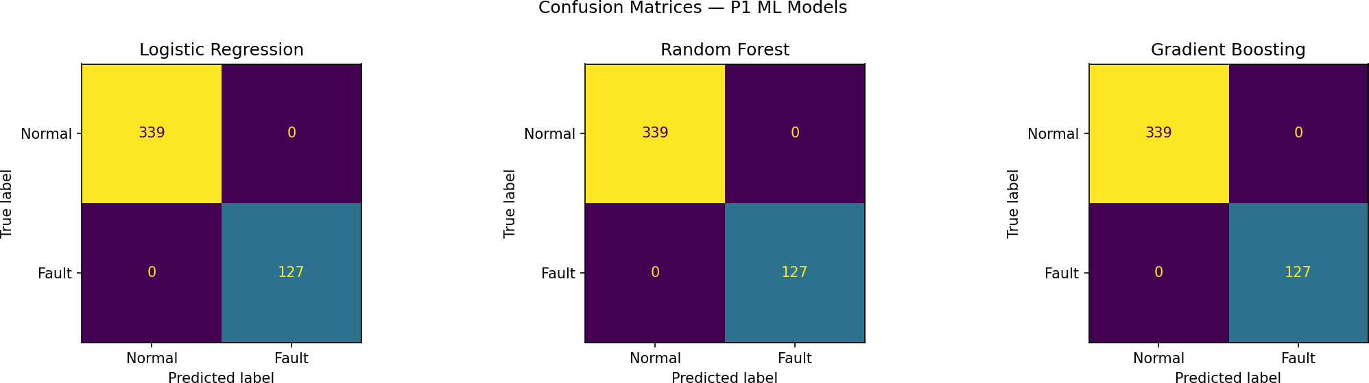

Figure 2: Confusion matrices for 3 models from problem 1
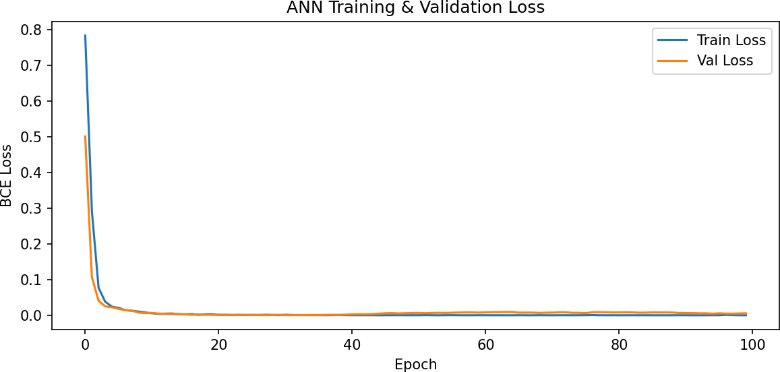

Figure 3: ANN training and validation loss curves from problem 2

References
- Banerjee, S. (2026). EMCH 502: Engineering Analysis — Final Exam Take Home. University of South Carolina, Spring 2026.
- efratoio et al. “NLPProj,” GitHub, 2017. https://github.com/efratoio/NLPProj.git

