GovCert
HeyGen Demo Video Script
Duration: ~5:35 | Professional presenter, business casual
Founder speaking to fellow business owners — confident, empathetic, authoritative

SCENE 1: THE FOUNDER STORY (0:00 – 0:50)
50 seconds — Dark navy background with GovCert logo
The founders of GovCert are the founders of House Strategies Group — a government contracting firm that spent hours, weeks, months, and even years putting together certification applications for govcon contracting vehicles. Particularly 8(a) Business Development and GSA Multiple Award Schedule.
Through that experience, one thing became painfully clear: all the information we needed to complete our applications was already available. Somewhere on our desk. In our inbox. In our Google Drive. Our tax returns were with our accountant. Our org chart was in a PowerPoint from last year. Our past performance references were scattered across three different email threads.
And once we finally tracked everything down? We had to read it, analyze it, and reorganize it into the specific language that each application demands.
There had to be an easier way.

SCENE 2: INTRODUCING GOVCERT (0:50 – 1:15)
25 seconds
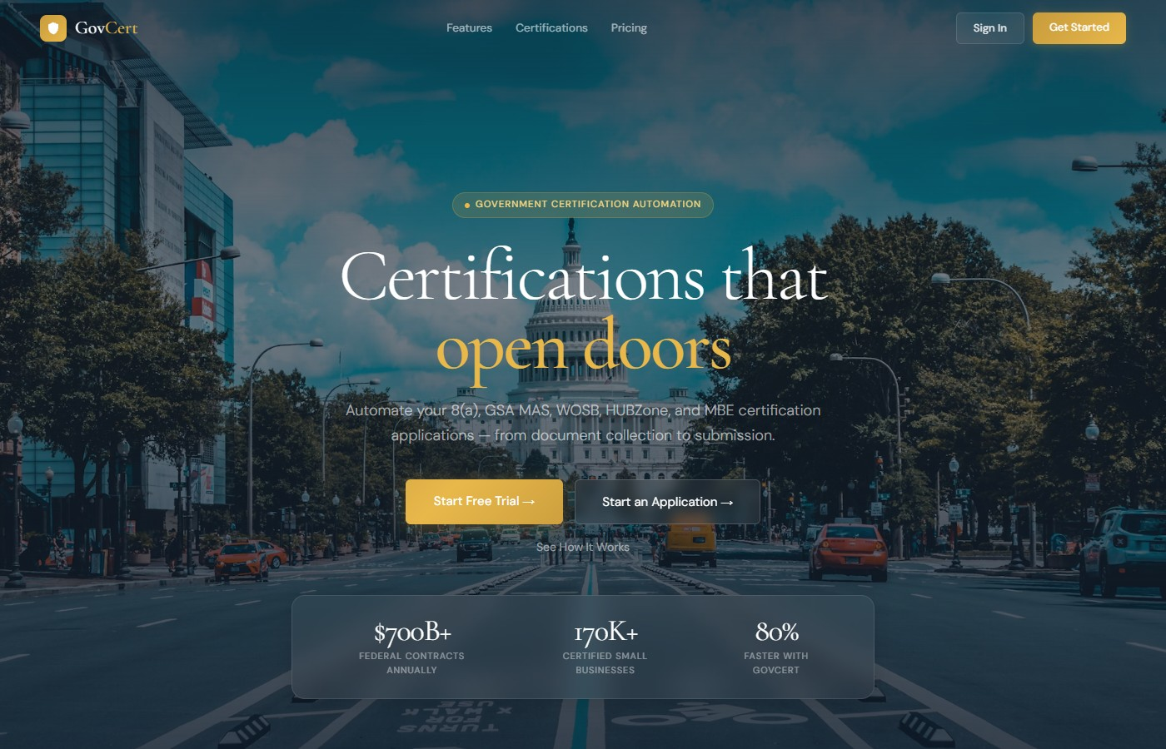
GovCert is the answer to the question: what is the easier way?
AI has enabled quick, accurate, and high-quality document and data distillation — taking your raw documentation and making it into review-ready certification applications. Quickly. Accurately. At a quality level that used to take a team of consultants weeks to produce.
Let me walk you through exactly how it works. Everything you’re about to see is live.

SCENE 3: SIGN UP (1:15 – 1:30)
15 seconds
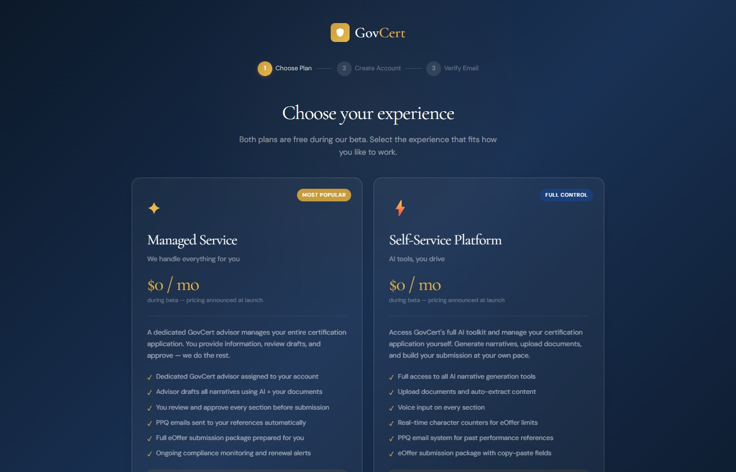
Creating an account takes thirty seconds. Choose between our Managed Service — where a dedicated GovCert advisor handles everything for you — or our Self-Service Platform, where you drive the process with our full AI toolkit. Both plans are free during our beta.

SCENE 4: THE ELIGIBILITY WIZARD (1:30 – 2:10)
40 seconds
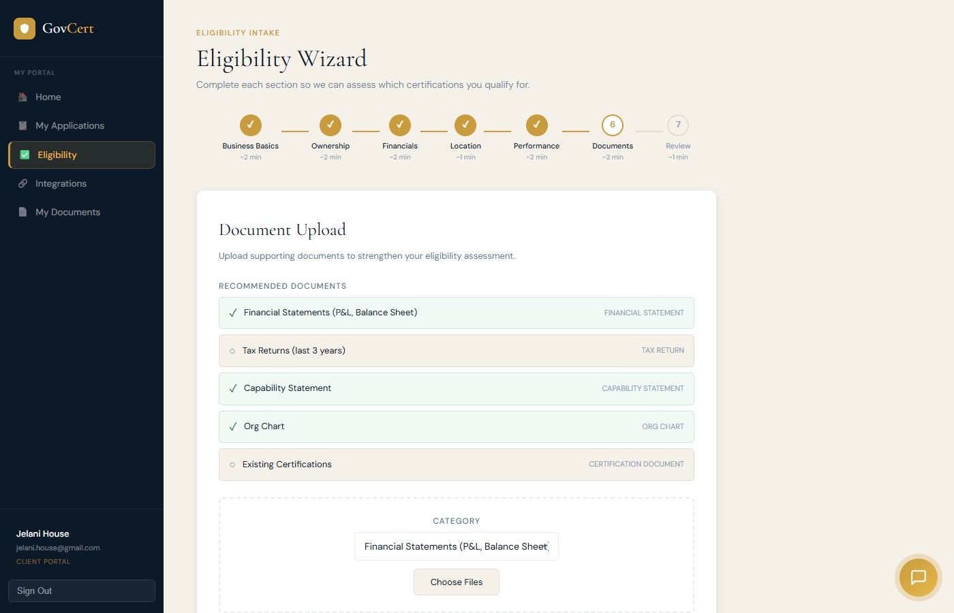
Once you’re in, GovCert launches the Eligibility Wizard. You answer straightforward questions about your business — the basics like entity type, when you were established, and your NAICS codes. Then ownership demographics. Then financials — and if you use QuickBooks, connect it right here and we pull your revenue data automatically. No manual entry.
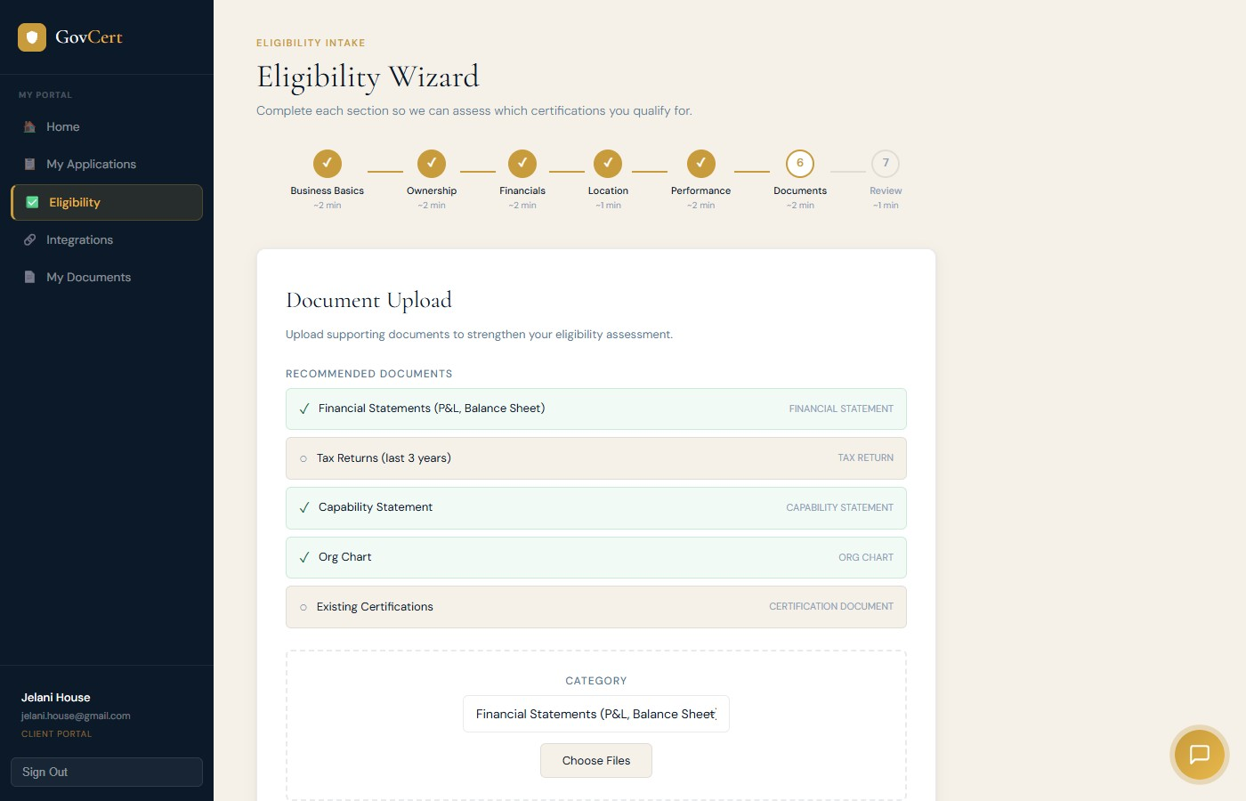
Then you upload your key documents — financial statements, tax returns, capability statements. Watch what happens. The moment you upload a document, GovCert’s AI reads it, categorizes it, extracts the year, and identifies the key data points. That pricing sheet? We already know it covers 2025 through 2029 and we’ve pulled every labor category and rate. That tax return? We know the fiscal year and your revenue numbers. All of this feeds directly into your application.

SCENE 5: ELIGIBILITY RESULTS (2:10 – 2:35)
25 seconds
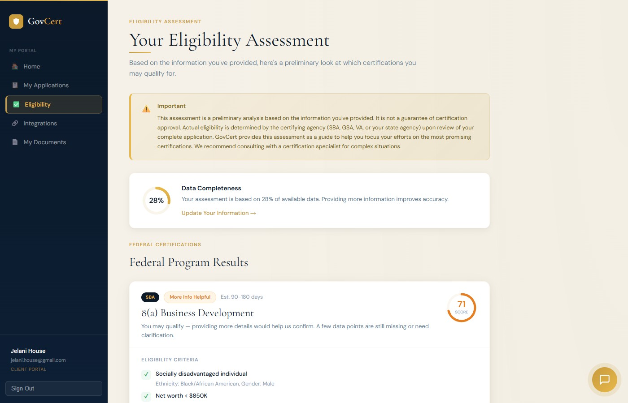
Click Run Eligibility Assessment and in seconds, GovCert analyzes everything you’ve provided against the actual requirements for every major federal certification.
You get an instant, clear answer. Which certifications you qualify for. Which ones you’re close on. And exactly what’s missing. Look at this — each criterion is checked against your data. Green checkmark means you meet it. Red X tells you exactly what needs to change. Required documents and required data are listed right there.
No five-thousand-dollar consultant fee just to know where you stand.

SCENE 6: APPLICATION DASHBOARD (2:35 – 3:00)
25 seconds
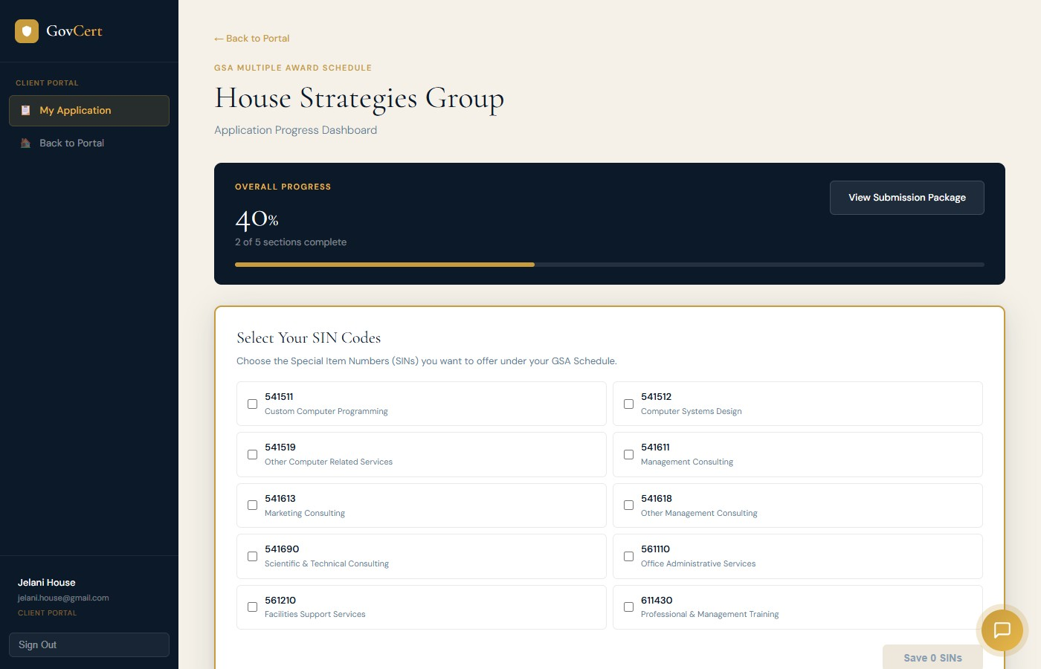
Ready to apply? GovCert builds your full application dashboard. For GSA Schedule, you start by selecting your SIN codes — the service categories you want to offer under your contract.
Your application immediately breaks down into every section GSA requires. Corporate Experience. Quality Control Plan. Past Performance — you need three references. Project Experience for each SIN you selected. Financials. And your CSP-1 pricing. You can see your progress at a glance. Green checkmarks mean those sections are done. You know exactly what’s left.

SCENE 7: AI-POWERED NARRATIVES (3:00 – 3:35)
35 seconds
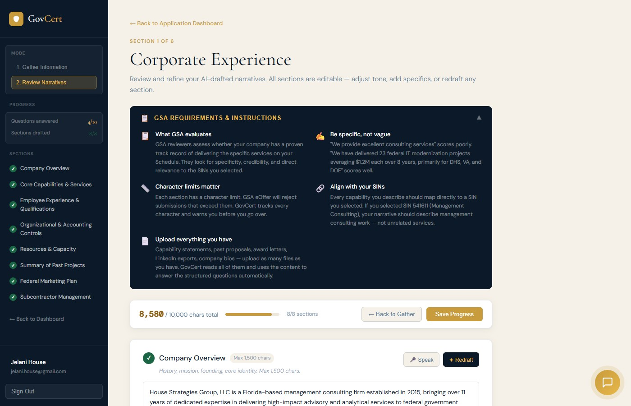
Here’s where GovCert saves you weeks of work. Click one button, and AI drafts your entire Corporate Experience narrative — all eight sections. Company overview, core capabilities, employee qualifications, organizational controls, resources, past projects, marketing plan, and subcontractor management.
This is not generic filler. Look at this — it references your company by name, mentions your certifications, your SAM.gov registration, your NAICS code, your specific services. GovCert uses everything it knows about your business to write specific, professional narratives tailored to your company.
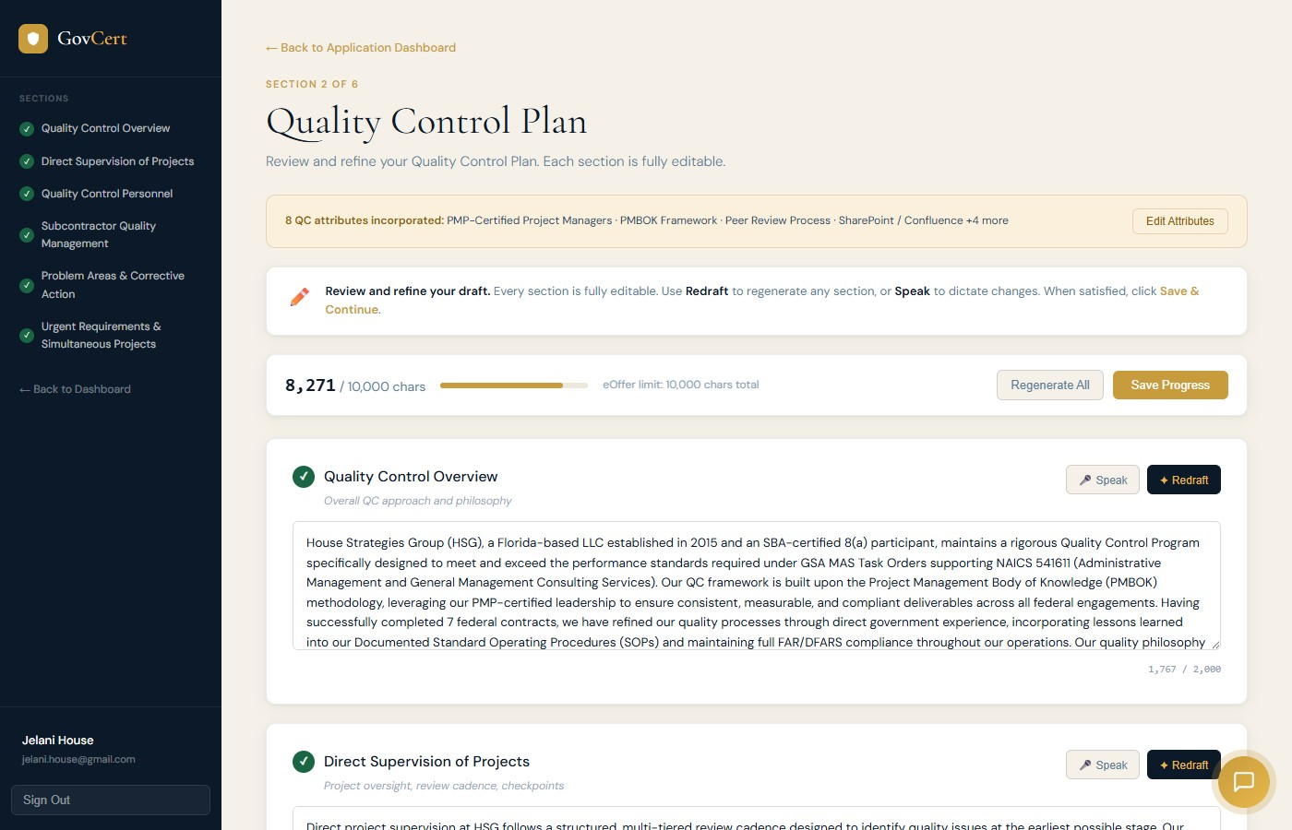
Same thing for your Quality Control Plan. GovCert automatically incorporates your QC attributes — PMP certifications, PMBOK framework, SharePoint and Confluence platforms — into detailed, GSA-compliant narrative sections. Every section is editable. Use the Redraft button to regenerate any section, or Speak to dictate changes with your voice.
And it stays within GSA’s ten-thousand-character limit automatically. You can see the counter right there — eight thousand two hundred seventy-one out of ten thousand.

SCENE 8: PAST PERFORMANCE & PPQ (3:35 – 4:05)
30 seconds
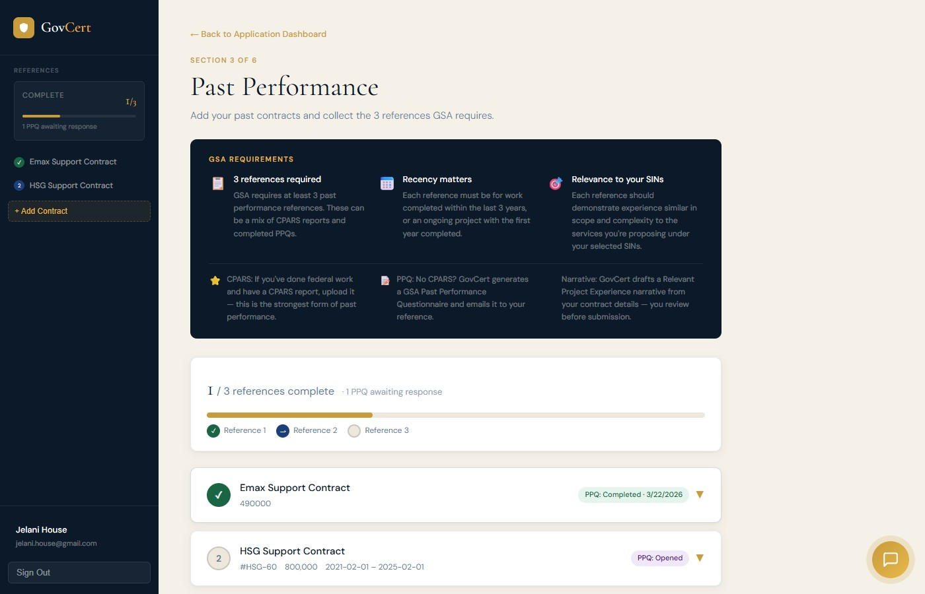
Past performance references are usually the most painful part of any certification. You need three, and you need them to fill out formal questionnaires. GovCert makes it painless.
Add your contracts, enter your reference’s name and email, and GovCert’s AI drafts a personalized email requesting the questionnaire. Your reference receives a clean, professional form with ratings, narrative questions, and a signature pad. You can track every reference in real time — look, this one shows PPQ Completed, this one shows PPQ Opened. When they submit, GovCert automatically generates a signed PDF and adds it to your documents.

SCENE 9: PRICING & CSP-1 (4:05 – 4:25)
20 seconds
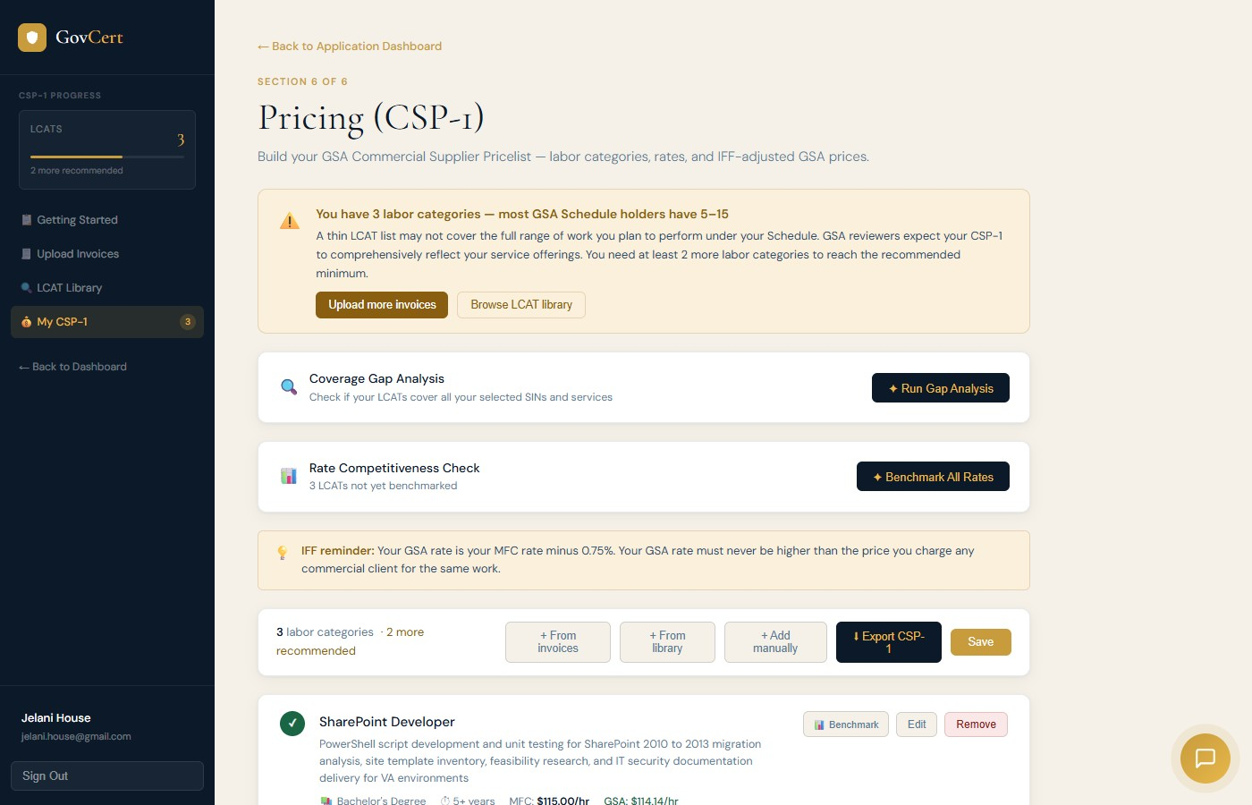
For GSA Schedule, you also need a Commercial Supplier Pricelist — your CSP-1. GovCert’s pricing builder lets you add labor categories, benchmark your rates against market data, and run gap analysis against your SINs. Upload your invoices and our AI extracts your service lines automatically.
Look at these three labor categories — SharePoint Developer, Project Manager, Subject Matter Expert. Each shows education requirements, experience level, your commercial rate, and the IFF-adjusted GSA rate calculated automatically. When you’re done, export your formatted CSP-1 ready to upload directly into eOffer.

SCENE 10: EOFFER SUBMISSION — YOUR COPY-PASTE COMPANION (4:25 – 5:05)
40 seconds
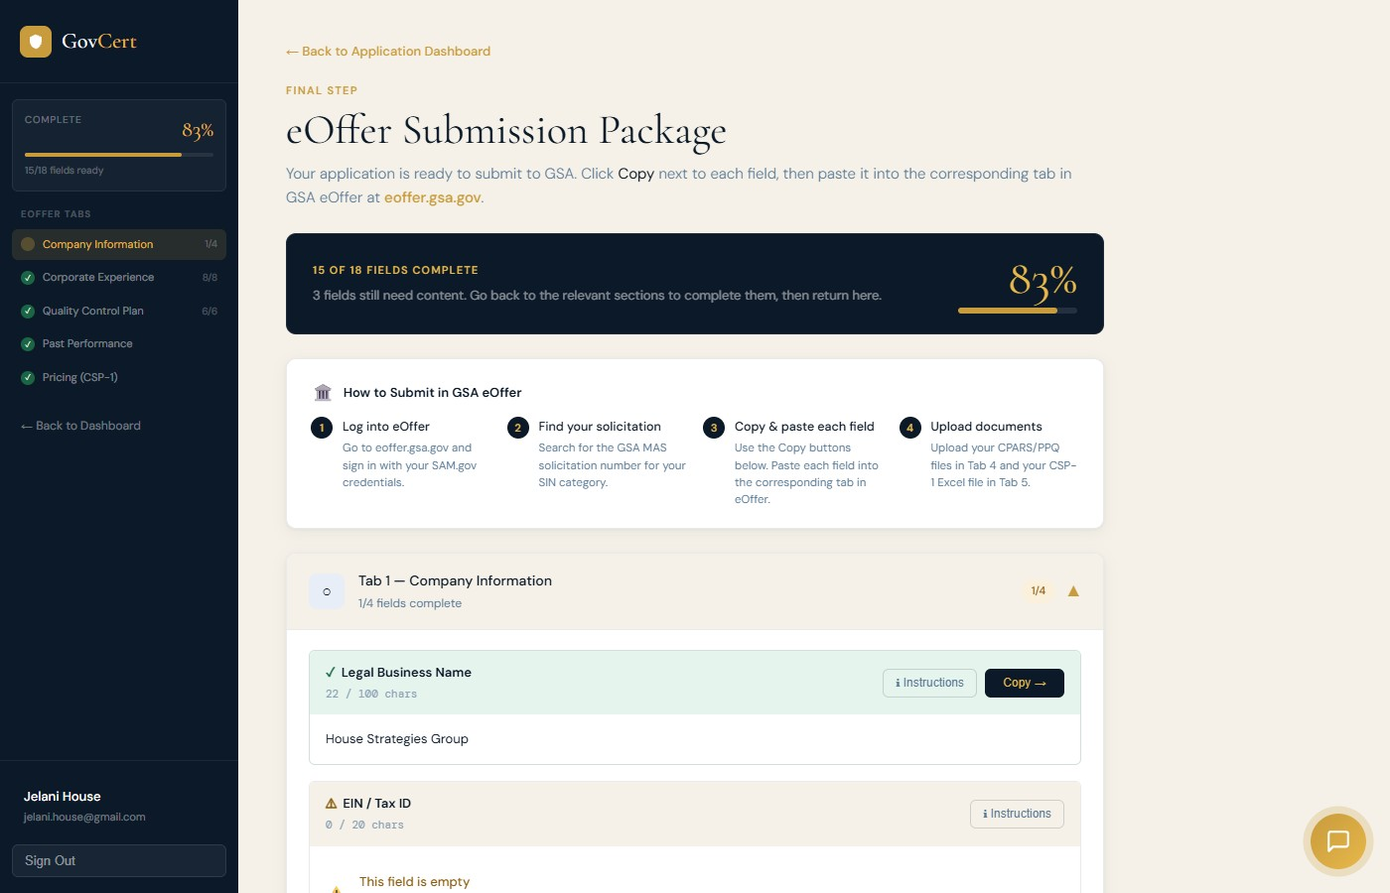
Now let’s talk about what everyone dreads — the actual submission.
If you’ve ever spoken to a government contractor about submitting a GSA MAS application, you’ve heard the horror stories. Industry surveys consistently show that most small businesses spend four to six months preparing their GSA Schedule offer. Some take over a year. Between gathering documents, writing narratives, collecting references, building your CSP-1, and figuring out which field goes where in eOffer — it’s overwhelming. That’s why so many businesses either give up halfway through or pay fifteen to twenty-five thousand dollars to a consultant to do it for them.
With GovCert, we’ve seen users go from first login to a submission-ready package in under two weeks. Some in days.
And this page — the eOffer Submission Package — is your copy-paste companion for the final stretch. Think of it as your cheat sheet that sits open on one side of your screen while GSA eOffer sits on the other.
Every field your application needs is organized by eOffer tab. Corporate Experience — all eight sections, done. Quality Control Plan — all six sections, done. Past Performance documents ready to upload. Your CSP-1 ready to download.
You open eOffer, you open GovCert, and you go field by field. Click Copy. Switch to eOffer. Paste. Next field. Copy. Paste. That’s it. The actual submission process takes about an hour — because GovCert already did the hard part.
Four to six months of work, compressed into days — and a submission process that’s as simple as copy, paste, submit.

SCENE 11: THE CLOSE (5:05 – 5:35)
30 seconds

We built GovCert because we lived this pain ourselves. At House Strategies Group, we spent years navigating the certification process — for our own business and for our clients. We knew every piece of information we needed was already in our hands. We just needed a smarter way to turn it into an application.
AI has made that possible. GovCert takes your raw documents — your tax returns, your invoices, your capability statements, your past proposals — and distills them into a complete, review-ready certification application. What the industry says takes four to six months, GovCert helps you do in days.
No more hunting for documents. No more staring at blank narrative fields wondering what to write. No more chasing references. No more guessing which field goes where in eOffer.
Built by government contractors. For government contractors.
Start your free trial today at govcert dot A-I. Your next certification is closer than you think.

