Ideas for method for estimating people density, and prediction

Simulation
- We have N nodes. Each node is a random process that produces a “desired person count”, D(t). D ramps up to a constant level, stays there for awhile, and then ramps down. The desired count is actually a vector, specifying the desired number of people of each type.
- We have M people in the system. Here is the data for each person:
  - Their state:
    - At a node resting
    - At a node pending departure (ie, new destination not assigned yet)
    - In transit
  - Their current location.
  - Their destination (if in transit) … could be another node or a sink
  - Their type
- We know sij, the correlation coeff between nodes i and j. If they are neighbors, we also know dij, the distance (in seconds) between them.
- Let tkl = the time between any nodes k and l. This is the minimum path length in terms of the dij’s between k and l.
- There are also some source/sinks. These they have a probability pSS(type) of a person of a certain type coming from or going to the source/sink.

The simulation control:
- Initialize everything. Then at each time t,
- Simulate sensor hits
- Draw scene
- Update nodes
  - Run the random processes for each node, to create, destroy, or evolve them. This produces the desired count D at each node.
  - Compute the actual+anticipated population of each node, A. This is the sum of the people that are currently at this node resting, or are in transit to this node. It doesn’t count the people that are pending departure, or are in transit.
  - Compute actual count at each node (includes resting, pending depart, and in transit)
- Change people states
  - For each node that has excess people (A>D), randomly take that number of people that are resting at that node, and mark them “pending departure”.
  - For each node that has a deficit of people (A<D):
    - For each deficit slot
      - First try to fill it with a person that is already in the system, with state = “pending departure”, and has the correct type. There is a fixed probability for this. Evaluate the existing people in random order.
      - If we can’t fill it with a person already in the system, we can try to create a new person from a source. For each source (in random order), there is a fixed probability for a person of that type coming from that source.
    - If we end up filling the slot, mark the person as “in transit” with destination equal to this node.
  - For each remaining person that is pending departure
    - For each such person, try to send this person to a sink. For each sink (in random order), there is a fixed probability for a person going to that sink.
    - If we end up sending the person, mark the person as “in transit” with destination equal to that sink.
- Move the people. For each person in the system that is “in transit”:
  - Take the person’s current location i, his destination k, and get a list of its neighbors (the nodes where it could possibly go to)
  - For each neighbor j in random order that has tjk < tik, move to that neighbor with probability that is proportional to sij
  - If the person moved, set the new location. If it is to the person’s destination, mark the new status “resting”. If it is to a sink, remove this person from our list of people.

In the simulation, probability of transition to a neighboring node
- We know that the average time to transition is n seconds
- Assume we try transitioning every second, with probability p
- The probability of getting a success on the nth try is p*(1-p)^(n-1) – this is a geometric rv
- The mean of a geometric random variable is 1/p
- So if I say that the mean transition time is t, then set the probability each second to be 1/t.

Estimation
- We have N nodes where we want to estimate people counts, x(t).
- Our state, at time t, is Xt = [ x1,x2, …, xN ], where xi is the number of people at node i
- Our measurement is the vector Z = [ z1,z2, …, zN ], where zi is a measurement associated with node i. Later we may want to consider measurements that are not associated with a particular node. For now, our measurement z is the reading from the motion sensor (0 or 1).
- Some nodes are hidden, in the sense that there are no sensors in those zones.
- There are also some source/sinks. These have no x(t) associated with them, but they have a probability pSource(t) of a person coming from or going to the source.
- The prediction prior probability – we can think of this as being generated by the diffusion equation: p(xt+1 | xt) = k exp(-dx^2/2). Specifically, a person at node i may move to node j with probability proportional to the maximum cross-correlation score, sij, between them. Namely, pmoveij = 1-exp(-a*sij). (if sij < 0, then pmoveij=0). We can generate a new Xt+1 from Xt, by randomly doing some of these transitions. The probability of the new vector is given by the product of the probabilities of each transition.
  - Example: Xt = (0 1 0).
    - P(Xt+1 | Xt) = 0.7 for Xt+1 = (0 1 0)
    - P(Xt+1 | Xt) = 0.2 for Xt+1 = (1 0 0)
    - P(Xt+1 | Xt) = 0.1 for Xt+1 = (0 0 1)
  - Later, we may consider P(Xt+dt | Xt).
- The measurement probabilities for each node are independent; ie P(Z|X) = product of all P(zi | xi)
- We know P(zi | xi), and they are the same for any time t

Old ideas:
- We have a potential at node i, and each of its neighbors j, due to all the D’s.
  - The potential ykl at node k, due to the charge at node l, is ykl = Dk/tkl. Actually, we may want potential to fall off more slowly than 1/r. Let’s use ykl = Dk*exp(-0.25*tkl) for now. This also has the advantage that ykl = Dk if tkl=0.
  - Sum ykl for all l, to get total potential yk at node k.

Future

- Might need to estimate people count in C(t), in “zones”. These zones correspond to rooms or sections of corridors. There may be multiple sensors per zone.
- What we know:
  - sensors associated with each zone
  - connectivity between zones
  - P(zi|xj) = probability of seeing sensor reading zi at sensor i, given count at zone j
15
17
19
14
13
11
10
12
16
18
1002
1000
1001
2
3
2
4
2
2
3

2
2
6.0
2
0.3/0.8
0.2/0.6
0.1/0.3

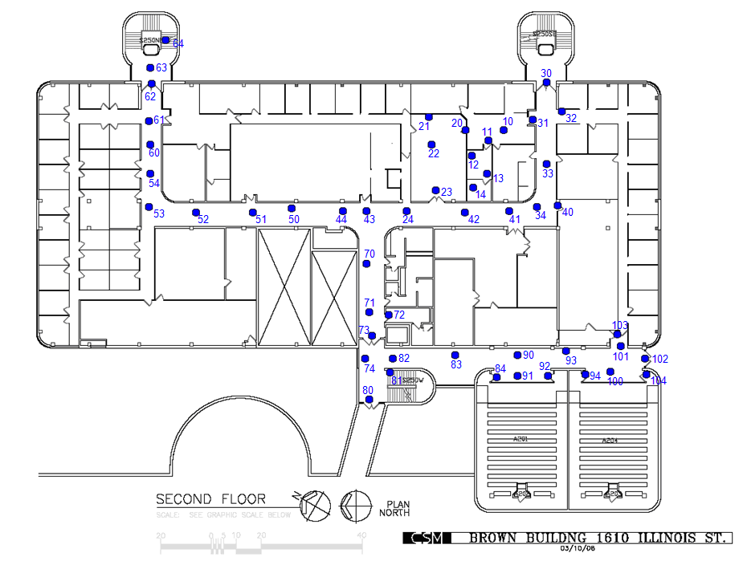
1000
1001
1002
1003
200
201
202
203
204

