The Smallest Object
Similar Triangles Math Lab

Expected Grade Level: 7th to 8th

About the Lab:
The purpose of this lab is to give students a real world example of when using similar triangles and proportions can be used. Specifically students will calculate the distance at which a given object is no longer able to be perceived by the human eye. To perform this calculation students will use only the distance of the object from the eye and some basic information about how the eye functions.

Lab Materials:  50 Meter of longer tape measure  Paper  Markers  Chairs  Calculators | Lab Times:  Initial Teacher Setup: 10 Minutes  Explanation: 25 Minutes  Exploration: 35 Minutes  Discussion: 10 Minutes  Total Lab time: 70 Minutes

Student group size: 1 to 4

Special Notes:
All images and problems referred to in this lab will be attached at the end.

Lab Procedure:
Initial Teacher Setup:
At the end of this lab is a sample template with different sized squares. These squares are to be colored based on the template guidelines. If possible avoid the use of light versions of the specified colors as they can be difficult to distinguish from white.

A chair setup outside with the 50 meter tape extending from it. The base of the tape measure should be under the chair with the starting location 50 meters away. If size, and resources permit the lab may work better if a chair for each color square is initially setup as this allows students of different speeds to move the the next station as they finish.

Explanation:
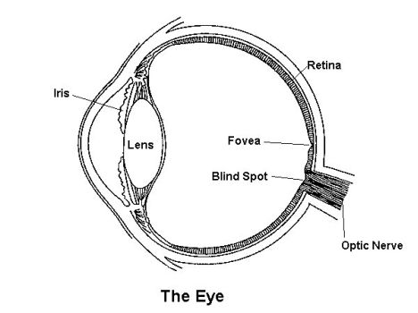
1. Students will first be given a short warmup problem involving similar triangles and how to solve for a missing value. The triangles used in this problem are very similar to the ones used in the lab.

2. A brief overview of the eye should now be given. Teachers may want to use the attached image of the eye for reference. A brief discussion of the function of the fovea of the eye along with the role of rod and cone cells should be given.

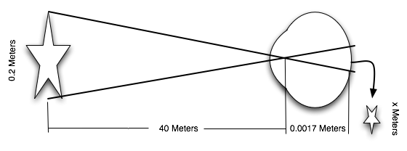
3. Students can now be shown how to setup the similar triangles to perform the initial experiment. To do this, a similar triangle figure can be setup as shown above. In the above example, the star projected onto the fovea will be approximately 0.0000085 meters in height (8.5 µm). Because the size of a typical within the area of the fovea is approximately 2.5 µm in height, this star will be visible at 40 meters distance. If the height of the projected image become small than 2.5 µm the star will be projected onto an area smaller than the size of a single cone cell, making it no longer visible.

Exploration:

Discussion:

