Standing Waves
Appropriate grade level: 6 - 8

Standards Addressed:

The following middle school mathematics and science standards are addressed through this lesson plan.

Mathematics:
  - Standard 2 – Algebraic Methods
  - Standard 3 – Data collection and analysis
  - Standard 5 – Measurement and uncertainty
  - Standard 6 – Computation

Science:
  - Standard 1 – Scientific Method
  - Standard 5 – Human Interrelationships

Standing Wave Demonstration

Objective: To explore the relationship between wave frequency and length. Students will be given a given a demonstration of standing waves in a speaker and be asked to calculate the wavelengths at various known frequencies. Using this information, students will calculate a linear equation from these measurements and use this equation to predict future wavelengths for given frequencies.

Assumed Knowledge: An understanding of wavelength, frequency and amplitude. Also, that students have at least a passing understanding of reflection, constructive/destructive interference and proportionality.

Demonstration Time: 30 minutes

Preparation Time: 10 minutes (Assuming speaker is setup)

Materials:
Speaker: Large Speaker
Connection to computer
Function or wave generator program for computer (many free programs exist)
Wide cellophane such as Saran Wrap

Demo: 1 Box Cornstarch
Water
Food Coloring
Mixing Bowl
Ruler

Before Students Arrive:
  - Build speaker and test. The larger the diameter of the speaker the better.
  - Line speaker with cellophane.
  - In mixing bowl, mix a one to one ratio of cornstarch and water solution.
  - Pour into speaker and test the waves at various frequencies. Lower frequencies (5 to 30) tend to perform best.
  - If standing waves are not yet apparent, add cornstarch. The thickness of the solution can depend on the properties of the speaker (It should look like figure 1).
  - Add food coloring until sufficient.

Procedure:
Have students gather around speaker and begin to slowly (4 hertz) start the speaker moving. At this speed, no waves should be apparent in the speaker cone. Slowly raise the frequency of the speaker until some of the most basic standing waves start to occur. Keep the demonstration fixed at the point and use this opportunity to ask if any students can point out examples of constructive and destructive interference. Ask if any students can point out places where wave reflection is happening. Then ask if any students can explain what is currently happening and why. With the demonstration still running, fill in any necessary gaps in the students understanding of the basic concepts of waves and explain the phenomenon they are now observing.
Now increase the frequency of the speaker. The waves should still be uniform and as the frequency increases the amplitude and wavelength of the solution should decrease. Ask the students why the amplitude and wavelength are smaller?
Using a ruler, at various frequencies, measure the wavelength. Since this is a linear equation (wavelength = 2*pi*frequency) only two points are needed, but collect a few points to give the students a larger table by which to determine the relationship between frequency and wavelength. Have the students determine what type of function they are dealing with and determine the actual function. Now, using their function, the students should be able to calculate the wavelength for any frequency. Test the accuracy of your findings by having them calculate what the wavelength should be at two new frequencies. Use the wave generator to test the accuracy of your findings.
Were the students exactly correct? Use this time to explain about any places of uncertainty in the demonstration and attempt to determine how they may be reduced.

Additional demonstrations:
Play a song in the speaker.

Mix the cornstarch and water to a much greater thickness (1.5 to 2 parts cornstarch to water). Place this in the speaker. At this thickness, waves will no longer be generated, but new interesting phenomena happens where the cornstarch appears to grow out of the speaker (Figure 2).

Images:
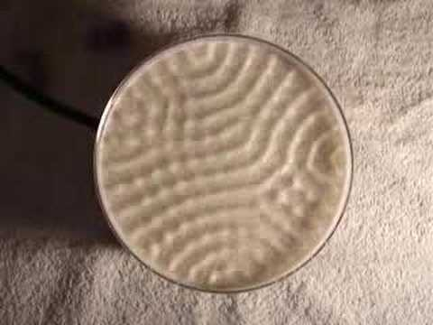
Figure 1: Standing waves in a speaker

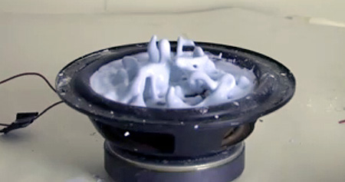
Figure 2: Cornstarch/water mix “growing” out of speaker

