Assignment report

Real-time Operating System - 48450

Student Name: Dung Quoc Thai

Student ID: 11990405

**Table of Contents**

I. Introduction 3

II. Theory of operation 3

III. Operating condition 3

IV. Implementation 3

1. Method 3

2. Flow chart 3

V. Experiments 3

1. Hypothesis 3

2. Results 3

VI. Conclusion/explanation 4

VII. References 4

1. Introduction

In this section, an introduction about the assignment is presented and some core technical knowledge that you will use are highlighted.

The goal of this assignment is to apply programing skills on CPU scheduling, FIFOs and Signal concepts. The core technical knowledge used in this assignment is programming with C, Google searching and reading lecture/lab slides.

1. Theory of operation

In this section, the brief but clear explanations about the technical knowledge are given for this assignment. For example, the theory, the functions and the usage etc.

The technical knowledge provided for this assignment include:

- The theory of shortest-remaining-time-first algorithm, and deadlock detection algorithm from lecture slides

- Functions for shortest-job-first function, FIFO read and write, deadlock provided in lab and online.

All theories and function provided was applied carefully during the assignment.

1. Operating condition

In this section, a summary about your understanding of the assignment is given. In order to complete the assignment, you might give a summary about key points that the assignment contains. In addition, you might explain the relationships between these points.

The programming assignment is distinctively separated into two programs. With program one focuses on CPU scheduling and FIFO, and program two focuses on deadlock detection and signaling.

Program one is a multi-threads program that applies CPU scheduling using Shortest-Remaining-Time-First (SRTF) algorithm and read/write data using FIFO concept. Information written to FIFO are output to a text file for user review.

Program two is a deadlock detection program that uses value from a provided text file. Values from the file are read by the program before processes any deadlock and output process information to the users via console using signaling and also provide information via a textfile.

1. Implementation
2. Method

In this section, you might list how you solve the problem and how you complete your program. You might write your software design strategy about your programing.

Programming strategy used for this project is similar to any other programming projects.

The first and most important step is to clearly understand the project. This was completed by carefully reading through the assignment notes. The second step is to understand logically how the program would work. his was completed by looking at key points, listing down how the program would run logically, and complete basic implementation of logical process on paper (see figure 1 and figure 2).

After the logic are listed, pseudo code was written, and the programming process was tackled in parts, following the listed logic (figure 1).

Strategy to solve problems during the coding period included; Google searching, consulting classmates, move away from the work space for a period of time to rethink about life, never give up.

After coding and debugging, the final step was to clean up all debugged output, nasty comments and recommended the project.

1. Flow chart

The flow chart about this assignment is shown below.

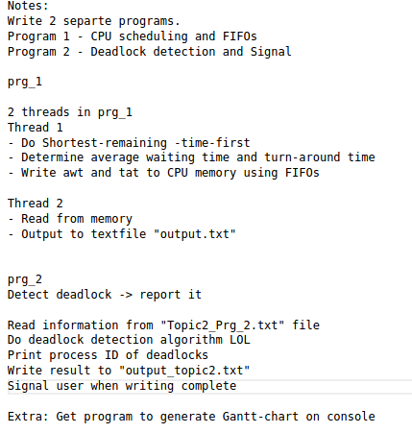Figure 1: Logic flows

1. Experiments
2. Results

For demonstration purpose, you might give some graphs about your program running. An example is shown below.

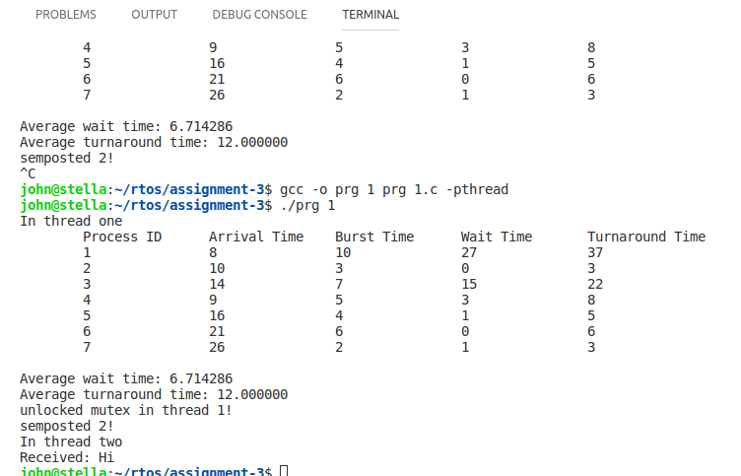

Figure 3: Program 1 test console output

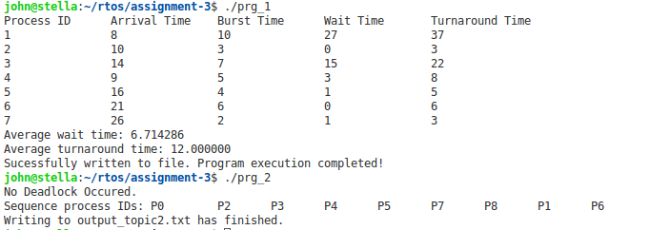Figure 4: Program 1 and 2 final console output

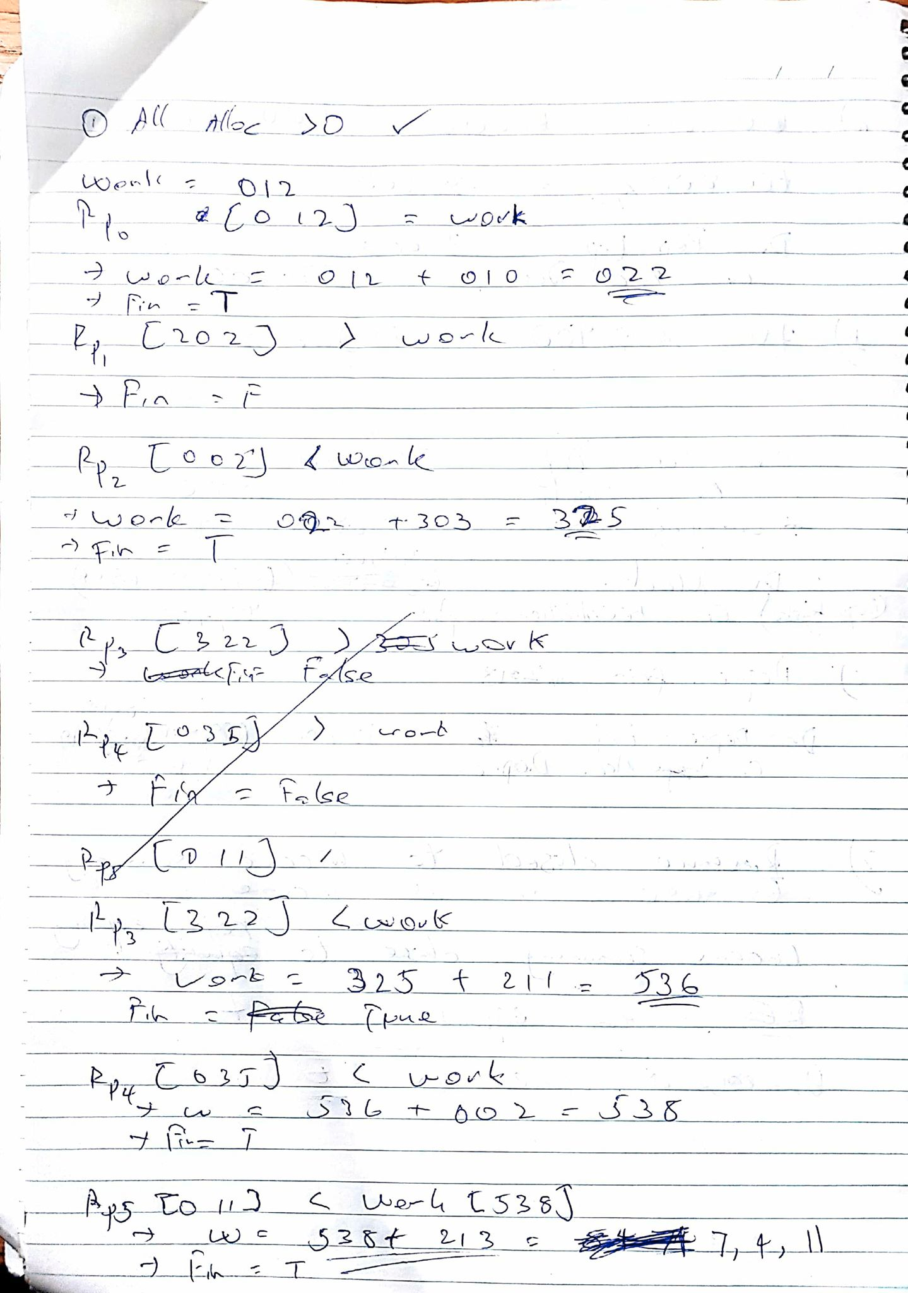Figure 5:

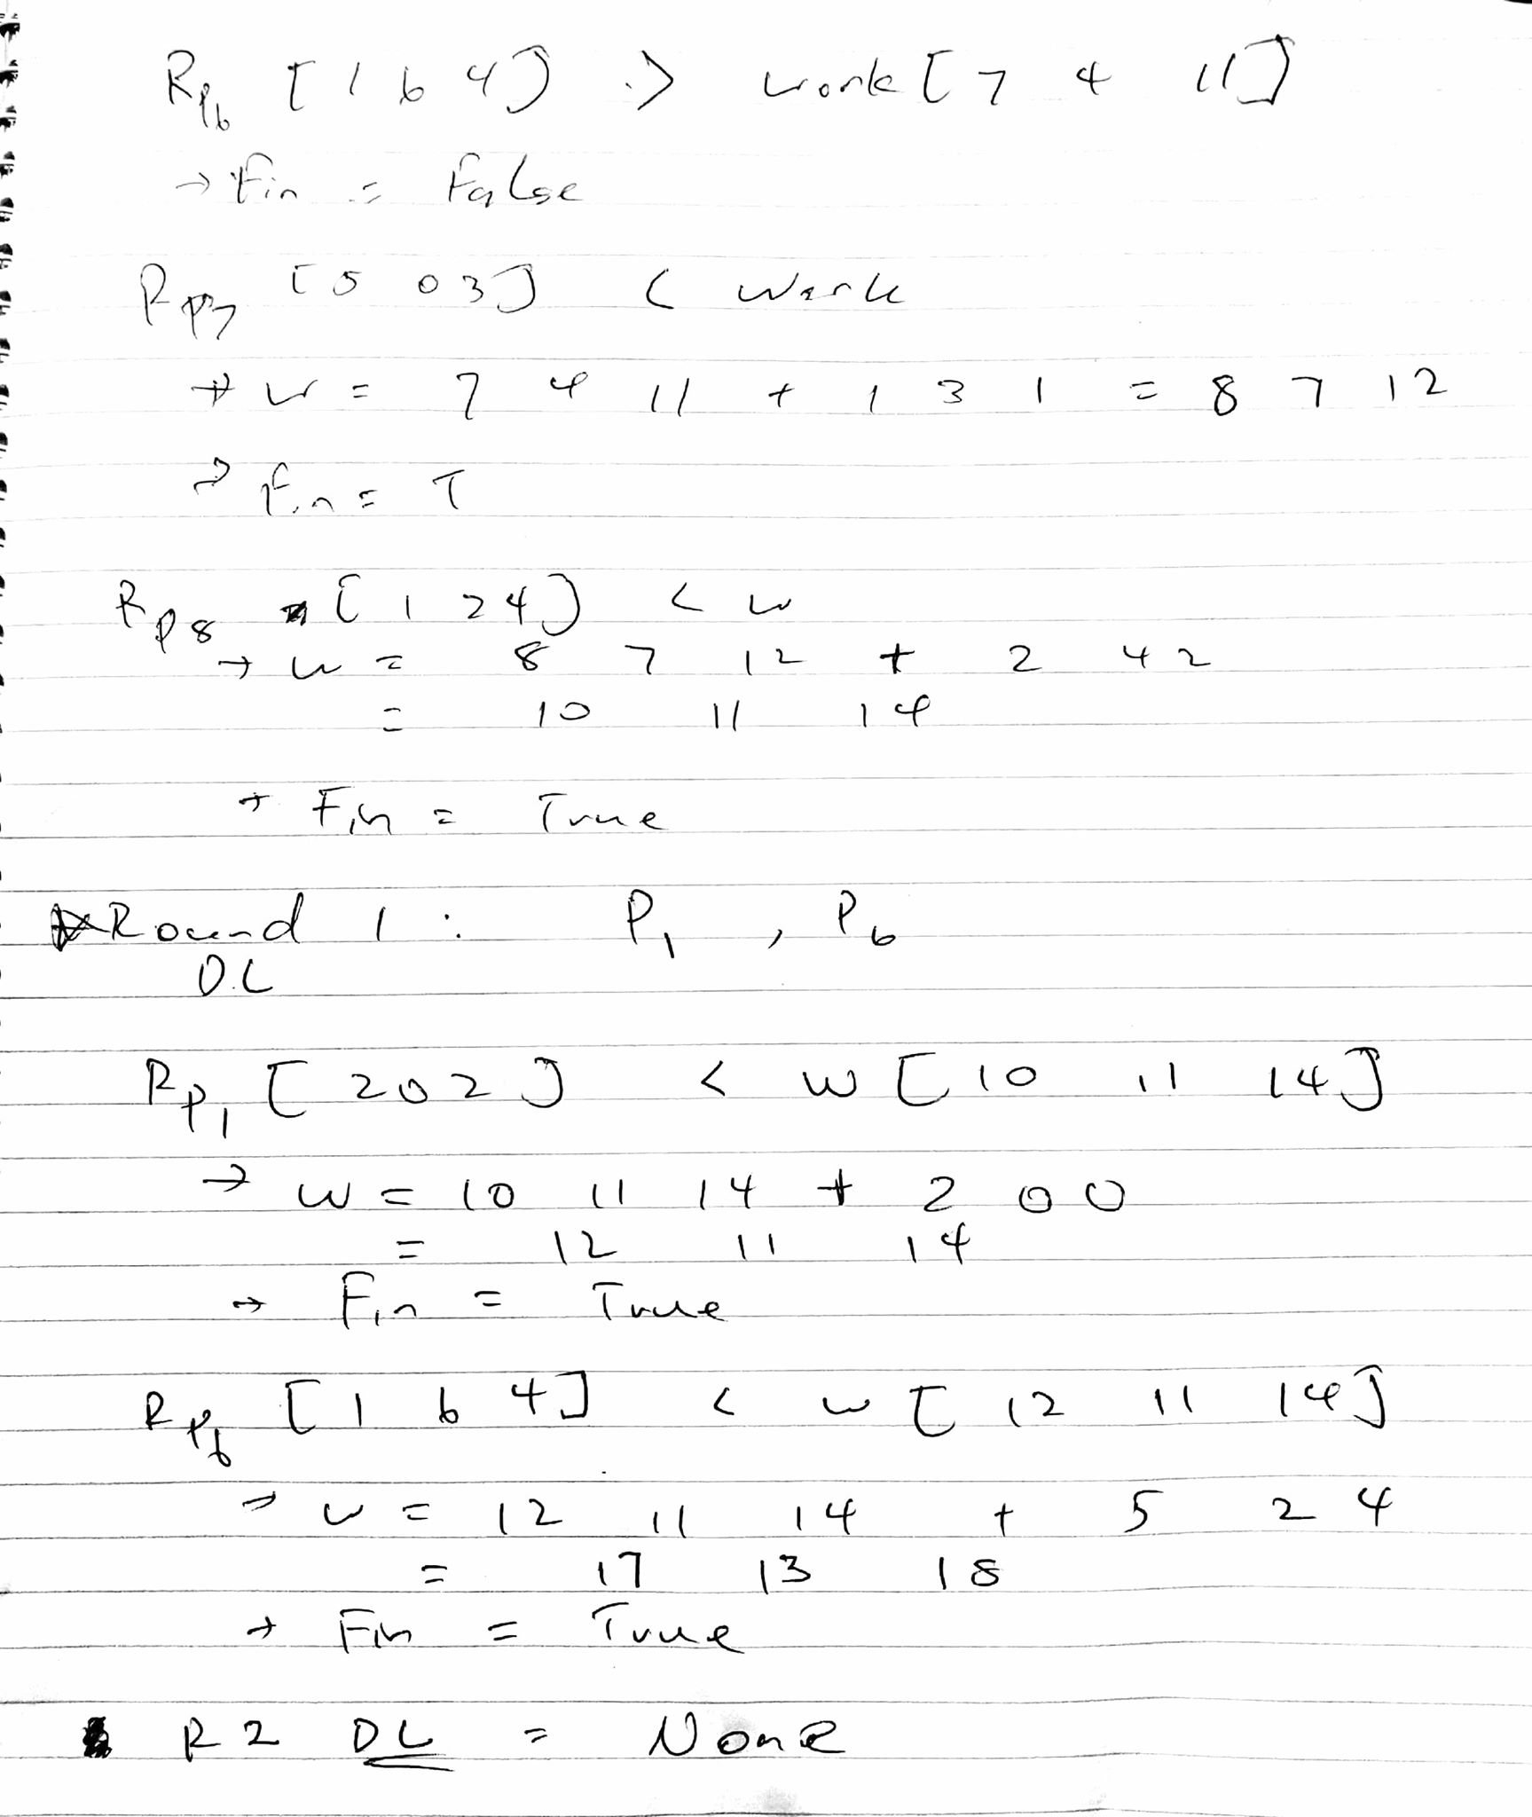Figure 6:

1. Conclusion on result analysis

If this is a simple report assignment, you might give a brief conclusion related this assignment.

If this is a report assignment, you might carefully observe the output of your program and give some explanations and analysis about the output/performance/outcomes based on our understanding.

Overall, this assignment is straightfoward, there were problems which were incurred in program two due to some incapability to convert deadlock detection algorithm to code by the programmer (myself). By carefully following the logical step as listed in method of implementation, the program eventually produce expected results as calculated.

1. References

If you have references, please referee it correctly.

A. Silberschatz, P. B. Galvin & G. Gagne, 2012, Operating System Concepts, 9 th edn, John Wiley & Sons, New York.