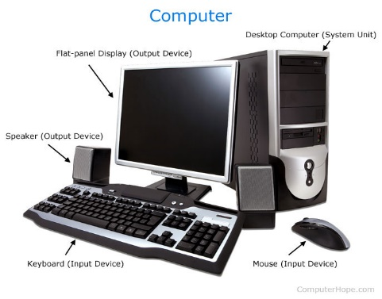
CHAPTER : 1 : COMPUTER FUNDAMENTALS
_{What is a Computer ?}
A computer is an electronic machine that accept data, processes it according to instructions, stores it, and produces meaningful information. In simple words, it helps us perform tasks quickly, accurately, and effeciently.
_{Data and Information}
_{Data} | _{Information}
_{Raw facts and figures.} | _{Processed and meaningful data.}

_{IPO CYCLE}
_{INPUT} → PROCESS (CPU) →OUTPUT
Storage
Example : Hard Disk, SSD, Pen Drive, Memory Card.
Real Life Example (ATM)
Input :Insert ATM Card and enter PIN.
Proicessing : Bank verifies account.
Output : Cash and receipt.
IMPORTANT POINTS
- Computer is an electronic machine
- Data becomes Information after Processing.
- CPU is called the brain of the Computer
- Computer =Input + Processing + Output + Storage.
Meaning of the Word ‘Computer’
The Word Computer’ is derived from the latin word ‘Computare’ , which means ‘To Calculate’. Earlier computers mainly used for calculations. Today they are used in every fields.
Examples :Type 5+7 using the keyboard (Input). The CPU performs the calculations (Processing). The monitor displays 12 (Output).
Feautres of a Computer
Feature | Explanation (English)
Speed | Works very fast.
Accuracy | Produces correct results when correct data is given.
Storage | Stores a large amount of data.
Diligence | Does not get tired.
Versatility | Can perform different types of work.

Where are Computers used ?
Computers are used in schools, hospitals, banks, railway stations, airports, offices, shopping malls, factories, homes, mobile phones and ATMs.
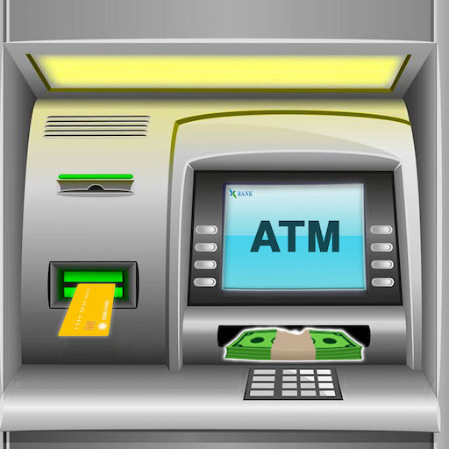
Real life Example
When you withdraw money from an ATM reads your cards, verifies your account, and dispenses cash. This entire process is performed by a computer.

Important Points
- Computer is an electronic machine.
- It follows the IPO Cycle.
- CPU is called the brain of the Computer.
- Computer works with speed, accuracy and storage

Important Note
There is no official full form of the Word COMPUTER. It is originally derived from the latin word ‘Computare’, meaning to Calculate’.

Commonly Taught Educational Full form
C | Commonly
O | Operating
M | Machine
P | Particularly
U | Used for
T | Technical
E | Educational
R | Research

Expanded Form
COMPUTER = Common Operating Machine Particularly Used for Technical and Educational Research

Teacher’s Explanation
Students should remember that this expanded form is only for learning purposes in many computer courses and exams. The actual word ‘Computer’ does not have an official full form.
Key Points
- Computer comes from the latin word ‘Computare’.
- There is no official full form of COMPUTER.
- The educational expansion is commonly used in classrooms.
Imagine this !
A human takes 10 minutes to calculate 10,000 numbers. A computer can do it in less than a second.
What are Computer Specifications ?
Computer specifications are the special qualities or characteristics that make a computer powerful, reliable and useful.
Specifications | English
Speed | Performs millions /billions of operations in seconds.
Accuracy | Produces highly accurate results if input is correct.
Storage | Stores huge amounts of data.
Diligence | Never gets tired or bored.
Versatility | Can perform many different tasks.
Automation | Works automatically after tasks.
Reliability | Gives consistent results repeatedly.
Multitasking | Runs multiple applications together.

Benefits of Computers
Area | English
Education | Online learning, presentations, digital books.
Banking | Fast transcations and online banking.
Healthcare | Patient records and online banking.
Business | Billing, accounting, and inventory
Communications | Email, video calls, and social
 | Media.
Entertainment | Movies, games, and music.

Fun Facts
- A modern smartphone is also a computer.
- NASA, banks and hospitals depend on computers every day.
- A Computer never be3comes tired, but it cannot think like humans.
Remember This
Computer _{= Speed +} Accuracy + Storage + Diligence + Reliability + Automation + Versatility + Multitasking

FAST & SMART MACHINE = COMPUTER

