Israel – Hamas Discourse on Reddit
Latent Dirichlet Analysis, Sentiment Analysis (VADER), and Principal Component Analysis
Michael Reiderman
Abstract
Utilizing various natural language processing methodologies, this project sought to analyze and uncover properties associated with public discourse on various subreddits relative to the Israel – Hamas war. Public discourse data taken off Reddit was utilized to generate various models associated with the following methodologies: Latent Dirichlet Analysis, Vader Sentiment Analysis, Principial Component Analysis (PCA). The results showed that the most significant topics of discussion related to the conflict were the following: Drawing attention to the decision making process of the Israeli government as it relates to the conflict in Palestine (with possible emphasis on enacting defiant economic behavior (boycott) as a way of protesting the ongoing conflict), allegations of genocide against the Israeli government, and Israel’s military conduct going after terrorists that might be embedded in civilian population areas (and collateral civilian damage caused by those military operations). The Vader sentiment analysis highlighted that a majority of the individuals captured in the data do not feel strongly, either positively or negatively, about the conflict. However, distinct differences are present when analyzing the frequency of negative to positive as related to particular sentiment scores, with a higher density of respondents feeling negatively about the conflict. Finally, the results of the PCA analysis showed that the most defining characteristics / features driving public discourse are Israel and Hamas. Taken together, this analysis presents an introductory assessment of the semantic space and emotional properties associated with the public discourse that was captured on Reddit.
I. Introduction
Goals
The current conflict between Israel and Hamas in Gaza has generated considerable public discourse not only concerning America’s foreign policy in the Middle East, but also about America’s relationship with Israel. Indeed, individuals are expressing their viewpoints regarding current events occurring in Israel and Gaza across various online communities. One such notable community is Reddit, which hosts a considerable number of individuals that frequent the website.
Using data available on Reddit, this project aims to analyze and understand the properties associated with public discourse regarding the Israel – Hamas conflict & related developments associated with the conflict. Through the utilization of Topic Modeling, Sentiment Analysis, and Principal Component Analysis methodologies, this project seeks to answer the following research questions.
- What are the most significant topics of discussion related to the conflict? What are their respective features?
- What is the overall sentiment represented in the data? Is there a particular distribution between positive to negative emotions?
- What are the most defining characteristics / features driving public discourse about the conflict?
Given the amount of literature / linguistic data relative to the Israel – Hamas conflict that’s readily available online, I figured it would be interesting to construct a topic model, in order to obtain an understanding of the features of various generated topics / ideas that are occurring in the captured public discussion data. By answering what the most prominent and significant features are relative to the topics of discussion, this project aims to draw a more detailed picture regarding the various properties associated with the most prominent topics of discussion.
Conducting a sentiment analysis of the data is beneficial to incorporate, because it uncovers, to a partial degree, the perceived emotional reality associated with discussions of the conflict. To put it quite simply, how does the public feel about the conflict? This project aims not only to analyze the overall sentiment found in the data, but to also analyze the distribution between positive emotions to negative emotions. This particular comparison allows this project to hopefully uncover potential differences associated with the density of relative emotional saliency values. Given that an emotional saliency value is captured on a scale ranging from -1 to 1 (Roehrick, K. October 12th, 2022), does the data show a particular skewness towards one emotion or another? If so, which one? And why?
Finally, this study aims to uncover the most influential and significant features are driving the captured public discourse relative to the Israel – Hamas conflict and other associated events. This level of analysis will be accomplished by utilizing Principal Component Analysis (PCA). PCA, as explained to a five-year-old, essentially consists of taking all the dimensions inherent to the data, and reducing that number to something more manageable, which in this case will be two dimensions (Keita, Z. Feb. 2023). The implementation of this methodology will allow the project to further reduce the amount of noise in the dataset, and by doing so, will hopefully uncover the most significant variables driving public discourse.
Literature Review
The utilization of natural language processing methodologies / algorithms to study public discourse relative to a specific geopolitical or social phenomena event has previously occurred in the past. The following studies have analyzed social media study in order to better understand, or document, how public sentiment has evolved over time relative to a major geopolitical / historical event.
A recently published study that utilized natural language processing methodologies was able to study the overall sentiment of specific subreddits associated with the COVID – 19 vaccines. In this particular study, a team of researchers collected a substantial amount of data from thirteen different subreddits, beginning from December 1st of 2020 to May 15th, 2021 (Melton, C. A., Olusanya, O. A., Ammar, N., & Shaban-Nejad, A. 2021). The results of the study found that sentiment across the studied subreddits were mainly positive rather than negative. The distribution of positive to negative sentiment did not seem to change in any meaningful manner since December 2020 (Melton, C. A., Olusanya, O. A., Ammar, N., & Shaban-Nejad, A. 2021).
In the very same study, an LDA analysis was conducted to better understand the specific topics / themes being discussed. The analysis concluded that the most prominent topic that persisted over time were associated with the side effects of the vaccine (Melton, C. A., Olusanya, O. A., Ammar, N., & Shaban-Nejad, A. 2021).
A different team of researchers utilized natural language processing techniques to study public discourse regarding the Russian – Ukrainian War happening on X, also formerly known as Twitter. The specific sentiment analysis conducted by the researchers showed a contrasting story regarding the overall sentiment towards the conflict. Sentiment results of data collected from regions excluding Russia were primarily negative. Wrath, fear, and worry (Sinha, A., Rout, B., Mohanty, S., Mishra, S. R., Mohapatra, H., & Dey, S. 2024) were the primary emotions associated with negative emotional sentiment. However, sentiment results associated with data collected from Russia were primarily positive in nature(Sinha, A., Rout, B., Mohanty, S., Mishra, S. R., Mohapatra, H., & Dey, S. 2024). This stark contrast highlights distinct differences in sentimentality about the war depending on the region the data was taken from.
Moving forward, this project aims to build upon the experimental methodologies of these previous studies by applying latent dirichlet analysis, sentiment analysis, and a dimensionality reduction methodology known as principial component analysis to analyze linguistic data from a different online community, Reddit. From a qualitative perspective, Reddit might be a superior source of data. A recent study concluded that roughly half of all X / Twitter discussion pertaining to the coronavirus was generated by bots (Allyn, B. 2020). Additionally, one of the studies mentioned indicated that Reddit is unlikely to populated with BOTS, given the “operational design of interactions” between users on the platform (Melton, C. A., Olusanya, O. A., Ammar, N., & Shaban-Nejad, A. 2021).
II. Data Sources, Research Questions / Methods
Data Collection & Pruning
A criticism mentioned in one of the preceding studies was a lack of representational power associated with the data being analyzed (Melton, C. A., Olusanya, O. A., Ammar, N., & Shaban-Nejad, A. 2021). The team of researchers concluded that since it’s incredibly difficult to obtain highly granular demographic data about reddit users, that ultimately, any demographic analysis of the data is incredibly difficult to achieve. (Melton, C. A., Olusanya, O. A., Ammar, N., & Shaban-Nejad, A. 2021). Further evaluation of this limitation will be discussed at the end of the paper. Nevertheless, this project aims to study linguistic information obtained from the most popular subreddits associated with the News category.
This project aims to build a dataset utilizing the following subreddits as sources of data: WorldNews, News, AskReddit, Israel, InTheNews, InternationalNews, and Politics. In order to accomplish this task, the Redditextractorr package was utilized. For each subreddit, a search query for the top threads over the past year was initialized, with the keyword associated with the search being “Gaza”. This returned a list of the top threads over the past year for each subreddit. After sorting from greatest to least relative to the number of comments contained in the discussion, the top twenty threads from each subreddit were subset, and subsequently integrated into an overarching dataframe.
Cleaning of the dataframe consisted of removing variables within the linguistic data that might introduce noise or artifacts into the analysis. This was primarily done by utilizing the Text Mining package. An extensive effort was undertaken in the hopes of removing unnecessary linguistic variables from the database; removing punctuation symbols / characters, transforming all the words into their lower (non-capitalized) representation, lemmatization of all the words, removing numbers, removing English stop words & additional features deemed relevant. Furthermore, URLs, hashtags, control / special characters, whitespaces (trailing & leading) were all removed from the data in preparation for subsequent analysis (Sudhaharan, R. No Date Given). The logic behind having multiple commands associated with cleaning was to ensure that no artifact was slipping through the cleaning arguments. The result of this extensive data cleaning resulted in a DTM with the following dimensions.
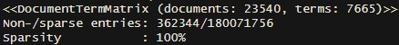
What are the most significant topics of discussion related to the conflict? What are their respective features?
In order to ascertain the most prominent and significant topics of discussions, a Latent Dirichlet Analysis (LDA) was conducted on the dataset. Prior to the construction of the LDA model, an effort was made to find the optimal number of topics for the LDA model. An LDAtuning package was incorporated to ascertain the proper number of topics relative to the amount of data (Murzintcev, N. 10-24-2016). This particular LDAtuning package concluded that the optimal number of topics is equal to 20 across 3 distinct metrics. However, additional quality assurance was conducted by compiling models with differentiating topic numbers, in order to obtain a better understanding of the feature composition associated with each topic.
During quality assurance testing of the LDA model, it was discovered that a distinct topic was generated that was associated with reddit comments / posts being removed by moderators. These features associated with this particular topic were combined into a list along with the English stop words, and were subsequently removed from the corpus.
An LDA model with n = 20 topics was generated with a control = list(seed = 852 to ensure reproducibility. Multiple visualizations were created in order to dive deeper into the data. Specific comments associated with the most prevalent topics were analyzed in greater detail to understand with greater clarity the output of the LDA model.
What is the overall sentiment represented in the data? Is there a particular distribution between positive to negative emotions?
Capturing and analyzing the emotional content of linguistic information associated with the subject matter being studied was accomplished utilizing the Vader package. This package was picked mainly due to its user case, as it’s specifically designed to analyze linguistic variables derived from social media platforms. Given that this project is analyzing linguistic variables derived from Reddit, a social media website, I figured using the Vader package would be the optimal choice for the subsequent sentiment analysis.
A sentiment analysis was conducted on the overall database, and a visualization depicting the overall sentiment accompanying the analysis. Figures showcasing the distribution between Positive vs. Negative sentiment were included as part of the overall analysis.
What are the most defining characteristics / features driving public discourse about the conflict?
In order to answer the question above, Principal Component Analysis methodology was conducted to reduce the overall noise, while at the same time reducing all the features and variables down to two dimensions of variance. Accomplishing this transformation would allow us to understand, with greater precision, which specific features are driving public discourse.
Using the stats package, a PCA was conducted on the matrix variant of the main dataset utilized for this project.
Results / Discussion
What are the most significant topics of discussion related to the conflict? What are their respective features?
After extensive data cleaning, the results of the top 40 most frequently occurring words in the document term matrix are visualized in the word cloud below.
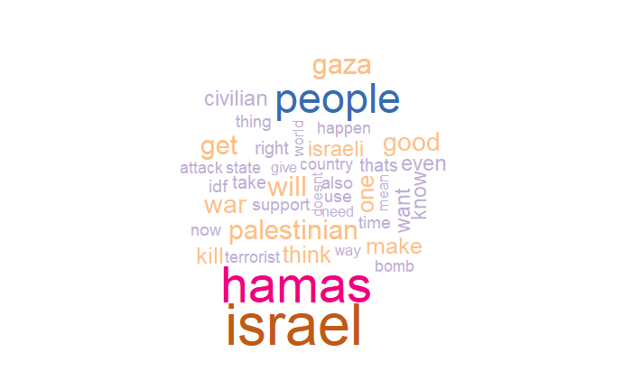
First pass investigation indicates that israel, hamas, people, palestinian, gaza seem to be the most frequently occurring features in the DTM. Another visualization depicting the top five most frequently occurring words in the DTM underscores the representational power these particular words have.
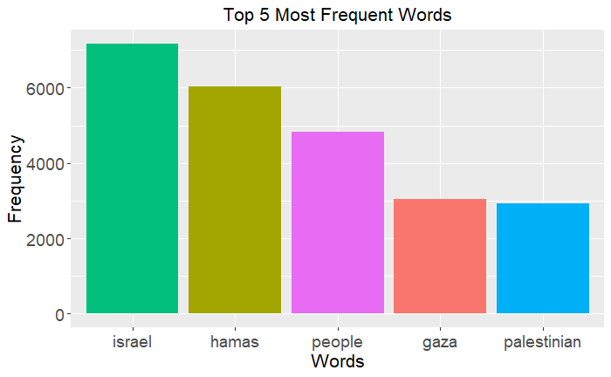
Individuals within the dataset are primarily utilizing features such as israel, hamas, people, gaza, and palestinian when discussing the conflict between Israel – Hamas or events / geopolitical developments associated with the conflict. Israel is the most frequent word utilized, hinting at the significant of this feature being utilized to relay or convey multiple semantic categories. Hamas is the second most occurring feature, and can also be considered to be quite significant given its frequency. People, gaza, and palestinian make up the rest of the top five most frequent words, and rightfully so. Given the amount of discussion associated with the plight of the Palestinian people living in Gaza, it would make sense that these features are highly represented.
As previously mentioned, an LDAtuning package was incorporated in order to ascertain the optimal number of topics given the amount of data. Three distinct metrics, CaoJuan2009, Griffiths2004, Arun2010 were utilized, with their results are shown below. Essentially, Griffiths compiles various LDA models with differentiating topic numbers, and the model with the closest value to 1 is deemed to be the most appropriate for subsequent analysis. The opposite is true for the other two metrics, Arun2010 and CaoJuan2009, which also compile models with differentiating topic numbers, and the model with the closest value to 0 is deemed to be the ideal model.
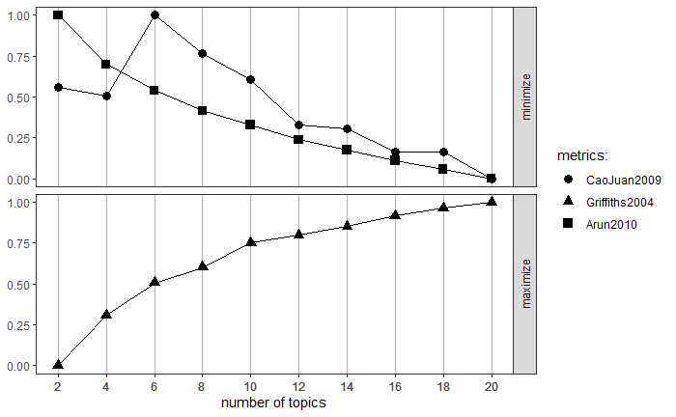
The results from the LDAtuning package seem to indicate that the optimal number of topics, given the size of the dataset, is roughly n = 20. Extensive manipulation of n = y took place. Models that were defined as having less than 10 topics created topics that were deemed to generalized for meaningful analysis. Models that were defined as having more than 20 topics resulted in topics that exhibited far too granularity for significant topic analysis, or introduced a certain degree of noise in terms of incoherent terms being grouped into topics. Ultimately, a topic number of 20 was utilized to create the LDA model, since it produced the most coherent features across all the generated topics (after successfully implementing a custom stopword list). Frankly, this topic number makes sense, given the number of differentiating topics associated with the conflict itself. A visualization showcasing the frequency of documents for each particular topic can be found below.
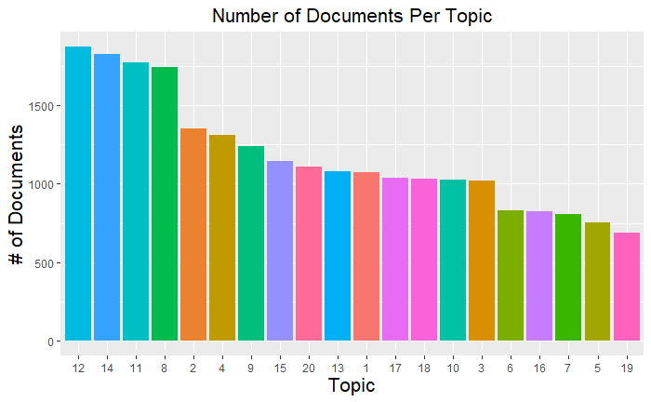
The LDA model generated 20 distinct topics, with topics 12, 14, and 11 being the most prominent topics across the entire data (as measured by number of documents per topic). The visualizations below depict the top features across all topics (as measured by their respective beta value).
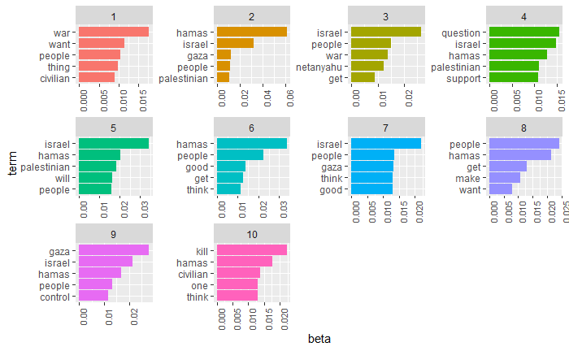
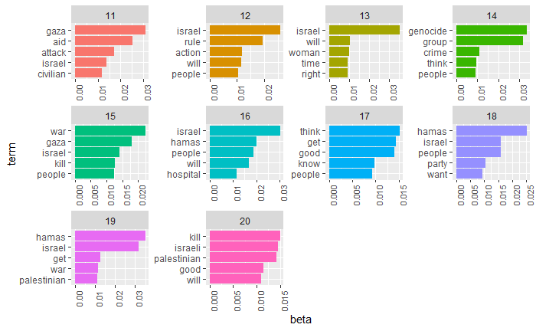
The most prominent topic across all the documents was 12. This topic contains the features israel, rule, action, will, and people. In my humble opinion, I believe this topic is associated with questioning Israel’s current territorial incursion in Gaza, with emphasis on the ramifications of such actions on the Palestinian people and beyond. There has been a great deal of discussion within the media in recent months regarding Israel’s actions in Gaza and the dire environmental conditions the military action against Hamas is affecting the overall population. Let’s take a look at the top comment associated with this particular topic.
"The point I was making **wasn\031t** that Israel was more important than Russia to the world economy.\r\n\r\nRather that I was pointing out that Israel is important in very different ways &amp; some of those ways mean that sanctioning Israel would cause an outsized amount of pain compared to another country of a similar economic size.\r\n\r\nIf you reduce it to strictly dollar terms, then sanctioning Israel looks like a trivial matter but the actual impact of sanctioning Israel would have far greater consequences.\r\n\r\nThere are specific &amp; highly specialized medical devices that are made only in Israel - those patients at best would have to suffer worse outcomes &amp; at worst would die.\r\n\r\nCould we eventually replace those devices with ones produced elsewhere? Absolutely but it would be much more expensive &amp; take a lot longer to do so than to find somewhere else to buy oil than Russia.\r\n\r\nCould Israel be sanctioned &amp; would the western economies survive if they imposed a Russian style sanctions regime on Israel?\r\n\r\nAbsolutely &amp; I wasn\031t claiming otherwise.\r\n\r\nYou can\031t just look at the dollar value of what a country exports to determine the pain a sanction will cause.\r\n\r\nIn fact, a far more important metric is the degree to which the specific products a country exports can be replaced, the amount of time &amp; money it would take to replace, &amp; the pain your people will experience without that product.\r\n\r\nIsrael has products that are much more difficult to replace than Russia.\r\n\r\nObviously, the world could easily sanction Israel\031s diamond trade &amp; that would definitely hurt Israel with next to zero pain for the rest of the world but that isn\031t the case for many of the exports it makes nor does a strict export perspective consider a great deal of the economic contributions that Israeli employees makes to western multinational corporations."
In my personal opinion, I believe this comment is reacting to another individual’s suggestion that boycotting / sanctioning Israel’s economy is a suitable solution in the face of Israel aggression in Gaza. Indeed, there has been recent movements to boycott economic products originating from Israel. Perhaps this topic is also semantically associated with what kind of action individuals living in the Western Hemisphere are able to conduct in order to help out the Palestinian people. This particular topic seems to be multifaceted.
The second most prominent topic was 14. This topic contains the features genocide, group, crime, think, and people. This topic is most likely associated with the accusations that Israel is conducting genocide on the Palestinian people. Within this topic, I believe individuals are discussing Israel’s alleged combat doctrine of targeting medical sites to support their claims that Israel is conducting a genocide. Ultimately, I believe this topic is discussing the criminal proceedings / litigations that Israel should face after the war given their military conduct. . Alternatively, this topic could be suggesting that the level of destruction caused in Gaza by the actions of the Israeli military is driving individuals towards extremism. A comment from topic 14 is found below.
"And how did that \034radical cancer\035 develop?"
This comment is reactionary, and seems to imply that “radical cancer” (resistance movement) might be due to the actions being committed by the Israeli military against the Palestinian people. This comment seems to imply that death and suffering caused by military actions undertaken by the Israeli military drive young adults into radicalism.
The third most significant topic of discussion is 11. The features that compose this topic are gaza, aid, attack, israel, and civilian. This one is fairly straightforward, as the features are most likely discussing a topic semantically associated with the Israel’s recent conduct pertaining to attacking not only civilian areas, but also international organizations responsible for distributing aid in Gaza. A recent example of Israel attacking an international organization distributing aid was the attack on the World Kitchen Aid convoy that ended up killing multiple foreign nationals. Let’s examine a representational comment of topic 11.
"Hey good question. Maybe Israel should actually answer that question instead of just razing homes and murdering civilians."
This comment criticizes the doctrine of Israel’s military as it relates to clearing out residential areas. Throughout the conflict, Israel has been criticized for its doctrine associated with targeting terrorists embedded in civilian areas. In my opinion, this comment suggests that Israel is conducting their anti-terrorist activities with complete disregard to the civilian population. Let’s take another look at a comment associated with this topic.
"Good job tbh - learn anything about war and anyone would realise that immediate \034hot\035 news is always super biased, and some semblance of truth only reveals itself many months or years later. Even death tolls are so variable because they have to factor the death toll given by either side and then make the best guess assumption of what the objective toll may be"
This comment seems to question the information that’s being released by the ministry of health in Gaza, which I believe is controlled by representatives of Hamas. This comment seems to suggest that while the civilian death tolls are terrible, that individuals should practice restrain and caution when interpreting breaking news information, as it may be inaccurate and incredibly biased. This applies to information being released from all parties associated with the conflict.
What is the overall sentiment represented in the data? Is there a particular distribution between positive to negative emotions?
The results of the VADER sentiment analysis are found in the visualization below. It depicts the overall sentiment.
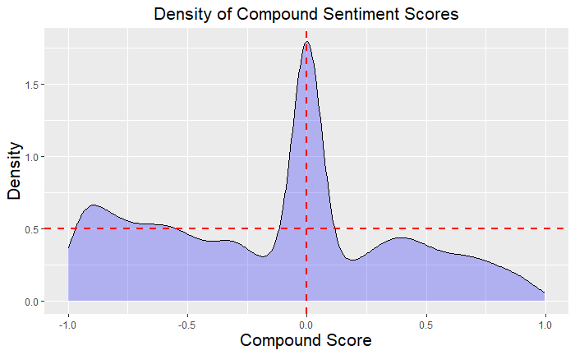
The compound score represents the overall sentiment held by the captured public data. Overall, the majority of the individuals captured in the data are associated with a compound score of 0, indicating a neutral emotional saliency towards the conflict. This is in sharp contrast relative to the opposing emotions displayed in the graph found in the next page.
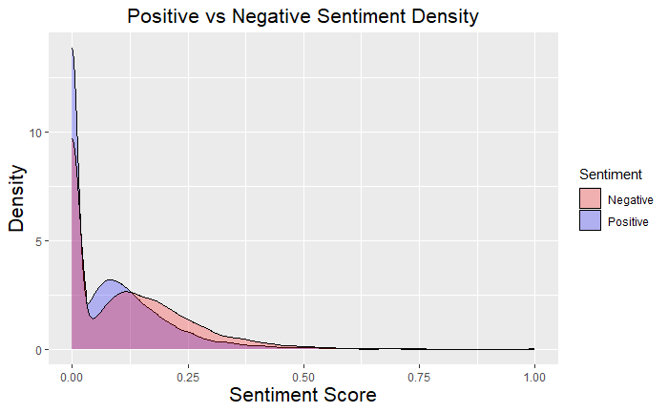
When investigating the particular density distributions between positive vs negative sentiments, the visualization above uncovers an interesting characteristic to the data. First and foremost, both positive and negative sentiment experience a left-hand skewness. Most of the sentiment scores across both categories are either 0, or very close to 0. This indicates that individuals captured in the data, on average, do not feel particularly strongly, either in a positive or negative direction, about the conflict.
With that being said, negative sentiment is seen to have a higher density associated with higher saliency sentiment scores compared to positive sentiment. This seems to suggest, on average, that individuals experience negative sentiment at higher saliency levels at greater frequency relative to positive ones when discussing the Israel – Hamas conflict. Given the large demonstrations that rocked the United States in recent months across multiple college campuses due to anger and outrage at the current situation, it is no surprise that this kind of sentiment distribution is also present here.
What are the most defining characteristics / features driving public discourse about the conflict?
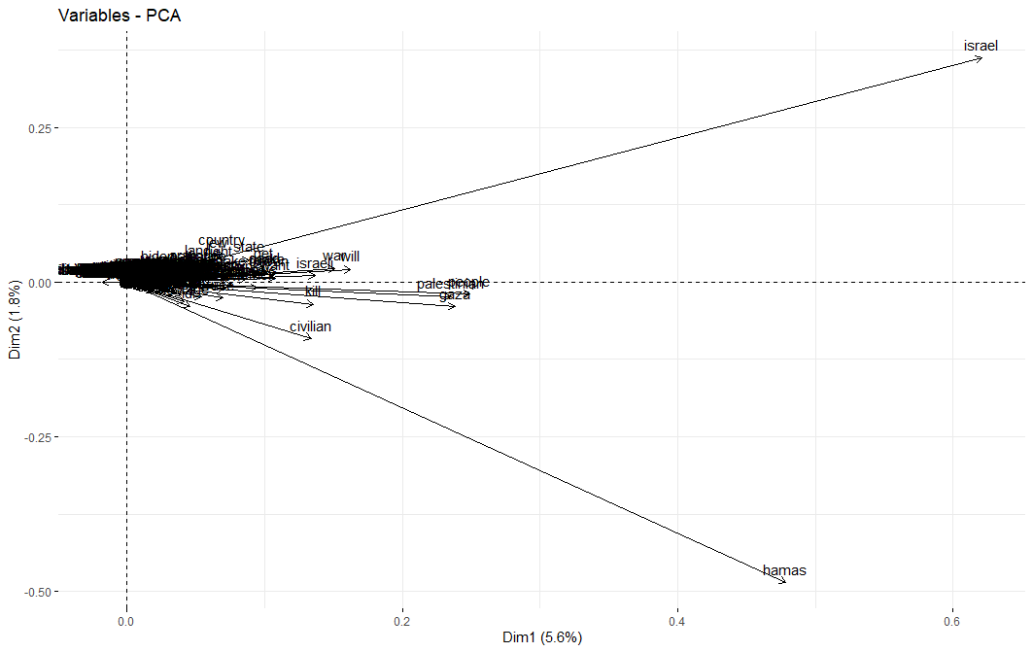
The results of the Principal Component Analysis is visualized above. The dimensionality associated with the data was reduced down to two dimensions, which were able to capture roughly 7.4% of the variance found in the dataset. Dimension 1 (5.6%) seems to be closely related to major topics associated with the conflict, while Dimension 2 (1.8%) seems to capture the more granular and subtle relationships between the terms used to describe the conflict.
As expected, the features Israel and Hama seem to contribute the most to the variation found in the data, as indicated by their relatively long distances from the origin. Additionally, given the distance between these two features, one could argue that they are associated with distinct themes or representations / viewpoints. Thus, we can consider these two terms to be the most defining features driving public discourse about the conflict.
There are a couple of additional terms that are centered around the origin of the visualizations. Given their proximity to the origin, it can be interpreted that they do not have much sway with regards to influencing variance found within the data.
Conclusion
The evidence provided in the aforementioned analysis serves as an introduction to understanding how public discourse about the Israel – Hamas conflict and associated events are playing out across the most popular subreddits associated with discussing events around the world.
By incorporating latent dirichlet analysis to understand the kind of topics being discussed, this project was able to uncover distinct topics with unique properties. The most prevalent topics being discussed on Reddit are associated with the following ideas / semantic spaces / themes: questioning the ramifications of Israel’s incursion into Gaza, and the ramifications that kind of behavior has on the Palestinian people. Additionally, it seems to be associated with forms of defiant behavior related to promoting a boycott of Israeli services / goods. The second most prevalent topic was associated with the concepts of genocide and crime. It is my impression that this particular topic is associated with not only the allegations that Israel is committing a genocide against the Palestinian people, but seems to underscore / suggest why young adults / general population might turn to a radical form of religion extremism (mainly in part as a way of protecting their identity and homeland). Finally, the third most prominent topic of discussion was semantically associated, in my opinion, with Israel’s military doctrine of going after terrorists that might be embedded in civilian areas, and subsequently attacking these terrorists, which, regrettably, often times results in civilian causalities (due to their close proximity).
The data collected was able to derive, to a limited degree, how the public feels about the conflict by incorporating VADER sentiment analysis. A majority of those captured in the data discuss the conflict and related developments in a largely neutral manner. Further analysis comparing the distribution of positive to negative sentiments found higher saliency scores were associated with the negative sentiment category. This seems to suggest that individuals are feeling more negatively about the conflict when compared to the positive sentiment category when comparing between the categories.
Finally, this project was able to conclude that the most defining characteristics / features, found to be driving public discourse about the conflict on Reddit to be Israel and Hamas. Their utilization can be considered to be a catalyst that drives ongoing discussion between emerging perspectives relative to the conflict occurring between Israel – Hamas.
Limitations
Often times, collecting data from Reddit is a difficult ordeal with regards to collecting proper demographic information related to the population utilized for this project. While this analysis succeeded in understanding several qualities about public discourse relative to the Israel – Hamas conflict on Reddit, it falls short with regards to associating those findings to unique demographic groups. Taking this into consideration, the analysis conducted in this project would’ve been significantly enhanced if proper demographic information was available to incorporate / associate with the findings. As it stands, the current analysis, while providing an introductory understanding of the public discord occurring on Reddit, fails to uncover how particular demographic communities are responding to the conflict. Further iterations of this project should acquire linguistic data from a data source that includes demographic information as well.
Additionally, the level of pre-preprocessing and fine tuning could’ve been enhanced. This project failed to take into consideration the presence of individuals who frequently comment on Reddit. These individuals are sometimes known as superusers due to their contributions to the discussion, and often times introduce a certain degree of bias / sway into the data. With that being said, future iterations of this study should consider this particular group of users by removing them from the analysis.
Finally, it should be noted that the Principal Component Analysis that was conducted was limited in its explanatory power. This is because it was only able to explain roughly 7.4% of the variance found within the data. Given the low number of variance able to be explained, further iterations of this project should focus on capturing a greater variance of the data by possibly changing the argument parameters associated not only with cleaning / pre – processing, but also establishing the proper number of tokens / features for subsequent PCA Analysis.

References (in order of presentation):
- Roehrick, K. (October 12th, 2022). "Valence Aware Dictionary and sEntiment Reasoner (VADER)". CRAN. Retrieved from https://cran.r-project.org/web/packages/vader/vader.pdf.
- Keita, Z. (Feb. 2023). PCA analysis in R: A tutorial . Retrieved August 5, 2024, https://www.datacamp.com/tutorial/pca-analysis-r.
- Melton, C. A., Olusanya, O. A., Ammar, N., & Shaban-Nejad, A. (2021). Public sentiment analysis and topic modeling regarding COVID-19 vaccines on the Reddit social media platform: A call to action for strengthening vaccine confidence. Journal of Infection and Public Health, 14(10), 1505-1512. https://doi.org/10.1016/j.jiph.2021.08.010
- Sinha, A., Rout, B., Mohanty, S., Mishra, S. R., Mohapatra, H., & Dey, S. (2024). Exploring Sentiments in the Russia-Ukraine conflict: A Comparative Analysis of KNN, Decision Tree, and Logistic Regression Machine Learning Classifiers. Procedia Computer Science, 235, 1068-1076. https://www.ncbi.nlm.nih.gov/pmc/articles/PMC10120493/
- Allyn, B. (2020). Researchers: Nearly half of accounts tweeting about coronavirus are likely bots. NPR. org. Retrieved August 7th, https://www.npr.org/sections/coronavirus-live-updates/2020/05/20/859814085/researchers-nearly-half-of-accounts-tweeting-about-coronavirus-are-likely-bots.
- Source: Rivera, I. (2023). Package ‘RedditExtractoR’ (V3.0.9), Comprehensive R Archive Network, Retrieved July 8th 2024, https://cran.r-project.org/web/packages/RedditExtractoR/RedditExtractoR.pdf
- Feinerer, Ingo, and Hornik, Kurt (20 April 2024). "TM: Text Mining Package". Comprehensive R Archive Network. Retrieved August 5th, 2024, https://cran.r-project.org/web/packages/tm/tm.pdf
- Sudhaharan, R., (No Date Given). "Text preprocessing in R". Tilburg ScienceHub. Retrieved August 6th, 2024, https://tilburgsciencehub.com/topics/manage-manipulate/manipulate-clean/textual/text-preprocessing/
- Murzintcev, N. (10-24-2016). LDA tuning. RPubs. Retrieved August 5, 2024, https://rpubs.com/siri/ldatuning.
- Hutto, C., (2022). "VADER-Sentiment-Analysis". Github. Retrieved August 11th, https://github.com/cjhutto/vaderSentiment.
- R-core R-core@R-project.org (2019). "stats package (version 3.6.2)". RDocumentation. Retrieved August 8, 2024, https://www.rdocumentation.org/packages/stats/versions/3.6.2.
- Van den Rul, C., (October 14th, 2019). "Create a word cloud with R. Towards Data Science". Towardsdatascience. Retrieved August 6th, https://towardsdatascience.com/create-a-word-cloud-with-r-bde3e7422e8a.
- Wichkam, H., Winston, C., Lionel, H., Pedersen, T., Takahashi, K., Wilke, C., Woo, K., Yutani, H., Dunnington, D., Brand, T.(2023). "ggplot2: Create elegant data visualisations using the grammar of graphics (Version 3.4.0)". CRAN. Retrieved August 6th, https://cran.r-project.org/web/packages/ggplot2/ggplot2.pdf
- Cao Juan, Xia Tian, Li Jintao, Zhang Yongdong, and Tang Sheng. 2009. A density-based method for adaptive lda model selection. Neurocomputing — 16th European Symposium on Artificial Neural Networks 2008 72, 7–9: 1775–1781. https://www.yumpu.com/en/document/read/39829095/a-density-based-method-for-adaptive-lda-model-selection-article-
- Thomas L. Griffiths and Mark Steyvers. 2004. Finding scientific topics. Proceedings of the National Academy of Sciences 101, suppl 1: 5228–5235. https://doi.org/10.1073/pnas.0307752101
- Rajkumar Arun, V. Suresh, C. E. Veni Madhavan, and M. N. Narasimha Murthy. 2010. On finding the natural number of topics with latent dirichlet allocation: Some observations. In Advances in knowledge discovery and data mining, Mohammed J. Zaki, Jeffrey Xu Yu, Balaraman Ravindran and Vikram Pudi (eds.). Springer Berlin Heidelberg, 391–402. http://doi.org/10.1007/978-3-642-13657-3_43
- Oxfam America. (2023). "Inflicting unprecedented suffering and destruction: An urgent call for action". Oxfam. Retrieved August 11th, https://webassets.oxfamamerica.org/media/documents/Oxfam-inflicting-unprecedented-suffering-and-destruction-150324-en_GKMWw3T.pdf
- No Author Provided (Feb 6th, 2024). "Israel's war on Gaza: Are boycotts hurting US brands?". AlJazeera News. Retrieved August 11th, https://www.aljazeera.com/news/2024/2/6/israels-war-on-gaza-are-boycotts-hurting-us-brands.
- No Authors Provided (April 1st, 2024). "7 WCK" team members killed in Gaza". World Central Kitchen. Retrieved August 11th, https://wck.org/news/gaza-team-update
- Lonas, L., (August 8th, 2024). "Students gearing up for round 2 of pro-Palestinian protests: ‘We’ve been working all this summer’". The Hill. Retrieved August 10, 2024, https://thehill.com/homenews/education/4803740-pro-palestinian-student-protests-college-campus-new-semester-israel-gaza-hamas/

Roehrick, K. (October 12th, 2022). "Valence Aware Dictionary and sEntiment Reasoner (VADER)". CRAN. Retrieved from https://cran.r-project.org/web/packages/vader/vader.pdf.
Keita, Z. (Feb. 2023). PCA analysis in R: A tutorial . Retrieved August 5, 2024, https://www.datacamp.com/tutorial/pca-analysis-r.
Melton, C. A., Olusanya, O. A., Ammar, N., & Shaban-Nejad, A. (2021). Public sentiment analysis and topic modeling regarding COVID-19 vaccines on the Reddit social media platform: A call to action for strengthening vaccine confidence. Journal of Infection and Public Health, 14(10), 1505-1512. https://doi.org/10.1016/j.jiph.2021.08.010
Melton, C. A., Olusanya, O. A., Ammar, N., & Shaban-Nejad, A. (2021). Public sentiment analysis and topic modeling regarding COVID-19 vaccines on the Reddit social media platform: A call to action for strengthening vaccine confidence. Journal of Infection and Public Health, 14(10), 1505-1512. https://doi.org/10.1016/j.jiph.2021.08.010
Melton, C. A., Olusanya, O. A., Ammar, N., & Shaban-Nejad, A. (2021). Public sentiment analysis and topic modeling regarding COVID-19 vaccines on the Reddit social media platform: A call to action for strengthening vaccine confidence. Journal of Infection and Public Health, 14(10), 1505-1512. https://doi.org/10.1016/j.jiph.2021.08.010
Sinha, A., Rout, B., Mohanty, S., Mishra, S. R., Mohapatra, H., & Dey, S. (2024). Exploring Sentiments in the Russia-Ukraine conflict: A Comparative Analysis of KNN, Decision Tree, and Logistic Regression Machine Learning Classifiers. Procedia Computer Science, 235, 1068-1076.
Sinha, A., Rout, B., Mohanty, S., Mishra, S. R., Mohapatra, H., & Dey, S. (2024). Exploring Sentiments in the Russia-Ukraine conflict: A Comparative Analysis of KNN, Decision Tree, and Logistic Regression Machine Learning Classifiers. Procedia Computer Science, 235, 1068-1076.
Allyn, B. (2020). Researchers: Nearly half of accounts tweeting about coronavirus are likely bots. NPR. org. Retrieved August 7th, https://www.npr.org/sections/coronavirus-live-updates/2020/05/20/859814085/researchers-nearly-half-of-accounts-tweeting-about-coronavirus-are-likely-bots.
Melton, C. A., Olusanya, O. A., Ammar, N., & Shaban-Nejad, A. (2021). Public sentiment analysis and topic modeling regarding COVID-19 vaccines on the Reddit social media platform: A call to action for strengthening vaccine confidence. Journal of Infection and Public Health, 14(10), 1505-1512. https://doi.org/10.1016/j.jiph.2021.08.010
Melton, C. A., Olusanya, O. A., Ammar, N., & Shaban-Nejad, A. (2021). Public sentiment analysis and topic modeling regarding COVID-19 vaccines on the Reddit social media platform: A call to action for strengthening vaccine confidence. Journal of Infection and Public Health, 14(10), 1505-1512. https://doi.org/10.1016/j.jiph.2021.08.010
Melton, C. A., Olusanya, O. A., Ammar, N., & Shaban-Nejad, A. (2021). Public sentiment analysis and topic modeling regarding COVID-19 vaccines on the Reddit social media platform: A call to action for strengthening vaccine confidence. Journal of Infection and Public Health, 14(10), 1505-1512. https://doi.org/10.1016/j.jiph.2021.08.010
Rivera, I. (2023). Package ‘RedditExtractoR’ (V3.0.9), Comprehensive R Archive Network, Retrieved July 8th 2024, https://cran.r-project.org/web/packages/RedditExtractoR/RedditExtractoR.pdf
Feinerer, Ingo, and Hornik, Kurt (20 April 2024). "TM: Text Mining Package". Comprehensive R Archive Network. Retrieved August 5th, 2024, https://cran.r-project.org/web/packages/tm/tm.pdf
Sudhaharan, R., (No Date Given). "Text preprocessing in R". Tilburg ScienceHub. Retrieved August 6th, 2024, https://tilburgsciencehub.com/topics/manage-manipulate/manipulate-clean/textual/text-preprocessing/
Murzintcev, N. (10-24-2016). LDA tuning. RPubs. Retrieved August 5, 2024, https://rpubs.com/siri/ldatuning.
Hutto, C., (2022). "VADER-Sentiment-Analysis". Github. Retrieved August 11th, https://github.com/cjhutto/vaderSentiment.
R-core R-core@R-project.org (2019). "stats package (version 3.6.2)". RDocumentation. Retrieved August 8, 2024, https://www.rdocumentation.org/packages/stats/versions/3.6.2.
Van den Rul, C., (October 14th, 2019). "Create a word cloud with R. Towards Data Science". Towardsdatascience. Retrieved August 6th, https://towardsdatascience.com/create-a-word-cloud-with-r-bde3e7422e8a.
Wichkam, H., Winston, C., Lionel, H., Pedersen, T., Takahashi, K., Wilke, C., Woo, K., Yutani, H., Dunnington, D., Brand, T.(2023). "ggplot2: Create elegant data visualisations using the grammar of graphics (Version 3.4.0)". CRAN. Retrieved August 6th, https://cran.r-project.org/web/packages/ggplot2/ggplot2.pdf.
Cao Juan, Xia Tian, Li Jintao, Zhang Yongdong, and Tang Sheng. 2009. A density-based method for adaptive lda model selection. Neurocomputing — 16th European Symposium on Artificial Neural Networks 2008 72, 7–9: 1775–1781. http://doi.org/10.1016/j.neucom.2008.06.011
Thomas L. Griffiths and Mark Steyvers. 2004. Finding scientific topics. Proceedings of the National Academy of Sciences 101, suppl 1: 5228–5235. http://doi.org/10.1073/pnas.0307752101
Rajkumar Arun, V. Suresh, C. E. Veni Madhavan, and M. N. Narasimha Murthy. 2010. On finding the natural number of topics with latent dirichlet allocation: Some observations. In Advances in knowledge discovery and data mining, Mohammed J. Zaki, Jeffrey Xu Yu, Balaraman Ravindran and Vikram Pudi (eds.). Springer Berlin Heidelberg, 391–402. http://doi.org/10.1007/978-3-642-13657-3_43
Murzintcev, N. (10-24-2016). LDA tuning. RPubs. Retrieved August 5, 2024, https://rpubs.com/siri/ldatuning
Wichkam, H., Winston, C., Lionel, H., Pedersen, T., Takahashi, K., Wilke, C., Woo, K., Yutani, H., Dunnington, D., Brand, T.(2023). "ggplot2: Create elegant data visualizations using the grammar of graphics (Version 3.4.0)". CRAN. Retrieved August 6th, https://cran.r-project.org/web/packages/ggplot2/ggplot2.pdf.
Silge, J., Robinson, D. (June 20th, 2024). "Text mining with R: A tidy approach: Chapter 6 Topic modeling". O'Reilly Media. Retrieved August 8th, https://www.tidytextmining.com/topicmodeling.
Silge, J., Robinson, D. (June 20th, 2024). "Text mining with R: A tidy approach: Chapter 6 Topic modeling". O'Reilly Media. Retrieved August 8th, https://www.tidytextmining.com/topicmodeling.
Oxfam America. (2023). "Inflicting unprecedented suffering and destruction: An urgent call for action". Oxfam. Retrieved August 11th, https://webassets.oxfamamerica.org/media/documents/Oxfam-inflicting-unprecedented-suffering-and-destruction-150324-en_GKMWw3T.pdf.
No Author Provided (Feb 6th, 2024). "Israel's war on Gaza: Are boycotts hurting US brands?". AlJazeera News. Retrieved August 11th, https://www.aljazeera.com/news/2024/2/6/israels-war-on-gaza-are-boycotts-hurting-us-brands.
No Authors Provided (April 1st, 2024). "7 WCK" team members killed in Gaza". World Central Kitchen. Retrieved August 11th, https://wck.org/news/gaza-team-update
Roehrick, K. (October 12th, 2022). "Valence Aware Dictionary and sEntiment Reasoner (VADER)". CRAN. Retrieved from https://cran.r-project.org/web/packages/vader/vader.pdf.
Roehrick, K. (October 12th, 2022). "Valence Aware Dictionary and sEntiment Reasoner (VADER)". CRAN. Retrieved from https://cran.r-project.org/web/packages/vader/vader.pdf.
Lonas, L., (August 8th, 2024). "Students gearing up for round 2 of pro-Palestinian protests: ‘We’ve been working all this summer’". The Hill. Retrieved August 10, 2024, https://thehill.com/homenews/education/4803740-pro-palestinian-student-protests-college-campus-new-semester-israel-gaza-hamas/.
Kelta, Z. (Feb 2023). "PCA analysis in R". Datacamp. August 6th, 2024, https://www.datacamp.com/tutorial/pca-analysis-r.

