SIMATS ENGINEERING

ASSESSMENT TOOL 3

COURSE NAME: COMPUTER NETWORKS COURSE CODE: CSA0714

COURSE OUTCOME COVERED

CO2: Configure IP addressing schemes, subnetting, and basic routing techniques using simulation tool, for efficient network design and topology. (BL3)
Assessment Tool Weightage: 30% Software:Cisco Packet Tracer,Wireshark

QUESTIONS: 5 Total Marks:50
Annexure A

Debugging & Optimisation Task

Code of Conduct:

I Jaya Harini BR (192565031) certify that this submission is my original work and that I have adhered to the guidelines specified for this assessment.
I understand that any violation of academic integrity rules will result in disciplinary action.

Signature of the student:

Jaya Harini B R
Annexure A

Debugging & Optimisation Task
- An organization has allocated the network 192.168.1.0/24 into several departments using the subnet masks /26, /27, and /28. Some departments report insufficient IP addresses, while others have a large number of unused addresses.
Task

Analyze and optimize the subnet allocation by:

  - Identifying the network address, broadcast address, and host range for each subnet.
  - Calculating the number of usable and unused IP addresses.
  - Identifying inefficient subnet allocations.
  - Debugging the addressing plan by locating subnet allocation mistakes.
  - Recommending an optimized subnetting scheme using VLSM to improve address utilization while supporting current departmental requirements.

ANSWER:

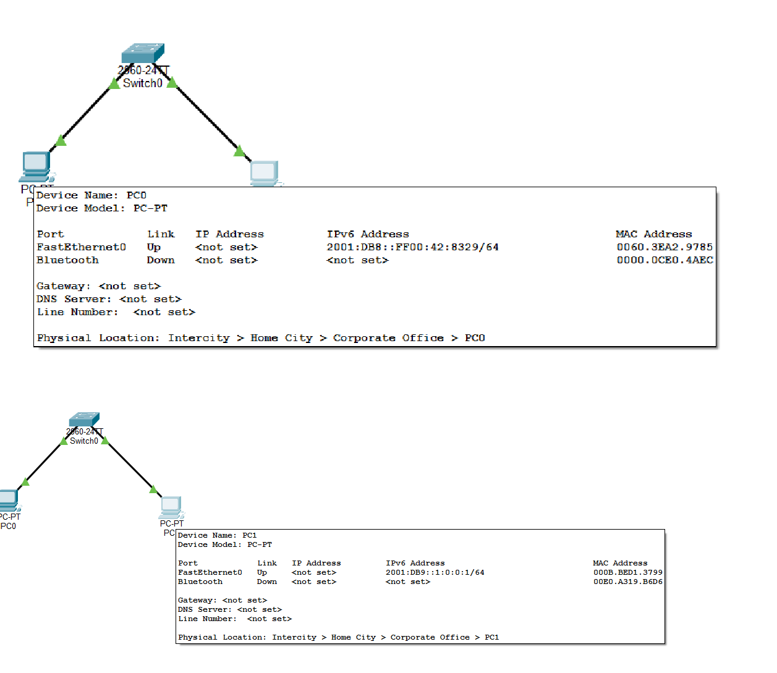
Initial Configuration
Device | IPv6 Address | Prefix Length
PC0 | 2001:db8::ff00:42:8329 | /64
PC1 | 2001:db8:0:0:1::1 | /64

Expanded IPv6 Addresses Device A
Compressed Address:2001:db8::ff00:42:8329
Expanded Address:2001:0db8:0000:0000:0000:ff00:0042:8329

Device B
Compressed Address:2001:db8:0:0:1::1
Expanded Address: 2001:0db8:0000:0000:0001:0000:0000:0001

Network Prefix Calculation
Since the prefix length is /64, the first four hextets represent the network portion.

Device A
2001:db8:0:0::/64

Device B
2001:db8:0:0::/64
Initially, both devices belong to the same subnet.

Debugging Scenario
To demonstrate IPv6 troubleshooting, the IPv6 address of PC1 was intentionally modified. Modified IPv6 Address of PC1
2001:db9:0:0:1::1/64
Now,

PC0 Network
2001:db8:0:0::/64

PC1 Network
2001:db9:0:0::/64
Since the network prefixes are different, both devices belong to different subnets, causing communication failure.
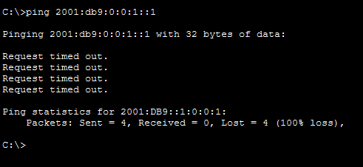

Optimized IPv6 Configuration
After debugging, the IPv6 configuration was corrected. Device Correct IPv6 Address Prefix PC0 2001:db8::ff00:42:8329 /64
PC1 2001:db8:0:0::20 /64
Both devices now belong to the same subnet.

AFTER DEBUGGING:

Reply from 2001:DB8::20
Packets: Sent = 4 Received = 4
Lost = 0
Communication was successfully restored after assigning the correct IPv6 address.

Available Host Addresses Prefix Length:/64
Remaining Host Bits:128 − 64 = 64 Available Host Addresses:2^64
= 18,446,744,073,709,551,616

Approximately 18.4 Quintillion host addresses are available in a /64 IPv6 subnet.

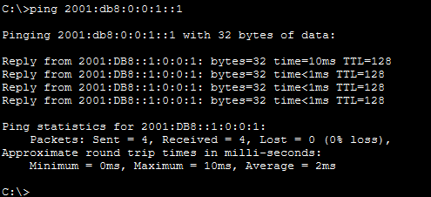

RUBRICS FOR CALCULATION

Criteria | Weightage | Level 4  (Exemplary) | Level 3 (Proficient  ) | Level 2  (Developing) | Level 1  (Beginning)
Problem Identification | 20% | Accurately identifies all errors and  root causes  with clear understandin  g | Identifies most errors with minor gaps | Identifies some errors  but misses key issues | Unable to identify errors correctly
Debugging | 25% | Applies systematic debugging techniques  effectively to resolve issues | Uses appropriate debugging methods  with minor errors | Limited debugging approach; requires guidance | Unable to  debug or resolve issues
Optimization | 20% | Optimizes code by significantly improving time complexity using efficient  algorithms | Improves time complexity with minor gaps in efficiency | Limited improvement in time  complexity | No improvement; inefficient approach retained
Analysis | 20% | Demonstrates strong logical reasoning and clear  justification of solutions | Shows reasonable analysis with some  justificatio n | Limited analysis; weak reasoning | No analytical reasoning demonstrated
Code Quality | 15% | Produces clean, well-structured code with proper comments and documentatio  n | Code is mostly clear with minor documentat ion gaps | Code lacks structure and proper documentatio n | Poorly written code with no documentatio n

