**Conditionals (What’s up?)**

**LAB # 05**

**SECTION # 1**

**Jesus Horacio Soto Gonzalez**

**SUBMISSION DATE: 10/07/2022**

# Problem

**DualShock 4 orientation: For this problem we had to determine how the controlled was positioned by interpreting the values of acceleration and position with more detail.**

# Analysis

**This problem involved very precise data so that the outputs can be displayed appropriately. The problem also required an understanding of how the controller and the computer interpret those precise measurements with help of our calculations to provide the expected output.**

# Design

**For the design of this program, we were given some useful hints in the form of the close_to function which my whole program ended up based around. I used this function to indicate all the precise values for each change in direction of the controller. The overall design of the code was listed as requirements, for example it had to be a “while” loop that will read inputs repeatedly. We also were instructed to adapt the program to automatically stop and end as soon as the user presses the triangle button on the controller.**

# Testing

**Testing was the most important part of this lab. I had to test each step of the program, even when small changes to the code were made to check that everything was working properly. As mentioned before, after I had all my functions and variables correctly integrated in the program, I made sure that the outputs provided were the ones I expected one at the time. For example, the first main challenge of the program was to print the word TOP when the controller was placed on the desk normally. I made sure that every time I ran the program TOP was printed when I wanted it to. Then I continued with all the other orientations one by one. After all the orientations were successfully outputted by the program, I modified the while loop to stop and end the program when the triangle button was pressed.**

# Comments

**This was one of the most challenging labs we have had so far but it was also one of the most fulfilling ones. Using the DualShock 4 controller is always interesting and all the different requirements that we had to fulfill in this lab helped me gain a better understanding of programming as a whole. I am very excited to continue working on labs like this one. There were times when the coding seemed difficult but after analyzing and understanding the process of each part of the program helped me obtained a successful result.**

***Questions and Experiments***

***1. How did you approach the design?*** The first thing was to make sure to cover all the requirements listed on the lab, I made sure that my function and variables were compatible, and I developed the code step by step as mentioned before to make sure that everything worked as expected.

***2. What data did you have to read in?*** The most important data for this lab was the value of each axis according to the orientation of the controller. With the value of each axis, I was able to link the different values that each orientation required and compare them with the magnitude to return a correct output.

***3. What functions did you choose to implement and why?*** The most important function in my program was the close_to since it helped detect and compare the value of the different positions on the controller. The magnitude function was also required to provide the correct output for each orientation change of the controller.

***4. What tolerance values did you pick and how did you decide on them?*** I picked the tolerance values that provided the best response and that were still efficient (0.05). At the same time, I wanted the change in orientation to print exactly when the controller was at the position describe and not anywhere in between, for that reason I had to pick a specific value a slightly tight tolerance.

**Screen Shots

**SS #1**

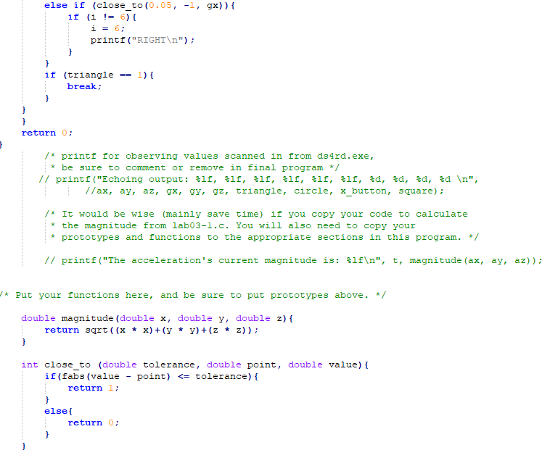

**SS #2**