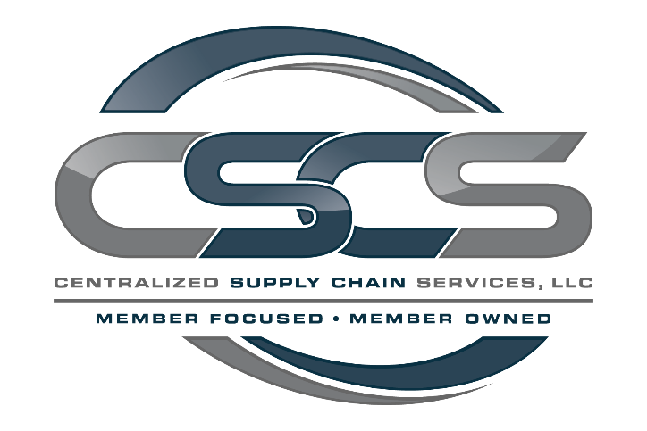

Contents
Proof of Concept Assignment 2
Item Lifecycle Hub Platform 2
Part 1: Simple POC (Required) 3
Part 2: Advanced POC (Optional, Highly Valued) 5
Deliverables 10

Proof of Concept Assignment

Item Lifecycle Hub Platform
Build a proof of concept (POC) web application that models a simplified Item Lifecycle workflow used within a multi-partner supply chain network. This assignment evaluates your ability to understand requirements, design data structures, build clean interfaces, and apply full stack development to a realistic enterprise scenario. You may use any tech stack, libraries, services, or tooling you believe is appropriate. This assignment is intended to showcase how you think, what you prioritize, and what you can build end to end.
Context
Centralized Supply Chain Services (CSCS) supports a large, national restaurant system by coordinating suppliers, distributors, and brand partners to move items through the supply chain. Before an item ever reaches a restaurant, it must pass through a structured sequence of checks, data submissions, pricing steps, and cross-partner handoffs.
In the real world, this involves multiple teams coordinating across applications, spreadsheets, emails, calls, and meetings. The goal of the future Item Lifecycle Hub is to centralize these steps into a unified platform that provides visibility, workflow management, and role-based responsibilities for items moving through three core lifecycle phases:
- New Items: Items entering the system for the first time
- Transitioning Items: Items changing specification and being replace
- Deleting Items: Items being discontinued or removed from distribution to be archived
For this POC, you will focus on the execution phase of this lifecycle, which is when CSCS is actively managing changing item activity in our supply chain, by simplifying the complex workflow into a manageable subset that still requires thoughtful data modeling and UI/UX clarity. You are not expected to recreate the full enterprise application; instead, demonstrate how you would approach it as a developer building an initial prototype that can evolve into a production-grade solution.

Evaluation Criteria: Our hiring team will evaluate your POC based on these areas using various weights:
- Speed and quality of execution
- Ability to interpret real supply chain processes
- Translation of requirements into a working application
- Code clarity, organization, and maintainability
- Data model quality
- UI/UX clarity
- Architectural depth in optional features
- Iterative thinking and explanation of next steps

Part 1: Simple POC (Required)
A functional prototype that can be completed in 2 to 6 hours. Emphasize clarity, correctness, and clean design.
Objective
Implement a minimal Item Lifecycle Hub that allows Internal CSCS users to:
- Create and manage item projects
- View and navigate lifecycle stages
- Understand & View role-based field ownership
- Advance an item through simplified workflow steps
- View all information in a clean, intuitive interface
A. Simplified Lifecycle to Model
Your POC must support movement through these stages:
- Project Creation
- Item Specification Requirements
- Workflow Steps with Approvals or Rejections
- Visibility and progress tracking
Internal CSCS users should be able to advance an item to the next stage or back a stage to re-require input.
B. Core Communities (Conceptual Only)
The full platform includes:
- Internal CSCS: Category Manager, Strategic Supply Manager, Pricing Specialist, Logistics, Admin
- Suppliers
- Distributors
For Part 1, only implement an Internal CSCS/Admin view. Simply group fields by which entity would own them; full permissions logic is not needed.
C. Role Responsibilities (Simplified)
Use the provided Permissions Matrix for labeling field ownership. Do not implement full RBAC in Part 1. Only label which fields belong to which community.
Required Features
1. Item Management
- Create item
- View item
- CRUD operations
- Show current lifecycle stage
- Advance to next stage or back a stage (Internal only)
2. User View
- A single Internal CSCS view
- Optional: simple role impersonation dropdown (no real authentication required)
3. UI Requirements
- Clean layout
- Clear lifecycle indicator
- Group fields by entity owner
- Functionality over polished UI
4. README Requirements
- Architecture overview
- Tech stack and rationale
- Local setup with easy to follow instructions
- What you would improve with more time

Part 2: Advanced POC (Optional, Highly Valued)
Show deeper workflow, architectural thinking, and supply chain context. Complete as many sections as desired; none are required.
A. Full Lifecycle Modeling
Design your data model and workflow engine to support all three item lifecycle types:
- New Item
- Transitioning Item
- Deleting Item
Support visibility of required inputs/outputs for each role and the ability to approve, reject, or request resubmission.
B. Full Role-Based Access & Privilege Model
Implement or demonstrate how complete RBAC would work across Internal CSCS, Suppliers, and DC Operators.
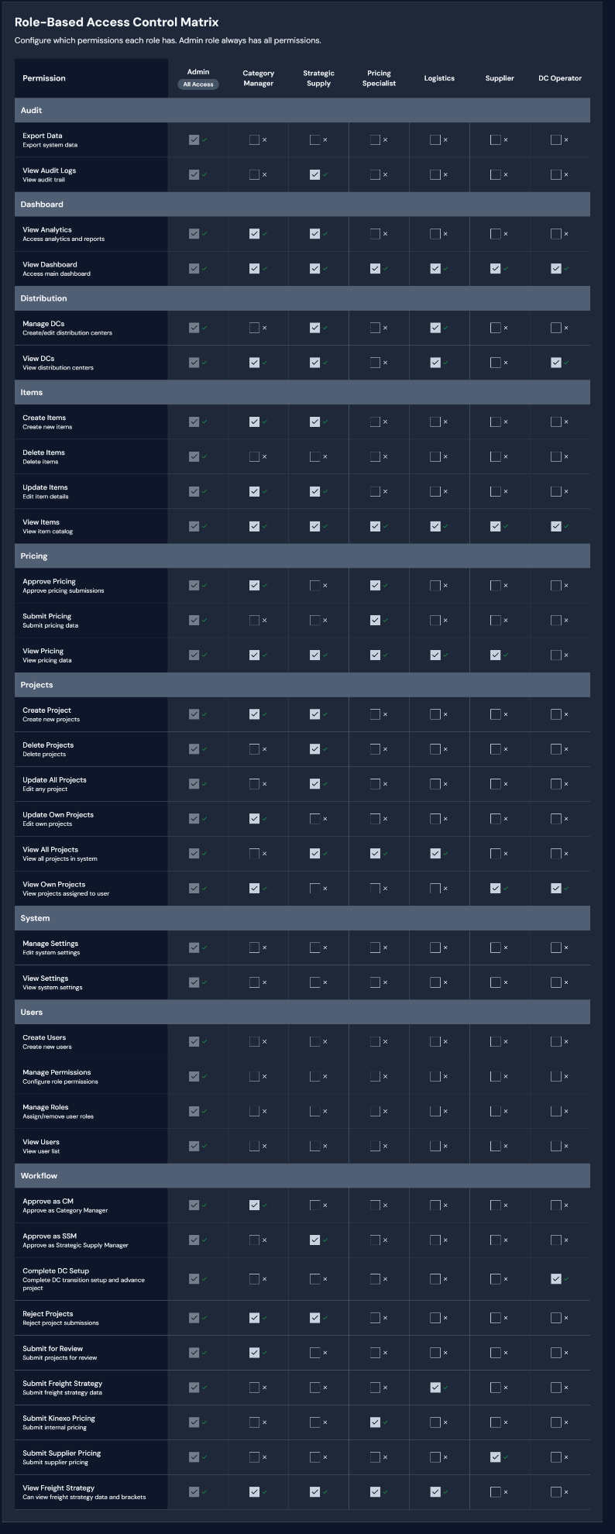
C. Asynchronous Business Processes
Demonstrate at least one asynchronous or collaborative workflow:
- Requests and approvals
- Waiting states (Waiting on Supplier, Waiting on Distributor, Internal Review, Completed)
- Activity logs or comments
- Stateful handoffs
Role simulation via separate views or impersonation is acceptable.
Sequential Workflow (For Context)
- Category Manager creates project
- Logistics provides freight requirements
- Suppliers submit item details and freight brackets
- Supplier pricing is loaded, reviewed, approved by Pricing Specialists
- CM or Hub identifies DC connections and freight brackets
- CM sends project to SSM for approval
- SSM updates Item Hub with required info
- DCs review NDT and begin transitions
- SSM manages ramp-up/runout and escalates issues
- When all DCs complete, SSM notifies CM to end pricing
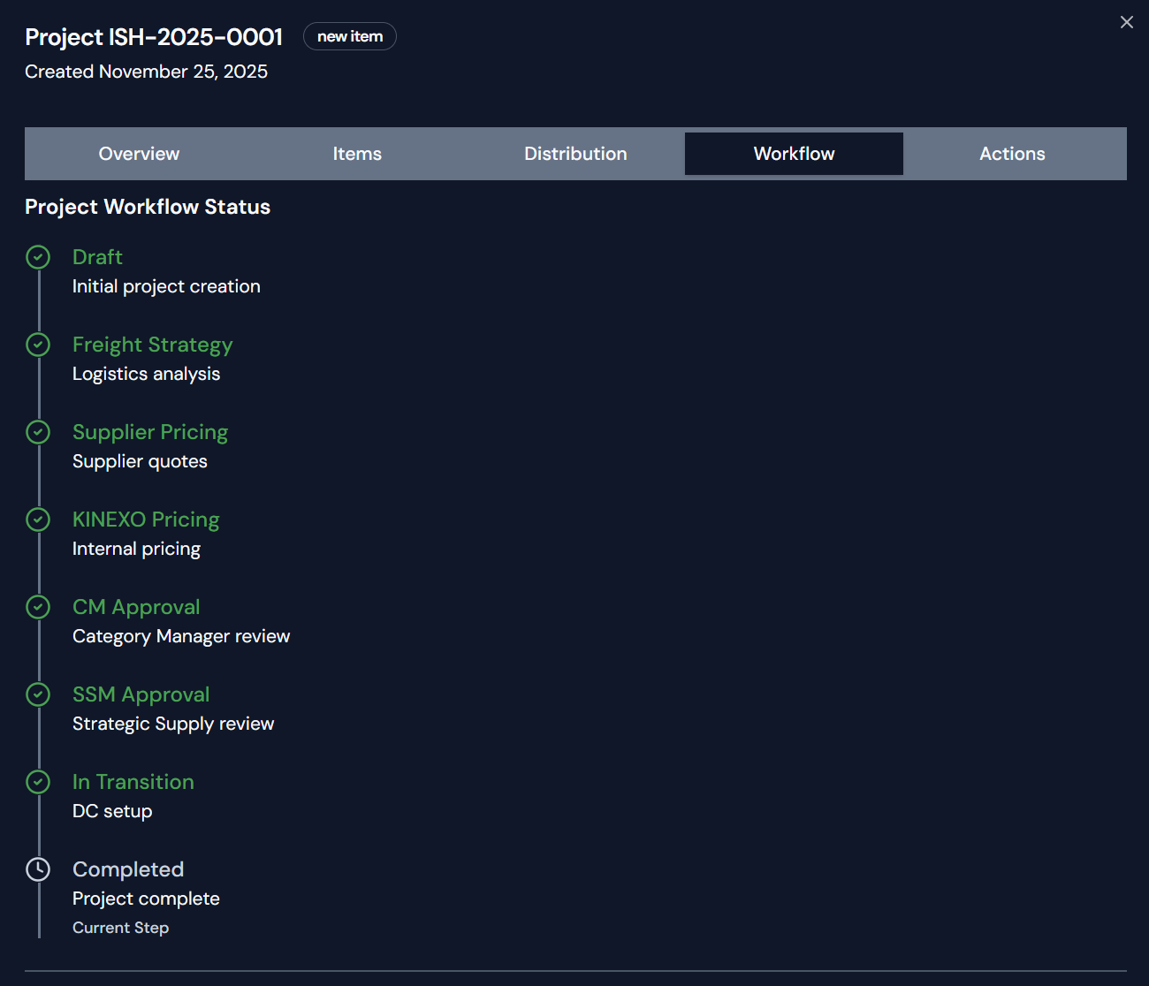

D. Expanded Data Model
Enhance the model with:
- Users, Roles
- Lifecycle stages
- Tasks, approvals, comments
- Status, stage, state
- Notifications
- Dashboards
- System settings and user management
E. Deployment (Bonus)
Deploy your app and include:
- Public URL with Credentials Provided
- Role impersonation instructions
- Seed/test data
F. Scalability & Enterprise Considerations
Briefly outline:
- Multi-tenant architecture
- Event-driven lifecycle asynchronous updates
- Audit logging and version history
G. Optional UI Enhancements
Examples:
- Role-aware interfaces
- Color-coded stages
- Dashboards and insights
- Full lifecycle visual flows
H. Bonus
If you have any additional features, improvements, or creative elements… they are always welcome.

Deliverables
- GitHub repository
- Local working application with setup instructions
- Deployment URL (optional)
- README with architecture, setup, and Part 2 notes
- Time spent on scoping, development, testing, and preparing for presentation
- What you would improve with more time

Next Steps
- Schedule 1 to 1.5 hours with james.hennahane@cscscoop.com to present an overview of your POC application

