Forensic Anthropology Case Report
New Mexico Office of the Medical Investigator
20XX-XXXXX
DATE

RE: Forensic anthropological analysis of type of remains (skeletal, etc.) discovered in COUNTY, STATE.
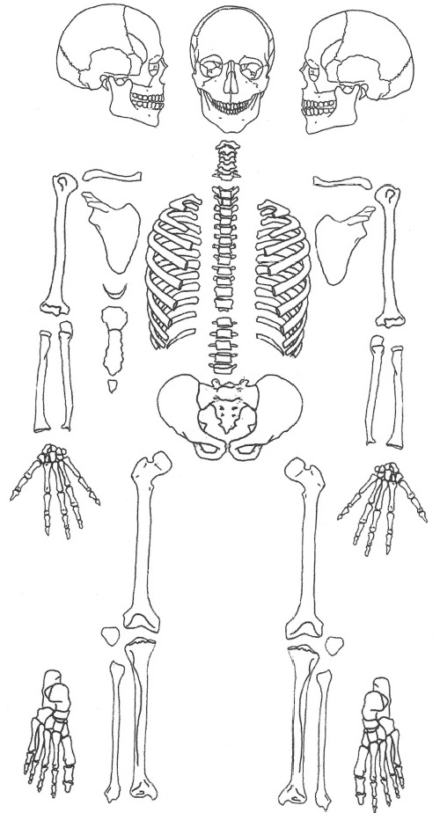  Present  Absent | BIOLOGICAL PROFILE:  - SEX:  - AGE:  - ANCESTRY:  - STATURE:  - Positively identified
 | INDIVIDUALIZING CHARACTERISTICS:
 | PERIMORTEM TRAUMA:
Figure 1. Skeletal elements present are in blue and the elements absent are in white.
BACKGROUND
(Brief introduction and background on the case and why an anthro exam was requested) The purpose of the forensic anthropological report was to:
- (what was asked)

Processing
how, who, when

FORENSIC OSTEOLOGICAL ANALYSIS

Inventory of human remains and number of individuals
Brief description of the remains, cite figure of picture of remains

Biological Profile
Sex: ??

Bioaffinity/Ancestry: (phrase as African (Black)/Asian/European (White) American)
(basis of estimation)
Method | Comparison groups | Ancestry estimate |  | Reference
Fordisc |  |  | Jantz and Ousley 2005
Dental morphology |  |  | Edgar 2013
Hefner Non-metric |  |  | Hefner and Ousley, 2014
(hu)MANid |  |  | Berg and Kenyhercz, 2017

Age: XX-XX years old
Age was estimated using the following:
Method | Comparison group | Age estimate | Reference
Pubic symphysis |  |  | Hartnett (2010)a
Auricular surface |  |  | Osborne et al. (2004)
Sternal rib end |  |  | Harnett (2010)b
Transition analysis pubic symphysis |  |  | Boldsen et al. (2002)
Transition analysis auricular surface |  |  | Boldsen et al. (2002)
Transition analysis cranial sutures |  |  | Boldsen et al. (2002)
Transition analysis consensus age |  |  | Boldsen et al. (2002)

Stature: XX-XX inches
(basis of estimation. Equation is based in inches)

Individualizing characteristics:
(list and describe characteristics)

SKELETAL TRAUMA

Around the time of death (perimortem)
The term “perimortem” refers to an injury occurring at or around the time of death (Scientific Working Group for Forensic Anthropology [SWGANTH], 2011). During the perimortem interval, bone retains its organic biomechanical properties and will react to forces as living bone, but exhibits no evidence of healing.
In addition to the documented skeletal trauma, it is possible that additional soft tissue injuries were present that did not impact bone.
(OR)
However, it is possible that soft tissue injuries were present that did not impact bone.

(summary)

Antemortem
Antemortem trauma refers to an alteration produced before an individual’s death that displays evidence of osteogenic reaction (healing; SWGANTH, 2011).
(summary)

TAPHONOMY

Forensic taphonomic analysis attempts to reconstruct the events surrounding and subsequent to death (including the postmortem interval) as well as develop scientific hypotheses regarding the movement, removal, and modification of biological tissues, particularly those related to human intervention (Dirkmaat and Cabo, 2012).

(summary)

Summary
(summary)

Prepared by

Heather Edgar, Ph.D., D-ABFA
Forensic Anthropologist

REFERENCES

Behrensmeyer, A. K. 1978. Taphonomic and ecologic information from bone weathering. Paleobiology 4(2): l50-l62.

Berg GE. Kenyhercz MW. 2017. Introducing human mandible identification [(hu)MANid}: a free, web-based GUI to classify human mandibles. J Forensic Sci 62(6): 1592-1598.

Boldsen JL, Milner GR, Hylleberg R. 2002. ADBOU Age estimation software. www.sdu.dk.

Brooks ST, Suchey JM. 1990. Skeletal age determination based on the os pubis: a comparison of the Ascádi-Nemeskéri and Suchey-Brooks methods. Hum Evolution 5:227-238.

Buikstra JE, Ubelaker DH. 1994. Standards for data collection from human skeletal remains. Arkansas archaeological survey research series no. 44. Fayetteville AR: Arkansas Archaeological Survey.

Dirkmaat DC, Cabo LL. 2012. A companion to forensic anthropology. Wiley-Blackwell Publishing Ltd.

Edgar HJHE. 2013. Estimation of Ancestry Using Dental Morphological Characteristics. J Forensic Sci 28:S3-S8.

Fully G. 1956. Une nouvelle me´thode de de´termination de la taille. Ann Med Legale 35:266–273.

Hartnett KM. 2010a. Analysis of age‐at‐death estimation using data from a new, modern autopsy sample—part I: pubic bone. Journal of forensic sciences, 55(5), 1145-1151.

Hartnett KM. 2010b. Analysis of age‐at‐death estimation using data from a new, modern autopsy sample—Part II: Sternal end of the fourth rib. Journal of forensic sciences, 55(5), 1152-1156.

Hefner JT. 2009. Cranial Nonmetric variation and estimating ancestry. J Forensic Sci 54(5):985-995.

Hefner JT, Ousley SD. 2014. Statistical classification methods for estimating ancestry using morphoscopic traits. J Forensic Sci 59(4):883-890.

Iȿcan MY, Loth S. 1986(a). Determination of age from the sternal rib in White males: a test of the phase method. J Forensic Sci 31:122-132.

Iȿcan MY, Loth S. 1986(b). Determination of age from the sternal rib in White females: a test of the phase method. J Forensic Sci 31:990-999.

Jantz RL, Ousley SD. 2005. Fordisc 3.1 Personal computer forensic discriminant functions. University of Tennessee.

Klales AR, Ousley SD, Vollner JM. 2012. A revised method of sexing the human innominate using Phenice’s nonmetric traits and statistical methods. Am J Phys Anthropol 149:104-114.

Langley N, Jantz LM, Ousley SD, Jantz RL, Milner G. 2016. Data collection procedures for forensic skeletal material 2.0.Knoxville: Forensic Anthropology Center, University of Tennessee.

Lovejoy CO, Meindl RS, Pryzbeck TR, Mensforth RP. 1985. Chronological metamorphosis of the auricular surface of the illium: a new method for the determination of age at death. Am J Phys Anthropology 68:15-28.

McCutcheon P. 1992. Burned archaeological bone. IN: Stein JK (Editor) Deciphering a shell midden. San Diego, CA: Academic Press.

Osborne DL, Simmons TL, Nawrocki SP. 2004. Reconsidering the auricular surface as an indicator of age at death. Journal of Forensic Science, 49(5), JFS2003348-7.

Passalacuqua NV, Rainwater CW. 2015. Skeletal trauma analysis: case studies in context. Chichester, West Sussex. John Wiley & Sons.

Phenice T. 1969. A newly developed visual method of sexing in the os pubis. Am J Phys Anthropol 30:297-301.

Raxter MH, Auerbach BM, Ruff CB. 2006. Revision of the Fully technique for estimating statures. Am J Phys Anthropol 130:374-384.

Sala N, Arsuaga JL. 2018. "Regarding beasts and humans: a review of taphonomic works with living carnivores." Quaternary International 466: 131-140.

Scientific Working Group for Forensic Anthropology. 2011. Trauma Analysis. https://www.nist.gov/sites/default/files/documents/2018/03/13/swganth_trauma.pdf

Walker PL. 2008. Sexing skulls using discriminant function analysis of visually assessed traits. Am J Phys Anthropol 136: 39-50.

Figure 2. Overall view of human remains demonstrating…
Figure 3. Six views of the cranium; A) anterior view, B) posterior view, C) left lateral view, D) right lateral view, E) superior view, and F) inferior view.
Figure 4. Add relevant graphs and tables with a description the take-away point.

