# dVRK Si controller testing instructions

v1 2/2024

This documentation explains how to test dVRK Si controllers after assembly.

# Hardware setup

The order of plugging in things does not matter. Just make sure you apply power last.

1. Insert an SD card with the latest firmware in SD card slot on the front panel.
2. Plug in the firewire cable to computer on front panel.
3. Plug in the **safety chain test plug** **(1)** on back panel.
4. Plug in the **dVRK Si Controller Test board** **(2)** on back panel.
5. Plug in the power cable and turn on the power switch. The front panel LED will display a chaser pattern for about 30 seconds, then after booting complete, change to green **PL** light and yellow **ESPM** light.



# Test program setup

1. Setup the linux test computer with the following script using “all” option:

<https://github.com/jhu-dvrk/dvrk-mfg-test/>

In step 6, run “sh scripts/setup.sh all”

You should get a dRAC Test icon on desktop.

# Test program run

1. Run **dRAC Test** on desktop.

2. Choose board ID to match the FPGA board (4, 6, 8, or 10). Choose the protocol (firewire), and click “Connect” 

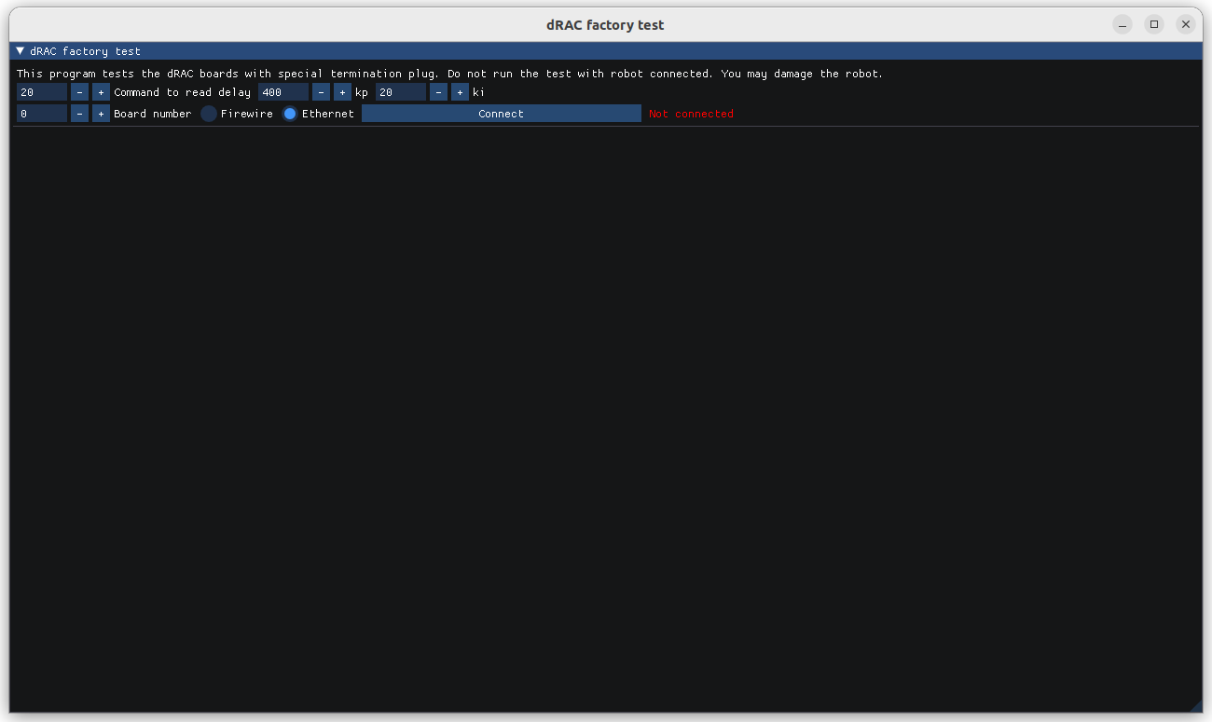

Sometimes the board takes a while to show up. Retry by clicking “connect” again.

3. Upon successful connect, you will see this.

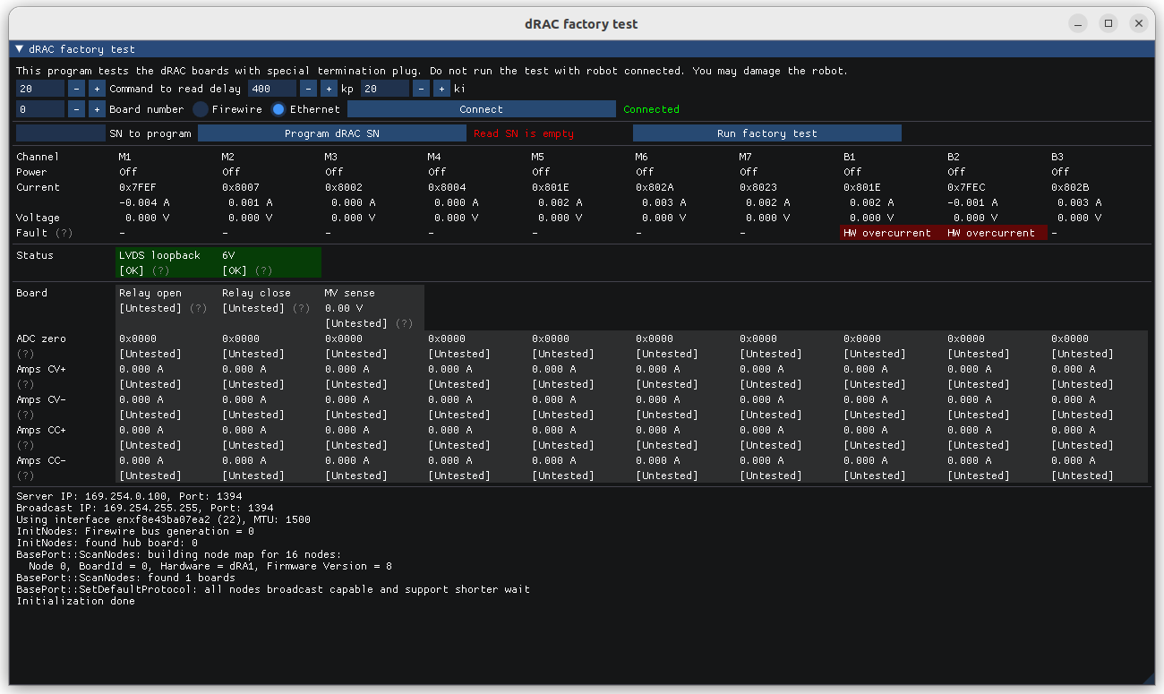

4. Run the tests. Click .

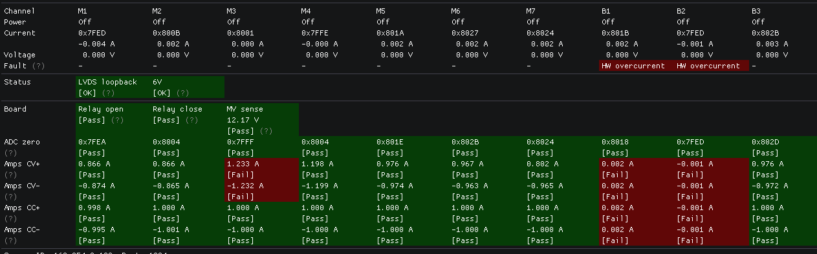

The test takes a couple seconds to complete. The red-marked items failed the test.

When a channel has a fault, it cannot turn on, and it will cause the tests in that channel to fail. Resolve the fault first. You can retry by clicking the run test button again.

All boxes should be green for the controller to be considered test pass.

The result files are saved in a folder named “dRAC_test_results”. Every time you click the test button, it creates a new file. The file name is “dRAC_[date-time]_[SN].txt”

5. Keep the window open when you are done with this controller. Simply power off the controller, and the program will automatically disconnect. Communication failure messages are expected. When you are ready for the next controller, click “connect” again.