From Address Limiter
Purpose
When an email is sent, it includes an unseen header that provides various information to the receiver regarding the sender. This information includes the domain of the sender. Most receiving email servers compare this information to the “From” address to determine if they match. When an email is received with a “From” address that does not match the sending server’s domain, it is referred to as “Spoofing”. This can happen for multiple (and not always nefarious) reasons. In most cases, when an email server receives an email where there is a mismatch, the email is rejected and never reaches the recipient.
This is an important REDCap consideration, as there are a few situations where this can create problems.
- Consider a multi-site project where DAG’s are being used, and individuals from other institutions have access. Survey invitations or alerts are configured with the “From” address specifying someone from another institution, there is a very good chance that any survey invitations and/or alerts will never be received.
- A user may add a secondary or tertiary email address that is not associated with the institutional email domain. Again, survey invitations and/or alerts will likely never be received.
- REDCap has no knowledge of what happens to the email once it is handed off to the local email server for delivery.
- When an automated survey invitation (ASI) is triggered, REDCap simply hands it off to the local email server for delivery. REDCap has no idea if it was successfully delivered. Further, ASI’s are tagged as “sent”, meaning they can’t be “re-run” once the “From” address issue is resolved.
The From Address Limiter module provides the ability to restrict “From” addresses based on the institution’s email domain(s). For example, “University Health System” can limit “From” addresses to those having the @university.edu and/or @university.mail.edu domain.
Configuration
Once installed on a REDCap instance:
- Specify the appropriate email domain(s) for the institution.
- Indicate if the module should “Warn” or “Prevent”. In most cases, the “Prevent” will be the appropriate implementation.
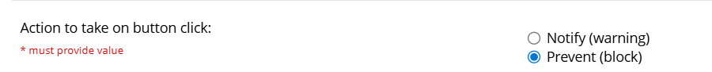
- Provide the desired messaging to be presented to the user when a non-compliant “From” address is specified (within the blue area below).
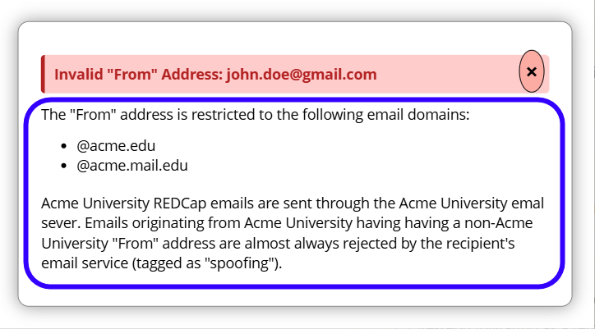
- Recommended:
  - Enable for all projects
  - Hide from non-Administrators
