Installing REDCap Using Docker
This guide provides step-by-step instructions for setting up a local REDCap instance using Docker. Screenshots are included for clarity.

Prerequisites
Ensure you have the following installed on your system:
- Docker Desktop (Windows/macOS) or Docker Engine (Linux)
- Git (optional, for cloning the repository)

Installation Steps

1. Download REDCap Docker Compose
- Go to https://github.com/jhu-redcap/redcap-docker-compose.
- Click the Code button and select Download ZIP.
- Extract the downloaded ZIP file to a directory where you want to store your REDCap Docker instance.

2. Configure the Environment File
- Open the extracted folder and navigate to the RDC directory.
- Rename the file .env-example to .env.

3. Start the Docker Containers
- Open File Explorer and navigate to the RDC folder.
- Open a Command Prompt at this location (Shift + Right-click and select Open Command Prompt Here).
- Run the following command to start REDCap:
- docker compose up -d
- This process may take several minutes, depending on your system and internet speed.
(Insert Screenshot: Command prompt running docker compose up -d)

4. Access REDCap Installation
- Open a web browser and navigate to:
- http://localhost
- Select the Community Consortium option.
- Enter your institutional credentials.
- Choose the REDCap version you wish to install.
- Check the option Prepopulate with table-based users and activate table authentication.
- Enter your email address in the provided field.
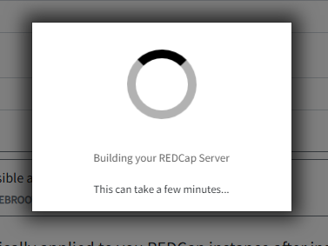
- Click Install REDCap.
⚠ Note: The installation process may take up to 20 minutes on a slow connection.

5. Verify Installation
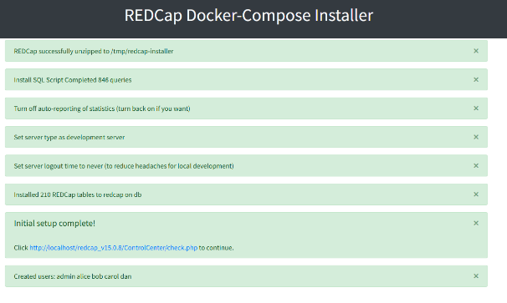
- Once the installation completes, click the Control Center / Check.php link.
- Log in using the default credentials:
- Username: admin
- Password: password
- If successful, you now have a fully functional local instance of REDCap.

Additional Notes
- To set up multiple versions of REDCap, refer to the repository documentation.
- To stop the REDCap instance, run:
- docker compose down
- To restart it later, run:
- docker compose up -d
- For troubleshooting, check the Docker logs using:
- docker compose logs
This guide ensures a smooth setup process for REDCap administrators looking to deploy a local instance quickly. Let me know if you need further refinements! 🚀

