**DJANGO WEB DEVELOPMENT FOR NGO DONATIONS**

**David Dudek**

[**David.r.dudek@gmail.com**](mailto:David.r.dudek@gmail.com)

**Himangshu Pal**

[**himangshu.pal1986@gmail.com**](mailto:himangshu.pal1986@gmail.com)

**Junxiong Huang**

[**yesterdayhjx123456@hotmail.com**](mailto:yesterdayhjx123456@hotmail.com)

**BACKGROUND**

Hetal at a tender age has realized that poverty can come in the way of anyone's dream. Instead of going to school, Hetal makes the rounds of four to five houses each day and takes care of her father, till her mother and elder sister return. Hetal's father has been bedridden for two years now, due to an accident. Since then, life has taken a bitter turn for Hetal. The only respite in Hetal's life comes from her dream of becoming an airhostess when she grows up.

Smile Foundation as an NGO in India has so far directly put more than 200,000 children like Hetal into the path of empowerment through education through its Mission Education program.

**PROBLEM STATEMNT**

Based on the social responsibility, the functional requirement is part of global web portal for customers. Customers are non-profit organizations and branches all over the world. For funding raising, they organize various activities and events on multiple cities and then accept donations using the portal.

Django is a Python-based free and open-source web framework, which follows the model-template-view architectural pattern. Django’s primary goal is to ease the creation of complex, database-driven websites. The framework emphasizes reusability and “pluggability” of components, less code, low coupling, so our team would like to deploy the Django website for NGO donations. Besides, Amazon Web Services (AWS) is a subsidiary of Amazon that provides on-demand cloud computing platforms to individuals, companies and governments, so the final website will be deployed with AWS cloud server.

**DJANGO FRAMEWORK SPECIFICATION AND DESIGN**

**USER ROLES**

1. Admin users, who are responsible for two main tasks which are user management and event management. For user management, the administrator can add, delete and update user information, for event management, the administrator can create, edit and inactivate the events.
2. Regular users, who are the customers for donations can view and register events. When the regular users login our webpage, the user can choose the donation type, if the user is the first time user, then the web page will automatically direct to personal information page will require the current users to input the personal information, after finishing the personal info table, the website will direct to the donation amount page and require the user to choose the amount of the donation he / she would like to donate, is the user is not the first-time user, the website will direct to the donation amount page. Finally, user can choose to pay his / her shopping cart of this time donation.

The following workflow will illustrate the functionality of the admin and regular users.

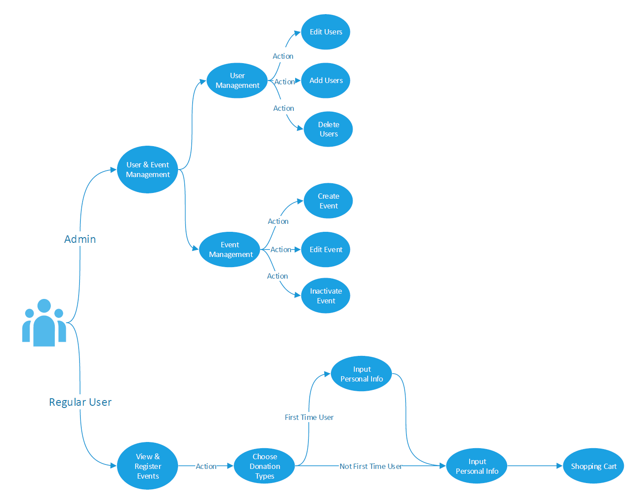

**ADMIN MODULE**

Admin users are responsible for regular users and events management, admin users can view all the donations which are made till date, the database table for the donations list will be sorted with date sequence, the sample donations list page is shown as follows,

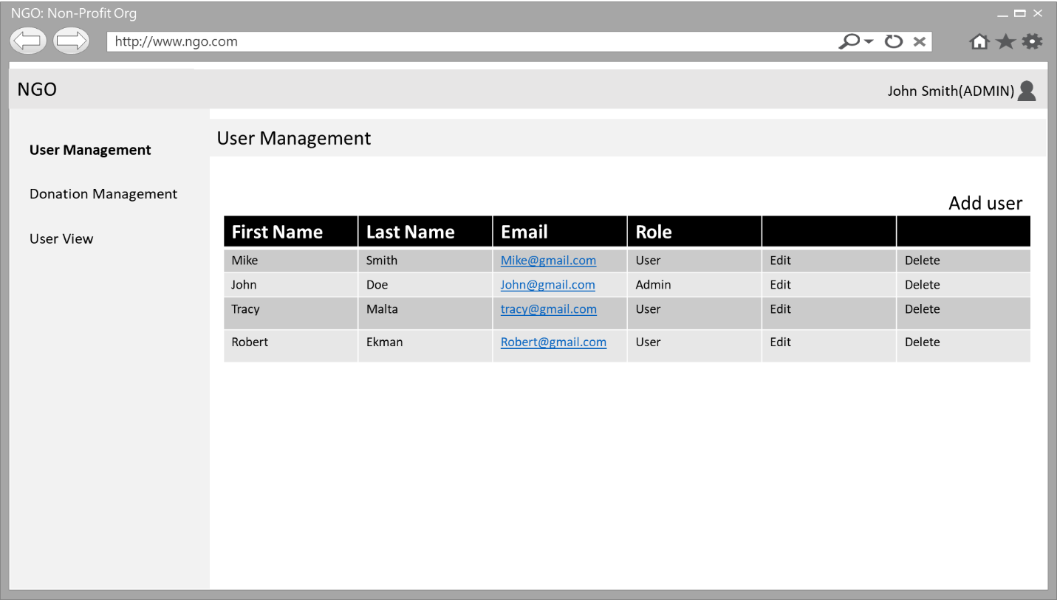

Admin Users Management is summarized as follows

* Add regular users
* Delete regular users
* Update regular users

Admin Events Management is summarized as follows

* Create events
* Edit events
* Inactivate events

**REGULAR USER MODULE**

The regular user part consists of four web pages, user management form, donation type form, personal information form and donation amount form.

The donation type choice form is to require users to choose the donation types which is shown as follows,

Regular Users Management is summarized as follows

* Choose donation type
* Input personal information
* Input donation amount
* Pay for shopping cart

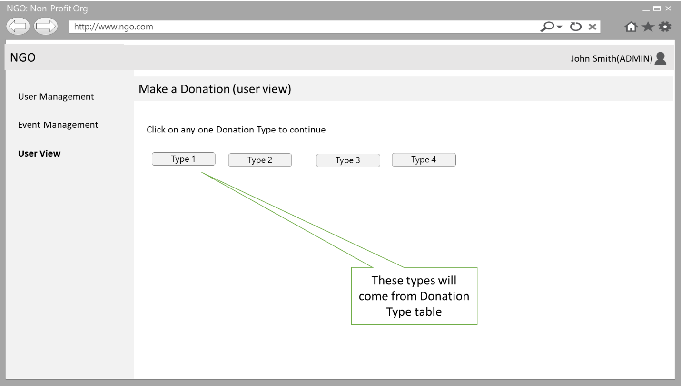

After choosing the donation type, the web page will direct to personal information form, which is shown as follows,

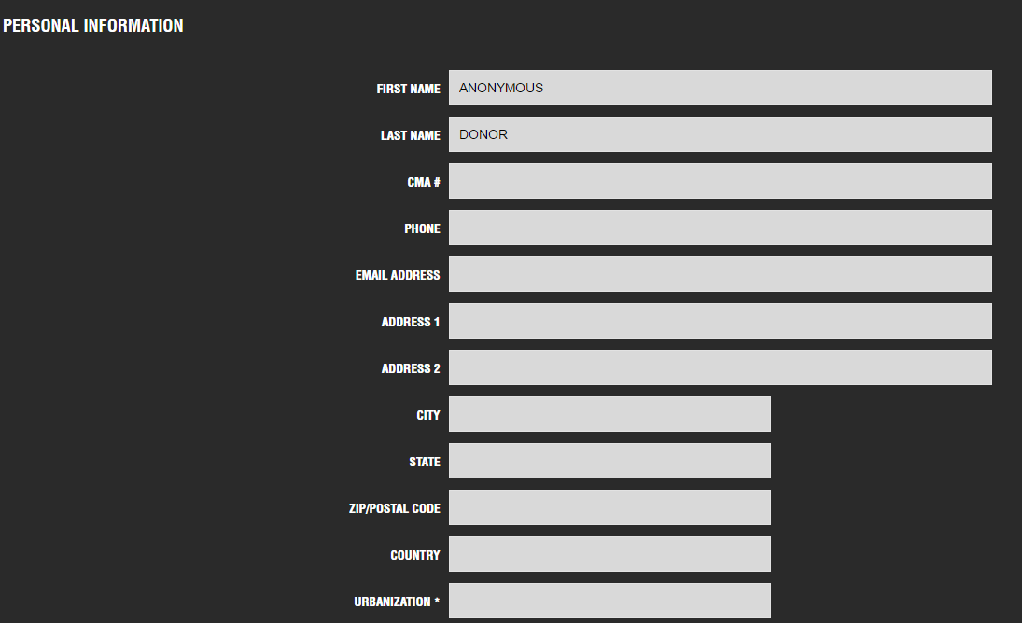

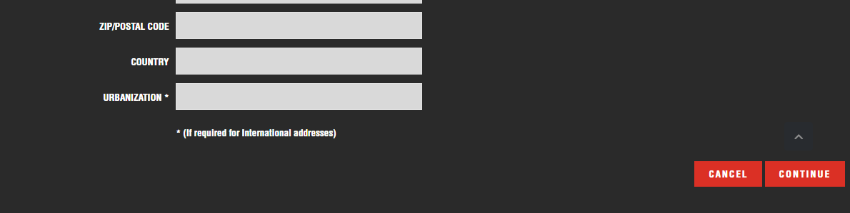

When the user click the cancel button, the user can refill in the personal info again, otherwise clicking the continue button, the web page will direct to donation amount page, which is shown as follows,

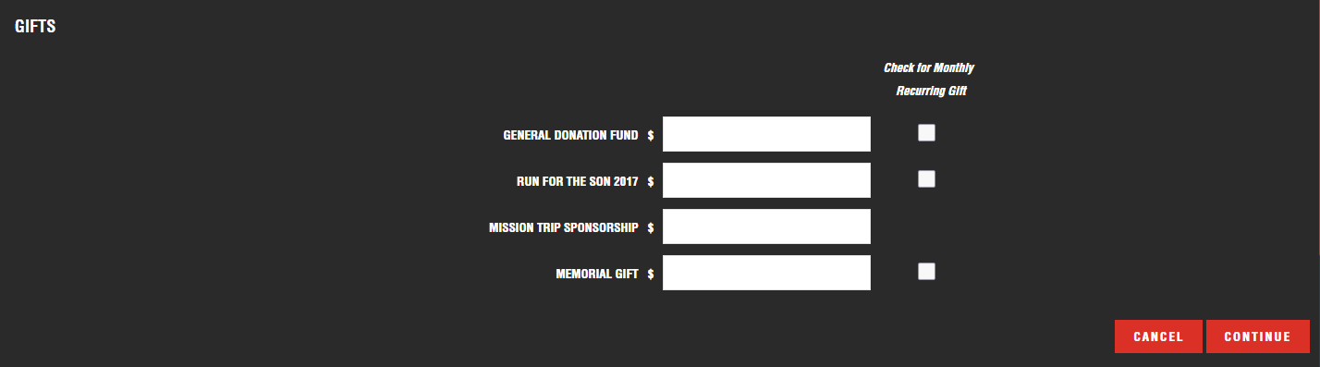

When the user click the cancel button, the user can refill the donation amount, otherwise clicking the continue button, the web page will direct to shopping cart for payment, which is shown as follows,

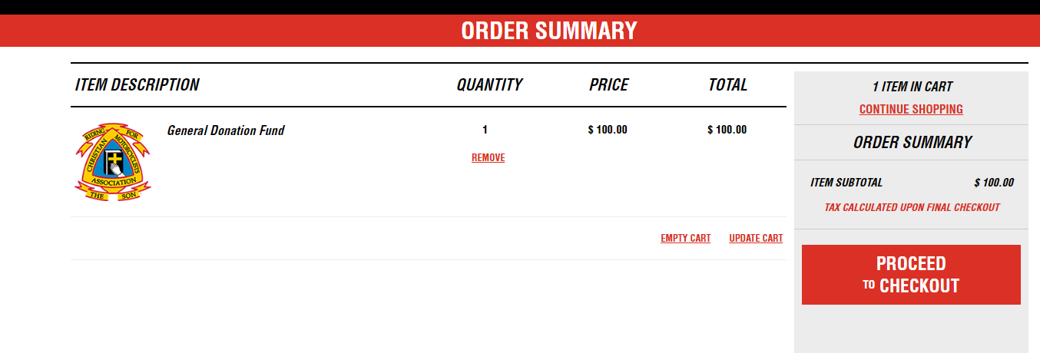

**DATABASE SPECIFICATION AND DESIGN**

MySQL database is an open-source relational database management system (RDBMS), enterprises are enjoying significant cost savings on new projects, the dependability and ease of management that accompany MySQL save your troubleshooting time which is otherwise wasted in fixing downtime issues and performance problems, based on these advantages of MySQL, our team decide to deploy MySQL for database task this time.

Five database table will be deployed which are specified as follows,

* user: Name, Email, Role, Password(encrypted).
* User_data: First name, Last name, Address line 1, Address line 2, City, Zip, State, Country.
* Event: Event name, Event ID, Event Status
* Donation: Name, Date, Amount, Event.
* Donator: Name, Amount

**ER diagram**

**AWS SPECIFICATION AND DESIGN**

Bitnami has integrated stacksmith with AWS’ service catalog and focus on the secure assembly and over-time maintenance of assets that are then be managed and posted for consumption in the AWS service Catalog, our team decides to deploy the website on Bitnami server this time.

When the user checkout the process, our server will send an email without processing payment, which is realized with AWS lambda function.