# Basestack

## 1 Install Docker

* Windows   
 - https://docs.docker.com/docker-for-windows/install/  
* Mac  
 - https://docs.docker.com/docker-for-mac/   
* Linux (Ubuntu)  
 - https://docs.docker.com/engine/install/ubuntu/

## 2 Install Basestack

1. Download Basestack from:
   * https://drive.google.com/drive/u/0/folders/1bk0VRREYviGZjUbyY9rrcg6nOETDluqq
   * The NIH/Fogarty Box Drive:
2. Choose your download based on your operating system:
   * Windows
     + RECOMMENDED - Basestack Setup 1.0.0.zip (~1.5GB)
       - Basestack will be installed in your applications listing similar to Microsoft Office or Adobe. THIS STEP REQUIRES ADMIN ACCESS TO YOUR LAPTOP TO INSTALL SOFTWARE
     + Basestack-Unpacked-Windows.zip (~1.5GB, No Admin Access)
       - Basestack will need to be double-clicked from a folder each time.
   * Mac
     + Basestack-1.0.0.dmg (~2.0 GB)
       - Basestack will be installed into /Applications
   * Linux
     + RECOMMENDED - Basestack-1.0.0.AppImage (~1.5GB)
     + Basestack-Unpacked-Linux.tar.gz (~1.5GB)
   * Expect to use about 14GB after full installation of the analysis pipeline.
3. Extract the zip or .tar.gz file (If compressed)
   * Note: Make sure you fully extract the file and don’t just double-click on it
4. Start Basestack by opening (double-clicking) the following file:
   * Windows:
     + EITHER: Basestack Setup 1.0.0.exe
       - You’ll be prompted to select the install location
     + OR: Basestack.exe (Unpacked)
   * Mac: Basestack.dmg
     + Simply drag + drop (when the window appears) into /Applications
   * Linux: Basestack-1.0.0.AppImage

## 3. Download Analysis Pipeline(s)

* Once Basestack opens up, click ‘Settings’ in the left panel.
* Click ‘Install Docker Image files Online’
* Click ‘OK’ on the small notification window that opens up.
* Follow the *Docker Install Log* to monitor progress and see when the analysis pipeline is ready for use (about 30-45 minutes on a fast internet connection)
* Download the test-data.zip file available in the same gDrive location as the software OR from the NIH/Fogarty Box Drive

## 4. Troubleshooting

* If you run into issues with the online install, you may want to download (or otherwise obtain) the offline install package
* Using the above download links, download the artic.tar.gz (~4.7GB)
* Drag or Browse to that file on the ‘Settings’ tab under the offline install link
* Click ‘Install Docker Image files Offline’
* See below Appendices for more detailed installation instructions.

## Appendices

### A1 Install Docker

#### A1.1 Windows Install Process for Docker (Click below)

View Steps (Click here)

1. Head over to the [Docker](https://docs.docker.com/docker-for-windows/install/) website to install **Docker**

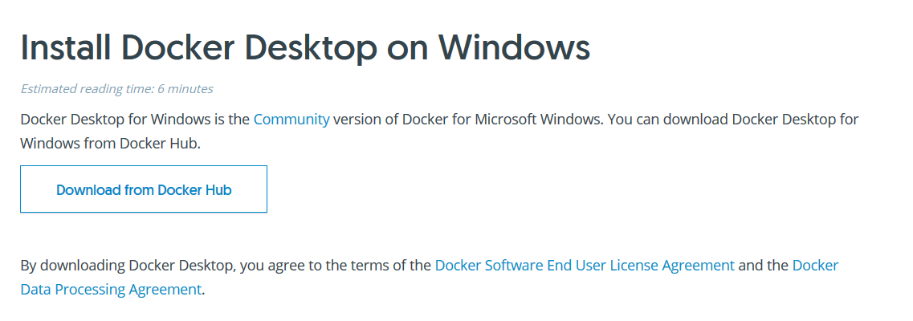

Step 1

1. Choose **Get Docker**

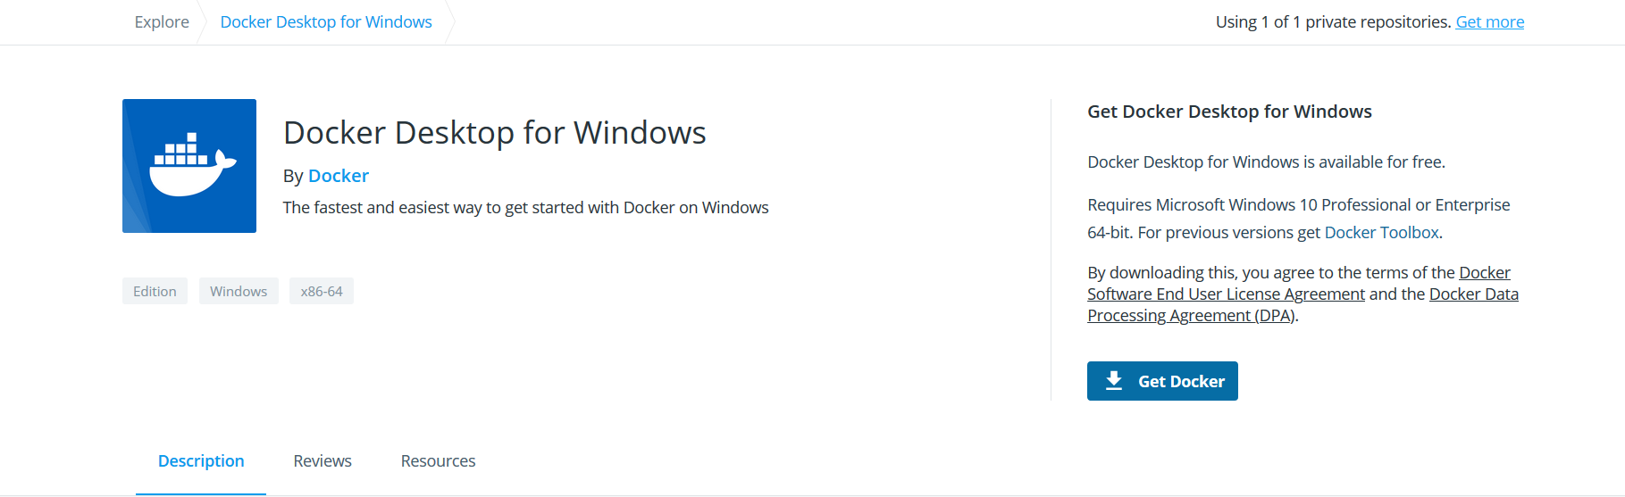

Step 2

1. Choose **Save File** from the prompt

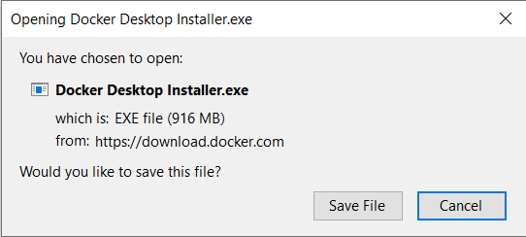

Step 3

1. Once you’ve installed docker for Windows, you can start it at the **Quick Launch** by search **Docker**. You can also view it on your right-hand-bottom tray by right-clicking

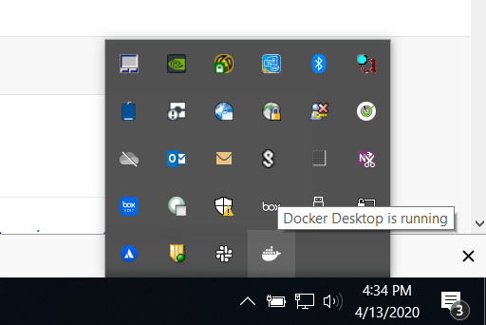

Step 4

1. Here Docker provides a GUI environment to manage your system. You can allocate or limit resources to your containers as well as set networking settings if you’d like. **We use default values for our app**

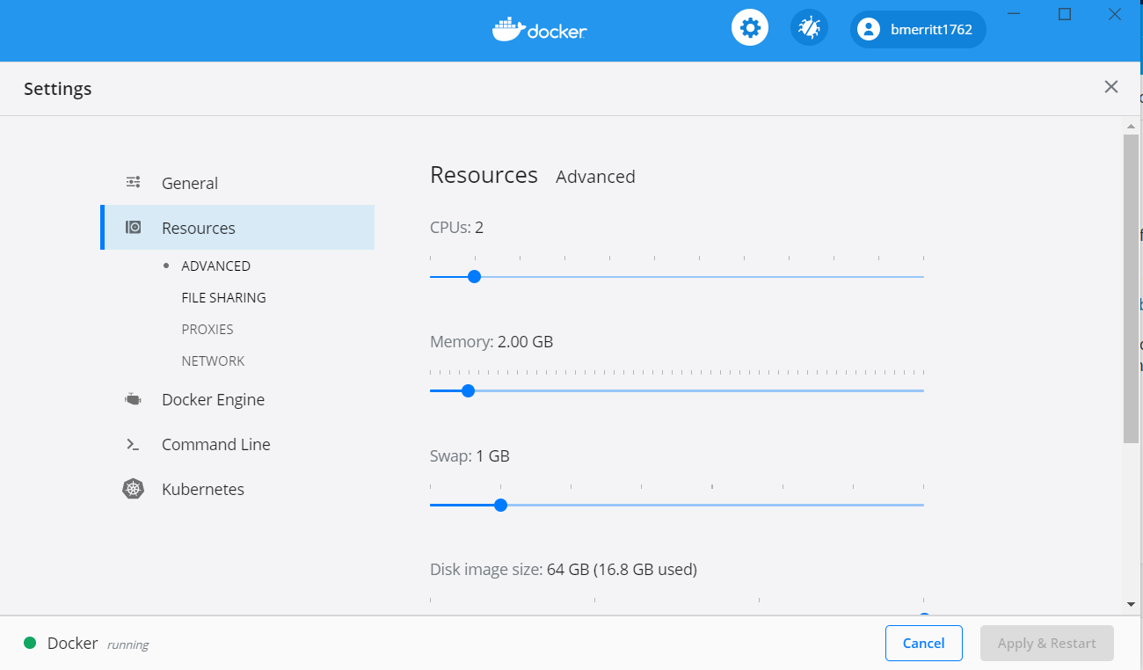

Step 5

1. **OPTIONAL** Choose Local drives to share with containers. Useful if you’re storing data on an external drive.

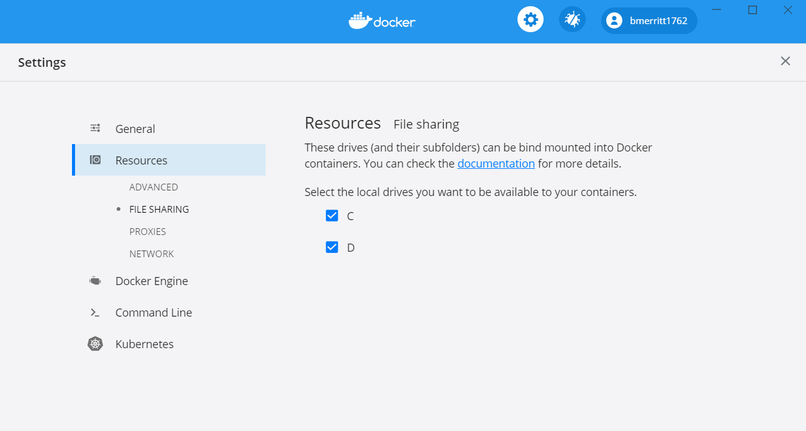

Step 6

1. Main image that allows you to manage specific containers

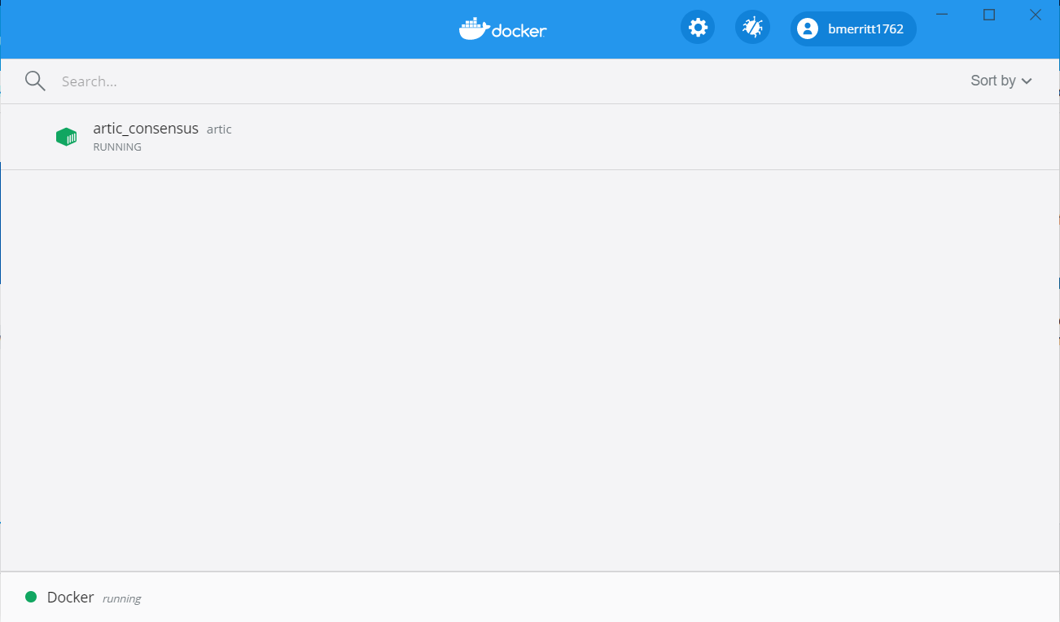

Step 8

#### Common Errors

##### ‘You are not allowed to use Docker, you must be in the “docker-users” group’

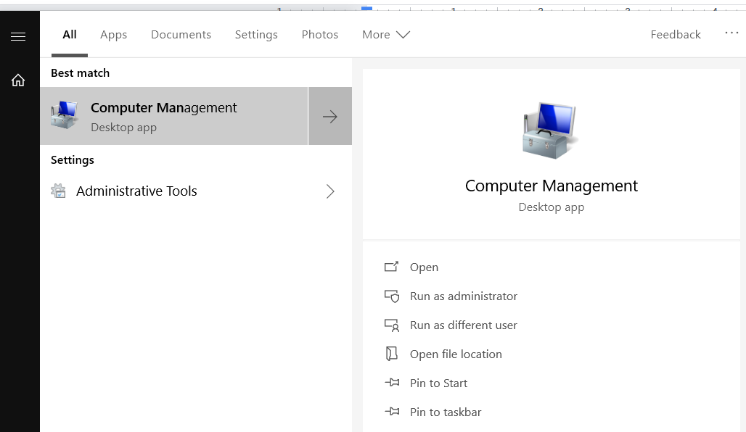

Step 1

* In the Windows search taskbar (bottom left icon), find Computer Management

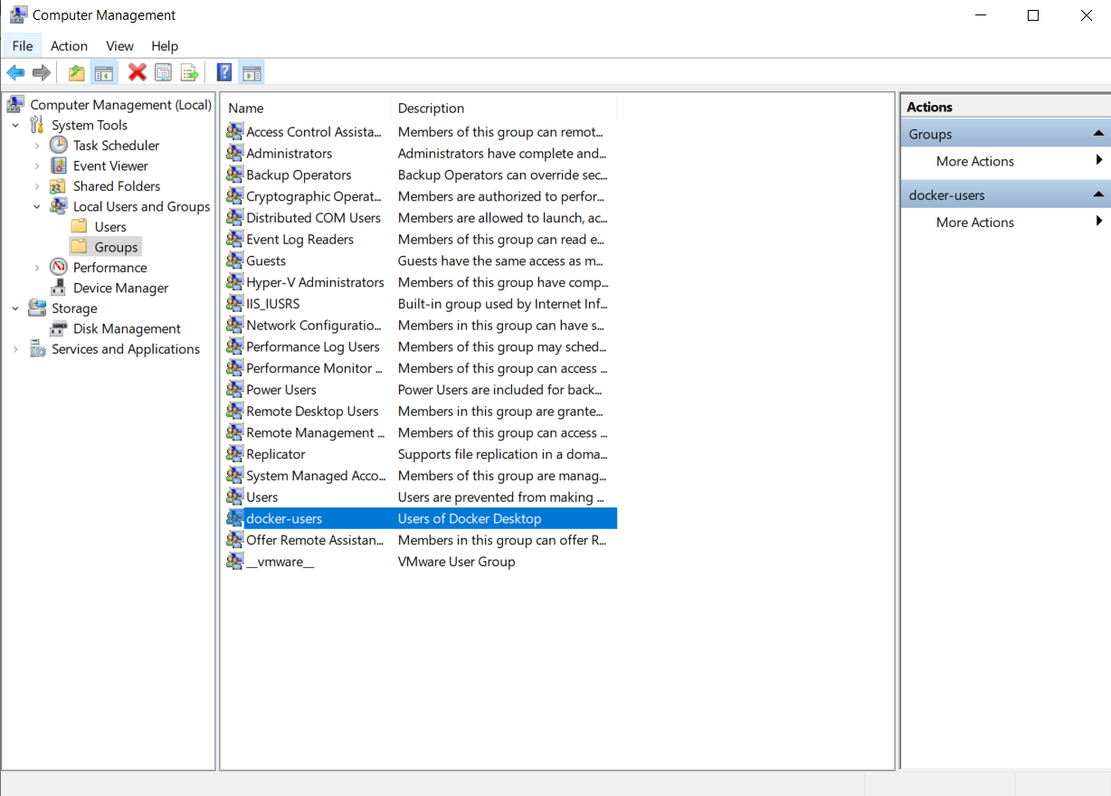

Step 2

* Select (left-side) System Tools -> Local Users and Groups -> Groups

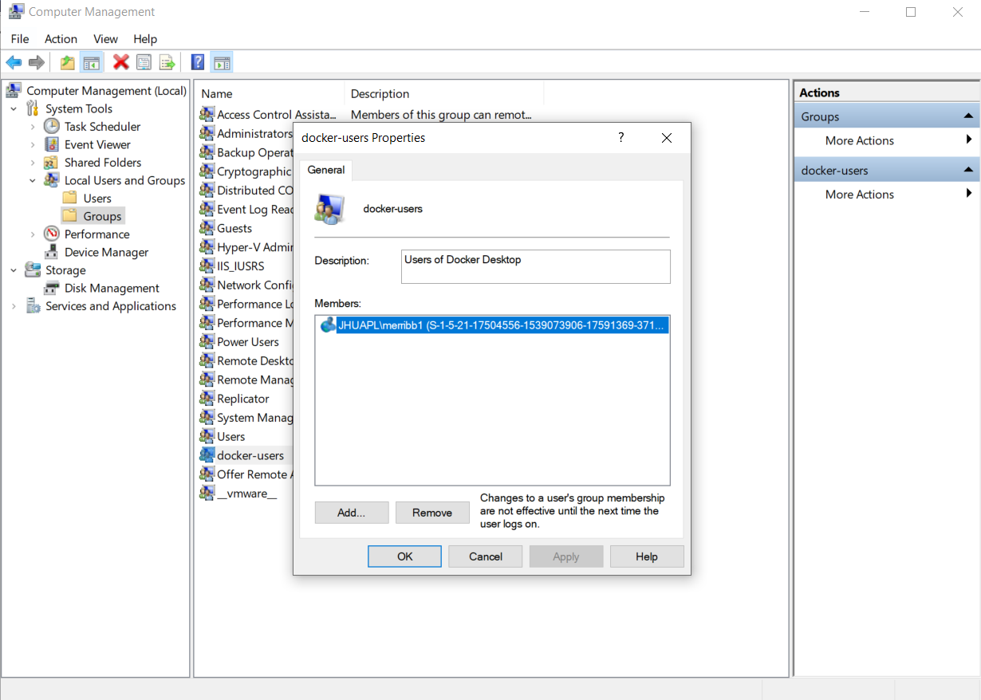

Step 3

* Double click docker-users and see if your name is there, if not:

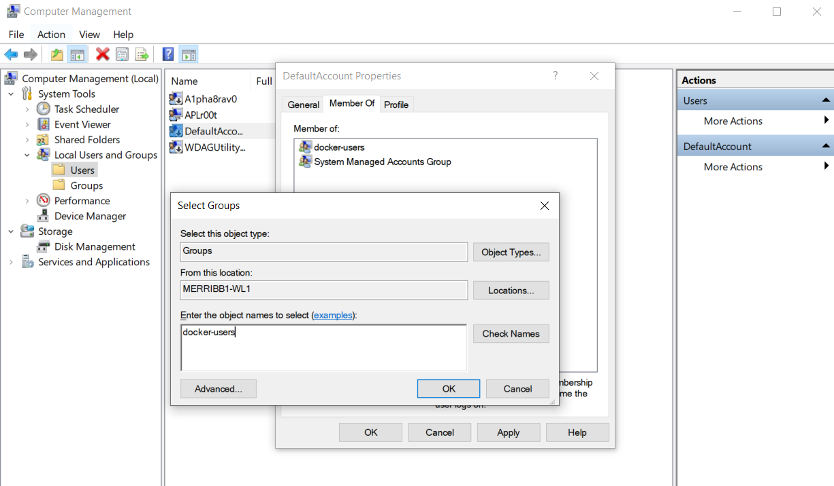

Step 4

* Select the Users folder right about where you clicked Groups
* Select the name of your user
* enter docker-users into the object field and add.
  + You will need to log out and back into your account for this to take effect

### A2 Install Basestack

Please choose one of the 2 following methods of install for your use case

#### A2.1 Production Mode (Most Users)

RECOMMENDED for most users * Double Click Your Executable - Windows: Basestack.exe - Linux: Basestack.AppImage - OSX: Basestack.dmg (under construction)

For example, on Windows, your directory will look like:

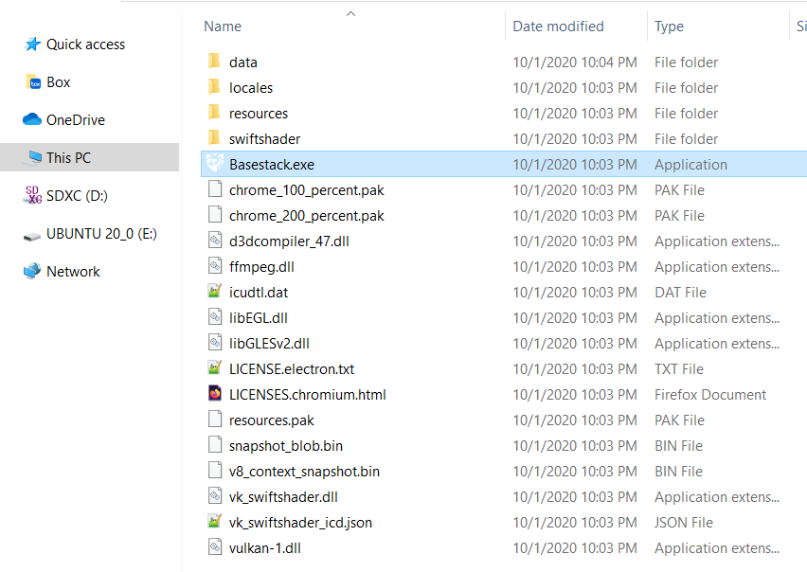

Step 1

You will double-click the Basestack.exe file to open the application

#### A2.2 Developer Mode

View Steps (Click here)

Prereq: python3, miniconda or anaconda environment (Windows Developers only. Installation handled for Mac and Linux in make process)

1. Install make
   * If on Windows you can get this in a conda environment
2. Clone this repo using git clone.
   * All source code will be obtained in the folder.
3. Build Conda Environment using conda
   * conda env create -f environment.yml
   * conda activate basestack
4. Build the App or Run in Development Mode
   * Building the app and dependencies make build-[unix|win]
   * Running hot reload for development make dev
     + Dependencies must be already installed with make build-[unix|win]

Only do this step (below) if you don’t have conda installed

View Details (click here)

https://docs.anaconda.com/anaconda/install/

Examples:

Ubuntu:   
 - wget https://repo.anaconda.com/archive/Anaconda3-2019.10-Linux-x86_64.sh  
 - bash Anaconda3-2019.10-Linux-x86_64.sh  
Mac   
 - https://docs.anaconda.com/anaconda/install/mac-os/  
Windows   
 - https://www.anaconda.com/distribution/#windows

##### Conda on Windows Install Process

View Steps

1. Select **Python3.7** version of Anaconda to install and choose **Save File**

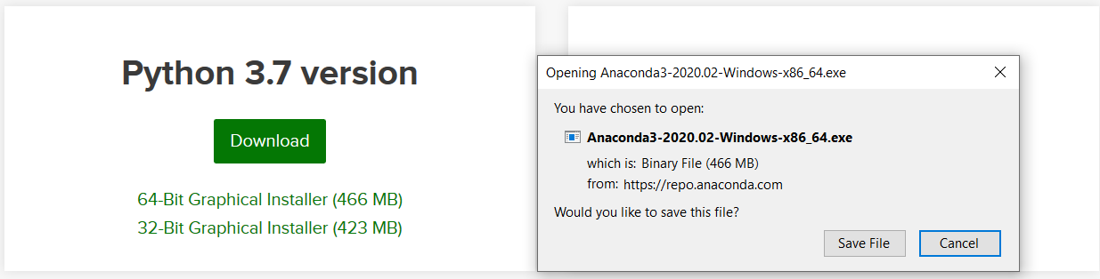

Step 1

1. Wait for the process to bring up the user interface. Select **Next** several times until you get to the install directory location

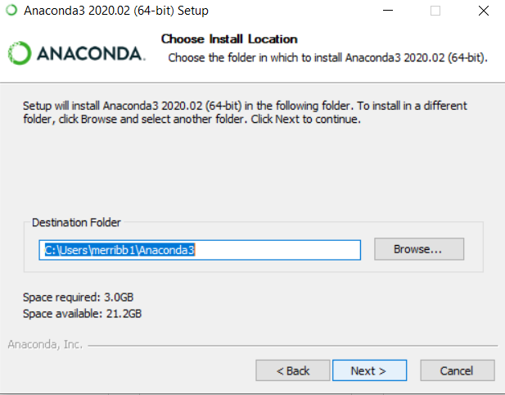

Step 1

If you’d like a new install location specify here. You will need to supply this path for **Step 2**

##### Note

* Both the back and frontend will be started by this command. However, we intend in future releases to utilize websockets to update information to the user interface rather than a separate backend server being served on the host.
* If you want to build for distros that aren’t your own (e.g. Build windows on an ubuntu machine), you will need to download the required third-party apps for this (in this example, wine). Take a look [here](https://www.electron.build/multi-platform-build) for more documentation. You can’t run make build[unix|win] either, you must run the npm commmand for it (located in client/package.json).
  + You can run npm run build:[win,linux,mac-dmg, mac-zip] to accomplish this in client. Leave the value after : blank if you want to opt for your host platform.
  + Currently, there is not support for building a .dmg file on another OS (Windows, Linux). You will have to build a zip folder with the app with npm run build:mac-zip. Mac users can run the default build OR npm run build:mac-dmg
* Mac OSX has not been fully tested for either installation and run/building
* Current Containers to Build:
  + Artic
* Upcoming Containers:
  + [Nextstrain](https://nextstrain.org/help/coronavirus/SARS-CoV-2)
  + [IGV](https://igv.org/)
  + [Mytax](https://github.com/tmehoke/mytax)

### A3 Download Analyis Pipelines

Select *Settings* and Select *Offline* or *Online* Installation of Docker Images

1. Online: Builds the docker images directly from scratch. Recommended for production builds with stable internet access.
   * Click *Install Docker image files Online*. This process can take upwards of 45 minutes depending on internet speeds. please be patient. Once complete, you will receive a notification that the image(s) are ready and you can begin analysis!
     + If you have slow internet speed you may get a message that the image failed to build. Attempt to retry the build process a few more times and see if it works. This usually happens after the first output line has been given and is dependent on how fast your communication with Docker Hub is.
2. Offline: Does not require stable internet. Builds the docker images from a large docker image. Recommended method for OFFLINE usage only.
   * Download artic.tar.gz from the source location (described in section 2 above).
   * If you’re using a Mac or Linux Operating system for the offline image, you must have write/read access to the UID/GID: 1000/1000
   * Once the app is opened, drag+drop the file (or browser to it by clicking the offline input box) into the offline install box (next to gear icon). Click *Install Docker image files offline*. This process can take some time but a notification will pop up when done. If this doesn’t work, please choose the *Online* method described above (Option 1) 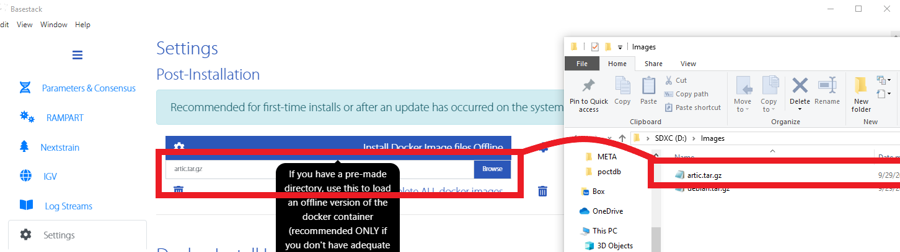

#### Note

These processes can take some time for either method. Rest assured that it will complete. For the online mode, if you receive a warning that the docker image didn’t build, try to rerun it a few more times. Interruptions specifically with internet do occur at times but the process will pick up right back where you last left it. If you keep getting the warning notification, also try refreshing the app at View -> Reload or Force Reload on the top left. You can also hard fresh the app by restarting it altogether (quit and re-enter).

#### Common Errors

Click here

##### I/O timeout

If installing as the offline method, sometimes you may retrieve and I/O exception as an error message. This is typically because you’ve tried to send docker to build too many images from large files in a short period of time. To fix this, you’ll need to rerun docker a specific way

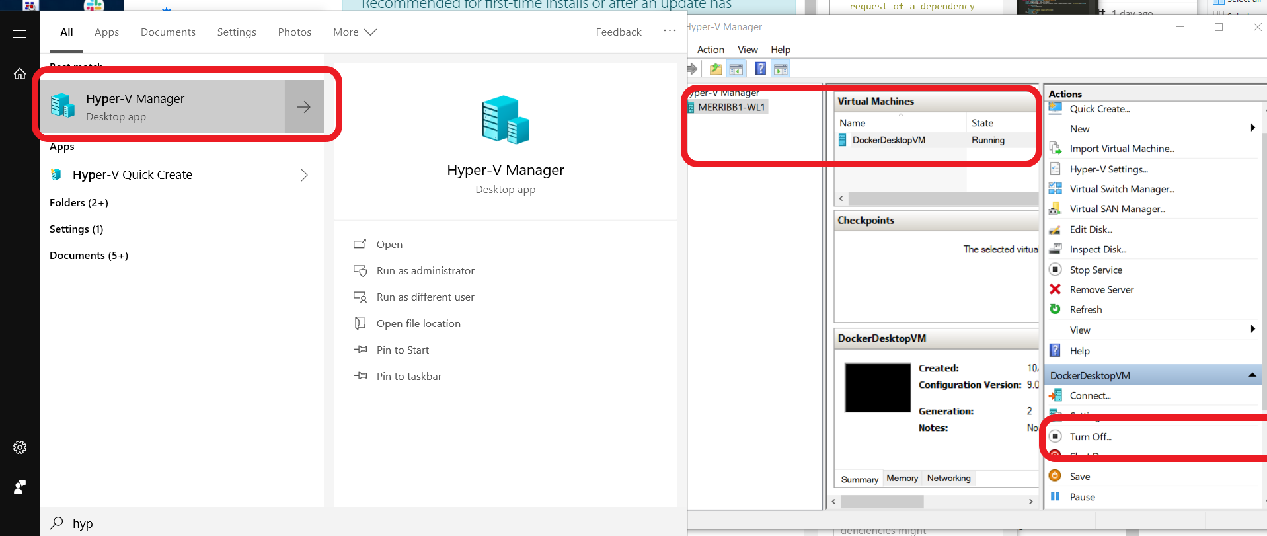

Step 1

* Simply seach for Hyper-V Manager in your toolbar, select the VM (usually your username is in its name), and then *Turn Off*. Docker will then shut down and you can restart it

##### Docker Connection

If you receive an error that you couldn’t connect to docker, please try to restart via the taskbar

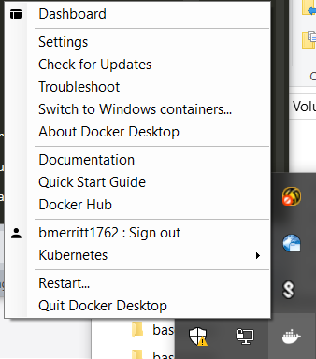

Step 1

### A4. Running Consensus Generation and Reporting

Consensus Generation is the main feature of this application and is used to generate a report of a run directory that was generated from a MinION run. It has multiple steps but is designed to be very automated once a job is submit for analysis.

Step 1 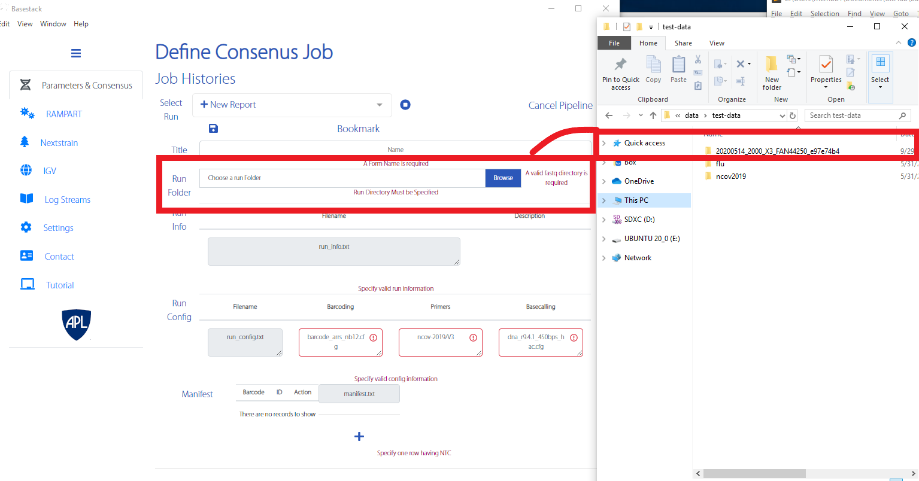

1. Select the appropriate test folder first. This folder is either included in the test-data folder in the source of this application OR you can retrieve it within the install location of the app. For example, in C:\Program Files\Basestack\client\data\test-data.
   * You can either drag + drop it into the *Run Folder* field or select it by left clicking and browser to the directory location on your computer
2. Once a folder has been input, you should see the text fields populate and turn green. If any field is marked as read, it is invalid and should be looked at further for proper formatting. These files should be valid for the test dataset. If you want to use your own data please follow the formatting in run_config.txt, run_info.txt, and manifest.txt. These formats are like:

You may skip this portion if you’d like

1. run_config.txt

|  |  |
| --- | --- |
| Column 1 | Column 2 |
| primers | nCoV-2019/V3 |
| basecalling | dna_r9.4.1_450bps_hac.cfg |
| barcoding | barcode_arrs_nb12.cfg |

* This should be 3 rows that dictate the primer (first), basecalling workflow (second), and barcoding cfg (third/last). Separate by tab.

1. run_info.txt

|  |  |
| --- | --- |
| Column 1 | Column 2 |
| title | plate 6, row c |

* This should be a single row that contains title on the left ALWAYS and short description on the right. Separate by tab

1. manifest.txt

|  |  |
| --- | --- |
| Column 1 | Column 2 |
| NB01 | NTC (always required somewhere in manifest.txt) |
| NB02 | MDHP-00058 |
| NB03 | MDHP-00059 |
| . | . |
| . | . |
| . | . |

* This should be any number of rows that contain barcode on the left ALWAYS and the sample code on the right. A no-template-control (NTC) must always be specified for a report to be completed. Separate by tab.
* You are allowed to input your own custom values for each of the 3 files where the app will overwrite that corresponding file on a job submission. That means you can populate these fields by either directly modifying the files OR by inputting them into the input fields
  + These values are currently not validating to their greatest extent so take care to correctly input values and delimit them with tabs if doing this manually.

Step 2 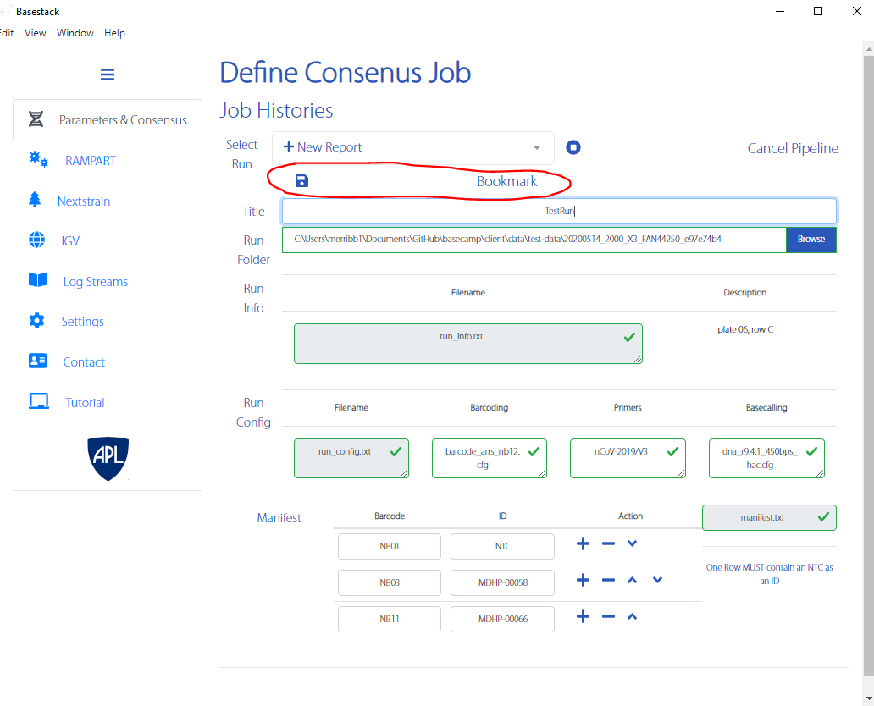

1. Once a folder is input and all greens are seen for the three main files, hit bookmark. The application will save all information and if any error occurs it will be reported appropriately. Please be aware that the software does not catch everything that could go wrong before a job submits

Step 3 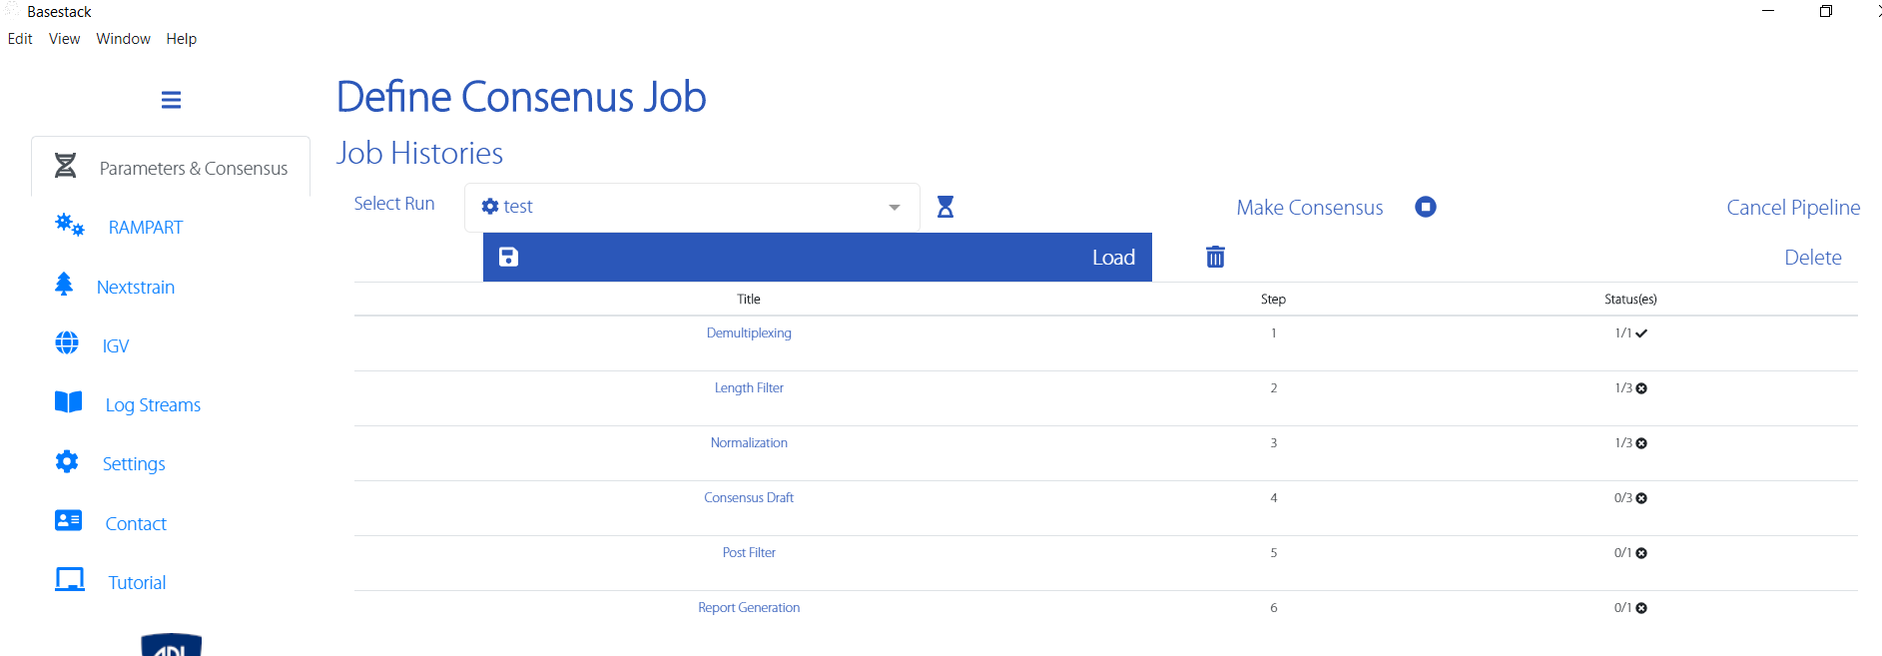

1. Once bookmarked, hit the newly-shown *Load* button to load it into the run. This will allow this tab and *RAMPART* to make use of your specified run directory.
2. Hit Make Consensus to start consensus generation.

*Note*: Depending on your method of installing Docker on Windows, you may receive a notification for docker to share a folder. Hit okay to allow the pipeline to continue. If you run Basestack as an admin, this error will be avoided. You can also opt to share the Basestack folder and sub-folders in the Docker Desktop on Windows as well (see how to do this in the next 2 images)

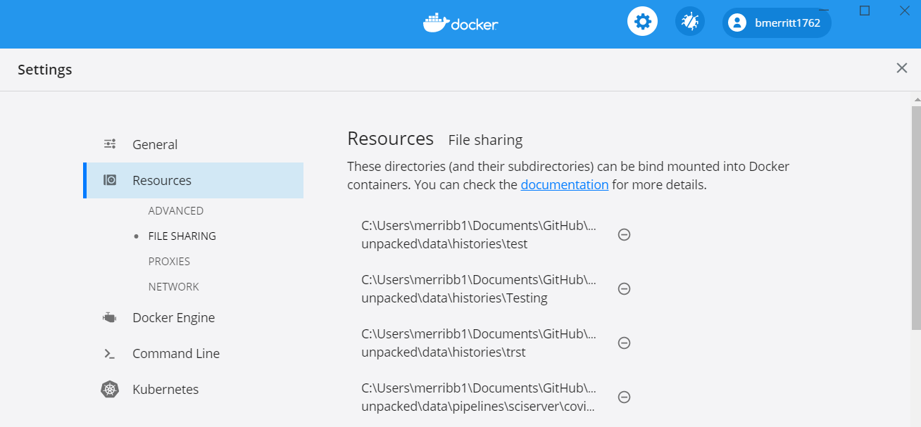

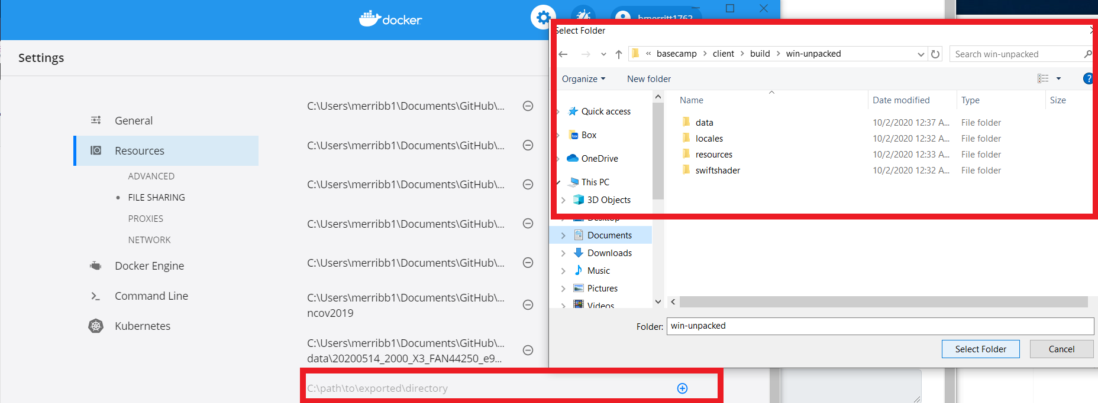

* Simply select the folder that contains the Basestack.exe file by selecting the plus-mark and navigation and selecting it within the browser. In this example it is: ...\build\win-unpacked

Step 4



Step 4

1. You can see the output of the run in the Log Streams tab on the left. You can also see the *Statuse(s)* column begin to change as modules are completed for your run. The final module is the report generation module and should always be *1/1* when complete

Step 5

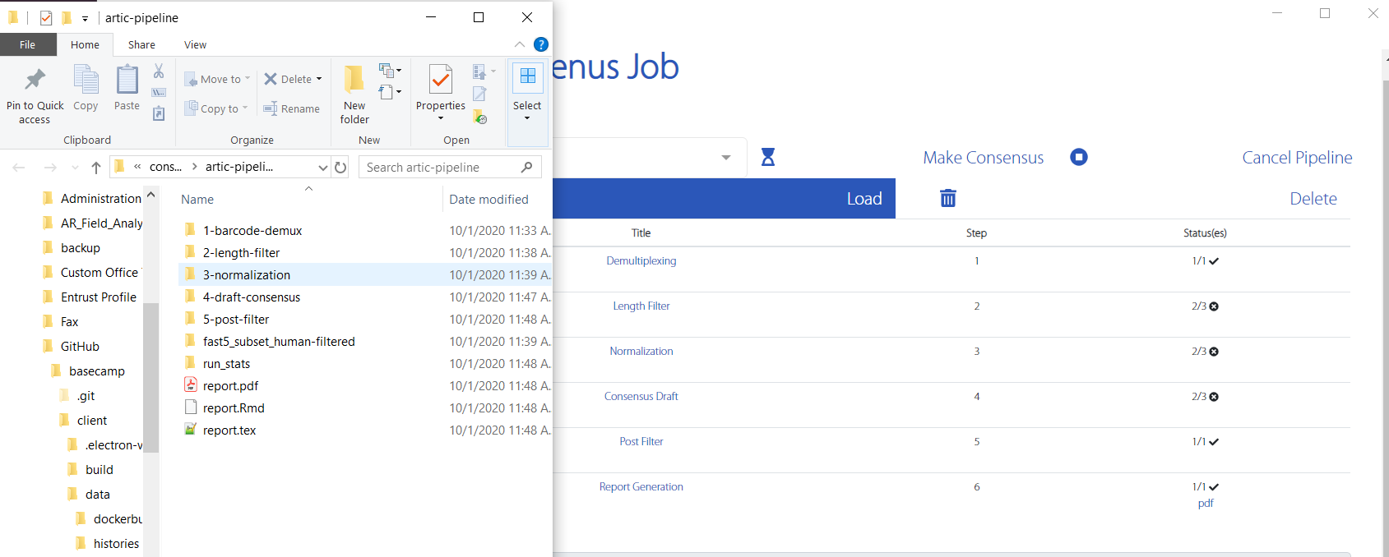

Step 5

1. Once complete, you can view the pdf report by clicking the *pdf* link underneath the final row’s status of *1/1*. You can also traverse to any of the module directories by hitting the link text on the first column for each module. In this example, I’ve chosen *Report Generation* as my link which is a top-level view of all modules, as well as the report.pdf location. Open this pdf to see your report either from the folder or the *pdf* link on the left-most column to see your results!

### A5. Running RAMPART

Rampart is an annotation tool provided by the Artic Network that gives quick, but less accurate reports for each of your demuxed samples. It is ideal for a quick look into what the annotations for each of your barcodes are but should not be fully relied on, instead opt for the pipeline that was just discussed.

1. Ensure you’ve loaded a run that has been bookmarked from the previous tab (described above).
2. Select one of the included primer-schemes from the drop-down list. For this example, the data is ncov-related so we will choose rampart-ncov-2019.
3. Select *Run Rampart* and wait a few seconds for the window to appear. If nothing appears, please hit *Refresh Rampart* and see if the window then appears. Only attempt this if a success message appears after running.

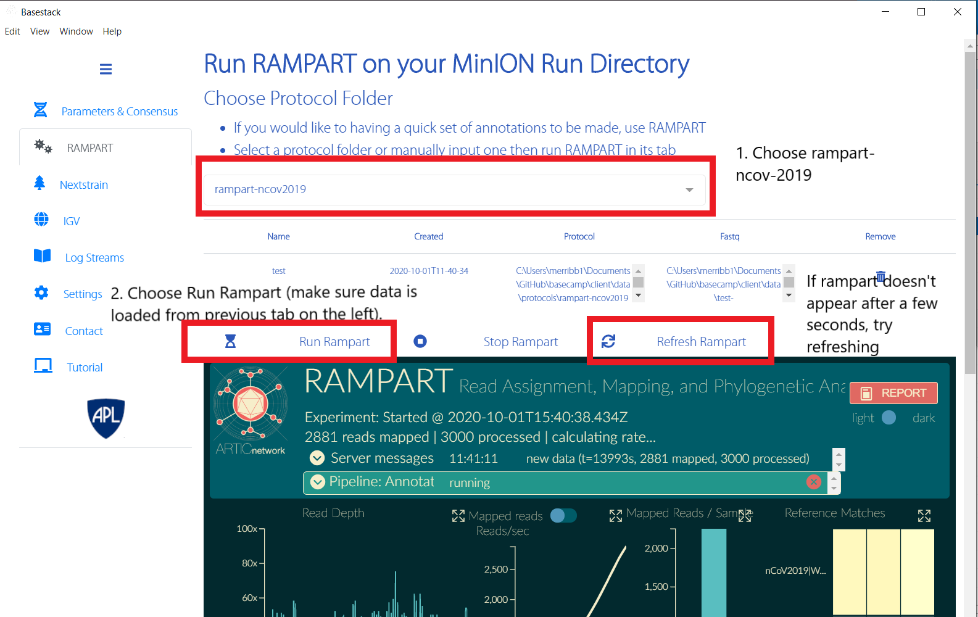

Step 1

### A6. Nextstrain

Requires Internet. Also available at https://nextstrain.org/ncov/global

After the app has generated consensus genomes from the previous 2 commands, you can view mutations or SNPs in your run by selecting the Nextstrain tab at the left-hand side. These mutations can be viewed around Page 11 or section 5.3

Let’s go into our report we just generated and traverse to section 5.3 or page 10-11. The tables provided are all reported mutations against the reference.

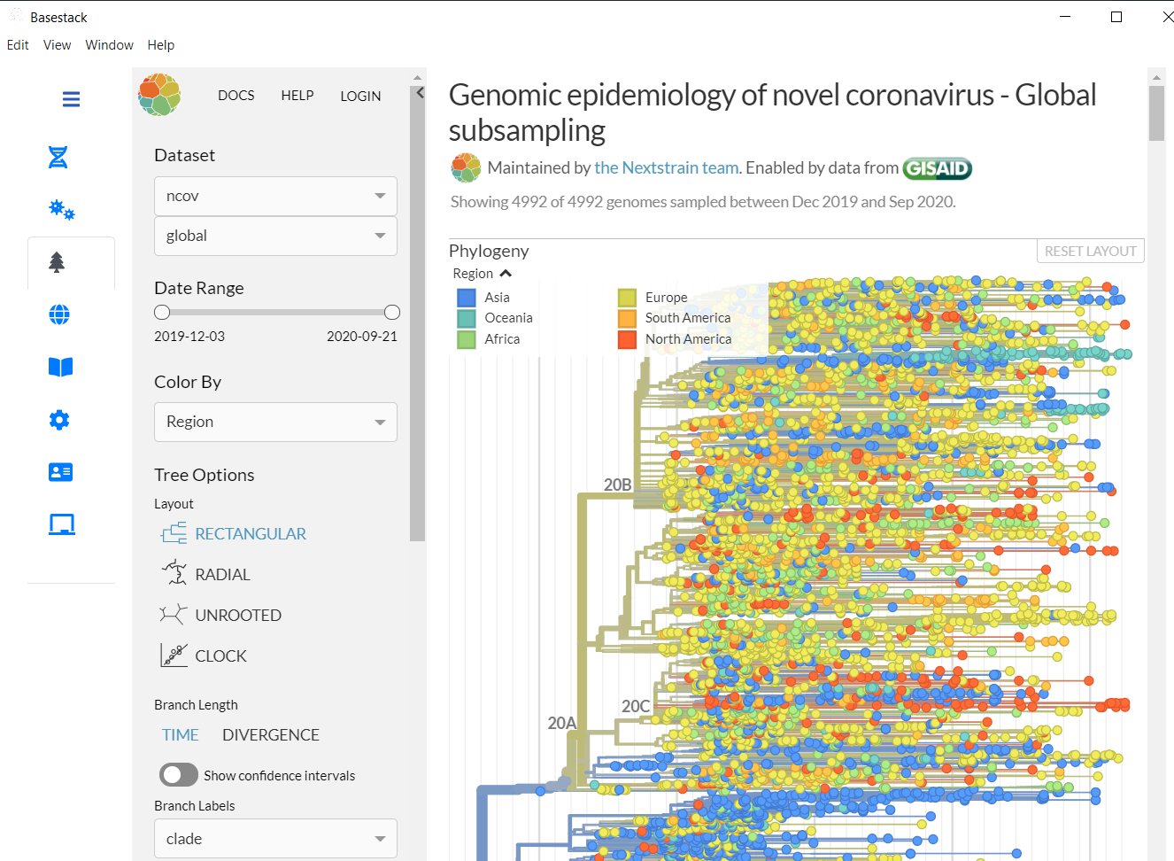

Step 1

* Position 18736 (for example) is a reported SNP for T to C mutation. The annotatin is a missense_variant (see all annotation types in the description of this figure for the report). Though nextstrain we can view this mutation across all samples available that have been sequences and input into nextstrain’s website.



Step 2

* Now that we’ve selected our mutation to view let’s move forward through the interactive site

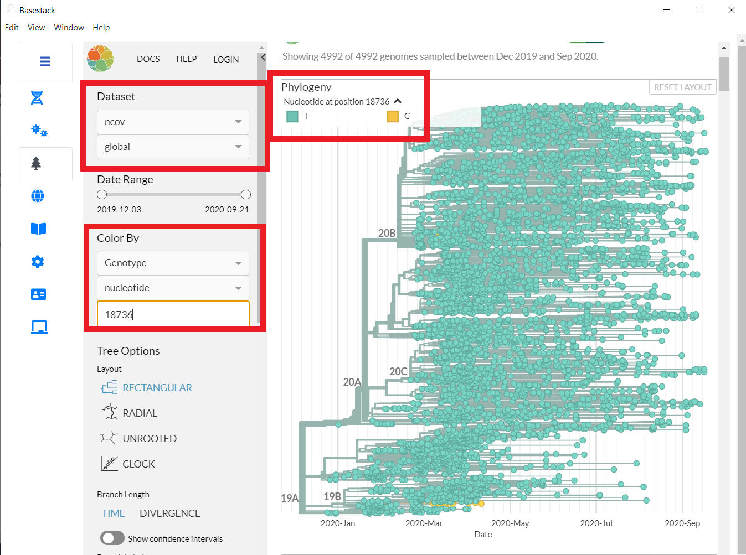

Step 3

To View a specific mutation (and this one for example) reported in the table, select underneath **Color By**

Genotype -> nucleotide -> [Your number here]

Also, be sure that the dataset is ncov and global. You can change the layout of the visualization(s) with the Tree Options parameters

### A7. IGV

Requires Internet. Also available at https://igv.org/app/

IGV is an interactive environment that allows you to view a genome and see any annotations at a specific position.

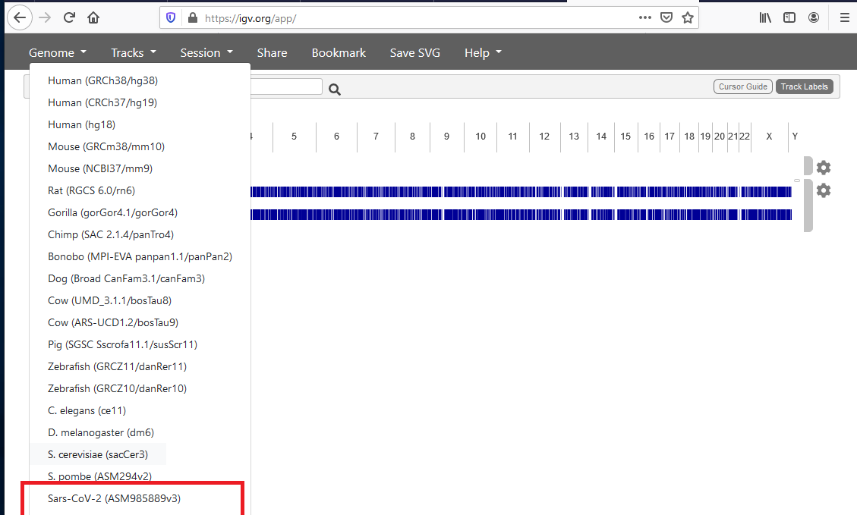

Step 1

1. First, we are going to select our genome of interest, Sars-CoV-2.

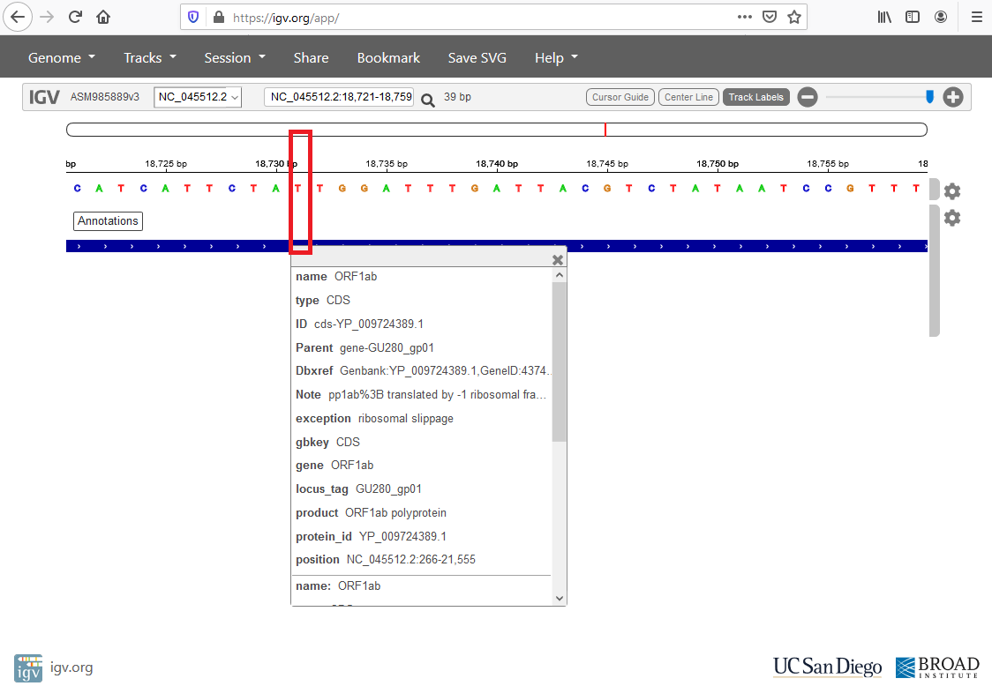

Step 2

1. For our example at position 18736, we can see that it belongs to ORF1ab from the reference and it has a T. As we saw in the report that T was change to a C when compared to the reference. We can also see what protein this position is a part of as well as supplemental information like the protein_id or Dbxref (references for external database resource)

## SUPPLEMENTAL

### Third Party Tools to use with the workshop(s)

These tools are optional and not needed to run any Basestack feature

They are not bundled within Basestack (supplemental to bioinformatic/genomics analysis) and must be downloaded separately. They are (mainly) discussed in the bioinformatics modules of the workshop provided with Basestack

* BEAST v1.10.4:
  + https://beast.community/
  + Available in all 3 OS types
* MEGA X
  + https://www.megasoftware.net/
  + Available in all 3 OS types
* AliView v1.26:
  + https://ormbunkar.se/aliview/downloads/linux/linux-version-1.26/
  + Available in all 3 OS types
* MAFFT v7
* https://mafft.cbrc.jp/alignment/software/
* Available in all 3 OS types
* BEAGLE v3.1.2 build from source (instructions)
  + https://github.com/beagle-dev/beagle-lib/
  + Available in all 3 OS Types
* TempEst v1.5.3
  + http://tree.bio.ed.ac.uk/software/tempest/
  + Available in all 3 OS Types
* Tracer v1.7.1
  + https://github.com/beast-dev/tracer/releases/tag/v1.7.1
  + Available in all 3 OS Types
* FigTree v1.4.4
  + http://tree.bio.ed.ac.uk/software/figtree/
  + Available in all 3 OS Types

Requires Internet. Also available at https://igv.org/app/

* IQTree v2.1.1
  + https://github.com/iqtree/iqtree2/releases
  + You will find the executable in the bin sub-folder. Copy all files in bin folder to your system search path such that you can run IQ-TREE by entering iqtree from the Terminal.
  + Available in all 3 OS Types
* FastTree v2.1.11 (double precision variant)
  + http://www.microbesonline.org/fasttree/
  + Available in all 3 OS Types (Less user-friendly)
* Python3
  + https://www.python.org/downloads/
  + Available in all 3 OS Types
* biopython
  + https://biopython.org/wiki/Download
  + Install after installing/updating Python

These tools are optional and not needed to run any Basestack feature

### Special Mentions

* Andrew Rambaut, James Hadfield and Team @ [artic-network](https://artic.network/)
* Trevor Bedford and Team @ [Nextstrain](https://nextstrain.org/)
* UC San Diego and Broad Inst. @ [IGV](https://igv.org/)

## Authors of Basestack

* Brian Merritt
* Tom Mehoke
* Craig Howser

## Uninstalling

Docker Image(s): - In Basestack, go to Settings - Select: Remove Docker Images - This will only remove Basestack-specific images Basestack: - Windows - UNPACKED - Delete the Basestack-Unpacked-Windows Folder - Remove C:\Users\<you>\AppData\Local\Basestack Name - Application - Add or remove programs -> Select Basestack -> Uninstall - Mac - Drag ~/Library/Application Support/Basestack to the Bin - Linux 1. Remove the Basestack.AppImage Folder or Executable 2. Remove the directory: ~/.config/Basestack User Data: - Mac OS: ~/Library/Application Support/Basestack (taken from the name property in package.json)> - Windows: C:\Users\<you>\AppData\Local\Basestack Name - Linux: ~/.config/Basestack