**PNG Basic Resize Linked Photo**

The image is originally 64x64, but is scaled up to 128x128. It should NOT be resized because the resulting HTML will automatically scale it up to fit.

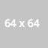

This image is 128x128 and has not been scaled at all. It should be untouched.

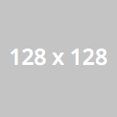

This image is originally 256x256 but has been scaled down to 128x128. It should be resized to 128x128 before being converted to a data uri.

