Interior Design
example

Contents
We know design 1
Our clients 2
Our mission 2
About us 2
Contact us 2
Visit us on the Web: 2

Joe Hudson
[Draw your reader in with an engaging abstract. It is typically a short summary of the document. When you’re ready to add your content, just click here and start typing.]
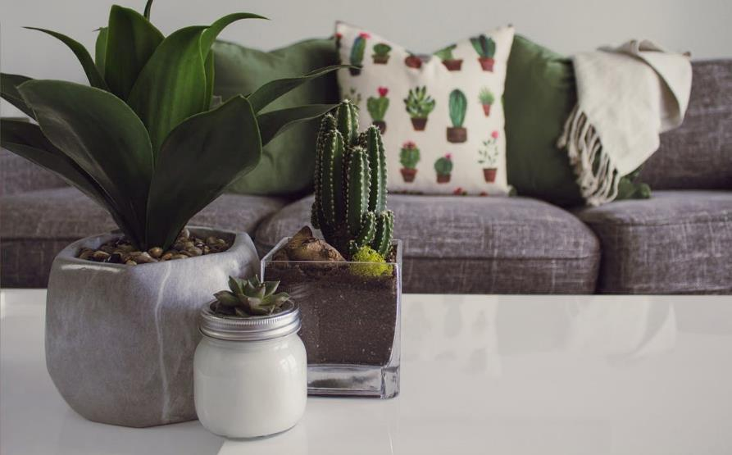
We don’t just curate, we create.  You can use this clean, professional brochure just as it is or easily customize it.  On the next page, we’ve added a few tips (like this one) to help you get started. |  | We know design  If you think a document that looks this good has to be difficult to format, think again!  We've created styles that let you match the formatting in this brochure with just a click. On the Home tab of the ribbon, check out the Styles gallery.

Bauhouse Design
Interior Design

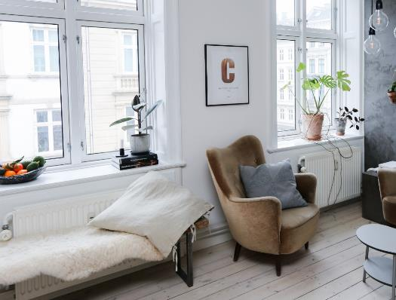
 |  | You might want to mention a few of your most impressive clients here:  - Big, important company  - Really well-known company  - Very impressive company  Our clients  Don’t be shy! Show them how fabulous you are. List or summarize key points here about what you do. |  | Our mission  To change any of the text in this document, just click on the block of text you want to update! The formatting has already been programmed for ease of formatting.  About us  If you replace a photo with your own and it’s not a flawless fit for the space, you can use the Desktop App to crop it to fit in almost no time. Just select the picture and then, on the Picture Format tab, click Crop.

Contact us
123 45th Ave.
Chicago, IL 54321
(909) 555-0199
[Email]

Visit us on the Web:
[Web Address]

