Getting Started on AnVIL

January 21, 2025

Table of Contents

# About this Book

This book is part of a series of books for the Genomic Data Science Analysis, Visualization, and Informatics Lab-space (AnVIL) of the National Human Genome Research Institute (NHGRI). Here, we present opinionated step-by-step guides for setting up accounts focused on three personas: PIs, Analysts, and Consortia.

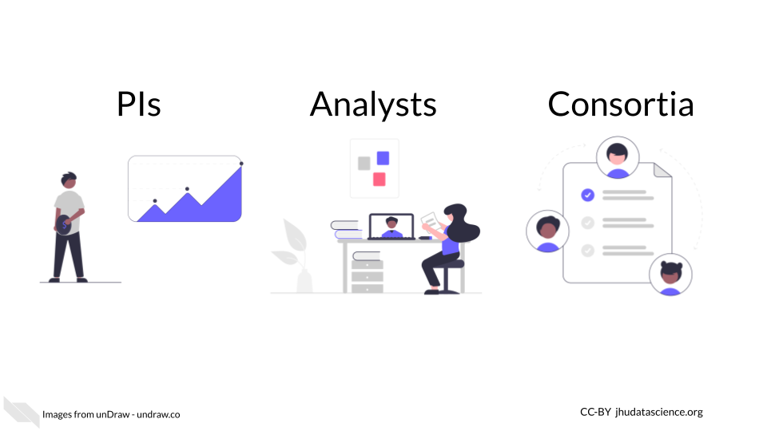

### Skills Level

Please choose the closest matching persona from the lefthand menu.

*Genetics*

**Novice**: no genetics knowledge needed

*Programming skills*

**Novice**: no programming experience needed

### AnVIL Collection

Additional guides are provided to help you with Workspaces, launch interactive tools, and start working with data. Learn more about AnVIL by visiting <https://anvilproject.org> or reading the [article in Cell Genomics](https://www.sciencedirect.com/science/article/pii/S2666979X21001063).

Please check out our full collection of AnVIL and related resources: <https://hutchdatascience.org/AnVIL_Collection/>

# 1 Student Guide

## 1.1 Activity One

You might want to create a student guide that contains a different subset of Rmd files from your book, or renders to a different output format (e.g. word document). You can specify the output and Rmd files that will be used for the student guide using the _output.yml and _bookdown.yml files in the student-guide directory.

## 1.2 Activity Two

Steps of the guide could go here.