Getting Started on AnVIL

August 27, 2025

Table of Contents

# About this Book

This book is part of a series of books for the Genomic Data Science Analysis, Visualization, and Informatics Lab-space (AnVIL) of the National Human Genome Research Institute (NHGRI). Here, we present opinionated step-by-step guides for setting up accounts focused on three personas: PIs, Analysts, and Consortia.

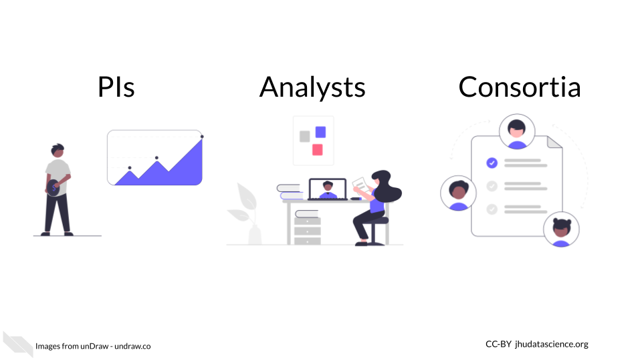

### Skills Level

Please choose the closest matching persona from the lefthand menu.

*Genetics*

**Novice**: no genetics knowledge needed

*Programming skills*

**Novice**: no programming experience needed

### AnVIL Collection

Additional guides are provided to help you with Workspaces, launch interactive tools, and start working with data. Learn more about AnVIL by visiting <https://anvilproject.org> or reading the [article in Cell Genomics](https://www.sciencedirect.com/science/article/pii/S2666979X21001063).

Please check out our full collection of AnVIL and related resources: <https://hutchdatascience.org/AnVIL_Collection/>

# 1 Student Guide

## 1.1 Activity One

Many of the AnVIL books that are designed for teaching a class or workshop contain information aimed at the instructor.

You might want to create a “student guide” that contains a different subset of Rmd files from your book, or renders to a different output format (e.g. word document). You can specify the output and Rmd files that will be used for the student guide using the _output.yml and _bookdown.yml files in the student-guide directory.

By default, repositories based on AnVIL_Template create a docx file containing this chapter as an example. Once you have adjusted student-guide/bookdown.yml to include the chapters you want in your student guide, you can link to it by replacing {repo-name} in the following URL:

https://github.com/jhudsl/{repo-name}/raw/main/student-guide/docs/Student_Guide.docx

When someone clicks this link, they will download the docx file. For example, here is the link for the student guide from AnVIL_Template:

<https://github.com/jhudsl/AnVIL_Template/raw/main/student-guide/docs/Student_Guide.docx>

## 1.2 Activity Two

Steps of the guide could go here.

# About the Authors

These credits are based on our [course contributors table guidelines](https://github.com/jhudsl/DaSL_Course_Template_Bookdown/wiki/How-to-give-credits).

***In*** [***memory***](https://galaxyproject.org/jxtx/) ***of*** [***James Taylor***](https://genomebiology.biomedcentral.com/articles/10.1186/s13059-020-02016-0)***, who was instrumental in initiating this project.***

| Credits | Names |
| --- | --- |
| **Pedagogy** |  |
| Lead Content Instructors | [Katherine Cox](https://publichealth.jhu.edu/faculty/4170/katherine-cox), [Ava Hoffman](https://www.avahoffman.com/) |
| Content Contributors | [Kai Kammers](https://www.hopkinsmedicine.org/profiles/details/kai-kammers), [Frederick Tan](https://carnegiescience.edu/frederick-tan), [Sarah Wheelan](https://publichealth.jhu.edu/faculty/1902/sarah-wheelan) |
| Content Editors/Reviewers | Natalie Kucher, [Jeff Leek](https://jtleek.com/), Valerie Reeves, [Frederick Tan](https://carnegiescience.edu/frederick-tan) |
| Content Directors | [Jeff Leek](https://jtleek.com/), [Frederick Tan](https://carnegiescience.edu/frederick-tan) |
| Content Consultants | [Allie Cliffe](https://www.linkedin.com/in/allie-cliffe/), Candace Patterson |
| **Production** |  |
| Content Publisher | [Ira Gooding](https://publichealth.jhu.edu/faculty/4130/ira-gooding) |
| **Technical** |  |
| Template Publishing Engineers | [Candace Savonen](https://www.cansavvy.com/), [Carrie Wright](https://carriewright11.github.io/) |
| Publishing Maintenance Engineer | [Candace Savonen](https://www.cansavvy.com/) |
| Technical Publishing Stylists | [Carrie Wright](https://carriewright11.github.io/), [Candace Savonen](https://www.cansavvy.com/) |
| Package Developers ([ottrpal](https://github.com/jhudsl/ottrpal)) | [John Muschelli](https://johnmuschelli.com/), [Candace Savonen](https://www.cansavvy.com/), [Carrie Wright](https://carriewright11.github.io/) |
| **Funding** |  |
| Funder | [National Human Genome Research Institute (NHGRI)](https://www.genome.gov/) #5U24HG010263 |
| Funding Staff | Fallon Bachman, Jennifer Vessio, Emily Voeglein |

## ─ Session info ───────────────────────────────────────────────────────────────  
## setting value  
## version R version 4.3.2 (2023-10-31)  
## os Ubuntu 22.04.4 LTS  
## system x86_64, linux-gnu  
## ui X11  
## language (EN)  
## collate en_US.UTF-8  
## ctype en_US.UTF-8  
## tz Etc/UTC  
## date 2025-08-27  
## pandoc 3.1.1 @ /usr/local/bin/ (via rmarkdown)  
##   
## ─ Packages ───────────────────────────────────────────────────────────────────  
## package * version date (UTC) lib source  
## bookdown 0.43 2025-04-15 [1] CRAN (R 4.3.2)  
## cachem 1.0.8 2023-05-01 [1] RSPM (R 4.3.0)  
## cli 3.6.2 2023-12-11 [1] RSPM (R 4.3.0)  
## devtools 2.4.5 2022-10-11 [1] RSPM (R 4.3.0)  
## digest 0.6.34 2024-01-11 [1] RSPM (R 4.3.0)  
## ellipsis 0.3.2 2021-04-29 [1] RSPM (R 4.3.0)  
## evaluate 1.0.4 2025-06-18 [1] CRAN (R 4.3.2)  
## fastmap 1.1.1 2023-02-24 [1] RSPM (R 4.3.0)  
## fs 1.6.3 2023-07-20 [1] RSPM (R 4.3.0)  
## glue 1.7.0 2024-01-09 [1] RSPM (R 4.3.0)  
## htmltools 0.5.7 2023-11-03 [1] RSPM (R 4.3.0)  
## htmlwidgets 1.6.4 2023-12-06 [1] RSPM (R 4.3.0)  
## httpuv 1.6.14 2024-01-26 [1] RSPM (R 4.3.0)  
## knitr 1.50 2025-03-16 [1] CRAN (R 4.3.2)  
## later 1.3.2 2023-12-06 [1] RSPM (R 4.3.0)  
## lifecycle 1.0.4 2023-11-07 [1] RSPM (R 4.3.0)  
## magrittr 2.0.3 2022-03-30 [1] RSPM (R 4.3.0)  
## memoise 2.0.1 2021-11-26 [1] RSPM (R 4.3.0)  
## mime 0.12 2021-09-28 [1] RSPM (R 4.3.0)  
## miniUI 0.1.1.1 2018-05-18 [1] RSPM (R 4.3.0)  
## pkgbuild 1.4.3 2023-12-10 [1] RSPM (R 4.3.0)  
## pkgload 1.3.4 2024-01-16 [1] RSPM (R 4.3.0)  
## profvis 0.3.8 2023-05-02 [1] RSPM (R 4.3.0)  
## promises 1.2.1 2023-08-10 [1] RSPM (R 4.3.0)  
## purrr 1.0.2 2023-08-10 [1] RSPM (R 4.3.0)  
## R6 2.5.1 2021-08-19 [1] RSPM (R 4.3.0)  
## Rcpp 1.0.12 2024-01-09 [1] RSPM (R 4.3.0)  
## remotes 2.4.2.1 2023-07-18 [1] RSPM (R 4.3.0)  
## rlang 1.1.6 2025-04-11 [1] CRAN (R 4.3.2)  
## rmarkdown 2.25 2023-09-18 [1] RSPM (R 4.3.0)  
## sessioninfo 1.2.2 2021-12-06 [1] RSPM (R 4.3.0)  
## shiny 1.8.0 2023-11-17 [1] RSPM (R 4.3.0)  
## stringi 1.8.3 2023-12-11 [1] RSPM (R 4.3.0)  
## stringr 1.5.1 2023-11-14 [1] RSPM (R 4.3.0)  
## urlchecker 1.0.1 2021-11-30 [1] RSPM (R 4.3.0)  
## usethis 2.2.3 2024-02-19 [1] RSPM (R 4.3.0)  
## vctrs 0.6.5 2023-12-01 [1] RSPM (R 4.3.0)  
## xfun 0.52 2025-04-02 [1] CRAN (R 4.3.2)  
## xtable 1.8-4 2019-04-21 [1] RSPM (R 4.3.0)  
## yaml 2.3.10 2024-07-26 [1] CRAN (R 4.3.2)  
##   
## [1] /usr/local/lib/R/site-library  
## [2] /usr/local/lib/R/library  
##   
## ──────────────────────────────────────────────────────────────────────────────

# 2 References