WDL Workflows

May 06, 2025

Table of Contents

knitr::opts_chunk$set(out.width = "100%")

# Overview

This book introduces WDL Workflows on AnVIL-powered-by-Terra. After introducing several concepts, including basic WDL syntax, we present hands-on exercises to run a workflow, write a WDL, localize a file, customize a Docker image, and join the Discourse. No local software installation is required as each exercise leverages web-based resources.

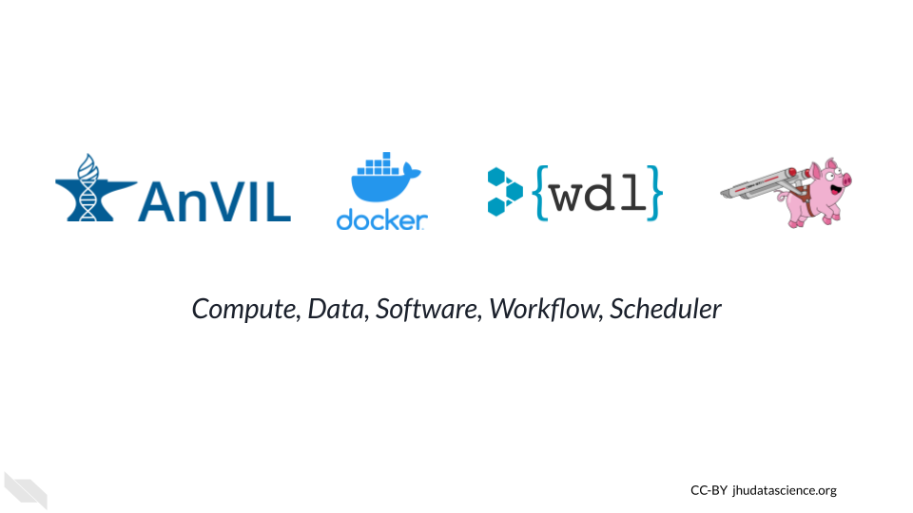

## Skills Level

*Genetics*  
**Novice**: No genetics knowledge needed

*Programming skills*  
**Novice**: No programming experience needed

## Learning Objectives

* Understand when WDL Workflows are the right tool
* Run a Workflow on AnVIL-powered-by-Terra
* Write a WDL using Broad Methods Repository
* Bring your own data to analyze
* Customize your Docker environment
* Join the conversation

## Timing

It should take approximately 1.5-2 hours to complete this course, including hands-on exercises.

## Branding

Due to differences in branding, some of the screenshots shown in this course may include different logos and colors than what you see on Terra. However, the same functions and menus are available regardless of whether you’re using AnVIL-powered-by-Terra, classic Terra, or another version of the platform.

## AnVIL Collection

Please check out our full collection of AnVIL and related resources: <https://hutchdatascience.org/AnVIL_Collection/>

# 1 Student Guide

## 1.1 Activity One

Many of the AnVIL books that are designed for teaching a class or workshop contain information aimed at the instructor.

You might want to create a “student guide” that contains a different subset of Rmd files from your book, or renders to a different output format (e.g. word document). You can specify the output and Rmd files that will be used for the student guide using the _output.yml and _bookdown.yml files in the student-guide directory.

By default, repositories based on AnVIL_Template create a docx file containing this chapter as an example. Once you have adjusted student-guide/bookdown.yml to include the chapters you want in your student guide, you can link to it by replacing {repo-name} in the following URL:

https://github.com/jhudsl/{repo-name}/raw/main/student-guide/docs/Student_Guide.docx

When someone clicks this link, they will download the docx file. For example, here is the link for the student guide from AnVIL_Template:

<https://github.com/jhudsl/AnVIL_Template/raw/main/student-guide/docs/Student_Guide.docx>

## 1.2 Activity Two

Steps of the guide could go here.

# About the Authors

These credits are based on our [course contributors table guidelines](https://github.com/jhudsl/DaSL_Course_Template_Bookdown/wiki/How-to-give-credits).

| Credits | Names |
| --- | --- |
| **Pedagogy** |  |
| Lead Content Instructor(s) | [FirstName LastName](link%20to%20personal%20website) |
| Lecturer(s) (include chapter name/link in parentheses if only for specific chapters) - make new line if more than one chapter involved | Delivered the course in some way - video or audio |
| Content Author(s) (include chapter name/link in parentheses if only for specific chapters) - make new line if more than one chapter involved | If any other authors besides lead instructor |
| Content Contributor(s) (include section name/link in parentheses) - make new line if more than one section involved | Wrote less than a chapter |
| Content Editor(s)/Reviewer(s) | Checked your content |
| Content Director(s) | Helped guide the content direction |
| Content Consultants (include chapter name/link in parentheses or word “General”) - make new line if more than one chapter involved | Gave high level advice on content |
| Acknowledgments | Gave small assistance to content but not to the level of consulting |
| **Production** |  |
| Content Publisher(s) | Helped with publishing platform |
| Content Publishing Reviewer(s) | Reviewed overall content and aesthetics on publishing platform |
| **Technical** |  |
| Course Publishing Engineer(s) | Helped with the code for the technical aspects related to the specific course generation |
| Template Publishing Engineers | [Candace Savonen](https://www.cansavvy.com/), [Carrie Wright](https://carriewright11.github.io/) |
| Publishing Maintenance Engineer | [Candace Savonen](https://www.cansavvy.com/) |
| Technical Publishing Stylists | [Carrie Wright](https://carriewright11.github.io/), [Candace Savonen](https://www.cansavvy.com/) |
| Package Developers ([Leanbuild](https://github.com/jhudsl/leanbuild)) | [John Muschelli](https://johnmuschelli.com/), [Candace Savonen](https://www.cansavvy.com/), [Carrie Wright](https://carriewright11.github.io/) |
| **Art and Design** |  |
| Illustrator(s) | Created graphics for the course |
| Figure Artist(s) | Created figures/plots for course |
| Videographer(s) | Filmed videos |
| Videography Editor(s) | Edited film |
| Audiographer(s) | Recorded audio |
| Audiography Editor(s) | Edited audio recordings |
| **Funding** |  |
| Funder(s) | Institution/individual who funded course including grant number |
| Funding Staff | Staff members who help with funding |

## ─ Session info ───────────────────────────────────────────────────────────────  
## setting value  
## version R version 4.3.2 (2023-10-31)  
## os Ubuntu 22.04.4 LTS  
## system x86_64, linux-gnu  
## ui X11  
## language (EN)  
## collate en_US.UTF-8  
## ctype en_US.UTF-8  
## tz Etc/UTC  
## date 2025-05-06  
## pandoc 3.1.1 @ /usr/local/bin/ (via rmarkdown)  
##   
## ─ Packages ───────────────────────────────────────────────────────────────────  
## package * version date (UTC) lib source  
## bookdown 0.41 2024-10-16 [1] CRAN (R 4.3.2)  
## cachem 1.0.8 2023-05-01 [1] RSPM (R 4.3.0)  
## cli 3.6.2 2023-12-11 [1] RSPM (R 4.3.0)  
## devtools 2.4.5 2022-10-11 [1] RSPM (R 4.3.0)  
## digest 0.6.34 2024-01-11 [1] RSPM (R 4.3.0)  
## ellipsis 0.3.2 2021-04-29 [1] RSPM (R 4.3.0)  
## evaluate 0.23 2023-11-01 [1] RSPM (R 4.3.0)  
## fastmap 1.1.1 2023-02-24 [1] RSPM (R 4.3.0)  
## fs 1.6.3 2023-07-20 [1] RSPM (R 4.3.0)  
## glue 1.7.0 2024-01-09 [1] RSPM (R 4.3.0)  
## htmltools 0.5.7 2023-11-03 [1] RSPM (R 4.3.0)  
## htmlwidgets 1.6.4 2023-12-06 [1] RSPM (R 4.3.0)  
## httpuv 1.6.14 2024-01-26 [1] RSPM (R 4.3.0)  
## knitr 1.48 2024-07-07 [1] CRAN (R 4.3.2)  
## later 1.3.2 2023-12-06 [1] RSPM (R 4.3.0)  
## lifecycle 1.0.4 2023-11-07 [1] RSPM (R 4.3.0)  
## magrittr 2.0.3 2022-03-30 [1] RSPM (R 4.3.0)  
## memoise 2.0.1 2021-11-26 [1] RSPM (R 4.3.0)  
## mime 0.12 2021-09-28 [1] RSPM (R 4.3.0)  
## miniUI 0.1.1.1 2018-05-18 [1] RSPM (R 4.3.0)  
## pkgbuild 1.4.3 2023-12-10 [1] RSPM (R 4.3.0)  
## pkgload 1.3.4 2024-01-16 [1] RSPM (R 4.3.0)  
## profvis 0.3.8 2023-05-02 [1] RSPM (R 4.3.0)  
## promises 1.2.1 2023-08-10 [1] RSPM (R 4.3.0)  
## purrr 1.0.2 2023-08-10 [1] RSPM (R 4.3.0)  
## R6 2.5.1 2021-08-19 [1] RSPM (R 4.3.0)  
## Rcpp 1.0.12 2024-01-09 [1] RSPM (R 4.3.0)  
## remotes 2.4.2.1 2023-07-18 [1] RSPM (R 4.3.0)  
## rlang 1.1.4 2024-06-04 [1] CRAN (R 4.3.2)  
## rmarkdown 2.25 2023-09-18 [1] RSPM (R 4.3.0)  
## sessioninfo 1.2.2 2021-12-06 [1] RSPM (R 4.3.0)  
## shiny 1.8.0 2023-11-17 [1] RSPM (R 4.3.0)  
## stringi 1.8.3 2023-12-11 [1] RSPM (R 4.3.0)  
## stringr 1.5.1 2023-11-14 [1] RSPM (R 4.3.0)  
## urlchecker 1.0.1 2021-11-30 [1] RSPM (R 4.3.0)  
## usethis 2.2.3 2024-02-19 [1] RSPM (R 4.3.0)  
## vctrs 0.6.5 2023-12-01 [1] RSPM (R 4.3.0)  
## xfun 0.48 2024-10-03 [1] CRAN (R 4.3.2)  
## xtable 1.8-4 2019-04-21 [1] RSPM (R 4.3.0)  
## yaml 2.3.8 2023-12-11 [1] RSPM (R 4.3.0)  
##   
## [1] /usr/local/lib/R/site-library  
## [2] /usr/local/lib/R/library  
##   
## ──────────────────────────────────────────────────────────────────────────────

# References