Course Name
December, 2025
Table of Contents

About this Course

0.1 Available course formats
This course is available in multiple formats which allows you to take it in the way that best suites your needs. You can take it for certificate which can be for free or fee.
- The material for this course can be viewed without login requirement on this Bookdown website. This format might be most appropriate for you if you rely on screen-reader technology.
- This course can be taken for free certification through Leanpub.
- This course can be taken on Coursera for certification here (but it is not available for free on Coursera).
- Our courses are open source, you can find the source material for this course on GitHub.

1 Testing Borrow Chapter
## Warning: Chunk option fig.align is not supported for docx output
## Warning: Chunk option fig.alt is not supported for docx output
## Warning: Chunk option fig.align is not supported for docx output
## Warning: Chunk option fig.alt is not supported for docx output
## Warning: Chunk option fig.align is not supported for docx output
## Warning: Chunk option fig.alt is not supported for docx output
## Warning: Chunk option fig.align is not supported for docx output
## Warning: Chunk option fig.alt is not supported for docx output
## Warning: Chunk option fig.align is not supported for docx output
## Warning: Chunk option fig.alt is not supported for docx output
## Warning: Chunk option fig.align is not supported for docx output
## Warning: Chunk option fig.alt is not supported for docx output
## Warning: Chunk option fig.align is not supported for docx output
## Warning: Chunk option fig.alt is not supported for docx output
## Warning: Chunk option fig.align is not supported for docx output
## Warning: Chunk option fig.alt is not supported for docx output
## Warning: Chunk option fig.align is not supported for docx output
## Warning: Chunk option fig.alt is not supported for docx output
## Warning: Chunk option fig.align is not supported for docx output
## Warning: Chunk option fig.alt is not supported for docx output
## Warning: Chunk option fig.align is not supported for docx output
## Warning: Chunk option fig.alt is not supported for docx output
## Warning: Chunk option fig.align is not supported for docx output
## Warning: Chunk option fig.alt is not supported for docx output
## Warning: Chunk option fig.align is not supported for docx output
## Warning: Chunk option fig.alt is not supported for docx output
## Warning: Chunk option fig.align is not supported for docx output
## Warning: Chunk option fig.alt is not supported for docx output
## Warning: Chunk option fig.align is not supported for docx output
## Warning: Chunk option fig.alt is not supported for docx output
## Warning: Chunk option fig.align is not supported for docx output
## Warning: Chunk option fig.alt is not supported for docx output
## Warning: Chunk option fig.align is not supported for docx output
## Warning: Chunk option fig.alt is not supported for docx output
## Warning: Chunk option fig.align is not supported for docx output
## Warning: Chunk option fig.alt is not supported for docx output
## Warning: Chunk option fig.align is not supported for docx output
## Warning: Chunk option fig.alt is not supported for docx output

1.1 Learning Objectives
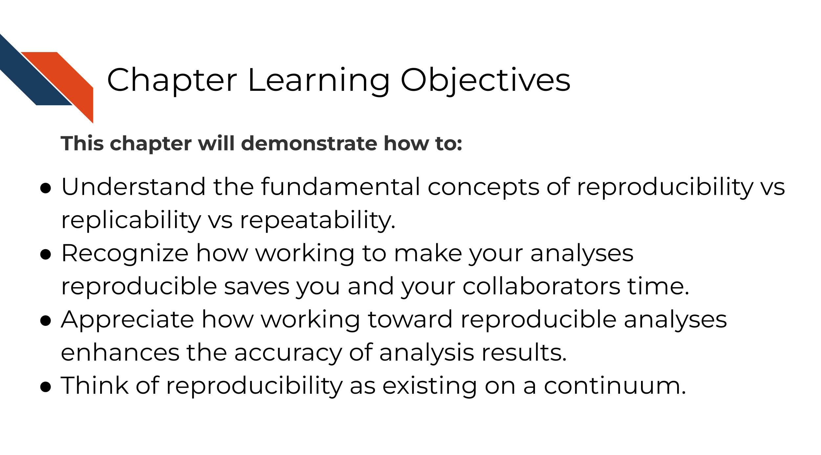

1.2 What is reproducibility
There’s been a lot of discussion about what is included in the term reproducibility and there is some discrepancy between fields. For the purposes of informatics and data analysis, a reproducible analysis is one that can be re-run by a different researcher and the same result and conclusion is found.
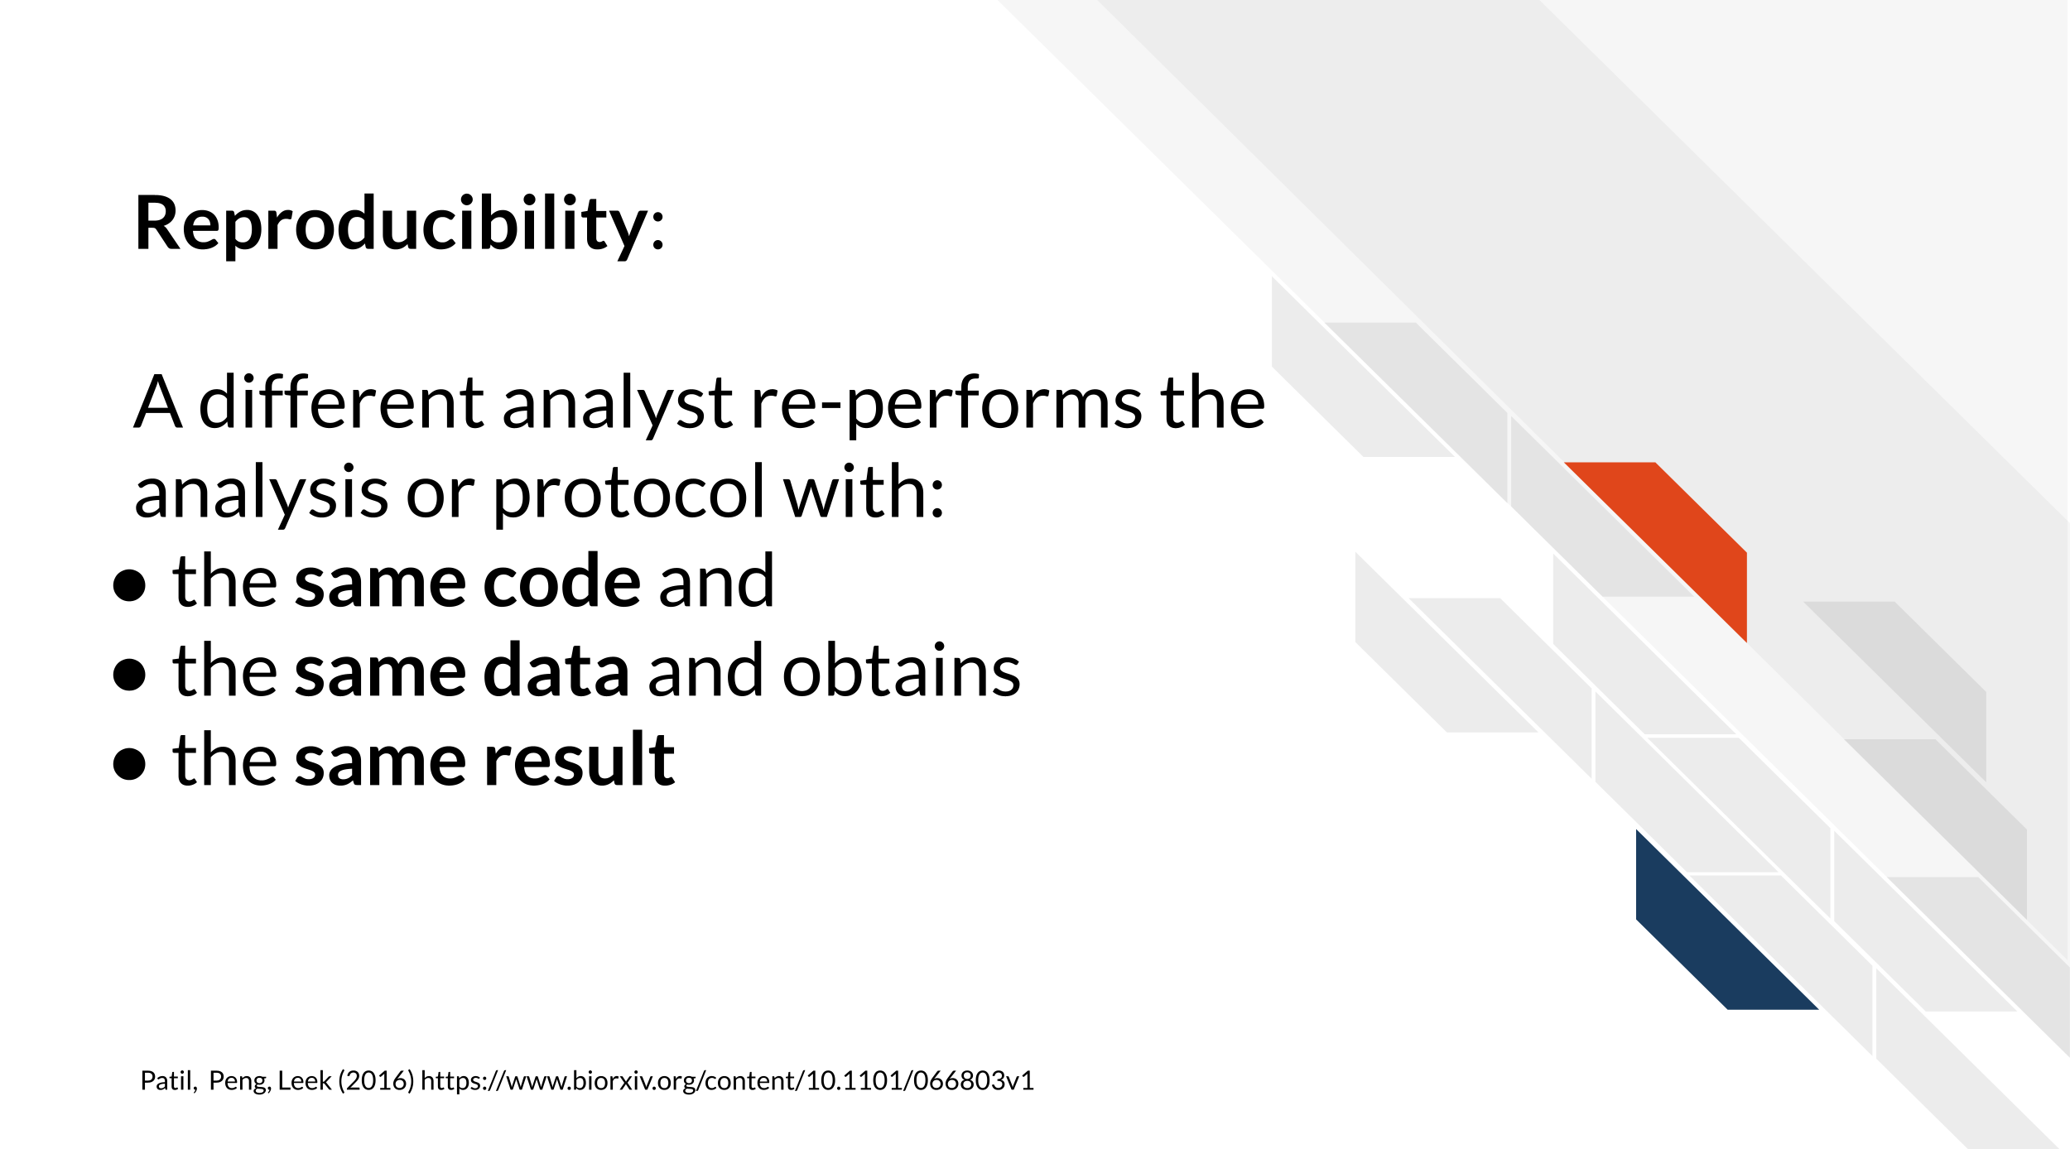
Reproducibility is related to repeatability and replicability but it is worth taking time to differentiate these terms.
Perhaps you are like Ruby and have just found an interesting pattern through your data analysis! This has probably been the result of many months or years on your project and it’s worth celebrating!
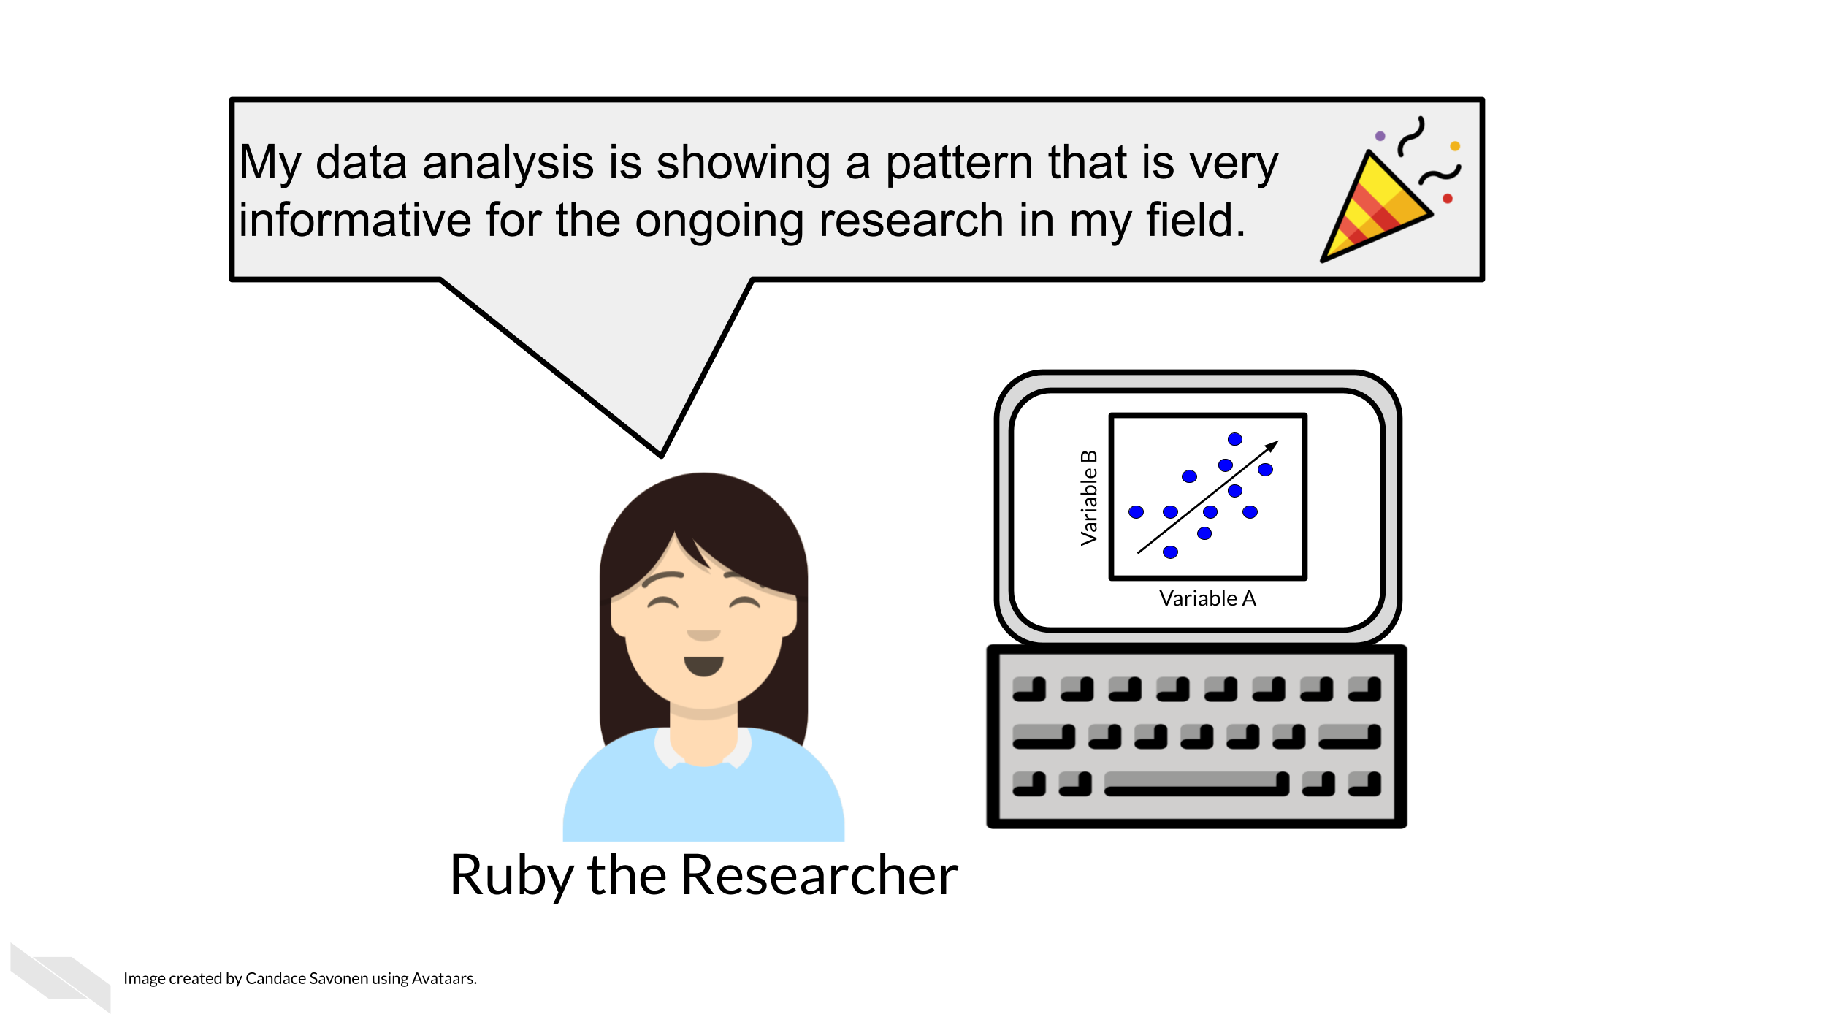
But before she considers these results a done deal, Ruby should test whether she is able to re-run her own analysis and get the same results again. This is known as repeatability.
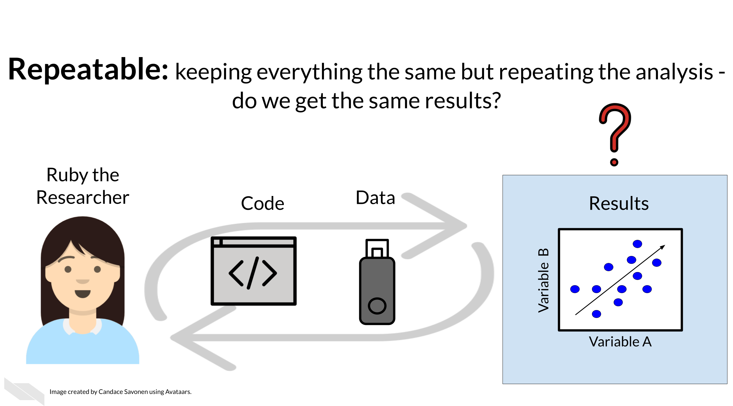
Given that Ruby’s analysis is repeatable; she may feel confident now to share her preliminary results with her colleague, Avi the Associate. Whether or not someone else will be able to take Ruby’s code and data, re-run the analysis and obtain the same results is known as reproducibility.
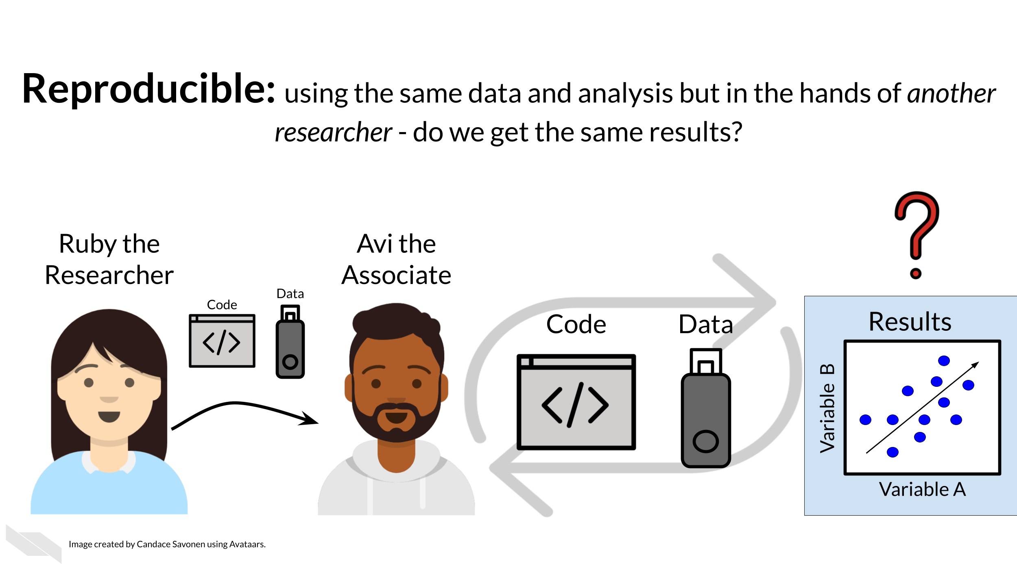
If Ruby’s results can be reproduced by Avi, now Avi may collect new data and use Ruby’s same analysis methods to analyze his data. Whether or not Avi’s new data and results concur with Ruby’s study’s original inferences is known as replicability.
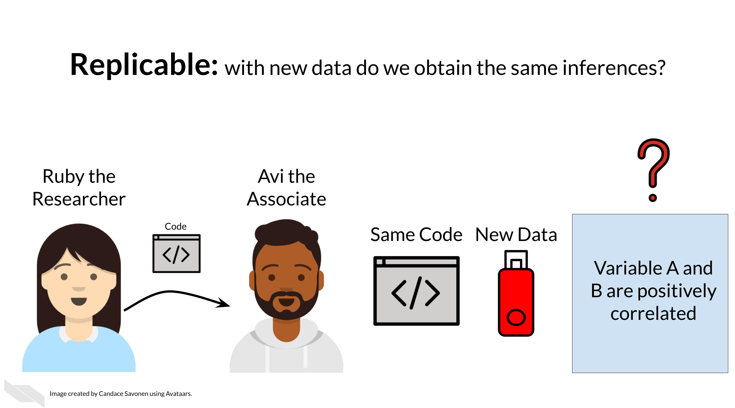
You may realize that these levels of research build on each other (like science is supposed to do). In this way, we can think of them in a hierarchy. Skipping any of these levels of research applicability can lead to unreliable results and conclusions.
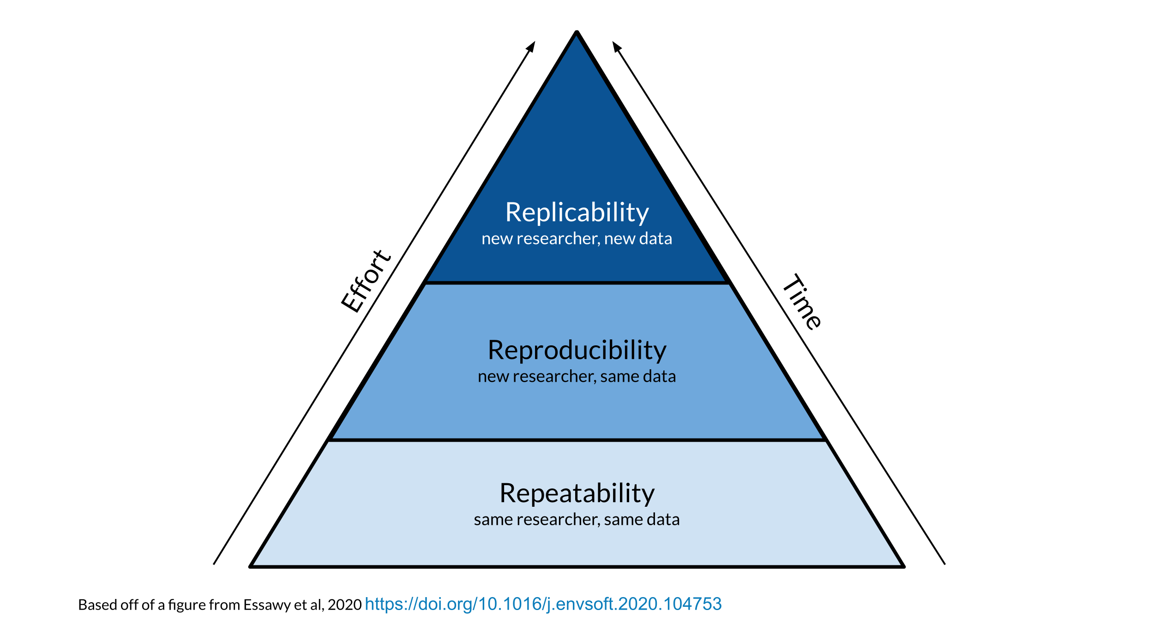
Science progresses when data and hypotheses are put through these levels thoroughly and sequentially. If results are not repeatable, they won’t be reproducible or replicable. If they are not reproducible, they won’t be replicable.
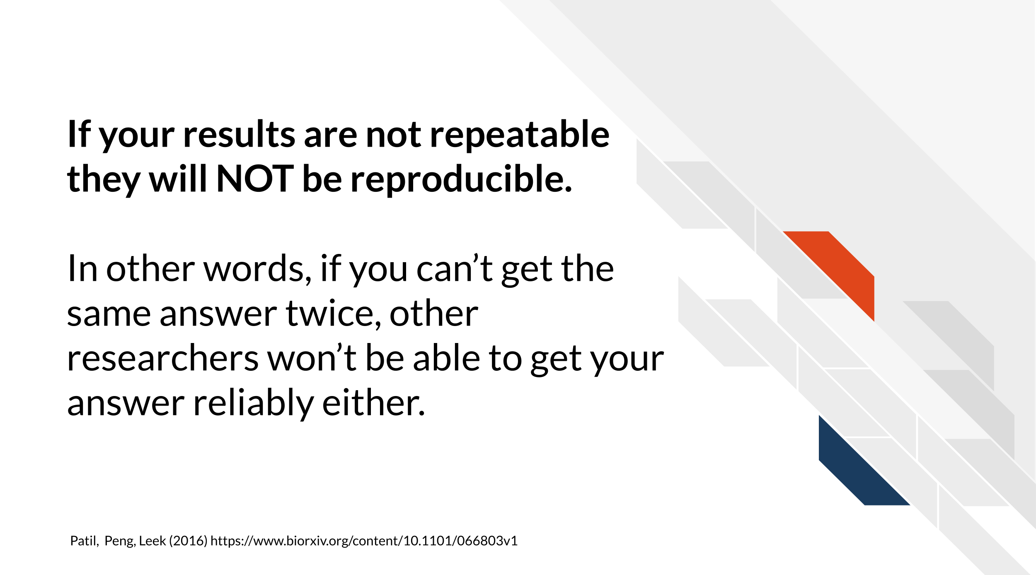
Ideally all analyses and results would be reproducible without too much time and effort spent; this would aid in the efficiency of research getting to the next stages and questions. But unfortunately, in practice, reproducibility is not as commonplace as we would hope. Institutions and reward systems generally do not prioritize or even measure reproducibility in research, and training opportunities for reproducible techniques can be scarce. Reproducible research can often feel like an uphill battle that is made steeper by lack of training opportunities.
In this course, we hope to equip your research with the tools you need to enhance the reproducibility of your analyses so this uphill battle is less steep.

1.3 Reproducibility in daily life
What does reproducibility mean in the daily life of a researcher?
Let’s say Ruby’s results are repeatable in her own hands and she excitedly tells her associate, Avi, about her preliminary findings. Avi is very excited about these results as well as Ruby’s methods!
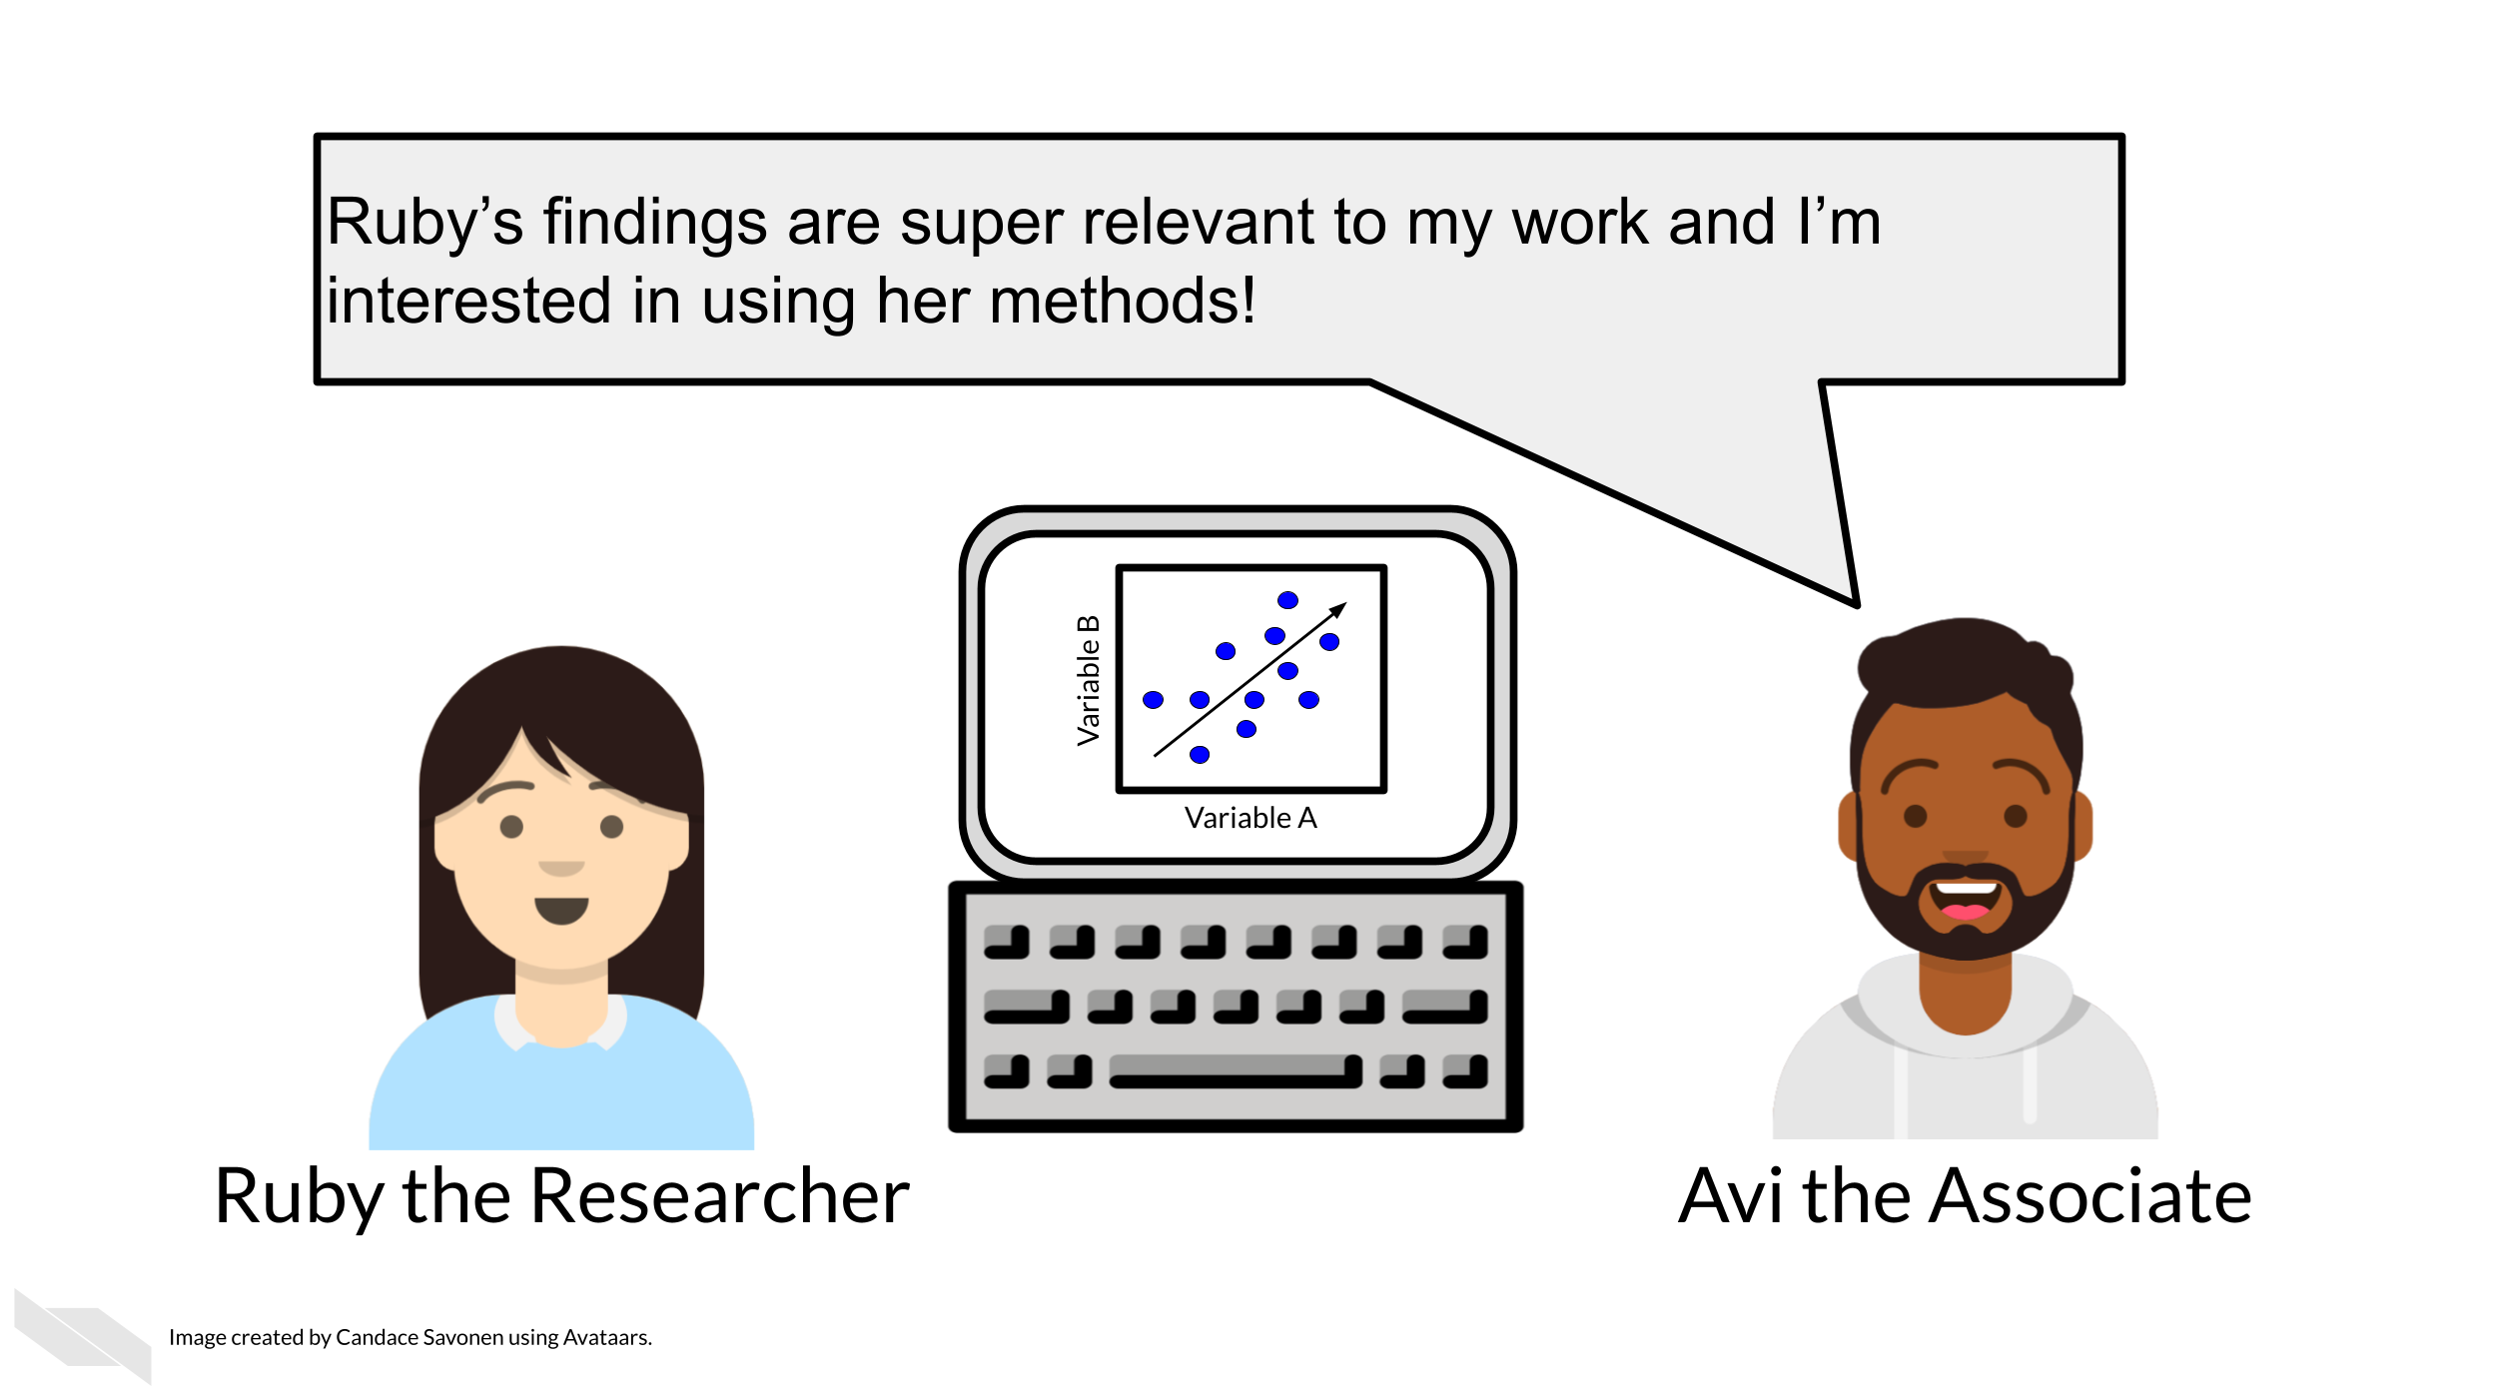
Ruby sends Avi the code and data she used to obtain the results. Now, whether or not Avi is able to obtain the same exact results with this same data and same analysis code will indicate if Ruby’s analysis is reproducible.
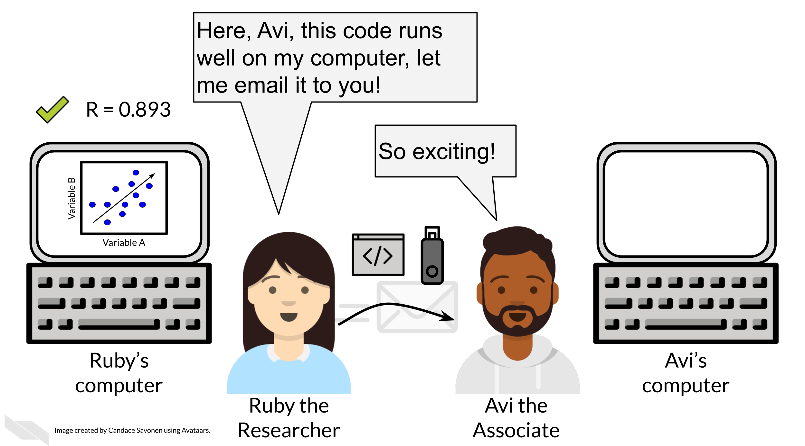
Ruby may have spent a lot of time on her code and getting it to work on her computer, but whether it will successfully run on Avi’s computer is another story. Often when researchers share their analysis code it leads to a substantial amount of effort on the part of the researcher who has received the code to get it working and this often cannot be done successfully without help from the original code author (BeaulieuJones2017?).
Avi is encountering errors because Ruby’s code was written with Ruby’s computer and local setup in mind and she didn’t know how to make it more generally usable. Avi is spending a lot of time just trying to re-run Ruby’s same analysis on her same data; he has yet to be able to try the code on any additional data (which may bring up even more errors).
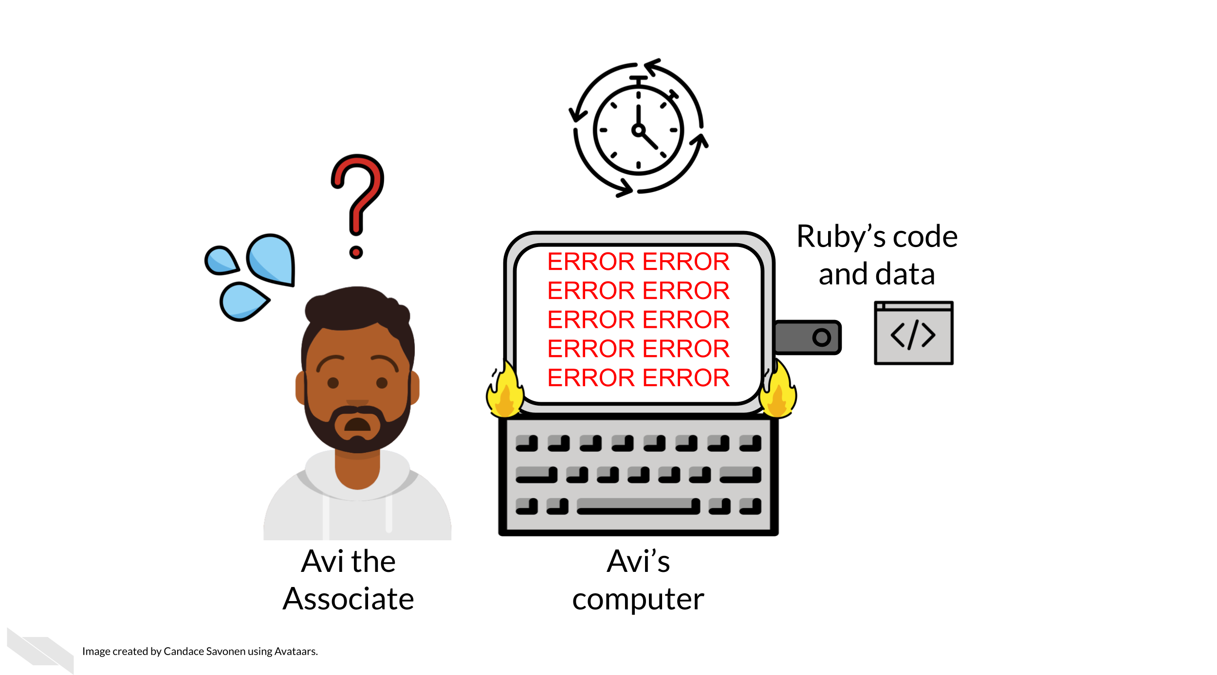
Avi is still struggling to work with Ruby’s code and is confused about the goals and approaches the code is taking. After struggling with Ruby’s code for an untold amount of time, Avi may decide it’s time to email Ruby to get some clarity. Now both Avi and Ruby are confused about why this analysis isn’t nicely re-running for Avi. Their attempts to communicate about the code through email haven’t helped them clarify anything. Multiple versions of the code may have been sent back and forth between them and now things are taking a lot more time than either of them expected.
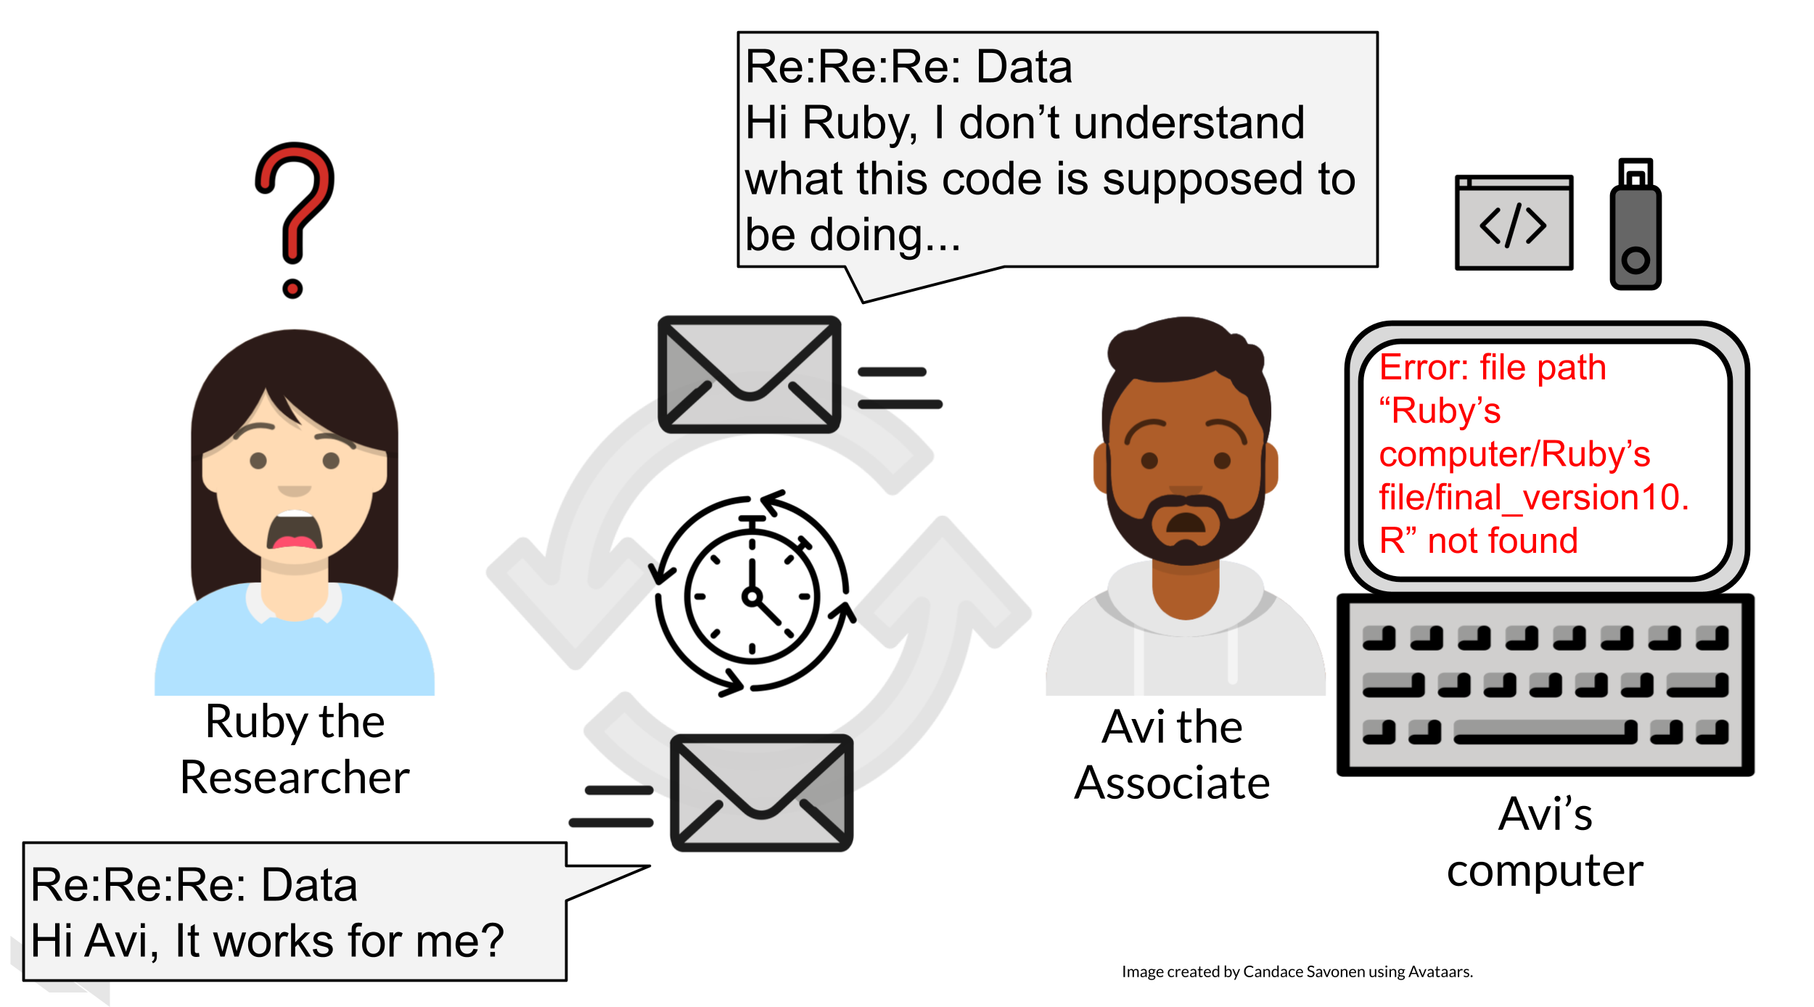
Perhaps at some point Avi is able to successfully run Ruby’s code on Ruby’s same data. Just because Avi didn’t get any errors doesn’t mean that the code ran exactly the same as it did for Ruby.
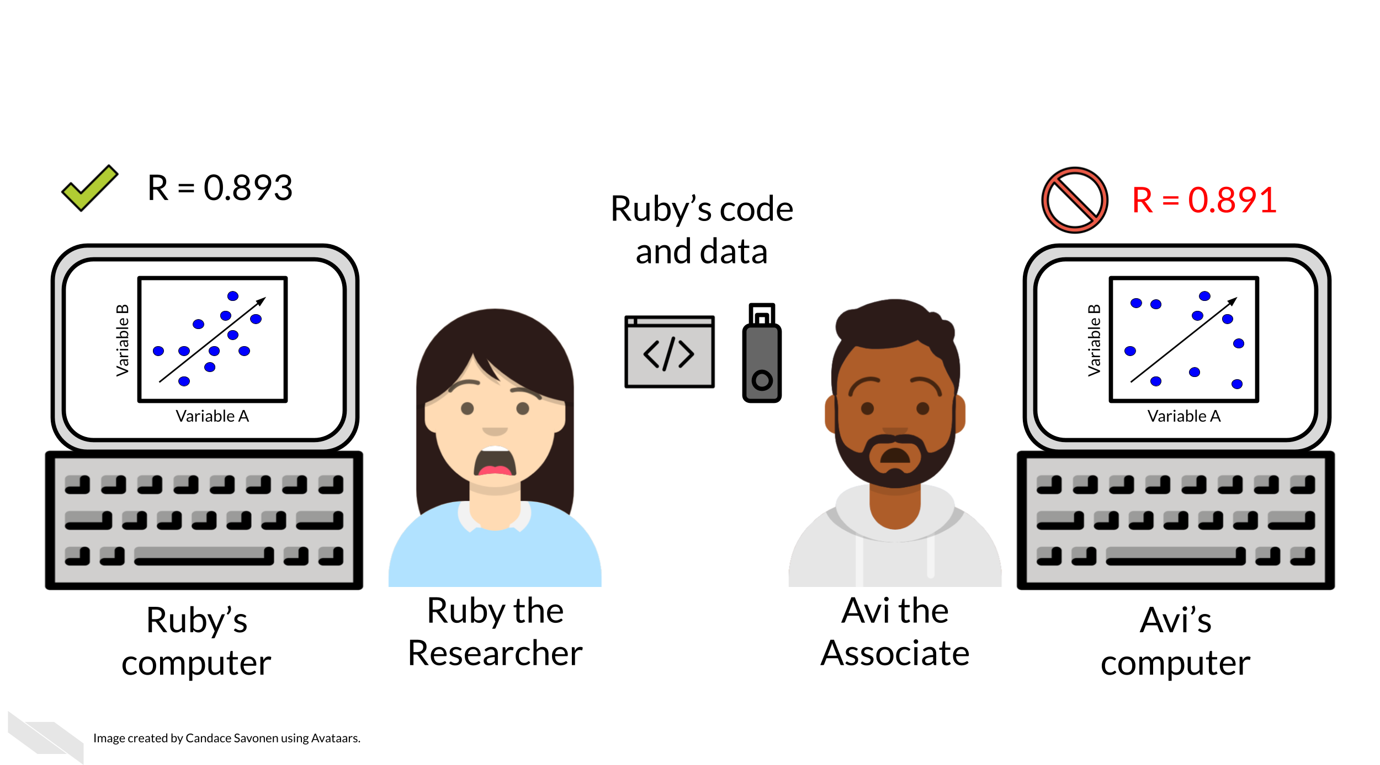
Lack of errors also doesn’t mean that either Ruby or Avi’s runs of the code ran with high accuracy or that the results can be trusted. Even a small difference in decimal point may indicate a more fundamental difference in how the analysis was performed and this could be due to differences in software versions, settings, or any number of items in their computing environments.

1.4 Reproducibility is worth the effort!
Perhaps you’ve found yourself in a situation like Ruby and Avi; struggling to re-run code that you thought for sure was working a minute ago. In the upcoming chapters, we will discuss how to bolster your projects’ reproducibility.
As you apply these reproducible techniques to your own projects, you may feel like it is taking more time to reach endpoints, but keep in mind that reproducible analyses and projects have higher upfront costs but will absolutely pay off in the long term.
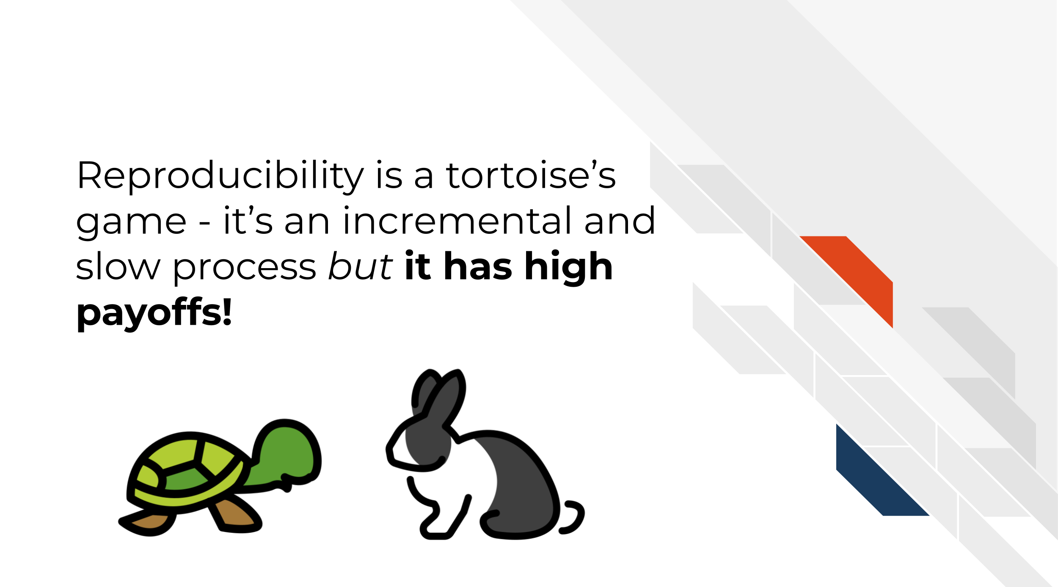
Reproducibility in your analyses is not only a time saver for yourself, but also your colleagues, your field, and your future self!
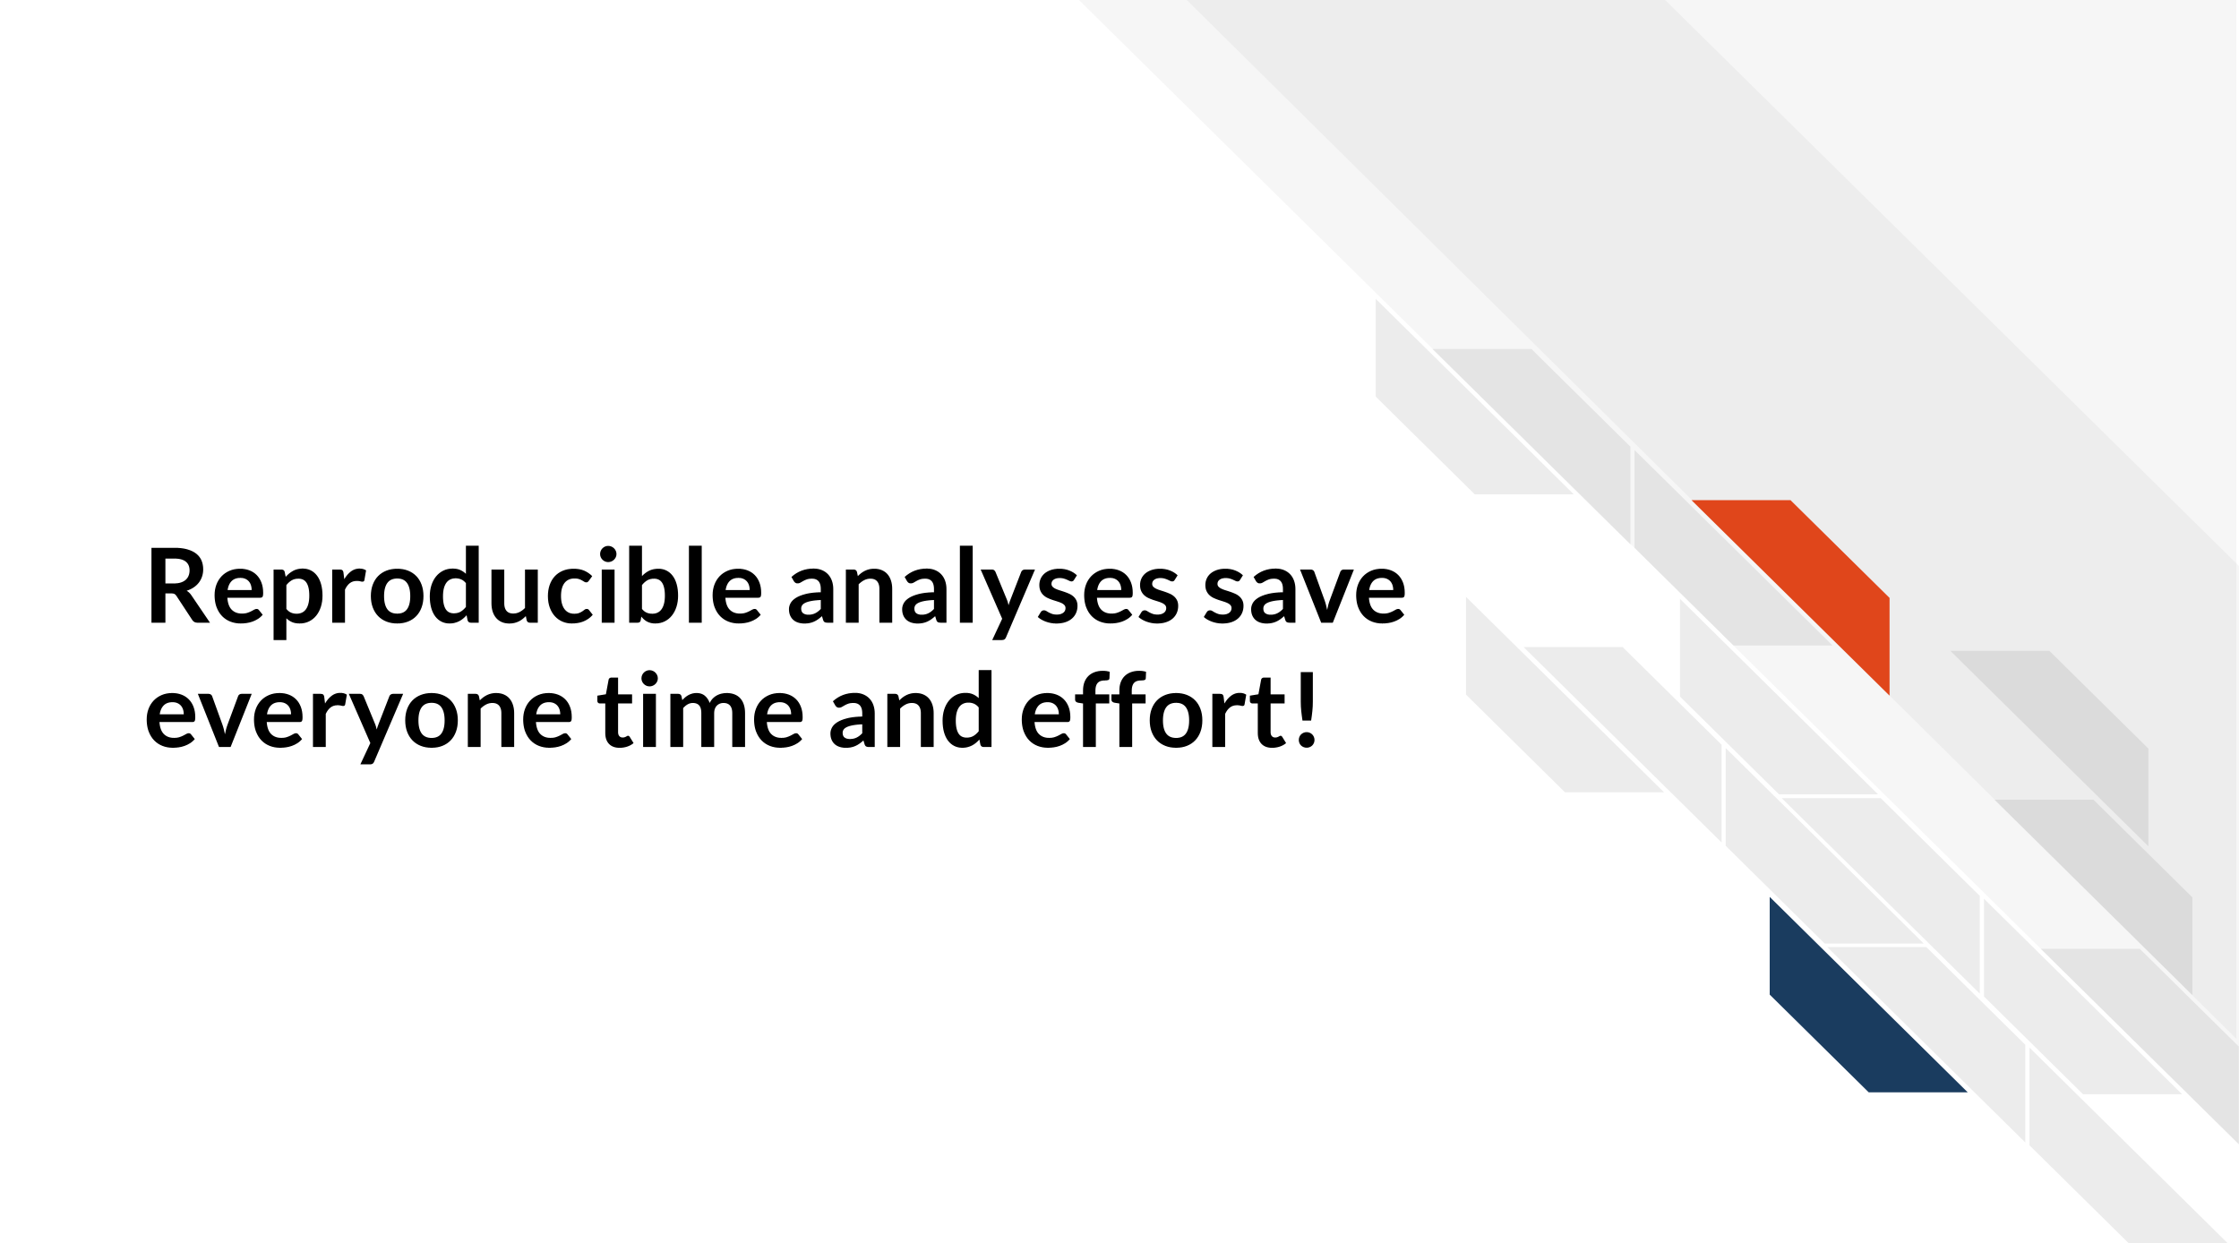
You might not change a single character in your code but then return to it in a few days/months/years and find that it no longer runs! Reproducible code stands the test of time longer, making ‘future you’ glad you spent the time to work on it. It’s said that your closest collaborator is you from 6 months ago but you don’t reply to email (Broman?).
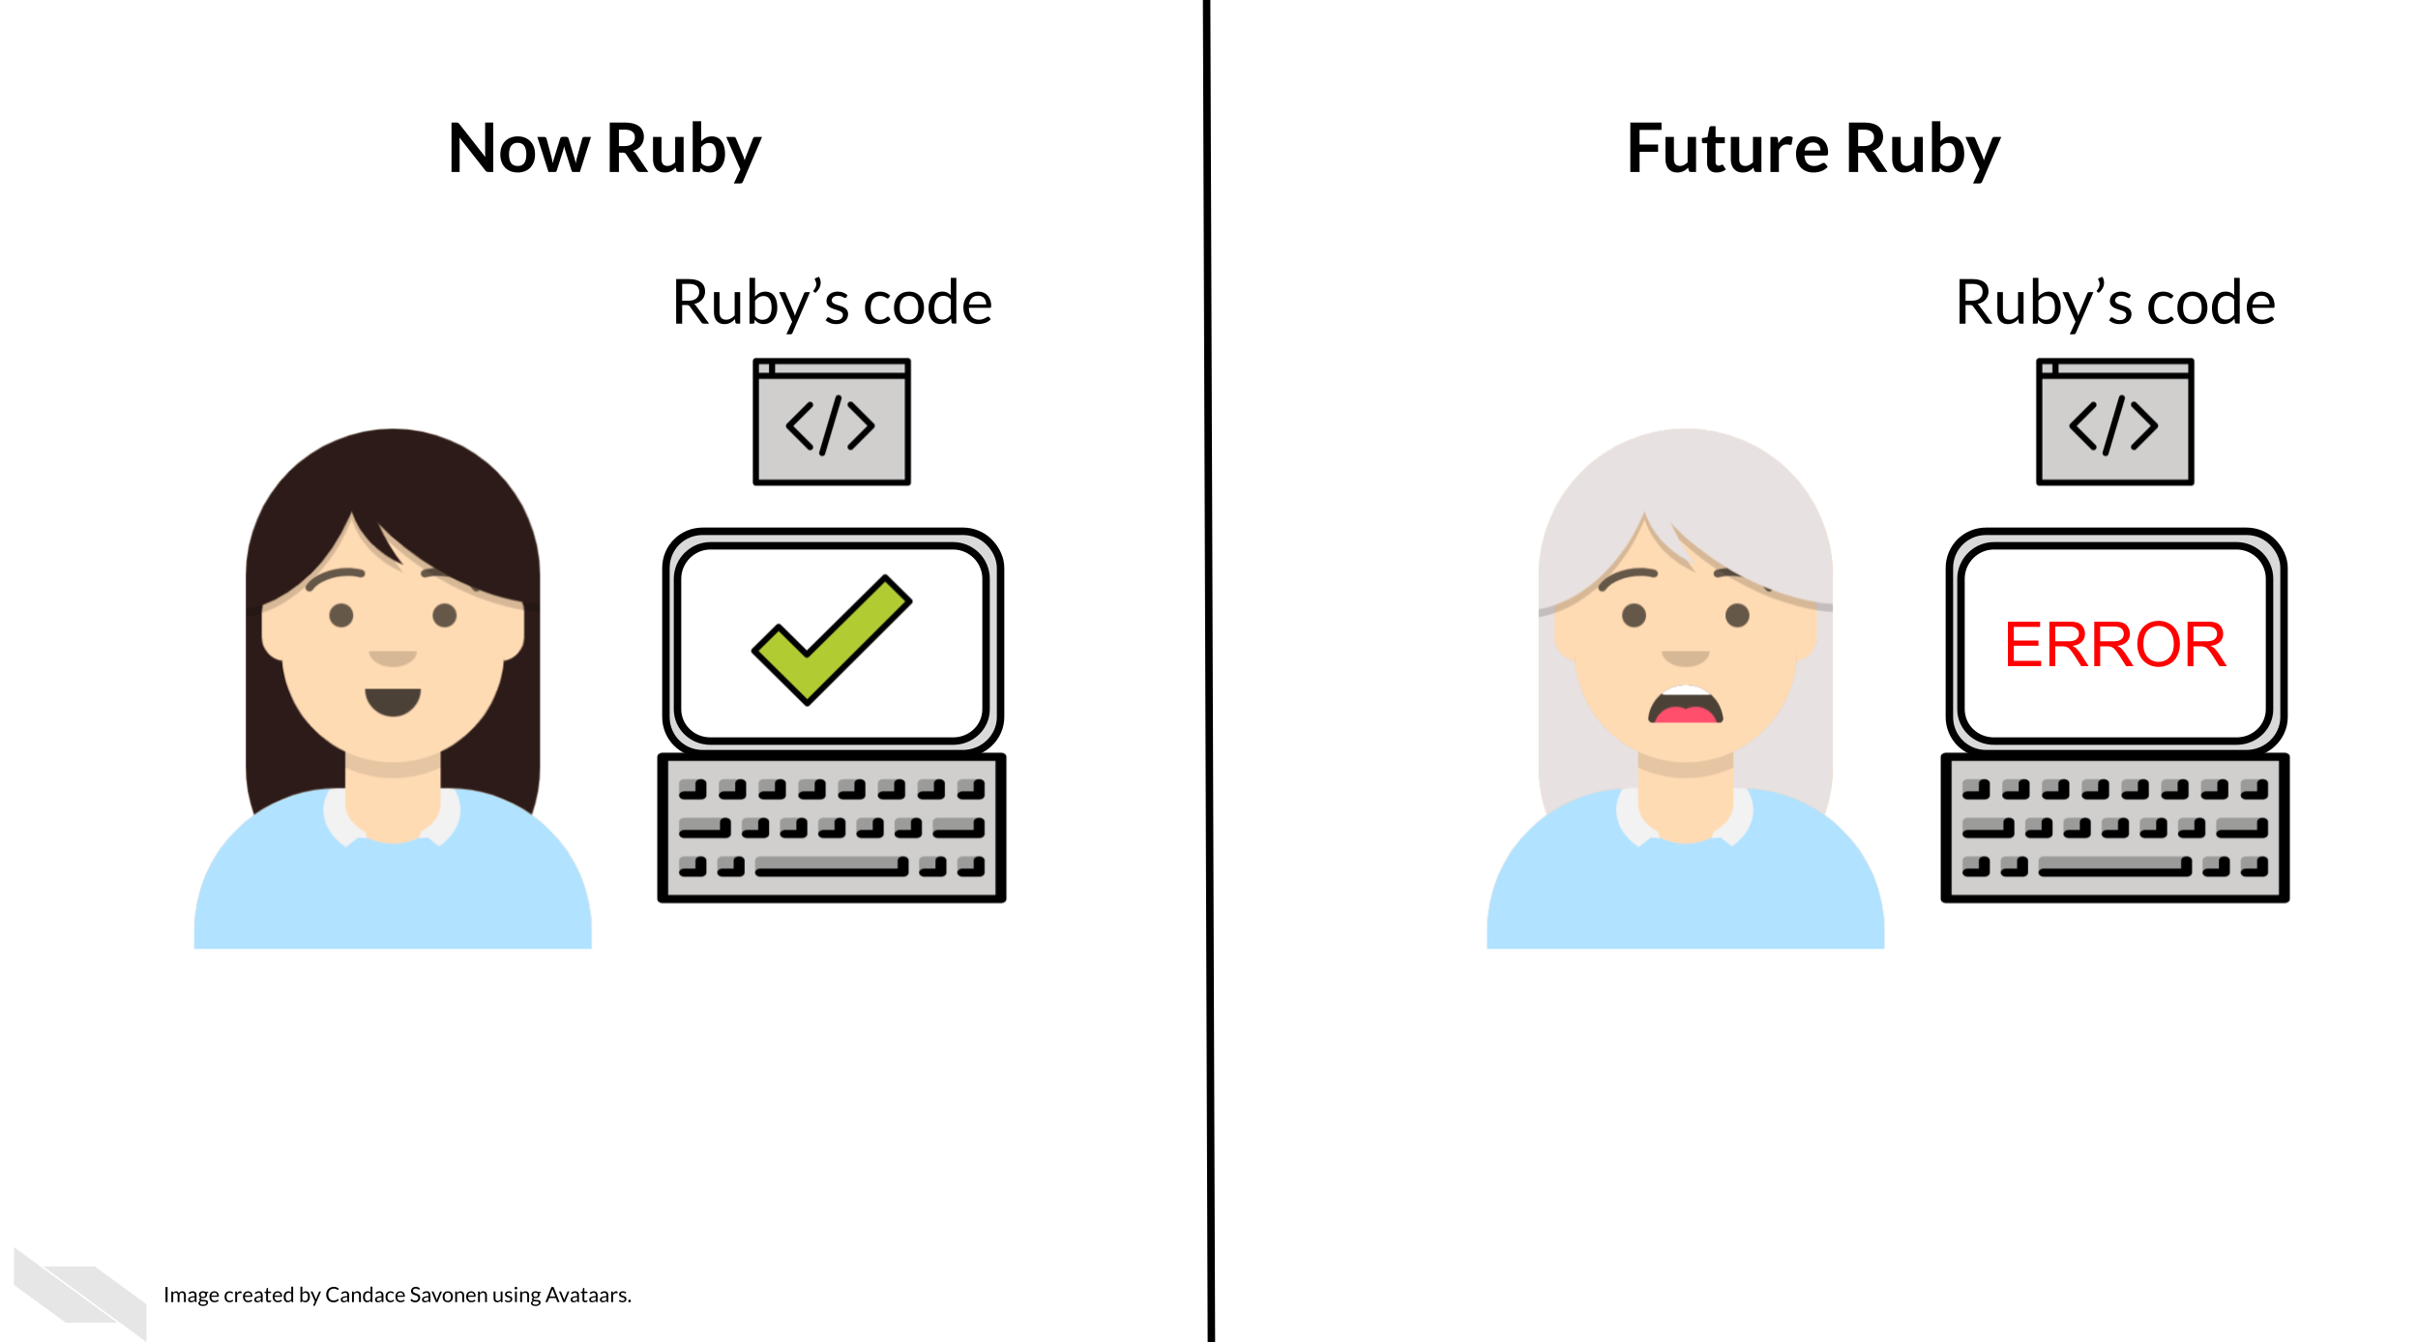
Many a data scientist has referred to their frustration with their past selves:
Dear past-Hadley: PLEASE COMMENT YOUR CODE BETTER. Love present-Hadley
— Hadley Wickham (@hadleywickham) April 7, 2016
The more you comment your code, and make it clear and readable, the more your future self will thank you.
Reproducible code also saves your colleagues time! The more reproducible your code is, the less time all of your collaborators will need to spend troubleshooting it. The more people who use your code and need to try to fix it, the more time is wasted. This can add up to a lot of wasted researcher time and effort.
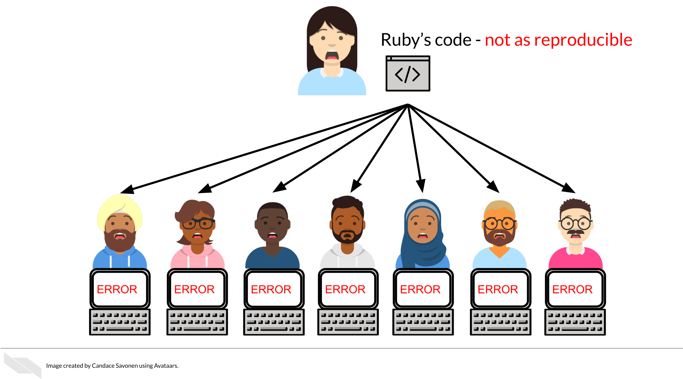
But, reproducible code saves everyone exponential amounts of time and effort! It will also motivate individuals to use and cite your code and analyses in the future!
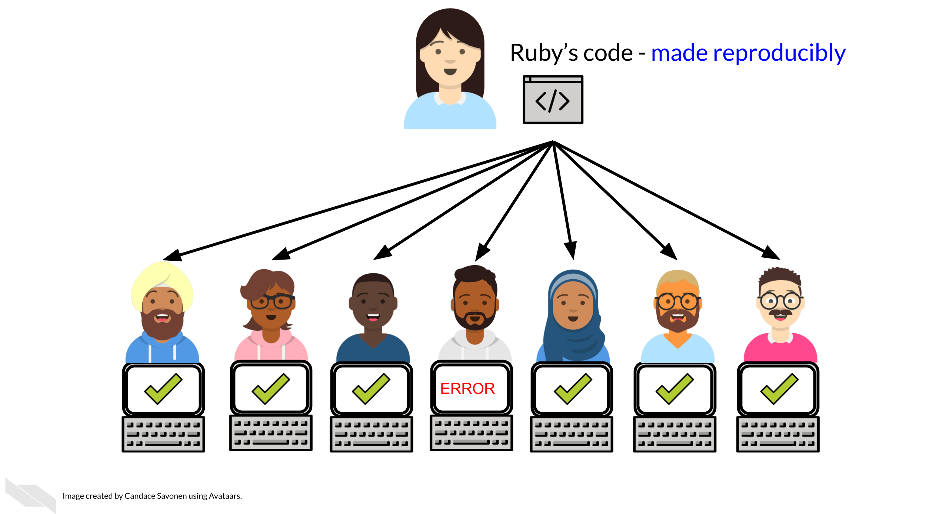

1.5 Reproducibility exists on a continuum!
Incremental work on your analyses is good! You do not need to make your analyses perfect on the first try or even within a particular time frame. The first step in creating an analysis is to get it to work once! But the work does not end there. Furthermore, no analysis is or will ever be perfect in that it will not be reproducible in every single context throughout time. Incrementally pushing our analyses toward the right of this continuum is the goal.
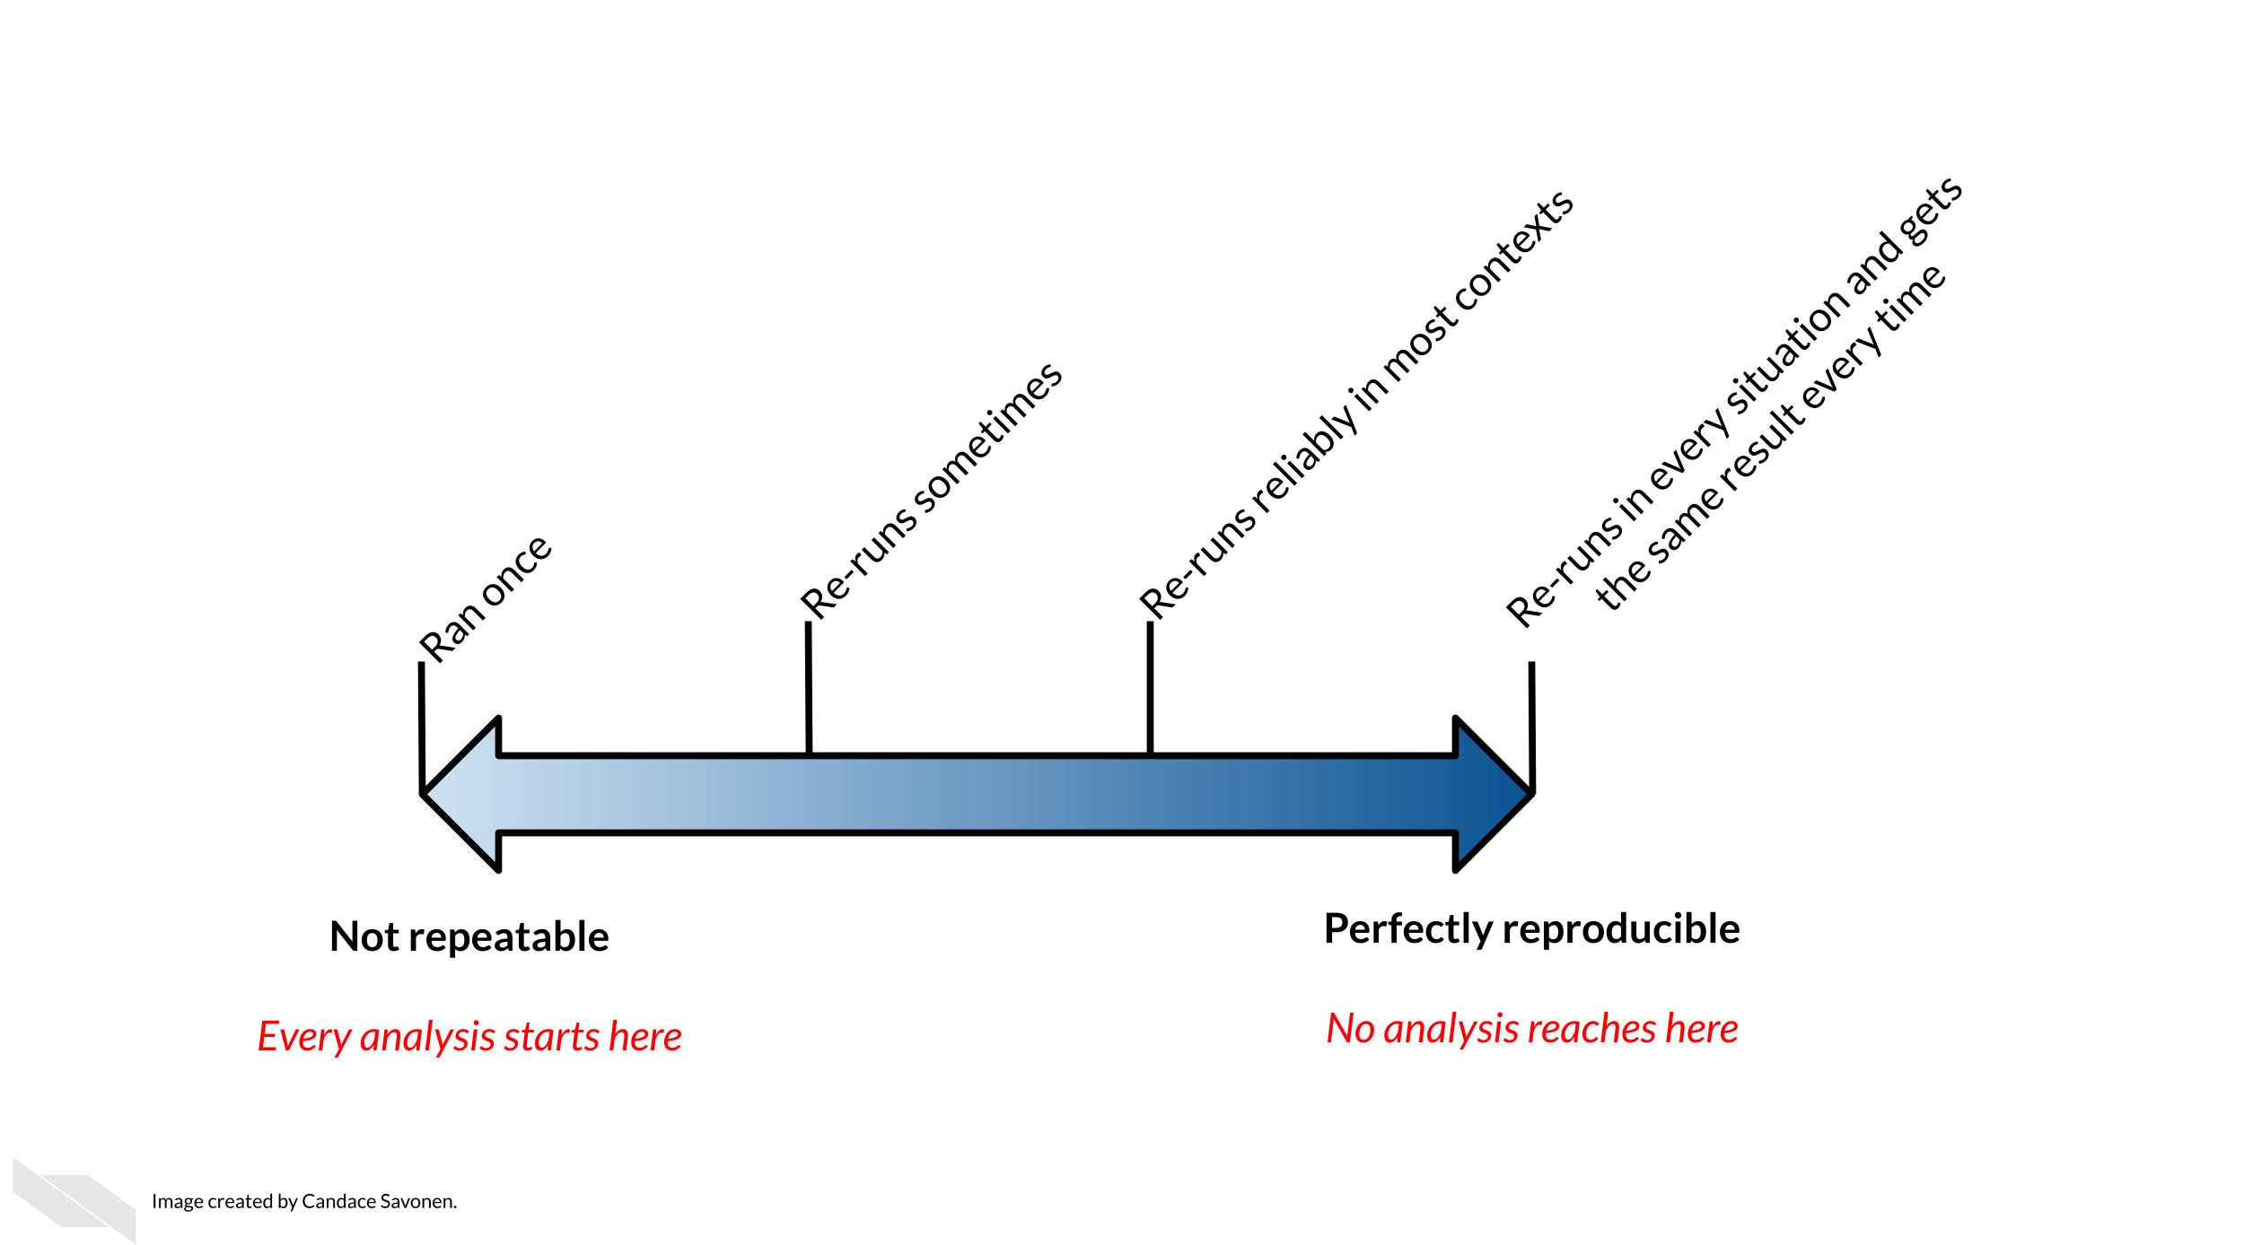

2 A new chapter
If you haven’t yet read the getting started documentation pages; start there.
To see the rendered version of this chapter and the rest of the template, see here: https://ottrproject.org/OTTR_Template/.

2.1 Learning Objectives
Every chapter also needs Learning objectives that will look like this:
This chapter will cover:
- {You can use https://tips.uark.edu/using-blooms-taxonomy/ to define some learning objectives here}
- {Another learning objective}

2.2 Libraries
For this chapter, we’ll need the following packages attached:
*Remember to add any additional packages you need to your course’s own docker image.
library(magrittr)

2.3 Topic of Section
You can write all your text in sections like this, using ## to indicate a new header. you can use additional pound symbols to create lower levels of headers.
See here for additional general information about how you can format text within R Markdown files. In addition, see here for more in depth and advanced options.

2.3.1 Subtopic
Here’s a subheading (using three pound symbols) and some text in this subsection!

2.4 Code examples
You can demonstrate code like this:
output_dir <- file.path("resources", "code_output")
if (!dir.exists(output_dir)) {
dir.create(output_dir)
}
And make plots too:
hist_plot <- hist(iris$Sepal.Length)
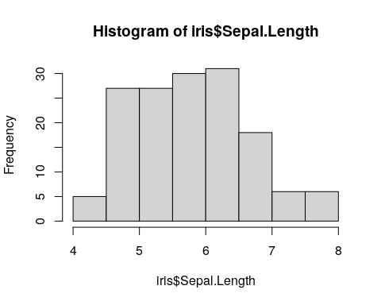
You can also save these plots to file:
png(file.path(output_dir, "test_plot.png"))
hist_plot
## $breaks
## [1] 4.0 4.5 5.0 5.5 6.0 6.5 7.0 7.5 8.0
##
## $counts
## [1] 5 27 27 30 31 18 6 6
##
## $density
## [1] 0.06666667 0.36000000 0.36000000 0.40000000 0.41333333 0.24000000 0.08000000
## [8] 0.08000000
##
## $mids
## [1] 4.25 4.75 5.25 5.75 6.25 6.75 7.25 7.75
##
## $xname
## [1] "iris$Sepal.Length"
##
## $equidist
## [1] TRUE
##
## attr(,"class")
## [1] "histogram"
dev.off()
## png
## 2

2.5 Image example
How to include a Google slide. It’s simplest to use the ottrpal package:

But if you have the slide or some other image locally downloaded you can also use HTML like this:

2.6 Video examples
You may also want to embed videos in your course. If alternatively, you just want to include a link you can do so like this:
Check out this link to a video using markdown syntax.

2.6.1 Using knitr
To embed videos in your course, you can use knitr::include_url() like this: Note that you should use echo=FALSE in the code chunk because we don’t want the code part of this to show up. If you are unfamiliar with how R Markdown code chunks work, read this.
## `google-chrome`, `chromium-browser` and `chrome` were not found. Try setting the `CHROMOTE_CHROME` environment variable to the executable of a Chromium-based browser, such as Google Chrome, Chromium or Brave or adding one of these executables to your PATH.

2.6.2 Using HTML

2.6.3 Using knitr

2.6.4 Using HTML

2.7 Website Examples
Yet again you can use a link to a website like so:
A Website
You might want to have users open a website in a new tab by default, especially if they need to reference both the course and a resource at once.
A Website
Or, you can embed some websites.

2.7.1 Using knitr
This works:

2.7.2 Using HTML
If you’d like the URL to show up in a new tab you can do this:
<a href="https://www.linkedin.com" target="_blank">LinkedIn</a>

2.8 Citation examples
We can put citations at the end of a sentence like this (Allaire et al. 2021). Or multiple citations Xie, Allaire, and Grolemund (2018).
but they need a ; separator (Allaire et al. 2021; Xie, Allaire, and Grolemund 2018).
In text, we can put citations like this Allaire et al. (2021).

2.9 Stylized boxes
Occasionally, you might find it useful to emphasize a particular piece of information. To help you do so, we have provided css code and images (no need for you to worry about that!) to create the following stylized boxes.
You can use these boxes in your course with either of two options: using HTML code or Pandoc syntax.

2.9.1 Using rmarkdown container syntax
The rmarkdown package allows for a different syntax to be converted to the HTML that you just saw and also allows for conversion to LaTeX. See the Bookdown documentation for more information (Xie, Dervieux, and Riederer 2020). Note that Bookdown uses Pandoc.
::: {.notice}
Note using rmarkdown syntax.
:::
Note using rmarkdown syntax.
As an example you might do something like this:
Please click on the subsection headers in the left hand navigation bar (e.g., 2.1, 4.3) a second time to expand the table of contents and enable the scroll_highlight feature (see more)

2.9.2 Using HTML
To add a warning box like the following use:
<div class = "notice">
Followed by the text you want inside
</div>
This will create the following:
Followed by the text you want inside
Here is a <div class = "warning"> box:
Note text
Here is a <div class = "github"> box:
GitHub text
Here is a <div class = "dictionary"> box:
dictionary text
Here is a <div class = "reflection"> box:
reflection text
Here is a <div class = "wip"> box:
Work in Progress text

2.10 Dropdown summaries
You can hide additional information in a dropdown menu
Here’s more words that are hidden.

2.11 Print out session info
You should print out session info when you have code for reproducibility purposes.
devtools::session_info()
## ─ Session info ───────────────────────────────────────────────────────────────
## setting value
## version R version 4.3.2 (2023-10-31)
## os Ubuntu 22.04.4 LTS
## system x86_64, linux-gnu
## ui X11
## language (EN)
## collate en_US.UTF-8
## ctype en_US.UTF-8
## tz Etc/UTC
## date 2025-12-16
## pandoc 3.1.1 @ /usr/local/bin/ (via rmarkdown)
##
## ─ Packages ───────────────────────────────────────────────────────────────────
## package * version date (UTC) lib source
## bookdown 0.46 2025-12-05 [1] CRAN (R 4.3.2)
## cachem 1.0.8 2023-05-01 [1] RSPM (R 4.3.0)
## chromote 0.5.1 2025-04-24 [1] CRAN (R 4.3.2)
## cli 3.6.5 2025-04-23 [1] CRAN (R 4.3.2)
## devtools 2.4.5 2022-10-11 [1] RSPM (R 4.3.0)
## digest 0.6.34 2024-01-11 [1] RSPM (R 4.3.0)
## dplyr 1.1.4 2023-11-17 [1] RSPM (R 4.3.0)
## ellipsis 0.3.2 2021-04-29 [1] RSPM (R 4.3.0)
## evaluate 1.0.5 2025-08-27 [1] CRAN (R 4.3.2)
## fansi 1.0.6 2023-12-08 [1] RSPM (R 4.3.0)
## fastmap 1.1.1 2023-02-24 [1] RSPM (R 4.3.0)
## fs 1.6.3 2023-07-20 [1] RSPM (R 4.3.0)
## generics 0.1.3 2022-07-05 [1] RSPM (R 4.3.0)
## gitcreds 0.1.2 2022-09-08 [1] RSPM (R 4.3.0)
## glue 1.7.0 2024-01-09 [1] RSPM (R 4.3.0)
## hms 1.1.3 2023-03-21 [1] RSPM (R 4.3.0)
## htmltools 0.5.7 2023-11-03 [1] RSPM (R 4.3.0)
## htmlwidgets 1.6.4 2023-12-06 [1] RSPM (R 4.3.0)
## httpuv 1.6.14 2024-01-26 [1] RSPM (R 4.3.0)
## httr 1.4.7 2023-08-15 [1] RSPM (R 4.3.0)
## jsonlite 2.0.0 2025-03-27 [1] CRAN (R 4.3.2)
## knitr 1.50 2025-03-16 [1] CRAN (R 4.3.2)
## later 1.3.2 2023-12-06 [1] RSPM (R 4.3.0)
## lifecycle 1.0.4 2023-11-07 [1] RSPM (R 4.3.0)
## magrittr * 2.0.3 2022-03-30 [1] RSPM (R 4.3.0)
## memoise 2.0.1 2021-11-26 [1] RSPM (R 4.3.0)
## mime 0.12 2021-09-28 [1] RSPM (R 4.3.0)
## miniUI 0.1.1.1 2018-05-18 [1] RSPM (R 4.3.0)
## ottrpal 2.0.0 2025-12-16 [1] Github (ottrproject/ottrpal@f72ad39)
## pillar 1.9.0 2023-03-22 [1] RSPM (R 4.3.0)
## pkgbuild 1.4.3 2023-12-10 [1] RSPM (R 4.3.0)
## pkgconfig 2.0.3 2019-09-22 [1] RSPM (R 4.3.0)
## pkgload 1.4.1 2025-09-23 [1] CRAN (R 4.3.2)
## processx 3.8.6 2025-02-21 [1] CRAN (R 4.3.2)
## profvis 0.3.8 2023-05-02 [1] RSPM (R 4.3.0)
## promises 1.2.1 2023-08-10 [1] RSPM (R 4.3.0)
## ps 1.9.1 2025-04-12 [1] CRAN (R 4.3.2)
## purrr 1.0.2 2023-08-10 [1] RSPM (R 4.3.0)
## R6 2.6.1 2025-02-15 [1] CRAN (R 4.3.2)
## Rcpp 1.0.12 2024-01-09 [1] RSPM (R 4.3.0)
## readr 2.1.5 2024-01-10 [1] RSPM (R 4.3.0)
## remotes 2.5.0 2024-03-17 [1] CRAN (R 4.3.2)
## rlang 1.1.6 2025-04-11 [1] CRAN (R 4.3.2)
## rmarkdown 2.25 2023-09-18 [1] RSPM (R 4.3.0)
## rprojroot 2.1.1 2025-08-26 [1] CRAN (R 4.3.2)
## rvest 1.0.5 2025-08-29 [1] CRAN (R 4.3.2)
## sessioninfo 1.2.2 2021-12-06 [1] RSPM (R 4.3.0)
## shiny 1.8.0 2023-11-17 [1] RSPM (R 4.3.0)
## spelling 2.3.2 2025-08-18 [1] CRAN (R 4.3.2)
## stringi 1.8.3 2023-12-11 [1] RSPM (R 4.3.0)
## stringr 1.5.1 2023-11-14 [1] RSPM (R 4.3.0)
## tibble 3.3.0 2025-06-08 [1] CRAN (R 4.3.2)
## tidyr 1.3.1 2024-01-24 [1] RSPM (R 4.3.0)
## tidyselect 1.2.0 2022-10-10 [1] RSPM (R 4.3.0)
## tzdb 0.4.0 2023-05-12 [1] RSPM (R 4.3.0)
## urlchecker 1.0.1 2021-11-30 [1] RSPM (R 4.3.0)
## usethis 2.2.3 2024-02-19 [1] RSPM (R 4.3.0)
## utf8 1.2.4 2023-10-22 [1] RSPM (R 4.3.0)
## vctrs 0.6.5 2023-12-01 [1] RSPM (R 4.3.0)
## webshot2 0.1.2 2025-04-23 [1] CRAN (R 4.3.2)
## websocket 1.4.4 2025-04-10 [1] CRAN (R 4.3.2)
## xfun 0.55 2025-12-16 [1] CRAN (R 4.3.2)
## xml2 1.5.1 2025-12-01 [1] CRAN (R 4.3.2)
## xtable 1.8-4 2019-04-21 [1] RSPM (R 4.3.0)
## yaml 2.3.12 2025-12-10 [1] CRAN (R 4.3.2)
##
## [1] /usr/local/lib/R/site-library
## [2] /usr/local/lib/R/library
##
## ──────────────────────────────────────────────────────────────────────────────

About the Authors
These credits are based on our course contributors table guidelines.

Credits | Names
Pedagogy
Lead Content Instructor(s) | FirstName LastName
Lecturer(s) (include chapter name/link in parentheses if only for specific chapters) - make new line if more than one chapter involved | Delivered the course in some way - video or audio
Content Author(s) (include chapter name/link in parentheses if only for specific chapters) - make new line if more than one chapter involved | If any other authors besides lead instructor
Content Contributor(s) (include section name/link in parentheses) - make new line if more than one section involved | Wrote less than a chapter
Content Editor(s)/Reviewer(s) | Checked your content
Content Director(s) | Helped guide the content direction
Content Consultants (include chapter name/link in parentheses or word “General”) - make new line if more than one chapter involved | Gave high level advice on content
Acknowledgments | Gave small assistance to content but not to the level of consulting
Production
Content Publisher(s) | Helped with publishing platform
Content Publishing Reviewer(s) | Reviewed overall content and aesthetics on publishing platform
Technical
Course Publishing Engineer(s) | Helped with the code for the technical aspects related to the specific course generation
Template Publishing Engineers | Candace Savonen, Carrie Wright, Ava Hoffman
Publishing Maintenance Engineer | Candace Savonen
Technical Publishing Stylists | Carrie Wright, Ava Hoffman, Candace Savonen, Katherine Cox
Package Developers (ottrpal) | Candace Savonen, Ava Hoffman, Howard Baek, Kate Isaac, Carrie Wright, John Muschelli
Art and Design
Illustrator(s) | Created graphics for the course
Figure Artist(s) | Created figures/plots for course
Videographer(s) | Filmed videos
Videography Editor(s) | Edited film
Audiographer(s) | Recorded audio
Audiography Editor(s) | Edited audio recordings
Funding
Funder(s) | Institution/individual who funded course including grant number
Funding Staff | Staff members who help with funding

## ─ Session info ───────────────────────────────────────────────────────────────
## setting value
## version R version 4.3.2 (2023-10-31)
## os Ubuntu 22.04.4 LTS
## system x86_64, linux-gnu
## ui X11
## language (EN)
## collate en_US.UTF-8
## ctype en_US.UTF-8
## tz Etc/UTC
## date 2025-12-16
## pandoc 3.1.1 @ /usr/local/bin/ (via rmarkdown)
##
## ─ Packages ───────────────────────────────────────────────────────────────────
## package * version date (UTC) lib source
## bookdown 0.46 2025-12-05 [1] CRAN (R 4.3.2)
## cachem 1.0.8 2023-05-01 [1] RSPM (R 4.3.0)
## cli 3.6.5 2025-04-23 [1] CRAN (R 4.3.2)
## devtools 2.4.5 2022-10-11 [1] RSPM (R 4.3.0)
## digest 0.6.34 2024-01-11 [1] RSPM (R 4.3.0)
## ellipsis 0.3.2 2021-04-29 [1] RSPM (R 4.3.0)
## evaluate 1.0.5 2025-08-27 [1] CRAN (R 4.3.2)
## fastmap 1.1.1 2023-02-24 [1] RSPM (R 4.3.0)
## fs 1.6.3 2023-07-20 [1] RSPM (R 4.3.0)
## glue 1.7.0 2024-01-09 [1] RSPM (R 4.3.0)
## htmltools 0.5.7 2023-11-03 [1] RSPM (R 4.3.0)
## htmlwidgets 1.6.4 2023-12-06 [1] RSPM (R 4.3.0)
## httpuv 1.6.14 2024-01-26 [1] RSPM (R 4.3.0)
## knitr 1.50 2025-03-16 [1] CRAN (R 4.3.2)
## later 1.3.2 2023-12-06 [1] RSPM (R 4.3.0)
## lifecycle 1.0.4 2023-11-07 [1] RSPM (R 4.3.0)
## magrittr 2.0.3 2022-03-30 [1] RSPM (R 4.3.0)
## memoise 2.0.1 2021-11-26 [1] RSPM (R 4.3.0)
## mime 0.12 2021-09-28 [1] RSPM (R 4.3.0)
## miniUI 0.1.1.1 2018-05-18 [1] RSPM (R 4.3.0)
## pkgbuild 1.4.3 2023-12-10 [1] RSPM (R 4.3.0)
## pkgload 1.4.1 2025-09-23 [1] CRAN (R 4.3.2)
## profvis 0.3.8 2023-05-02 [1] RSPM (R 4.3.0)
## promises 1.2.1 2023-08-10 [1] RSPM (R 4.3.0)
## purrr 1.0.2 2023-08-10 [1] RSPM (R 4.3.0)
## R6 2.6.1 2025-02-15 [1] CRAN (R 4.3.2)
## Rcpp 1.0.12 2024-01-09 [1] RSPM (R 4.3.0)
## remotes 2.5.0 2024-03-17 [1] CRAN (R 4.3.2)
## rlang 1.1.6 2025-04-11 [1] CRAN (R 4.3.2)
## rmarkdown 2.25 2023-09-18 [1] RSPM (R 4.3.0)
## sessioninfo 1.2.2 2021-12-06 [1] RSPM (R 4.3.0)
## shiny 1.8.0 2023-11-17 [1] RSPM (R 4.3.0)
## stringi 1.8.3 2023-12-11 [1] RSPM (R 4.3.0)
## stringr 1.5.1 2023-11-14 [1] RSPM (R 4.3.0)
## urlchecker 1.0.1 2021-11-30 [1] RSPM (R 4.3.0)
## usethis 2.2.3 2024-02-19 [1] RSPM (R 4.3.0)
## vctrs 0.6.5 2023-12-01 [1] RSPM (R 4.3.0)
## xfun 0.55 2025-12-16 [1] CRAN (R 4.3.2)
## xtable 1.8-4 2019-04-21 [1] RSPM (R 4.3.0)
## yaml 2.3.12 2025-12-10 [1] CRAN (R 4.3.2)
##
## [1] /usr/local/lib/R/site-library
## [2] /usr/local/lib/R/library
##
## ──────────────────────────────────────────────────────────────────────────────

3 References
Allaire, JJ, Yihui Xie, Jonathan McPherson, Javier Luraschi, Kevin Ushey, Aron Atkins, Hadley Wickham, Joe Cheng, Winston Chang, and Richard Iannone. 2021. Rmarkdown: Dynamic Documents for r. https://github.com/rstudio/rmarkdown.
Xie, Yihui, J. J. Allaire, and Garrett Grolemund. 2018. R Markdown: The Definitive Guide. Boca Raton, Florida: Chapman; Hall/CRC. https://bookdown.org/yihui/rmarkdown.
Xie, Yihui, Christophe Dervieux, and Emily Riederer. 2020. R Markdown Cookbook. Boca Raton, Florida: Chapman; Hall/CRC. https://bookdown.org/yihui/rmarkdown-cookbook.

