Supplementary material

Table S1: Virus data sets used to construct the hyper priors on the base distributions for analyses on viral sequences.
Virus | Gene
Avian influenza A H7N7 | HA
Bovine respiratory syncytial virus | G
Classical swine fever | E2
Equine arter virus | GP
Human enterovirus 71 | VP1
FluC | NP
Foot and mouth disease A | VP1
Foot and mouth disease C | VP1
Foot and mouth disease O | VP1
Hepatitus C 1b | E1E2
Human immunodeficiency 1 subtype EC | ENV
Human immunodeficiency 1 subtype EC | GAG
Human respiratory syncytial A | G
Human respiratory syncytial B | G
Human parainfluenza 1 | HN
Infectious bursal disease | VP2
Japanese encephalitis | E
Louping ill | E
Rabbit hemorrhagic disease | VP60
Rabies | G
Rubella | E1
St. Louis encephalitis | E
Tick-borneencephalitis | E
Venezuelan equine encephalitis | E2
Western equine encephalitis | E1
Yellow fever | E

Table S2: Mammal data sets used to construct the hyper priors on the base distributions for analyses on the sequences of Mammalian FGF1 gene.
ENSEMBL ID | SYMBOL
ENSG00000033178 | UBE1L2
ENSG00000038002 | AGA
ENSG00000067208 | EVI5
ENSG00000069702 | TGFBR3
ENSG00000072422 | RHOBTB1
ENSG00000073614 | JARID1A
ENSG00000077380 | DYNC1I2
ENSG00000077782 | FGFR1
ENSG00000081177 | EXDL2
ENSG00000091436 | MLTK
ENSG00000092421 | SEMA6A
ENSG00000093100 | MICA3
ENSG00000100201 | DDX17
ENSG00000100997 | ABHD12
ENSG00000114770 | ABCC5
ENSG00000115159 | GPD2
ENSG00000131374 | TBC1D5
ENSG00000134775 | FHOD3
ENSG00000136854 | STXBP1
ENSG00000138448 | ITGAV
ENSG00000150764 | DIXDC1
ENSG00000160392 | C19ORF47
ENSG00000169398 | PTK2
ENSG00000182901 | RGS7
ENSG00000184454 | C1ORF130

Table S3: Chain lengths (in millions of iterations) for the substitution mixture model analyses.

Data set | SDPM1 |  | SDPM2
 | SC | LNRC | SC | LNRC
EBOV | 270 | 450 | 270 | 480
HCV-4 | 100 | 360 | 180 | 200
Mammal | 25 | 25 | 25 | 25
RSVA | 50 | 50 | 50 | 50
HCV-1b | 700 | 800 | - | -

Table S4: Posterior mean and 95\% HPD of the number of categories with strict clock model
Data set | Clock model | RDPM | SDPM1 | SDPM2
 |  | K^{r} | K | K^{Φ} | K^{r}
EBOV | SC | 2.6 (2,4) | 4.7 (3,6) | 4.7 (3,6) | 2.6 (2,4)
EBOV | LNRC | 2.7 (2,4) | 4.7 (3,6) | 5.2 (4,7) | 2.6 (2.4)
HCV-4 | SC | 5.4 (3,7) | 9.0 (7,11) | 7.0 (5,9) | 4.2 (2,6)
HCV-4 | LNRC | 5.4 (4,7) | 9.2 (7,11) | 6.9 (5,9) | 4.5 (3,7)
Mammal | SC | 2.6 (2,4) | 3.9 (3,5) | 2.7 (2,4) | 2.6 (2,4)
Mammal | LNRC | 2.6 (2,4) | 3.9 (3,5) | 2.7 (2,4) | 2.7 (2,4)
RSVA | SC | 2.7 (2,4) | 2.7 (2,4) | 2.3 (1,4) | 2.7 (2,4)
RSVA | LNRC | 2.7 (2,4) | 2.7 (2,4) | 2.2 (1,4) | 2.7 (2,4)
HCV-1b | SC | 4.7 (4,6) | 10 (8,12) | - | -
HCV-1b | LNRC | 5.0 (4,7) | 10 (8,12) | - | -

Table S5 presents the 95% credible tree sets (CTS) and the 50% and 5% credible clade sets (CCSs). For EBOV, the 95% CTSs, 50% and 5% CCSs of the SDPMs are slightly larger than the respective statistics of other substitution models. In every analysis on HCV, the 1000 sampled trees are all unique. HCV data has the largest number of taxa in this study, therefore it has a much larger tree space. The CCSs of DPM models widen with increasing complexity of the DPM model and are wider than those of other substitution models. Assuming the substitution process of the mammal sequences is clock-like, the 95% CTSs of SDPM models are around twice as large as those of other models. With a strict clock, SDPMs appear to produce flatter tree topology distributions for Mammal. The tree topology distributions of RSVA do not display clear differences in the distribution statistics across the substitution models. Overall, it seems incorporating the uncertainty of substitution model partitioning may result in greater uncertainty in the inference of tree topology.

Table S5: Statistics on the posterior distribution of tree topology
Data set | Clock model | Statistic | HKY+Γ₄+I | GTR+Γ₄+I | SRD2006 | GY94+Γ₄+I | RDPM | SDPM1 | SDPM2
EBOV | SC | |95% CTS|¹ | 793 | 757 | 698 | 654 | 816 | 877 | 857
EBOV | SC | |50% CCS|² | 92 | 92 | 80 | 63 | 93 | 98 | 91
EBOV | SC | |5% CCS|³ | 44 | 42 | 38 | 41 | 44 | 51 | 45
EBOV | LNRC | |95% CTS| | 911 | 920 | 909 | 861 | 910 | 941 | 936
EBOV | LNRC | |50% CCS| | 109 | 118 | 111 | 94 | 108 | 123 | 122
EBOV | LNRC | |5% CCS| | 54 | 56 | 52 | 47 | 57 | 92 | 78
HCV-4 | SC | |95% CTS| | 950 | 950 | 950 | 950 | 950 | 950 | 950
HCV-4 | SC | |50% CCS| | 2407 | 2367 | 3024 | 3067 | 3695 | 5021 | 5638
HCV-4 | SC | |5% CCS| | 673 | 654 | 798 | 735 | 835 | 1001 | 1093
HCV-4 | LNRC | |95% CTS| | 950 | 950 | 950 | 950 | 950 | 950 | 950
HCV-4 | LNRC | |50% CCS| | 3070 | 2741 | 2551 | 3442 | 3750 | 5372 | 6102
HCV-4 | LNRC | |5% CCS| | 755 | 749 | 685 | 775 | 830 | 990 | 1071
Mammal | SC | |95% CTS| | 13 | 19 | 16 | 14 | 16 | 31 | 34
Mammal | SC | |50% CCS| | 11 | 11 | 11 | 11 | 11 | 11 | 12
Mammal | SC | |5% CCS| | 11 | 11 | 11 | 11 | 11 | 11 | 11
Mammal | LNRC | |95% CTS| | 106 | 110 | 136 | 64 | 61 | 145 | 106
Mammal | LNRC | |50% CCS| | 15 | 15 | 18 | 13 | 14 | 15 | 15
Mammal | LNRC | |5% CCS| | 11 | 11 | 11 | 11 | 11 | 11 | 11
RSVA | SC | |95% CTS| | 950 | 949 | 949 | 943 | 950 | 949 | 949
RSVA | SC | |50% CCS| | 133 | 137 | 129 | 124 | 133 | 127 | 133
RSVA | SC | |5% CCS| | 99 | 98 | 98 | 92 | 104 | 93 | 108
RSVA | LNRC | |95% CTS| | 947 | 950 | 948 | 943 | 949 | 949 | 950
RSVA | LNRC | |50% CCS| | 135 | 137 | 135 | 131 | 134 | 132 | 138
RSVA | LNRC | |5% CCS| | 94 | 100 | 105 | 94 | 105 | 96 | 103
¹Size of the 95% posterior credible tree set
²Size of the 50% posterior credible clade set
³Size of the 5% posterior credible clade set
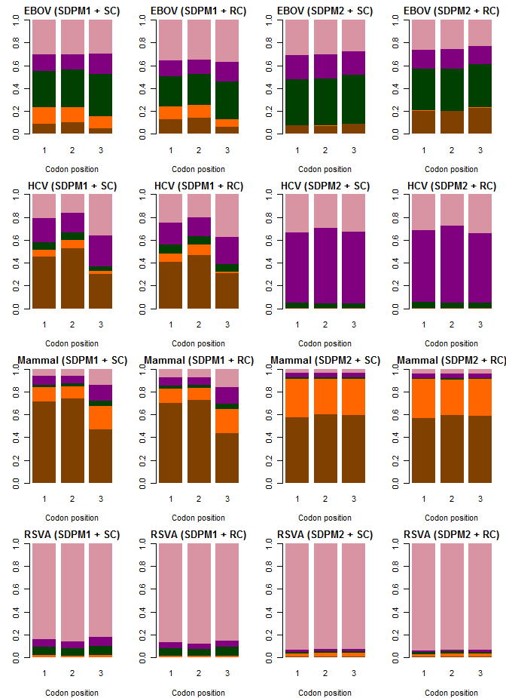

Figure S1: Posterior mean proportion of sites at each codon position modelled by each type of nucleotide substitution model. K80 is colored in brown, F81 in orange, HKY in green, TN93 in purple and GTR in pink.

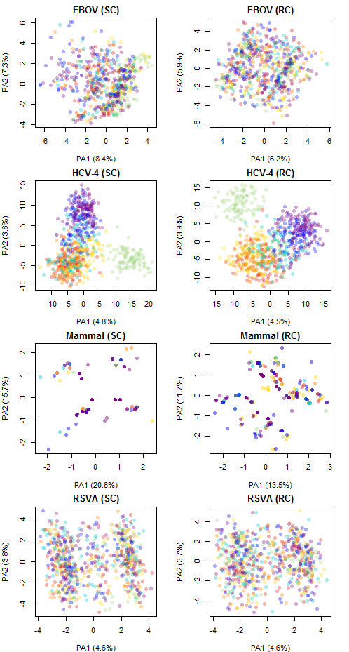
Figure S2: Reduced tree space based of the Robinson-Fould distance among MCC trees produced using different substitution models.

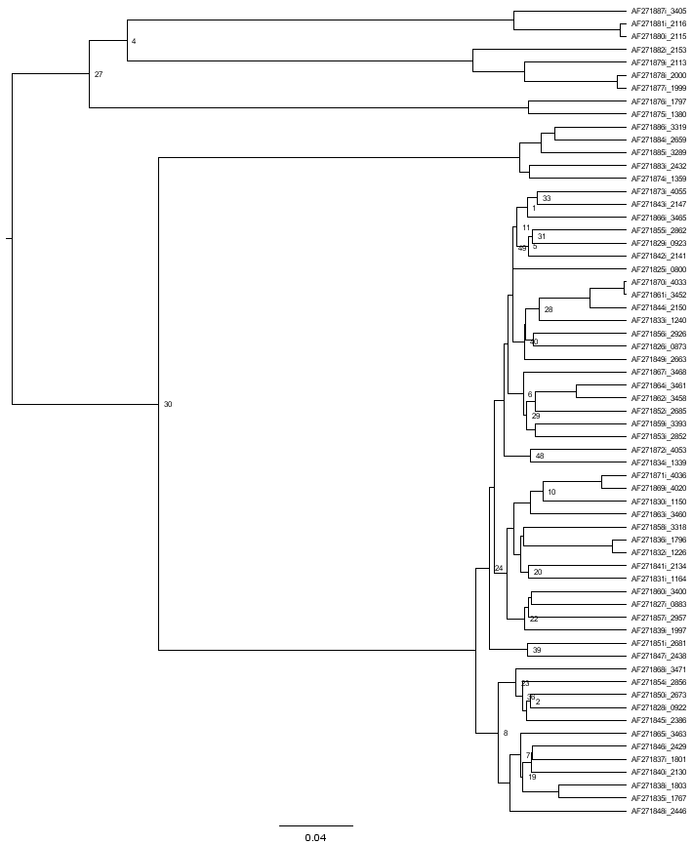
Figure S3: The MCC tree from strict clock analysis with GTR+Γ₄ +I.

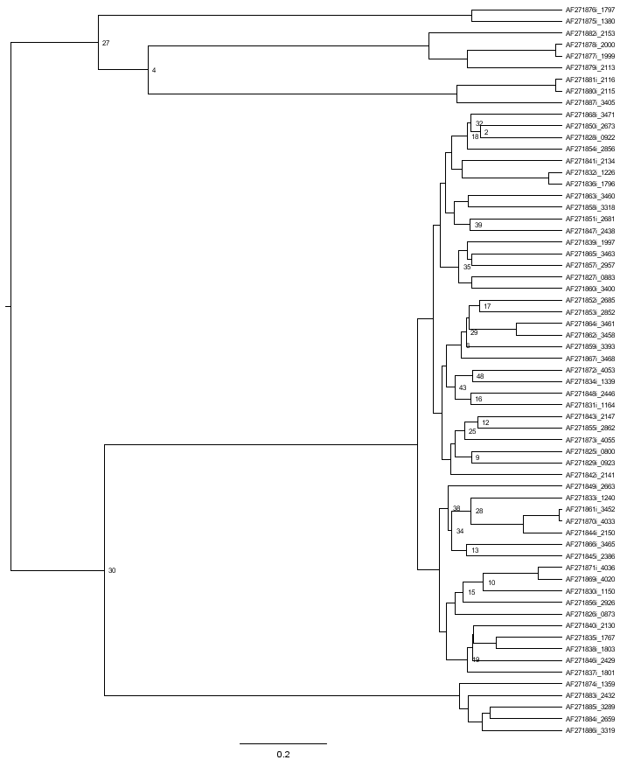
Figure S4: The MCC tree from strict clock analysis with GY94+Γ₄ +I.

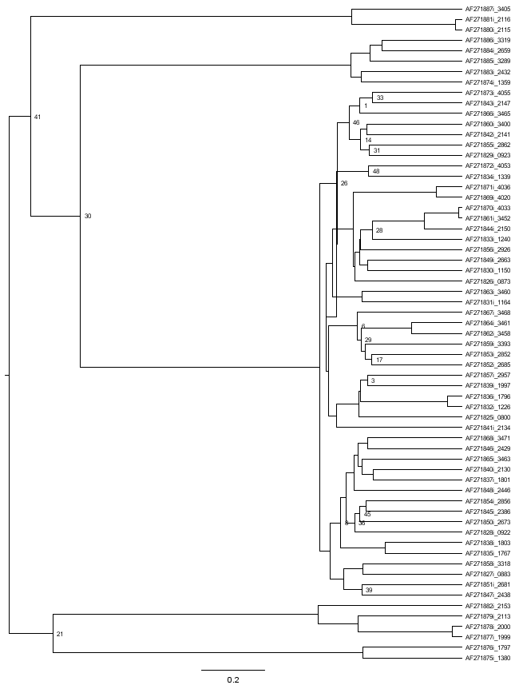
Figure S5: The MCC tree from strict clock analysis with SDPM2.

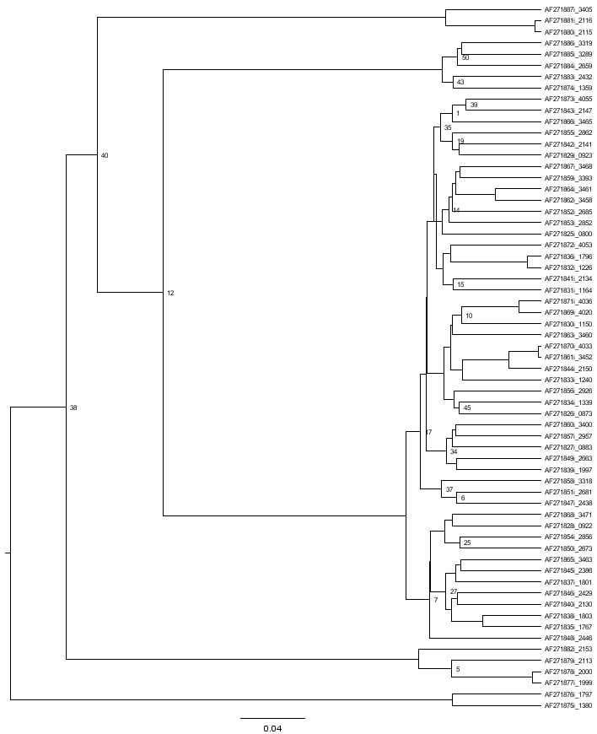
Figure S6: The MCC tree from LNRC analysis with GTR+Γ₄ +I.
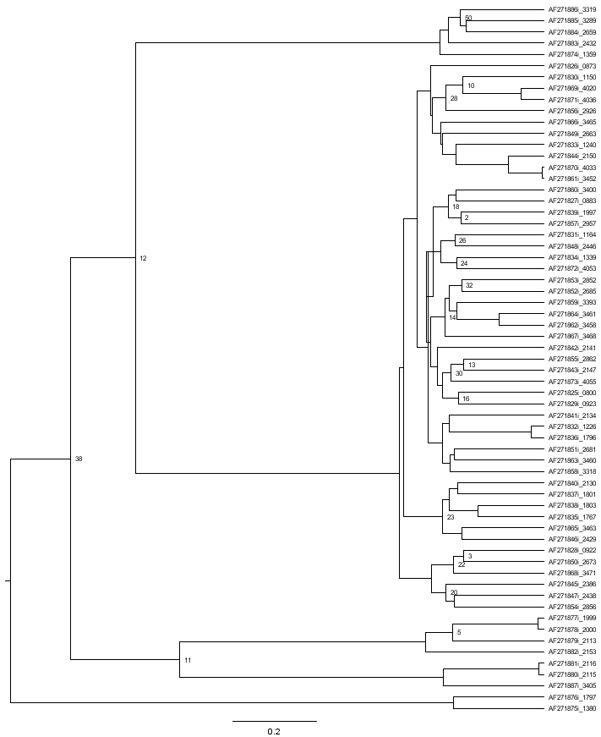
Figure S7: The MCC tree from LNRC analysis with GY94+Γ₄ +I.
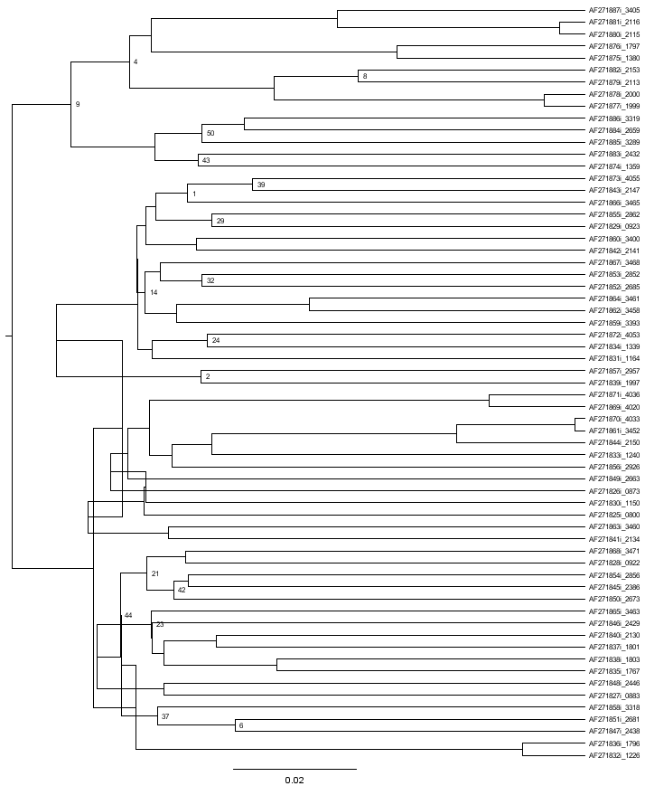
Figure S8: The MCC tree from LNRC analysis with SDPM2.
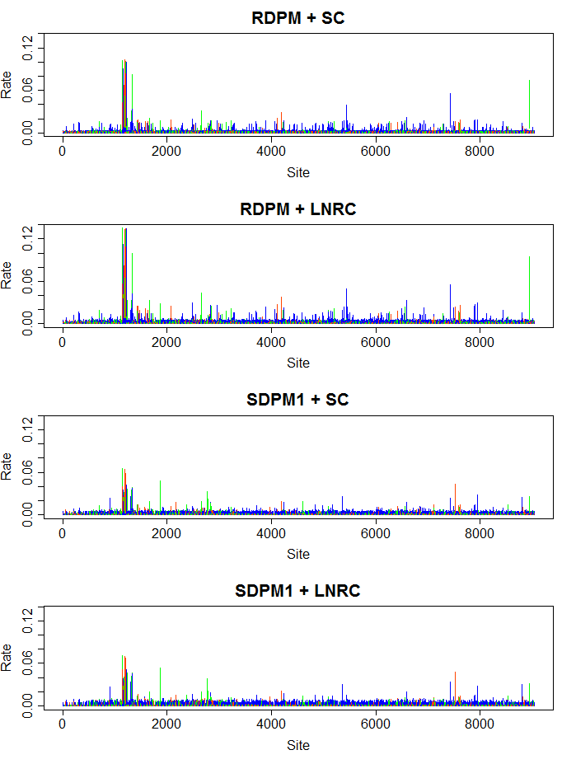
Figure S9: The 95% HPD intervals of site specific rates for the HCV-1b genome sequences. Codon positions 1, 2 and 3 are coded in red, green and blue respectively.
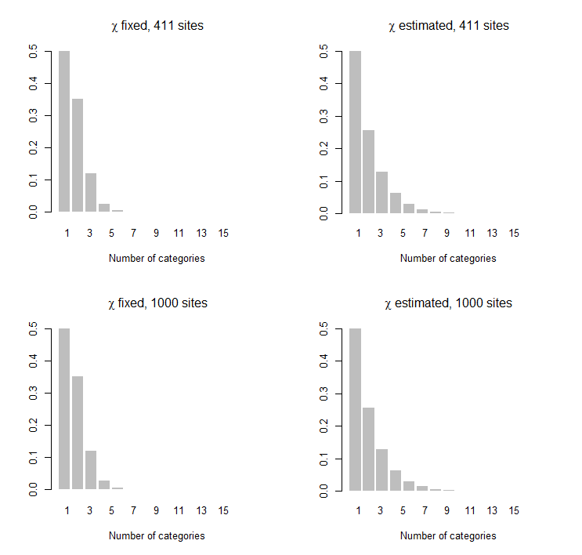
Figure S10: Prior distributions on the number of categories used in the simulation study.

