Supplement for Improving Comprehension of Measurements Using Concrete Re-expression Strategies

# Database Construction Pipeline

## Additional CrowdSourced Task Interfaces

Our pipeline relies on crowdsourced tasks to 1) identify which WordNet synsets from the *artifact* tree are rigid, countable, and likely to be purchaseable on Amazon; 2) to verify that instances of objects (synsets) that we obtained by querying the synset names on Amazon, DBPedia, and Freebase are in fact examples of the intended synset; and 3) to gather more fine-grained familiarity scores. We present the interface for (3) in the paper. Interfaces for (1) and (2) are depicted below.

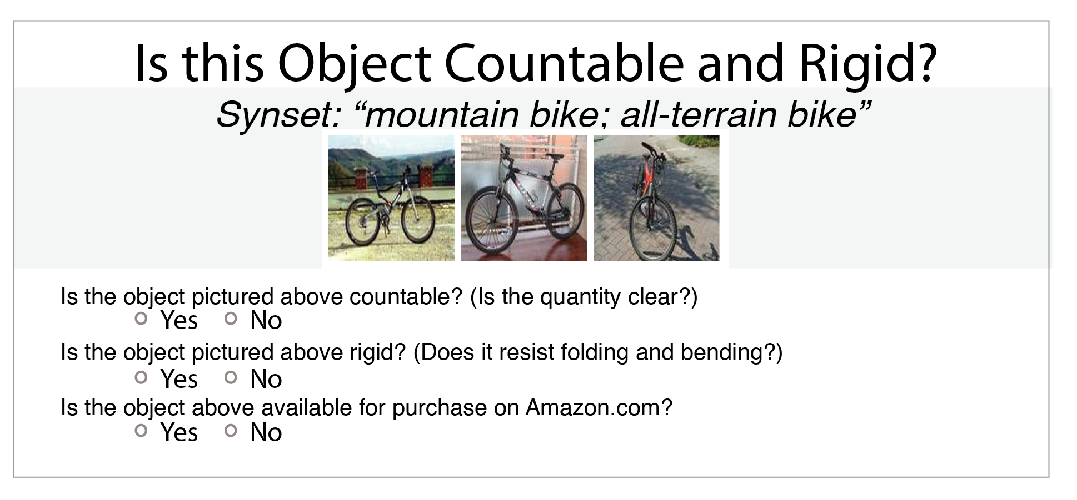

Figure 1: Interface for our concrete, rigid, purchaseable HIT.

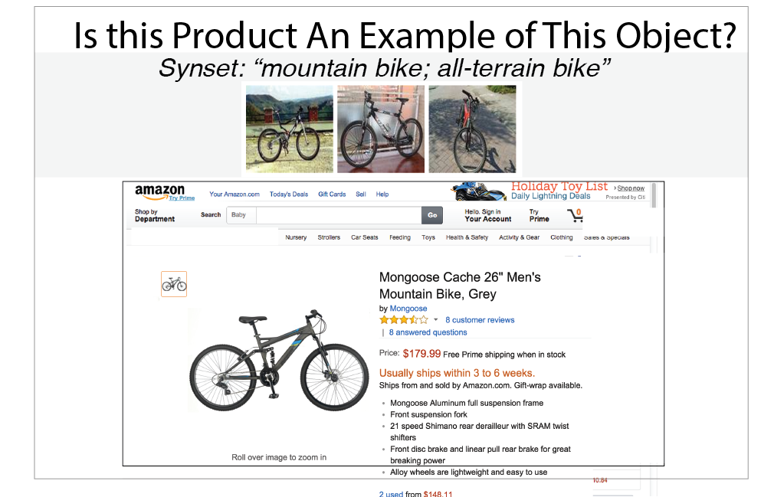

Figure 2: Interface for our HIT asking crowdworkers to verify if instances (from Amazon, DBPedia, and Freebase) are in fact examples of the intended object (synset).