

UNIVERSITY INSTITUTE OF COMPUTING

PROJECT REPORT

Smart Medical Store Sales & Inventory Analysis Using Python

Program Name: BCA

Subject Name/Code: Python (24CAH-301)

Submitted by: Submitted to:

Name: Jhuna Kumar Name:Mr. Dheeraj Panwar Sir
UID: 24BCA10198 Designation: Assistant Professor
Section: BCA – 2 “A” Signature:-------------------

1
S no | Contents | Page
1 | Introduction | 2
2 | Problem Statement | 3
3 | Objectives | 3
4 | Scope of the Project | 4
5 | Tools and Technologies Used | 5
6 | Implementation | 6-8
7 | Results and Findings | 9to 12
8 | Future Scope | 13
9 | Conclusion | 13 to 14
10 | References | 14

- Introduction
The Smart Medical Store Sales & Inventory Analysis Using Python is a data analysis project designed to analyze medical store sales, profits, medicine stock, and expiry information. Medical stores manage a large amount of data related to medicines, purchases, sales, prices, and inventory. Analyzing this data helps store owners understand business performance and make better decisions.The main purpose of this project is to use Python programming and its libraries to process and analyze medical store data. Libraries such as Pandas and NumPy are used for data cleaning, calculations, and analysis, while Matplotlib and Seaborn are used to create graphs and visualizations.This project focuses on identifying the best-selling medicines, calculating total sales and profit, analyzing monthly sales trends, monitoring low-stock medicines, and identifying medicines that are expired or approaching their expiry dates. These analyses can help improve inventory management and reduce unnecessary losses.The project also presents the results through charts and graphs, making complex data easier to understand. It demonstrates how Python can be applied to a real-world business problem.Overall, this project provides practical experience in data analysis, data visualization, and problem-solving using Python. It can also serve as a foundation for future improvements, such as automated stock alerts, sales forecasting, and database integration.

- Problem Statement

Medical stores manage large amounts of data related to medicine sales, purchases, prices, inventory, and expiry dates. Managing this information manually can be time-consuming and may lead to errors in record keeping and calculations.Without proper data analysis, it becomes difficult to identify top-selling medicines, calculate total sales and profit, monitor low-stock items, and identify medicines that are expired or approaching their expiry dates. These problems can lead to inventory mismanagement, financial losses, and poor business decisions.The main objective of this project is to develop a Python-based data analysis system that processes medical store data, performs sales and profit analysis, monitors inventory, and presents useful information through graphs and charts.By using Python libraries such as Pandas, NumPy, Matplotlib, and Seaborn, the project aims to convert raw data into meaningful insights that can help improve inventory management and support better business decisions.
- Objectives
Sales Analysis: To analyze total sales and understand the overall performance of the medical store.
Profit Analysis: To calculate and analyze the profit earned from medicine sales.
Top-Selling Medicines: To identify the medicines that have the highest sales.
Inventory Management: To monitor medicine stock and identify medicines with low inventory.
Expiry Analysis: To identify expired and near-expiry medicines to help reduce losses.
Data Cleaning: To identify and handle missing values, duplicate records, and incorrect data.
Data Visualization: To represent sales, profit, and inventory information using graphs and charts.
Monthly Sales Analysis: To examine monthly sales trends and identify periods of high and low sales.
Python Implementation: To use Python libraries such as Pandas, Bumpy, Diplomatic, and Seaborg for data analysis and visualization.
Better Decision-Making: To provide useful insights that can help medical store owners improve sales performance and inventory management.

- Scope of the Project
The scope of the Smart Medical Store Sales & Inventory Analysis Using Python** project is to analyze medical store data and generate useful insights about sales, profit, and inventory management. The project focuses on improving the understanding of business performance through data analysis and visualization.
Sales Analysis:-Analyzing total sales, product sales, and monthly sales trends.
Profit Analysis:- Calculating profit and identifying profitable medicine categories.
Inventory Monitoring:- Identifying medicines with low stock levels.
Expiry Monitoring:- Identifying expired and near-expiry medicines using available expiry-date data.
Data Cleaning:- Handling missing values, duplicate records, and incorrect entries.
Data Visualization:- Presenting analytical results through graphs and charts.
Business Insights:-Supporting better decisions related to stock management and sales performance.
This project uses Python libraries such as Pandas, NumPy, Matplotlib, and Seaborn to perform data processing, calculations, and visualization.

- Tools and Technologies Used
The Smart Medical Store Sales & Inventory Analysis project uses Python programming and its libraries to analyze medical store data. The following tools and technologies are used in the project.
1. Python: Python is the main programming language used to process, analyze, and interpret medical store data.
2. Jupiter Notebook: It provides an interactive environment to write, execute, and test Python code.
3. Pandas: Used to load datasets, clean data, handle missing values, and perform data analysis.
4. Bumpy: Used for numerical calculations and mathematical operations.
5. Diplomatic: Used to create charts and graphs for visual representation of sales and profit data.
6. Seaborg: Used to create attractive statistical visualizations and identify patterns in the datasets.
7. Excel/CSV: Used to store and organize medical store data, including medicine names, prices, sales, stock, and expiry dates.
8. Visual Studio Code (Optional): Used as an alternative environment for writing and running Python programs.
These tools help transform raw medical store data into meaningful information through data cleaning, analysis, calculations, and visualization.

Implementation
import pandas as pd
import matplotlib.pyplot as plt
data = {
"Medicine Name": [
"Paracetamol",
"Amoxicillin",
"Cetirizine",
"Ibuprofen",
"Azithromycin"
],
"Selling Price": [20, 80, 30, 50, 100],
"Quantity": [150, 90, 120, 100, 70]
}
df = pd.DataFrame(data)
# Calculate total sales
df["Total Sales"] = df["Selling Price"] * df["Quantity"]
print("Medical Store Dataset:")
print(df)
print("\nTotal Sales:", df["Total Sales"].sum())
# 1. Bar Chart
plt.figure(figsize=(8, 5))
plt.bar(df["Medicine Name"], df["Quantity"])
plt.title("Medicine Quantity - Bar Chart")
plt.xlabel("Medicine Name")
plt.ylabel("Quantity")
plt.xticks(rotation=45)
plt.tight_layout()
plt.show()
# 2. Horizontal Bar Chart
plt.figure(figsize=(8, 5))
plt.barh(df["Medicine Name"], df["Quantity"])
plt.title("Medicine Quantity - Horizontal Bar Chart")
plt.xlabel("Quantity")
plt.ylabel("Medicine Name")
plt.tight_layout()
plt.show()
# 3. Pie Chart
plt.figure(figsize=(7, 7))
plt.pie(
df["Quantity"],
labels=df["Medicine Name"],
autopct="%1.1f%%",
startangle=90
)
plt.title("Medicine Quantity - Pie Chart")
plt.axis("equal")
plt.show()
# 4. Line Chart
plt.figure(figsize=(8, 5))
plt.plot(
df["Medicine Name"],
df["Total Sales"],
marker="o"
)
plt.title("Medicine Sales - Line Chart")
plt.xlabel("Medicine Name")
plt.ylabel("Total Sales")
plt.xticks(rotation=45)
plt.tight_layout()
plt.show()
plt.figure(figsize=(8, 5))
plt.scatter(df["Selling Price"], df["Quantity"])
plt.title("Selling Price vs Quantity - Scatter Plot")
plt.xlabel("Selling Price")
plt.ylabel("Quantity")
plt.tight_layout()
plt.show()
# 6. Histogram
plt.figure(figsize=(8, 5))
plt.hist(df["Quantity"], bins=5)
plt.title("Medicine Quantity - Histogram")
plt.xlabel("Quantity")
plt.ylabel("Frequency")
plt.tight_layout()
plt.show()
# 7. Box Plot
plt.figure(figsize=(8, 5))
plt.boxplot(df["Quantity"])
plt.title("Medicine Quantity - Box Plot")
plt.ylabel("Quantity")
plt.show()
# 8. Area Chart
plt.figure(figsize=(8, 5))
plt.fill_between(
range(len(df)),
df["Total Sales"],
alpha=0.5
)
plt.plot(df["Total Sales"], marker="o")
plt.title("Medicine Sales - Area Chart")
plt.xlabel("Medicine Index")
plt.ylabel("Total Sales")
plt.tight_layout()
plt.show()

- Results and Findings
The Smart Medical Store Sales & Inventory Analysis project uses Python to analyze medical store data and identify useful patterns related to sales, profit, and inventory management. The results are presented through calculations, graphs, and charts created using Python libraries such as Pandas, NumPy, Matplotlib, and Seaborn.
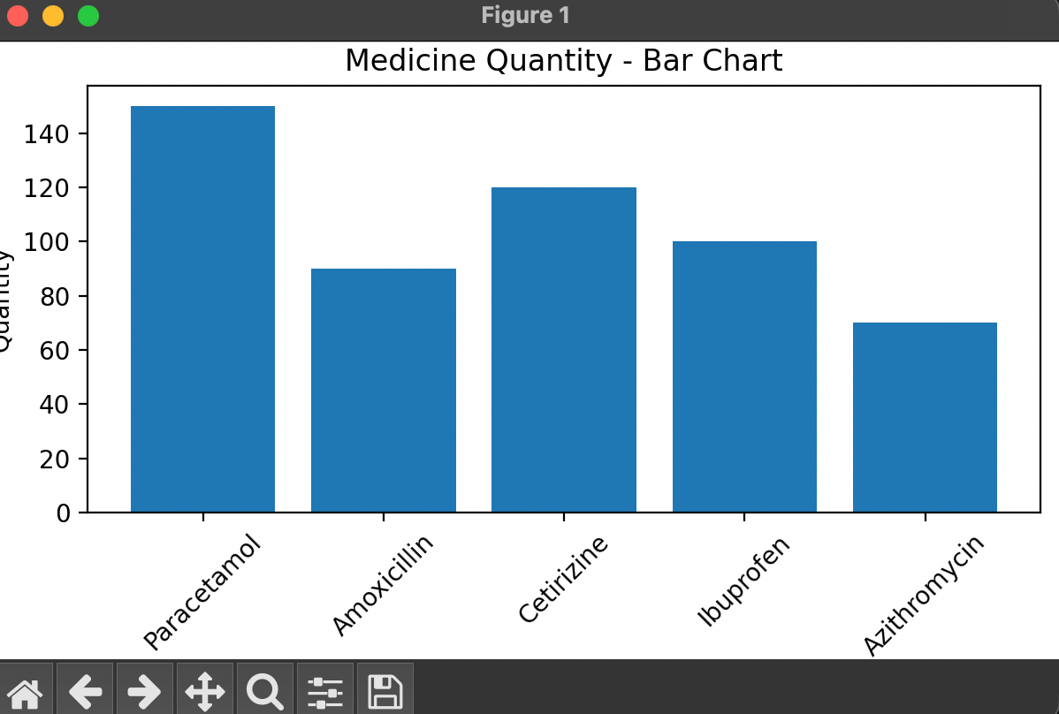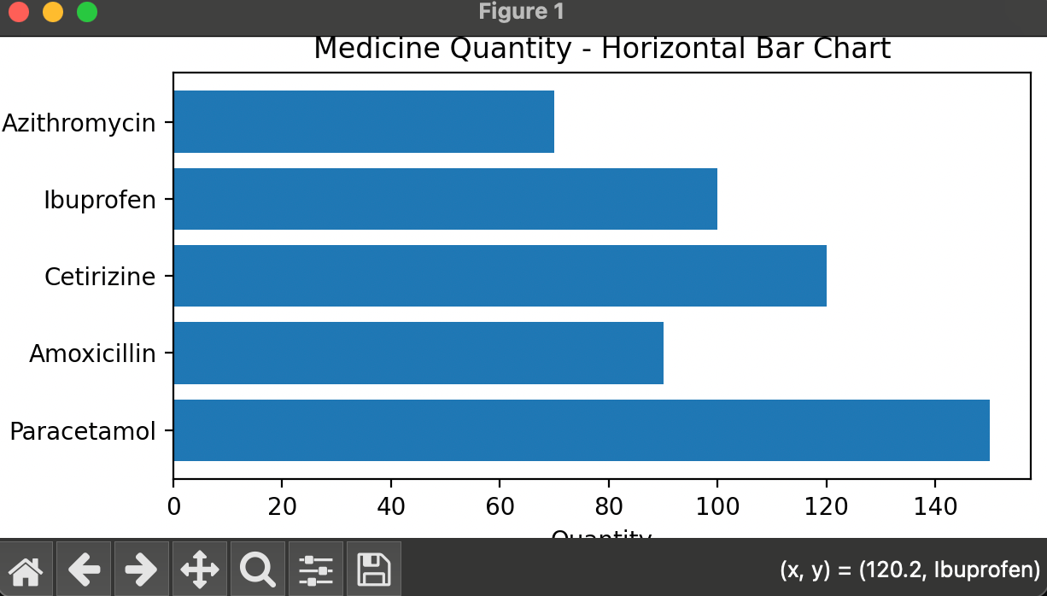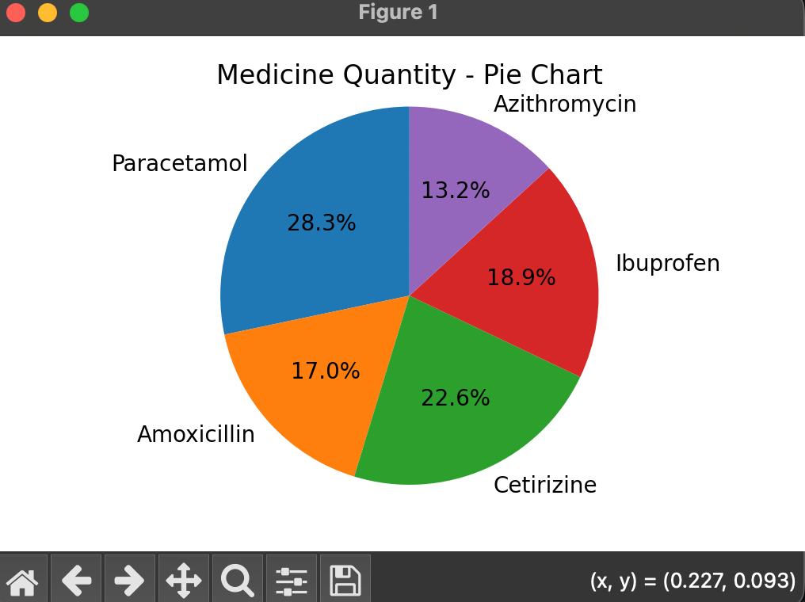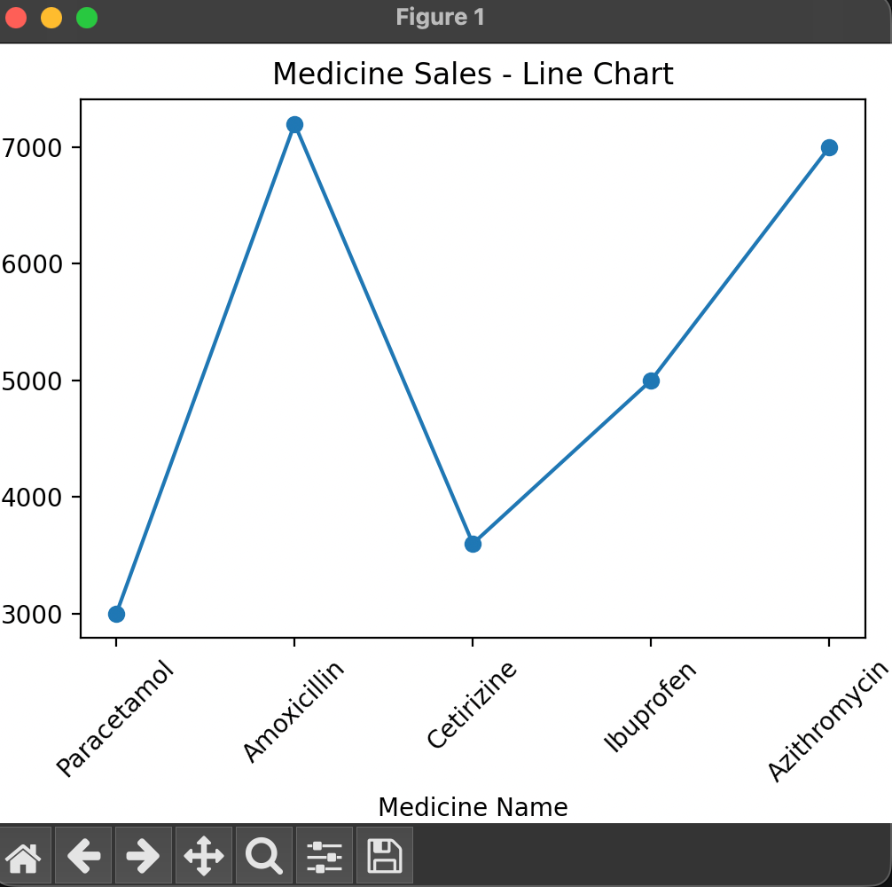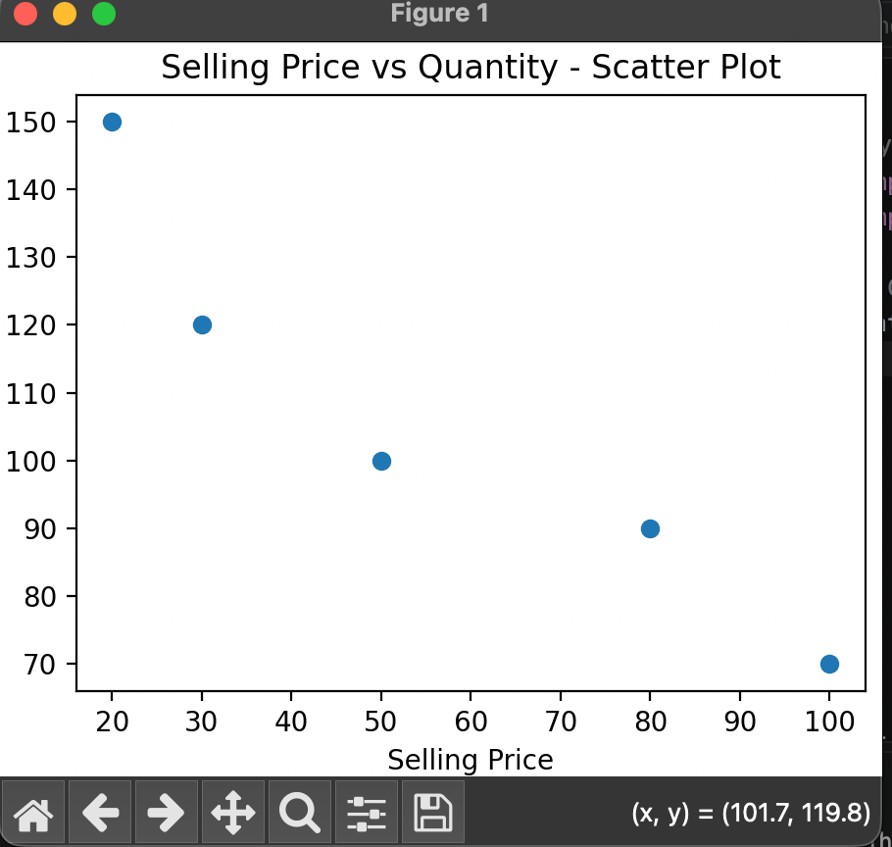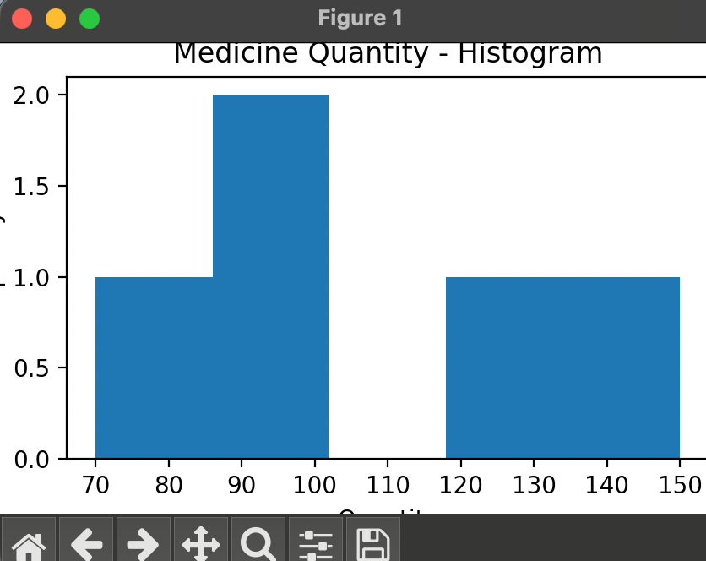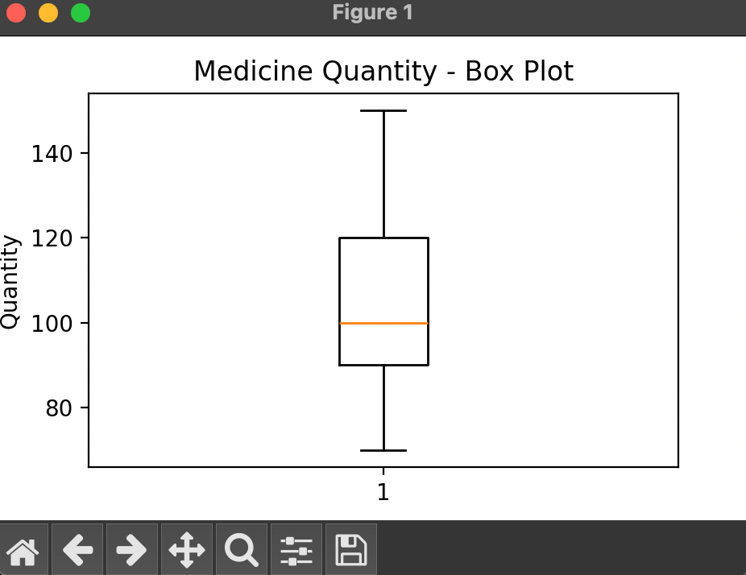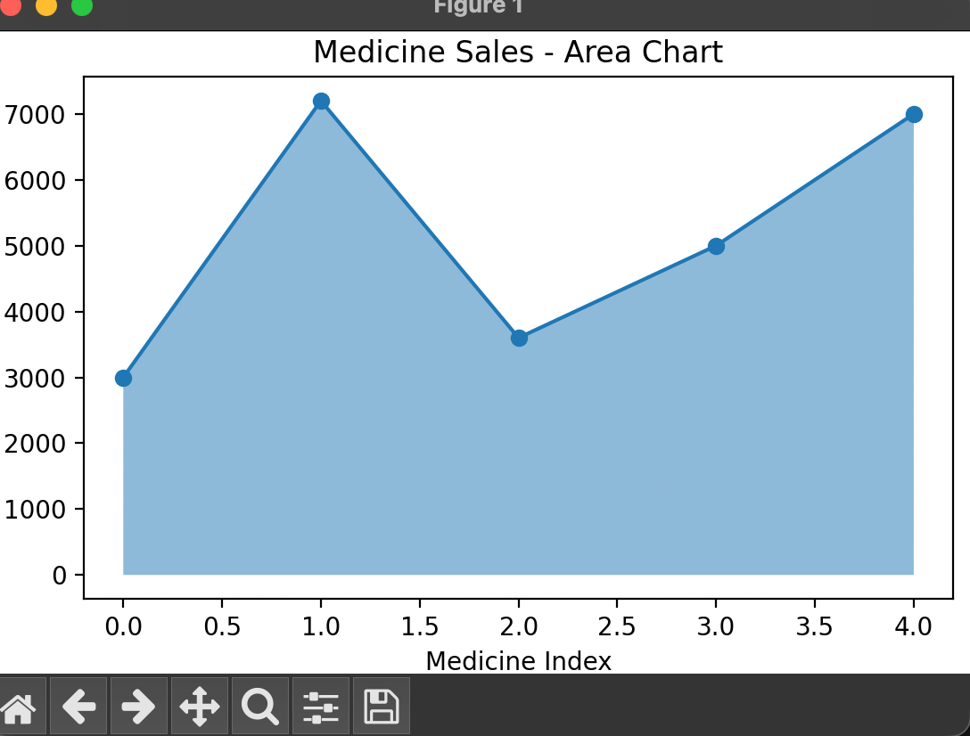

- Future Scope
The project can be improved and expanded in several ways:
1. Real-Time Data Integration:- Connect the system to a live database to . update sales and inventory records automatically.
2. Automatic Stock Alerts:- Generate notifications when medicine stock falls . below a specified level.
3. Expiry Notifications:-Automatically alert store owners about . medicines approaching their expiry dates.
4.Sales Prediction:- Use machine learning techniques to predict future medicine demand.
5.Database Integration:-Integrate MySQL to store and manage . large amounts of medical store data.
6. Graphical User Interface:-Develop a user-friendly interface . using Python . Tkinter.
7. Web Application:-Convert the project into a web-based application for easier access and management.
- Conclusion
The Smart Medical Store Sales and Inventory Analysis project was developed using Python to analyze medical store data and understand sales and inventory patterns. The main objective of this project is to use data analysis and visualization techniques to extract useful information from medical store records. This project demonstrates how Python can be used to solve real-world business problems in a simple and effective way.Python provides several useful libraries for data analysis and visualization. In this project, Pandas is used to read, organize, and process the dataset. Matplotlib and Seaborn are used to create different graphical representations of the data. These libraries make it easier to understand the information and identify important patterns.
Different visualizations, such as bar charts, pie charts, scatter plots, histograms, box plots, and correlation heatmaps, are created to analyze medicine quantity, selling prices, and purchase prices. The bar chart helps compare medicine quantities, while the pie chart shows the percentage distribution of quantities. The scatter plot helps observe the relationship between selling price and quantity. The histogram and box plot provide information about quantity distribution and possible outliers. The correlation heatmap shows the relationships between numerical variables.The project also helps in understanding the importance of data preprocessing, data cleaning, and data visualization. These steps improve the quality of data and make the analysis more meaningful. The results can help medical store owners understand medicine demand, compare product quantities, and make better inventory-related decisions.Through this project, practical knowledge of Python programming, Pandas, Matplotlib, and Seaborn is gained. It also provides an understanding of how data analysis can be applied in the healthcare retail sector.
References
1. Python Official Documentation — https://docs.python.org/3/
2. Pandas Documentation — https://pandas.pydata.org/docs/
3. NumPy Documentation — https://numpy.org/doc/
4. Matplotlib Documentation — https://matplotlib.org/stable/
5. Seaborn Documentation — https://seaborn.pydata.org/
6. Jupyter Documentation — https://docs.jupyter.org/

