RESULTS
Reading Comprehension Summary Table
Track | Reading Comprehension | Interpretation
ACAD | 8.51 | Independent
AD | 9.25 | Independent
TVL | 7.98 | Independent
BCSHS | 8.30 | Independent

Numeracy Summary Table
Track | Numeracy | Interpretation
ACAD | 3.63 | Low Numerate
AD | 3.13 | Low Numerate
TVL | 3.16 | Low Numerate
BCSHS | 3.40 | Low Numerate

Bar Graph Comparison of Reading Comprehension and Numeracy Level
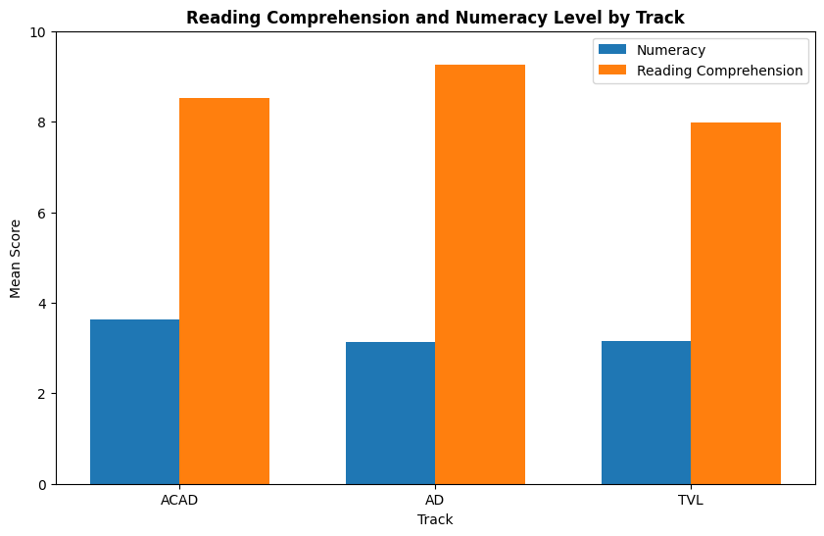

Kruskal-Wallis Test – Reading Comprehension
Variable | H_statistic | p_value | Interpretation
Reading Comprehension | 8.58 | 0.01 | reject H0

Kruskal-Wallis Test – Numeracy
Variable | H_statistic | p_value | Interpretation
Numeracy | 4.51 | 0.10 | fail to reject H0
Heatmap of Post-hoc (Dunn Test) Analysis on Reading Comprehension
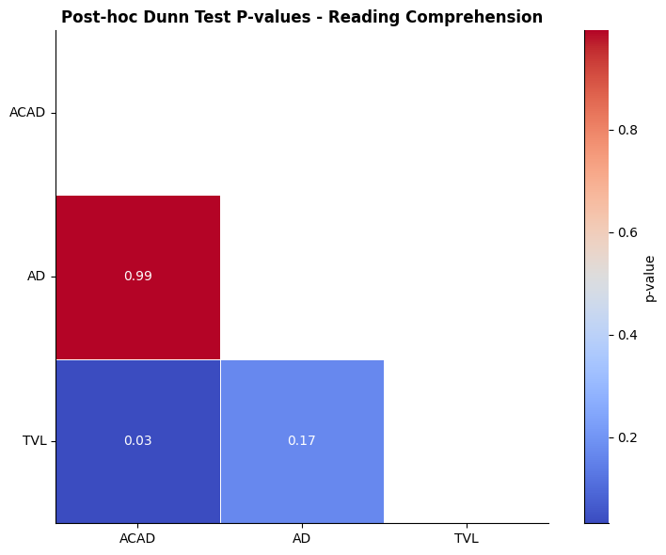
Spearman’s Rank Correlation Table
Spearman_rho | p_value | Significance | Strength
0.18 | 0.01 | Significant correlation | Negligible correlation

Scatterplot of Spearman Result
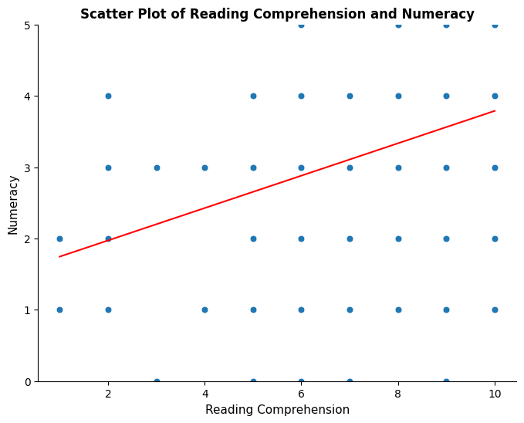

APPENDICES
Shapiro-Wilk Test Result
Variable | W_statistic | p_value | Interpretation
Reading Comprehension | 0.78 | 4.06E-17 | reject H0
Numeracy | 0.94 | 2.5E-08 | reject H0

Histograms of the Spread of Data
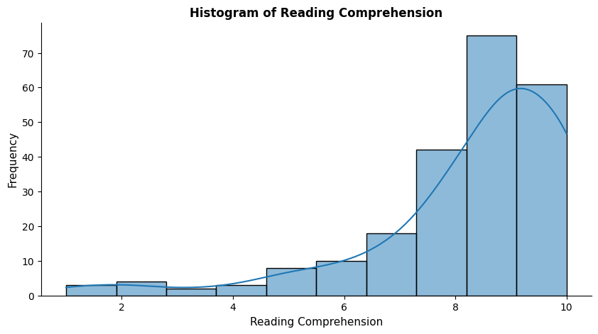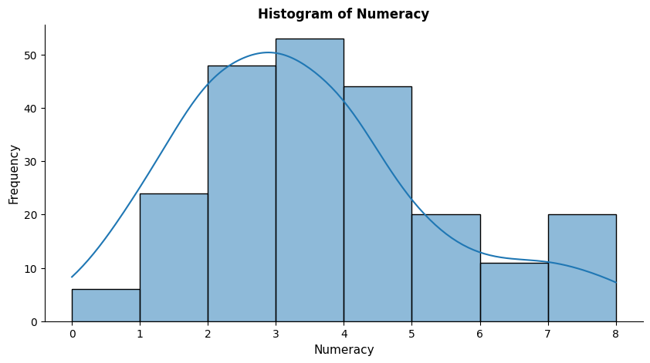

Levene’s Test Result
Variable | Levene_statistic | p_value | Interpretation
Reading Comprehension | 1.82 | 0.16 | fail to reject H0 (equal variances)
Numeracy | 0.44 | 0.64 | fail to reject H0 (equal variances)

Box Plot of each Variable
