**ISAAC**

**In-Situ Automated Artificial Companion**

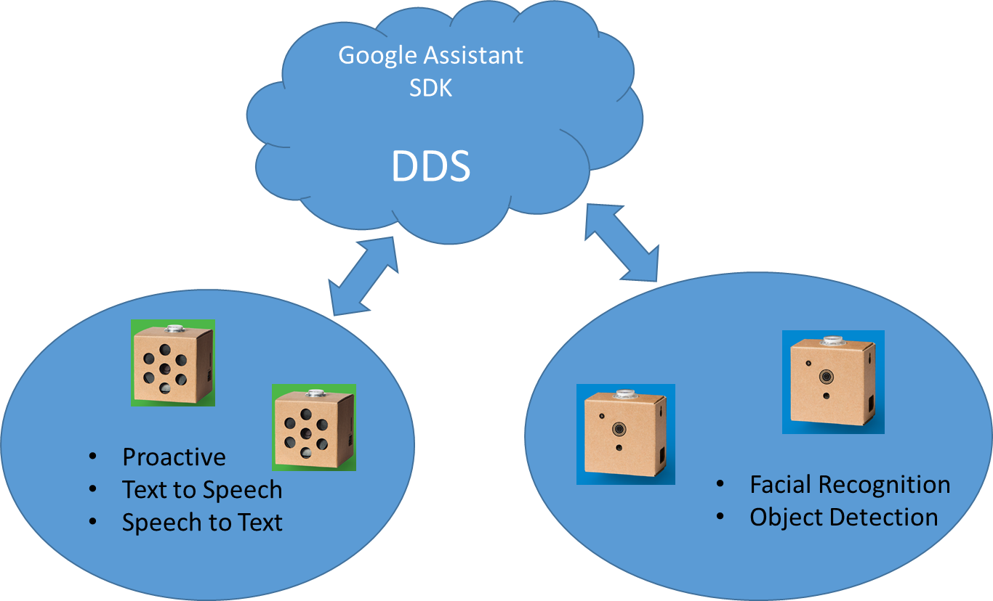

Four Main Parts:

1. Proactive Text to Speech and Speech to Text
2. DDS communications between parts
3. Facial Recognition
4. Object Detection and Classification

# Project Goals

1. Get all the kits built and do the included demos.
2. Investigate using OpenCV for facial detection, object detection and classification
3. Get OpenDDS working between the RaspberryPis
   1. use DDS to communicate between vision and audio kits
4. Get some baseline test cases working for the ***demo at the end***:
   1. When you walk up to the Vision Kit it should perform facial recognition
      1. Send out DDS event that someone is present
         1. The person is known to ISAAC.
            1. “Hello <name>, it is nice to see you. I can tell from your expression you are having <a good day> or <bad day>”
         2. The person is not known to ISAAC
            1. “Hello, my name is ISAAC. I do not believe that we have meet. What is your name?”
            2. ISAAC stores images of the person and is able to recognize him in the future.
   2. Ask ISAAC what he sees
      1. Use object detection to have ISSAC list all the objects he can see.
   3. Have the group come up with ideas.

**Raspberry Pis:**

* The latest AIY image has already been flashed on the 32 GB microSD card.
* Set password to: STEM2019!