Running head: PRICING MODEL OF PROPERTY IN SECOND LIFE
Virtual Appraisals
A Hedonic Pricing Model of Property in Second Life
John Hurliman
Washington State University
Pullman, WA 99163
U.S.A.
jhurliman@wsu.edu
Abstract
This paper explores the fast growing market of property in online virtual worlds by researching land prices in the online world of Second Life. As computing power and access to broadband Internet increases, immersive three dimensional worlds are increasing in popularity. In Second Life, a currency system with a floating exchange rate to the US dollar is in place and user-created synthetic goods are bought and sold. The only constrained resource is virtual real estate, and the more you own the larger and more complex structures you can build. A strong correlation between property size and price can be clearly established, but is this the only determinant of cost? A closer look at the parcels being purchased shows that size may not be the only consideration. Some residents may prefer a tropical beachfront location over snowy cliffs, or a more heavily trafficked area as a location for a new business. A background on the methods used to collect research data from Second Life is presented, and a basic hedonic pricing model for property in Second Life is constructed.
Keywords: second life, virtual property, property value
Introduction
In recent years online gaming has gained the attention of everyone from eager entrepreneurs across the globe, to US congressional committees, to economists attempting to understand this new frontier of commerce. In late 2006 a virtual real estate agent by the pseudonym of Anshe Chung in the online world Second Life became “the first person to achieve a net worth exceeding one million US dollars from profits entirely earned inside a virtual world.” (Anshe Chung Studios, 2006) In 2004 economist Edward Castronova estimated the economic production of the online role-playing game Everquest to be approximately the same as the country of Namibia (Ward, 2004). The US Congress has launched a committee probe into these virtual worlds to investigate the tax implications (Reuters, 2006) as several online worlds achieve higher GNP levels than many third world countries.
While research has been done on the real-world trade done through auction websites such as eBay (Castronova, A Cost-Benefit Analysis of Real-Money Trade in the Products of Synthetic Economies, 2006), the trade in these economies has typically been against the terms of service of the online worlds and not officially embraced. In (Ondrejka, 2004), the differences with Second Life are highlighted including the built-in exchange market for the free-floating game currency and the sale of virtual land. This paper analyzes sales data that is gleaned from the Second Life world using custom software and attempts to build a hedonic pricing model of virtual real estate in Second Life. Extensive studies have been done on real estate prices in the real world, and there are many obvious factors such as geographic location. But in a world where you can teleport anywhere instantly and residents never get cold or need food, do these same factors carry the same weight or even make a difference?
This is interesting because virtual worlds are becoming an increasingly large source of economic activity, with Second Life showing USD $1,517,000 worth of virtual currency exchanging hands in the last 24 hours (April 24th, 2007, Source: http://www.secondlife.com/). Large corporations such as Coldwell Banker are entering the Second Life real estate business, brand names are clamoring for Second Life property for advertising (as seen in Figure Figure ), and overseas virtual worlds such as ‘QQ’ in China have built up such a strong currency that the central bank of China is taking measures to prevent it from threatening the Yuan (Fowler & Qin, 2007).
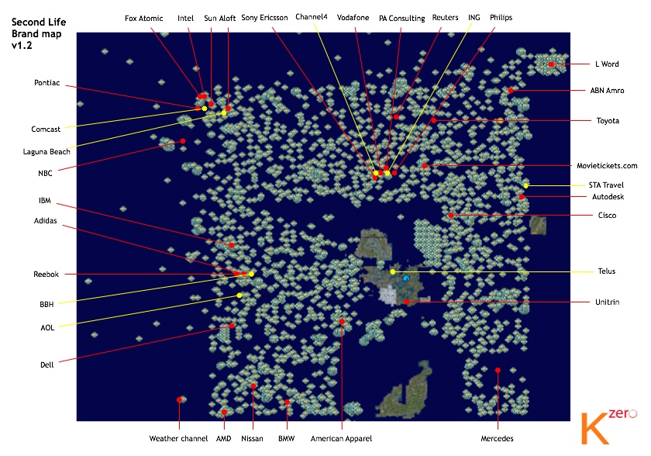
Figure I. A map of brand names in Second Life (from http://www.kzero.co.uk/blog/?p=424)

Background
Second Life is organized as a vast grid of space, measured in meters. Each block in the grid is called a region, and is 256 square meters of land. A small portion of the grid is shown in Figure , while the entire grid currently has over 6,000 regions. Residents pilot around this land through an avatar, the virtual representation of the player’s body. Just as websites on the Internet are run on physical web servers, regions in Second Life are run on computers called simulators. Each simulator can power four regions, and as demand increases for land new simulators are brought online and regions are added to the grid. Regions are either owned by the company operating Second Life—Linden Labs—or they are leased to private owners. These privately owned regions are separate islands that are not part of the main continents and are known as private estates, while regions owned and operated by Linden Labs and connected to the main continents are known as ‘mainland’. This paper only looks at data collected from mainland sales, as private estates can have separate rules and closed communities. Land on the mainland is auctioned off on the web in large portions which are split up into smaller parcels by buyers and resold in the Second Life world. While the auction market is worthy of analysis on its own, this paper will only focus on the secondary land market inside Second Life.
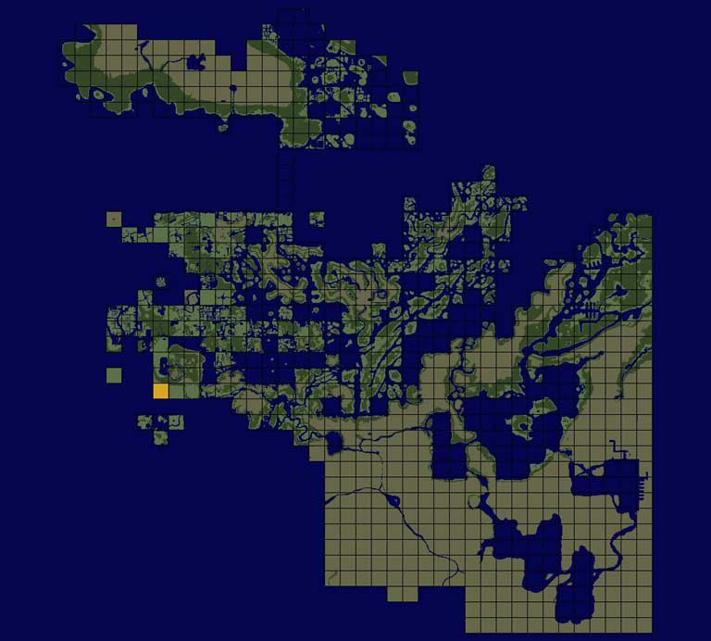
Figure II. Part of the Second Life grid, each square is a 256 square meter region
Not all regions in Second Life are identical. Some are flat, grassy land; some are a series of small islands and others are snowy mountains, to name a few. Anyone can put their land up for sale, free of charge, by entering a sale price and ticking a checkbox which will add a for sale listing to a searchable database in-world. Residents looking to purchase land enter criteria into the land search engine and can instantly teleport out to a parcel to inspect and potentially purchase it. The transactions all occur in the Second Life currency system, the Linden Dollar (L$), and there are no taxes or fees for buying or selling land. However, there are tiers of monthly fees that increase based on the amount of land you can own at any given time.
User-created content is built by linking basic 3D shapes together called primitives, or ‘prims’. Each parcel of land supports a fixed number of total primitives it can hold which is a linear relationship to the size of the parcel. The larger the plot of land you own the larger storefront you can put on it, or the more intricate statue you can build on it. Land is typically used for building a personal home, setting up a store to sell objects, installing a club, casino, or event center, or as a sandbox for building new creations. The primitive limitation on land suggests a strong correlation between the size of land and its value, since larger businesses and residences will need more land to overcome both size restraints and primitive count restraints.

Data Collection
The main barrier to doing any sort of economic analysis in Second Life is that there is only limited aggregate data available, mostly focusing on the size of the virtual world in terms of active users. There is no listing of completed land sales transactions, so custom software had to be developed. Using the libsecondlife programming library that allows software to connect to the Second Life world, a ‘bot’ program was written that looks at a sampling of the top for-sale listings every half hour, and watches for parcels that change ownership to detect sales. Once a sale is detected and the bot has confirmed the basic properties of the land have not changed since the sale, various attributes are detected and logged to a database.
The individual algorithms were tested and visually confirmed in-world for accuracy, and the sales detection was manually monitored and confirmed for the initial rounds. During this process it became apparent that the large majority of land sales were not going to people that purchased the land to develop on, but to real estate agents that were buying land and increasing the price, or dividing it up into smaller parcels for larger profit margins. Manual observation showed that this activity was very common during the entire data collection phase.

A Simple Price Model for Second Life Property
As described in (Wen, Lu, & Lin, 2004), the prevalent method for valuing real estate is to construct a hedonic price index of a property with given characteristics. Research in the field of virtual commodities has shown that due to artificial scarcity (or in the case of Second Life, real scarcity that is driven by the cost of running the simulators), meaningful data can be collected from virtual worlds and this data can be analyzed using some of the same methods as real world goods (Nash & Schneyer, 2004) (Castronova, 2003). Using these assumptions, a hedonic price model will be built for virtual property in Second Life. Starting with just the parcel area we can draw a strong correlation between price and area as shown in Figure .
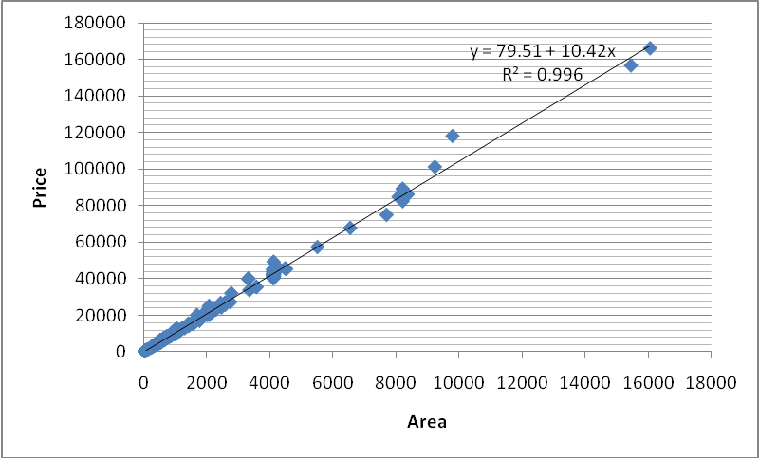
Figure III. Scatter plot and regression of parcel price and area
It can be seen from the R-Squared value of 99.6% that the price of a parcel in Second Life is mostly explained by the area for sale. However we will try to get an even more accurate pricing model by introducing additional descriptive variables. The characteristic variables chosen describe the for-sale listing, the geographic properties of the parcel, and the normality of the parcel in relation to a flat, rectangular plot of land. Table I lists these variables along with a description of the meaning and values, Table II lists these variables along with basic statistical measures. Dummy variables are used to represent snowy, underwater, and waterfront parcels with dry, non-snowy parcels being the control.
Table I
MEANINGS AND MEASURE METHODS OF VIRTUAL PROPERTY CHARACTERISTIC VARIABLES
Variable |  | Variable meanings and measure methods
Area |  | Size of the parcel in square meters
Picture |  | 1 = A picture was included in the for sale listing, 0 otherwise
Height range |  |  | The difference between the maximum and minimum terrain elevations on the parcel
Shape deviation |  |  | The difference between a rectangular bounding box around the parcel and the area of the actual parcel, measuring the deviation of the parcel shape from a perfect rectangle
Snow |  | 1 = Snow covered region, 0 = Grassy region
Underwater |  | 1 = Parcel is completely submerged, 0 otherwise
Waterfront |  | 1 = Parcel is partially submerged, 0 otherwise

A total of 842 samples were collected during random sampling intervals over the course of four days in the month of April 2007. An alternative measure for the response that was considered was the listing price of land plots. The problem with this approach is that there is no listing fee or deterrent from listing land for sale, so the data biases to overpriced plots of land that don’t intend to compete on the market. The refined method of monitoring the market for sales eliminates this problem. Additional variables that were considered were Mature, which describes if a parcel is in a region that allows adult-oriented content, Dwell, a Second Life measurement to describe the amount of time avatars have spent on that land, and Prims, which gives a count of the number of primitives (building blocks of content) that are sold along with the land. The Mature variable was tracked during data collection but every parcel sale logged was in a region that allowed adult content. The Dwell value was tracked as well but was zero for all of the sales logged. This was expected as most of the selling activity happens in fresh, undeveloped simulators where the only traffic is from avatars setting up the land for sale and purchasers. The number of primitives sold along with a parcel would be useful as a stepping stone to detecting whether houses are being sold along with parcels, but that data was not able to be collected with the software as it is written since it only checks parcels after a sale has been completed.
Table II
DESCRIPTIVE STATISTICS
Variable |  | Obs | Mean | Std. Dev. | Min | Max
Price |  | 291 | 12759.803 | 15724.837 | 148 | 86500
Area |  | 291 | 1262.566 | 1553.645 | 16 | 8192
Picture |  | 291 | 0.021
Height Range |  | 291 | 4.192 | 5.963 | 0 | 46.36
Shape Dev. |  | 291 | 111.390 | 371.560 | 0 | 2901
Land |  | 291
Underwater |  | 291
Waterfront |  | 291
Dry |  | 291

From this simple model several questions can be formulated. Initial evidence suggests that snowy land sells for less than the traditional green grass land or the coveted beachfront property. To what extent do these geographical differences affect the pricing? Some residents of the world have suggested that there is a 1:1 correlation between price and size, and none of the auxiliary factors are statistically relevant to the value of land. Beyond the parcel itself the listing can be analyzed as well. On auction sites such as eBay, adding additional information such as a picture in the listing costs a premium and is assumed to attract more buyers. In Second Life, where a plot of land can be seen beforehand and complete information is available before the purchase, does putting a picture in the for sale listing have an effect on the sale price?

The Empirical Model
The form of the initial hedonic price model is a multivariate linear regression using the OLS method:
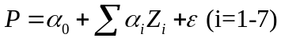
R-Squared of the model is 99.7% with an adjusted R-Squared of 99.7%, a slight margin over the univariate regression using only area as the independent variable. Table III shows the resulting coefficients in the hedonic regression, and which coefficients were statistically significant at the 95 percent confidence level. With the data collected only three of the variables had statistical significance. Area is still the most prominent, and Picture is showing a strong correlation as well. With a coefficient of 392.31 it seems that land sales with pictures in the listing were selling at a slight premium over listings with no picture. It’s important to look at exactly what having a picture in the listing means in Second Life. You can put any picture you want in the listing, and it costs 10 Lindens (Second Life currency, equivalent to approximately four cents at the current exchange rate) to upload a new picture. Because of the small fee and the time involved to take a picture of the land you are selling and upload the picture, many virtual realtors put their personal or company logo in the picture. Since so few listings actually have pictures of the land that is being sold this may be evidence of a preference for land sold by experienced realtors, or it may be evidence that experienced realtors are selling better land.

Table III
HEDONIC REGRESSION OF PARCEL PRICE ON PARCEL AND LISTING ATTRIBUTES
Independent Variables | Price
Area | 10.3403*
Picture | 392.31*
Height Range | 5.104
Shape Dev. | 0.0209
Snow | -323.0
Underwater | 211.9
Waterfront | 7186.6*
Constant | -21.43
R² | 0.997
N = 842. Source: Detected Second Life parcel sales, April 18, 2007 – April 22, 2007. Asterisks indicate statistical significance at the 95 percent confidence level.
The final variable that showed statistical significance is waterfront property with only three samples collected, showing a strong premium on waterfront land with a coefficient of 7186.6. This is in line with the original hypothesis. Underwater property could not be effectively tested as there was only a single underwater parcel sold during the data collection period. Snowy land does show a negative correlation but the results were not statistically significant, with 18 samples collected. Interestingly the height range and shape deviation of parcels showed no correlation. One explanation for the height range is that parcel owners can terraform their land to some degree, lowering hills and smoothing over rough areas. This only works to some degree; a steep hillside can’t become a completely flat terrace, but a terrace can be built with the tools in-world which gives land owners the ability to overcome non-ideal terrain.
Shortcomings
There are several problems with the work described above. We are not directly collecting sales information, only making inferences about sales by periodically polling for new data. It is possible for land to be purchased and quickly resold between data polls, or for land to be purchased and quickly joined with another plot of land (which destroys the original land plot and removes it from our data). An overlooked portion of data is that seller information is not taken into account. Of the 842 sales logged, there were 173 unique sellers. As businesses and individuals grow larger and real estate empires in Second Life become more notorious, purchasers make conscious decisions to trust that seller, boycott their land sales, or other actions that can change the demand for the seller’s land.
The time span over which data is collected presents a problem. If sales are logged over a period of time they cannot be treated equally as more land is created all the time, changing the supply. An extensive analysis that shows land pricing trends, the effects of an increasing user base, supply shocks as new land is put online, and how changes in the legal and social atmosphere affect pricing would require months or years of historical data, using panel data analysis.
However, the number one major problem in collecting this data is a selectivity bias imposed by the land search functions available in Second Life. With something close to a million parcels of land in Second Life and many of them set for sale, the search tools are not adequate for finding the exact parcel of land you want. If a resident is looking to purchase land and has 15,000 Linden dollars, he can search for all mainland parcels under that price and maybe limit it to parcels that are 1024 square meters or larger. Page after page of results will be given, sorted by price per square meter, and the description of each parcel can be read and the resident can even teleport out to prospective purchases and inspect before buying. The sheer amount of sales means the resident may never find the premium waterfront land by doing this, as it might not show up in the listings until page 23. A better method of monitoring sales is needed to do accurate research, and a better method of finding land for sale is needed for the land market to operate efficiently.
Conclusion
The data collected reveals a very competitive market for land in Second Life. Although everyone has the same opportunity to buy and sell land, the market is made up of far fewer sellers than parcels of land for sale. Some of the original hypotheses proved correct. Putting a picture in the for-sale listing has been shown to increase the premium on land sales, and waterfront property sells at a much higher premium than the typical dry land. There was not enough statistical significance to reject the null hypothesis for snowy or underwater parcels, although this may be due to a limited number of available samples for those types of parcels.
The software used to monitor land sales was successful and effective at finding sales, but limited in scope. Collecting a completely random sampling of land for sale was not possible due to the selectivity bias imposed by the land search tools available in Second Life, and finding all of the land sales was not possible without a much more intensive software application. To test the hypotheses with perfect data would require access to the land sales database kept by the creators of Second Life. Although the historical database information is probably not as in depth as what could be collected using custom software, a long term graph of price vs. area would show trends as the virtual world grows. Finer grained current data would also be useful, with more advanced software algorithms for detecting the roughness of terrain, swampy land, and detecting objects sold with the land including common pre-fabricated homes or custom homes.

References
Anshe Chung Studios. (2006, November 26). Anshe Chung Becomes First Virtual World Millionaire. Retrieved April 23, 2007, from Anshe Chung Studios: http://www.anshechung.com/include/press/press_release251106.html
Castronova, E. (2006). A Cost-Benefit Analysis of Real-Money Trade in the Products of Synthetic Economies. Info , 8 (6).
Castronova, E. (2003). The Price of 'Man' and 'Woman': A Hedonic Pricing Model of Avatar Attributes in a Synthetic World. CESifo Working Paper Series (957).
Fowler, G. A., & Qin, J. (2007, March 30). QQ: China's New Coin of the Realm? The Wall Street Journal , p. B1.
Nash, J., & Schneyer, E. (2004, May 6). Virtual Economies: An In-Depth Look at the Virtual World of Final Fantasy XI: Online. Unpublished manuscript.
Ondrejka, C. R. (2004, November 7). Aviators, Moguls, Fashionistas and Barons: Economics and Ownership in Second Life. Retrieved April 23, 2007, from Social Science Research Network: http://ssrn.com/abstract=614663
Reuters, A. (2006, October 15). US Congress launches probe into virtual economies. Retrieved April 23, 2007, from Reuters/Second Life: http://secondlife.reuters.com/stories/2006/10/15/us-congress-launchs-probe-into-virtual-economies/
Ward, M. (2004, August 19). Virtual gaming worlds overtake Namibia. Retrieved April 23, 2007, from BBC News Online: http://news.bbc.co.uk/2/hi/technology/3570224.stm
Wen, H. Z., Lu, J. F., & Lin, L. (2004). An Improved Method of Real Estate Evaluation Based on Hedonic Price Model. Zhejiang University, P.R. China: International Engineering Management Conference.

Appendix

The shape deviation algorithm (shapedev in the data) takes the area of the smallest rectangular bounding box the entire parcel will fit in minus the actual area of the parcel. This gives a value that linearly increases for parcels that deviate further away from perfect rectangles.
The height range algorithm (heightrange in the data) is simply the maximum terrain elevation on the parcel minus the minimum terrain elevation on the parcel.
Snowy land is detected by looking at the terrain textures for the region and matching the base texture against the known base snow texture.
Dry, waterfront, and underwater land is detected by looking at the water elevation in the region and the terrain height of every square meter on the parcel. If it is all above water the land is dry, all below water is underwater, and some of both is considered waterfront.

The author is the lead developer of an open source software library called libsecondlife that enables programmers to write software that connects to Second Life through an avatar. Since the avatar is controlled by a software program instead of human interaction this type of software is typically referred to as a ‘bot’.

