Milestone 5: Data recovery simulation

1. As a test to restore database, I selected to delete the following three tables from the database.
AdventureWorks22 > Tables and then proceeded to delete the first three tables:
(a) AWBuildVersion
(b) dbo.Database.log
(c) dbo.ErrorLog

5a

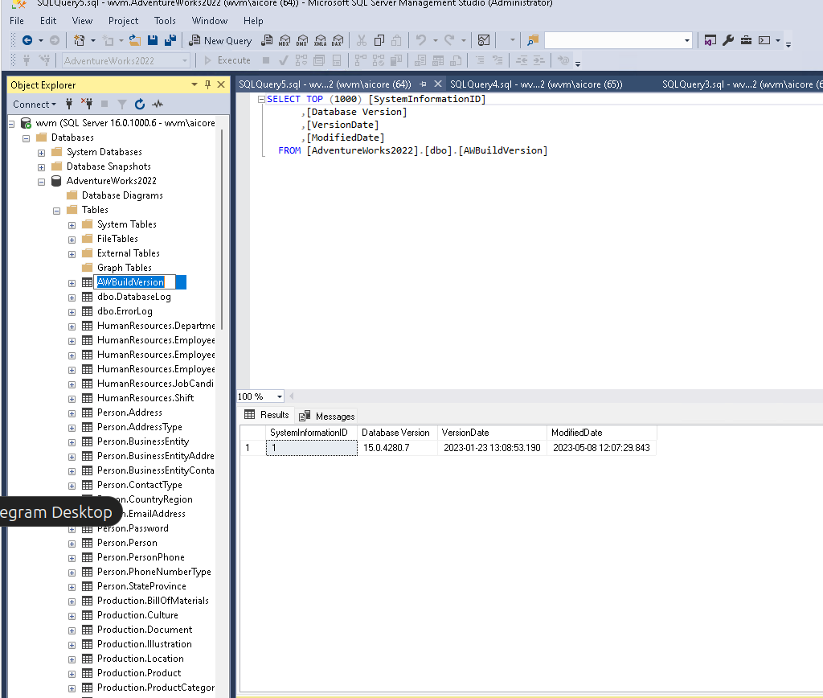
2. You can see some errors already from the assessment summary:
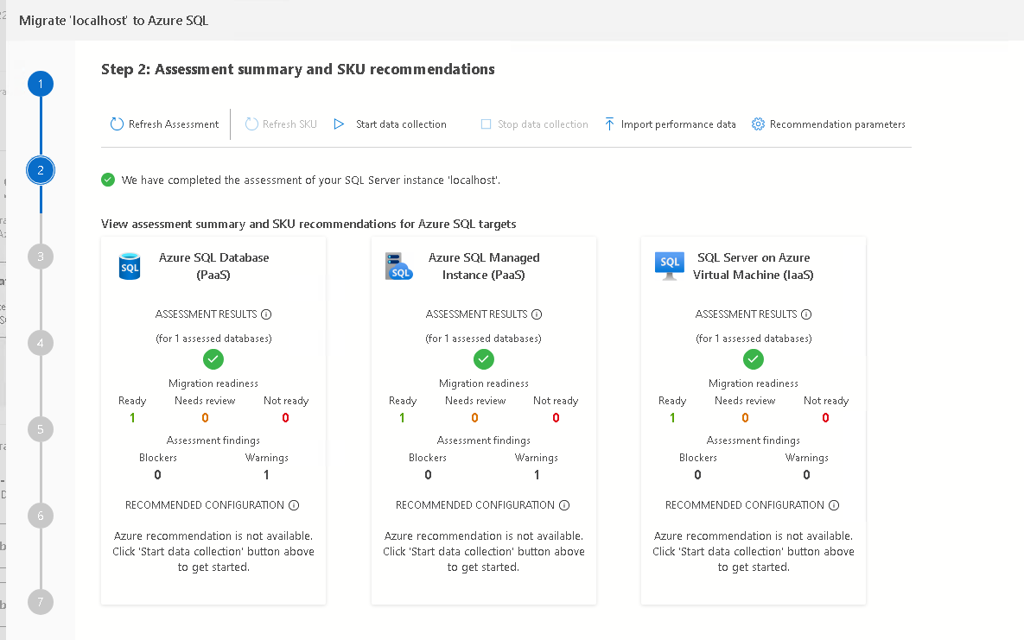

and the three tables are missing from a quick inspection of the database from azure data studio:

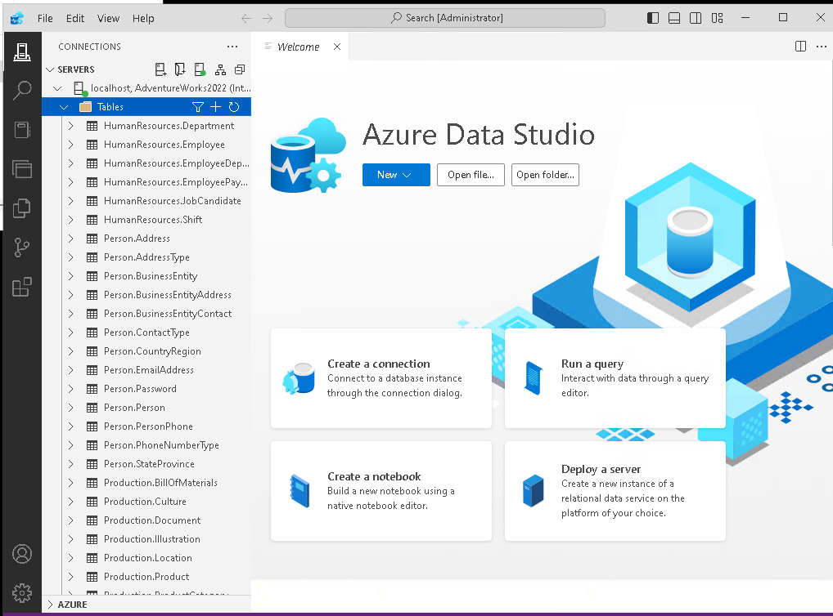

before backup:

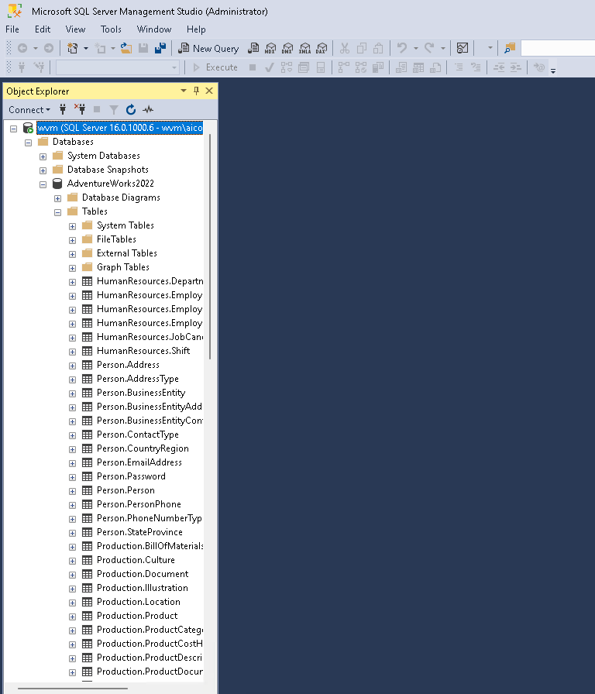

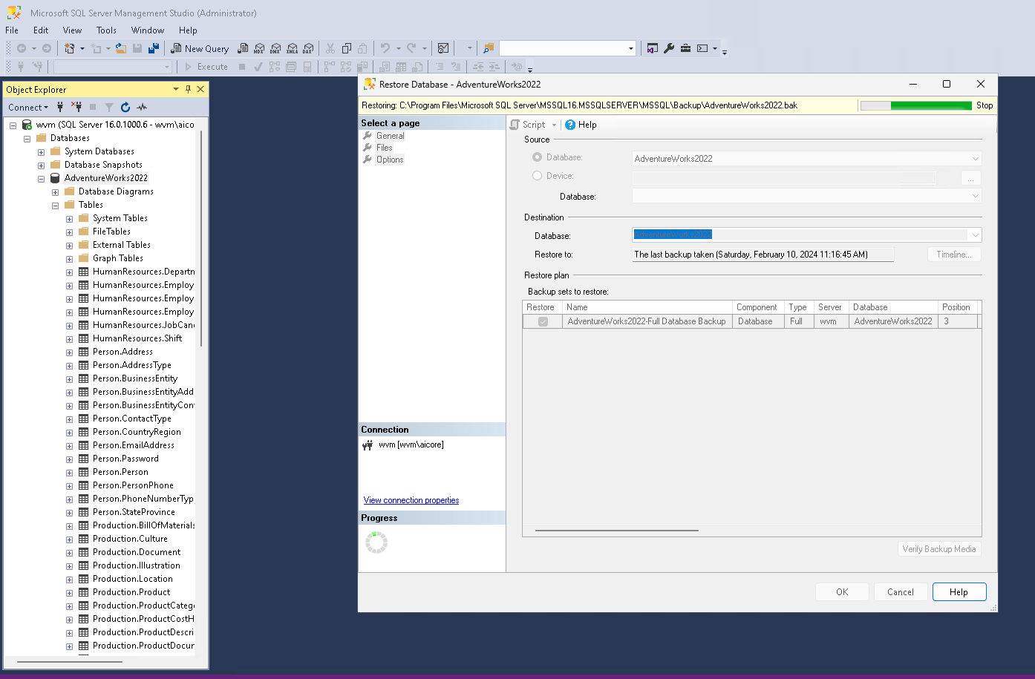
restoring database:
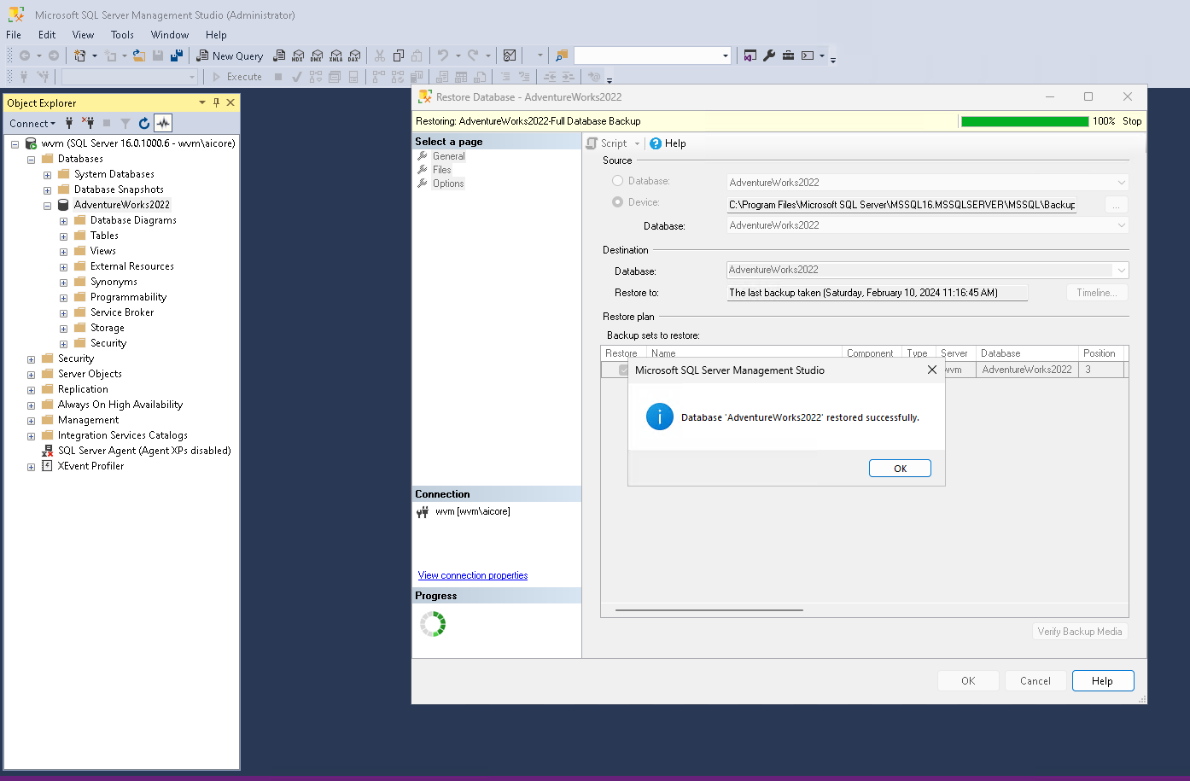
also verified successful backup in azure data studio:
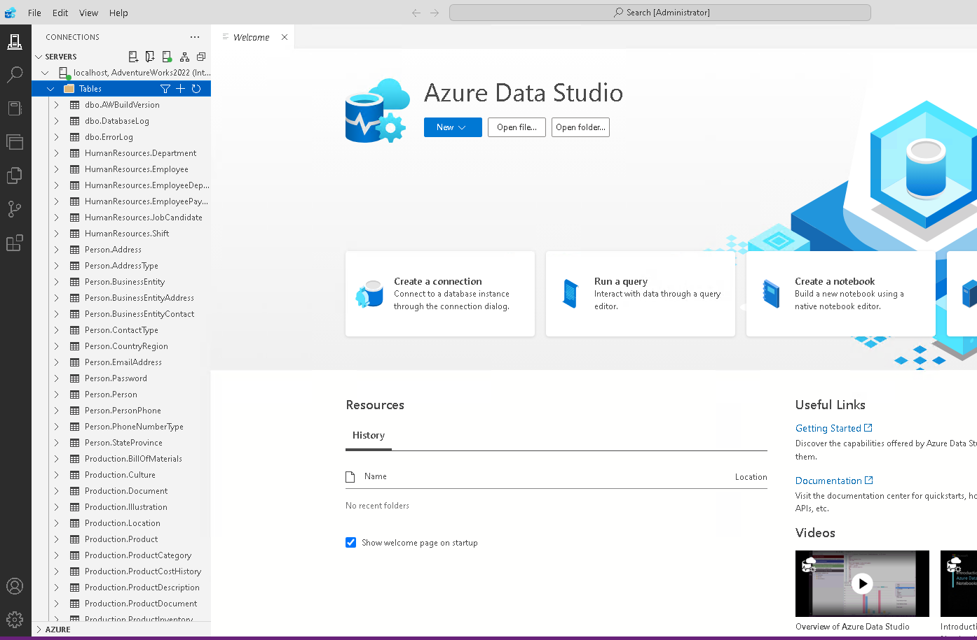
Carried out the same exercise from azure cloud services. This time I restored data back back a few hours, at 10AM this morning, before mimicking data loss:
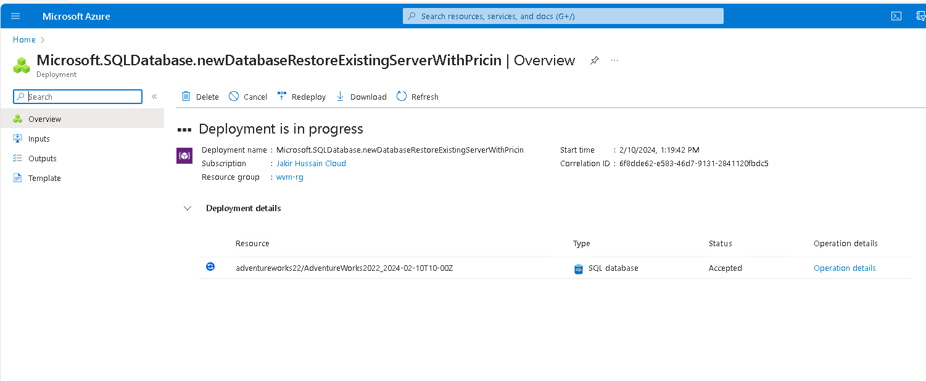
Deployment completed.

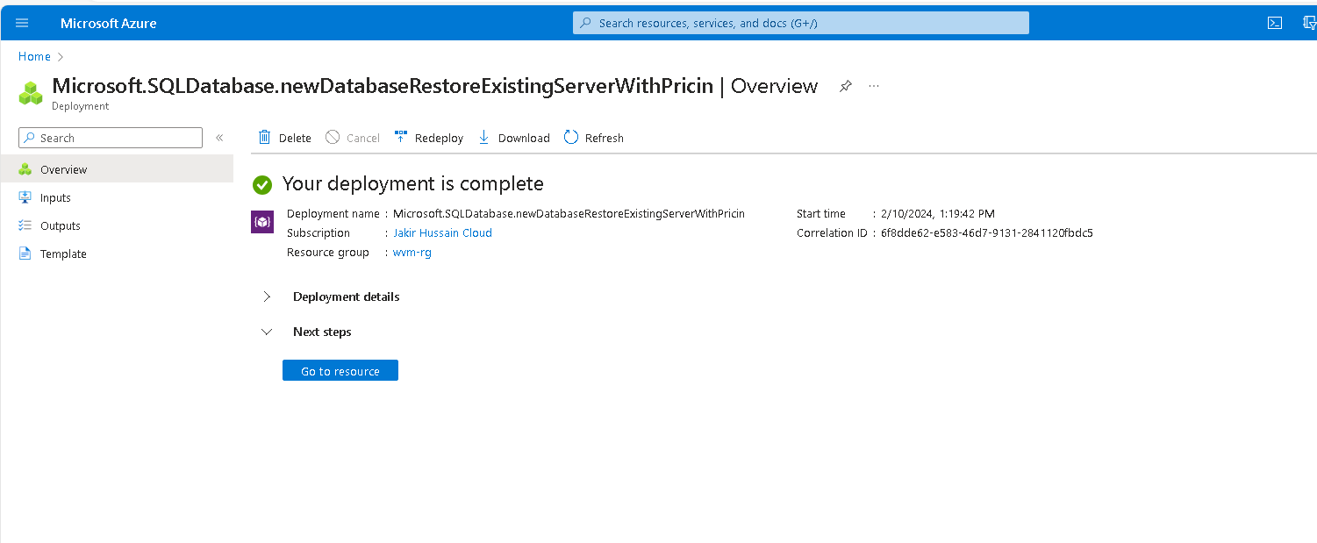

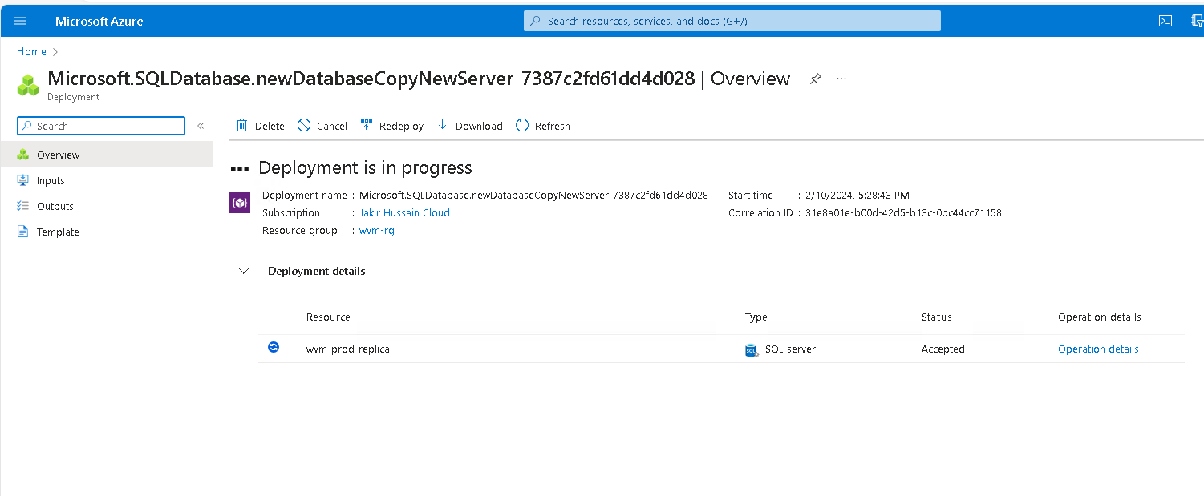
Geo replication of the same server in Azure SQL database:
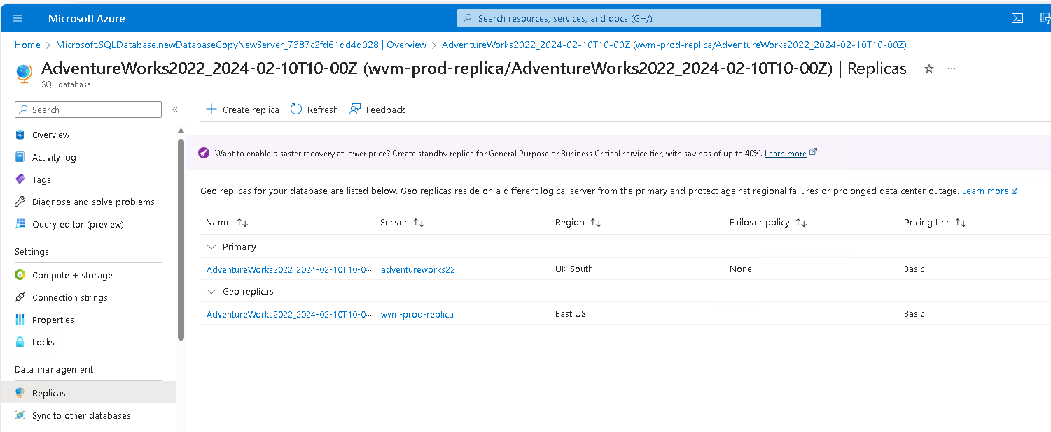
now we have two: primary and geo replica:

Test Failover and Tailback

Initiating a Test Failover to the Secondary Region

Create your failover group and add your single database to it using the Azure portal.
- Select Azure SQL in the left-hand menu of the Azure portal. If Azure SQL isn't in the list, select All services, then type Azure SQL in the search box. (Optional) Select the star next to Azure SQL to favorite it and add it as an item in the left-hand navigation.
- Select the database you want to add to the failover group.
- Select the name of the server under Server name to open the settings for the server.
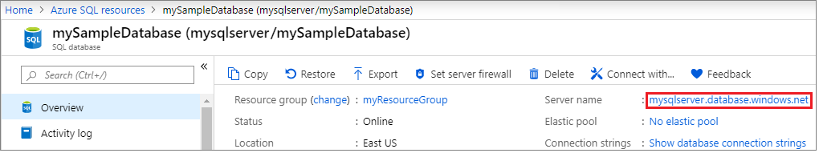
- Select Failover groups under the Settings pane, and then select Add group to create a new failover group.
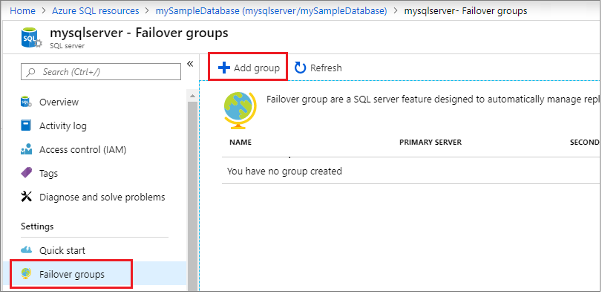
- On the Failover Group page, enter or select the required values, and then select Create. Either create a new secondary server, or select an existing secondary server. The secondary server in the failover group must be in a different region than the primary server.
  - Databases within the group: Choose the database you want to add to your failover group. Adding the database to the failover group will automatically start the geo-replication process.
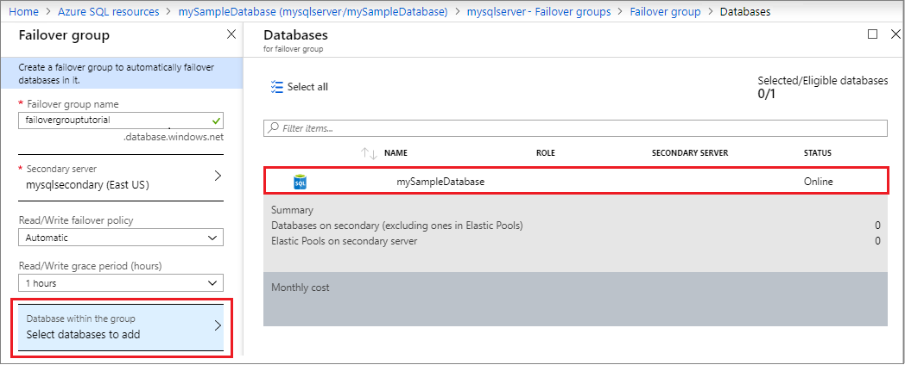

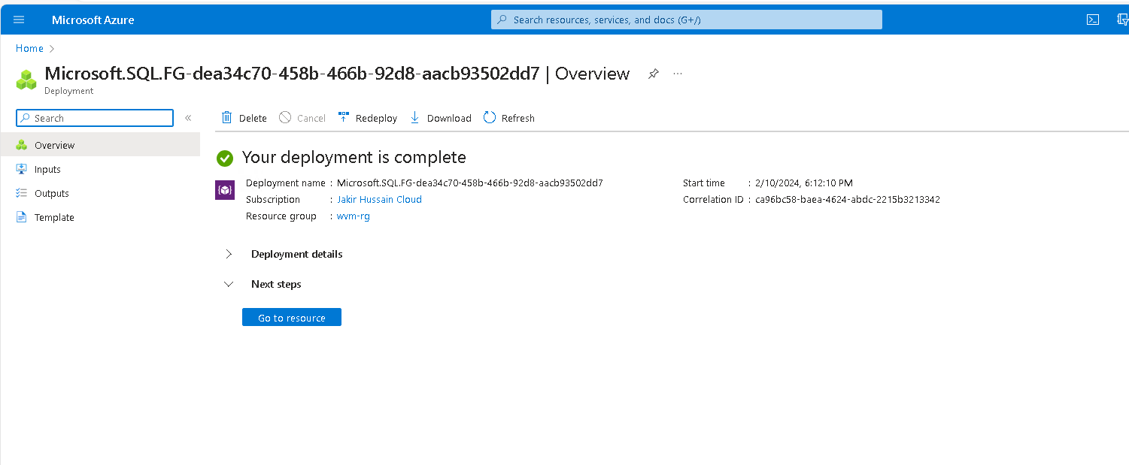
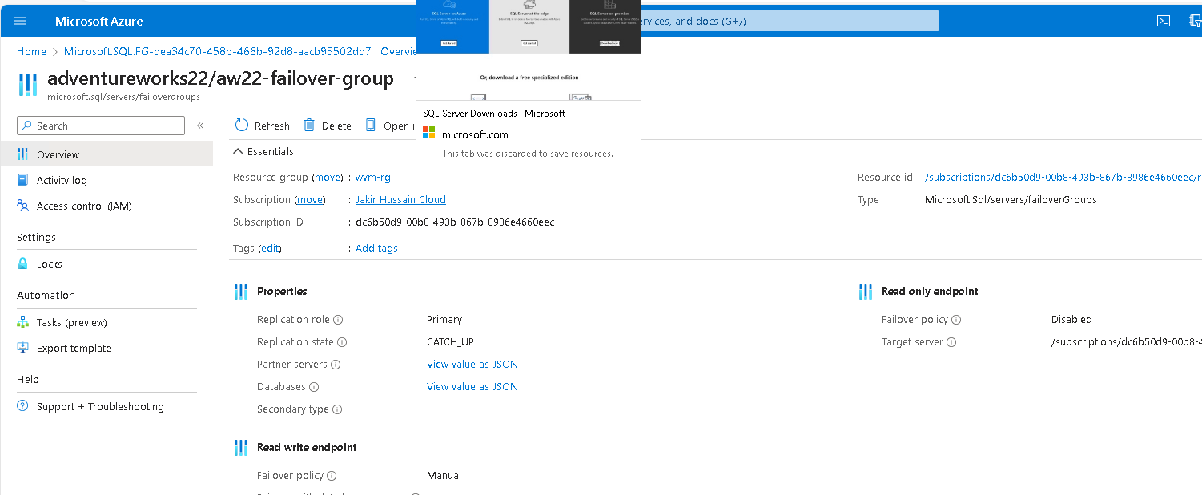
going to resource:

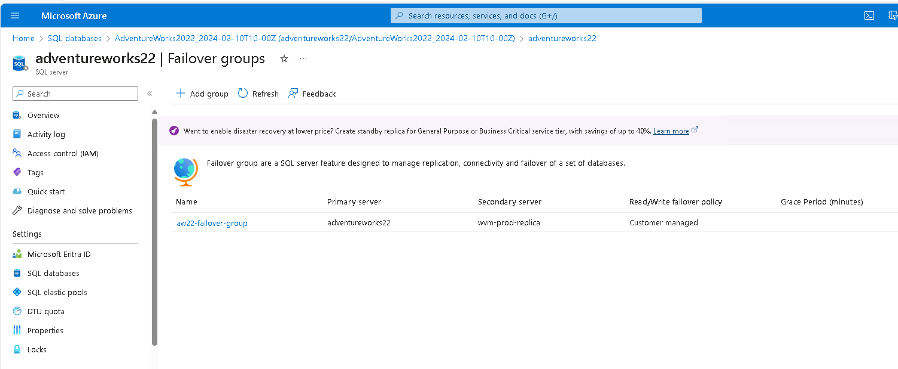
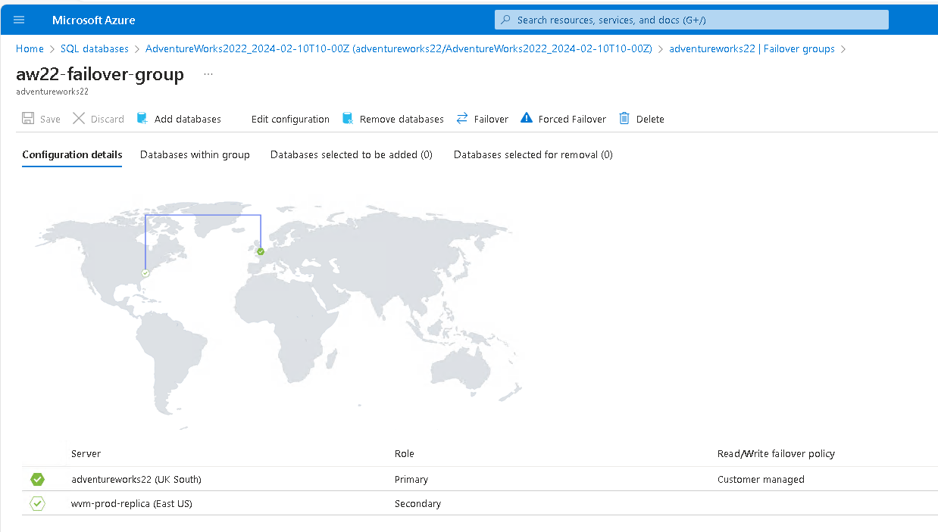
Access fail-over groups:
which should now indicate two servers in the fail-over group:
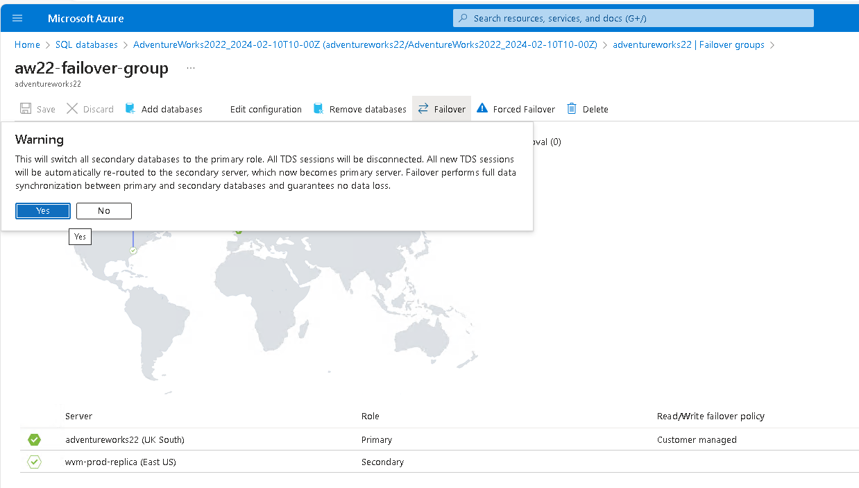
select failover and yes:
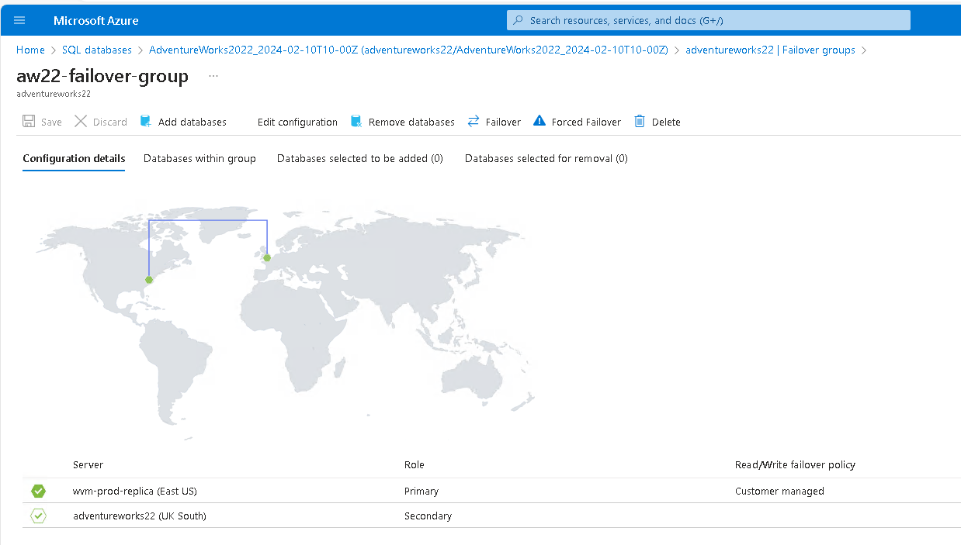
in a few moments you will see the servers swap roles where the replica is now the primary:
Select Failover again to fail the servers back to their original roles

By following these steps, you can safely perform a test failover to verify your disaster recovery environment's functionality. and then perform a tailback to revert to the primary region.
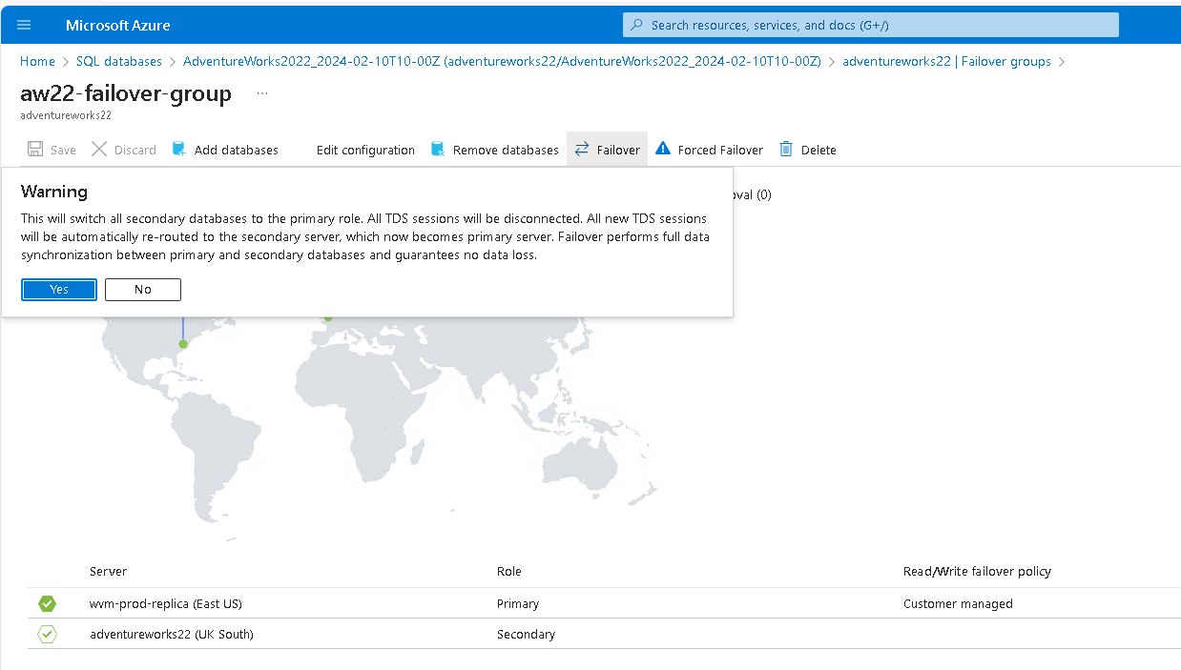
Result of tailback:
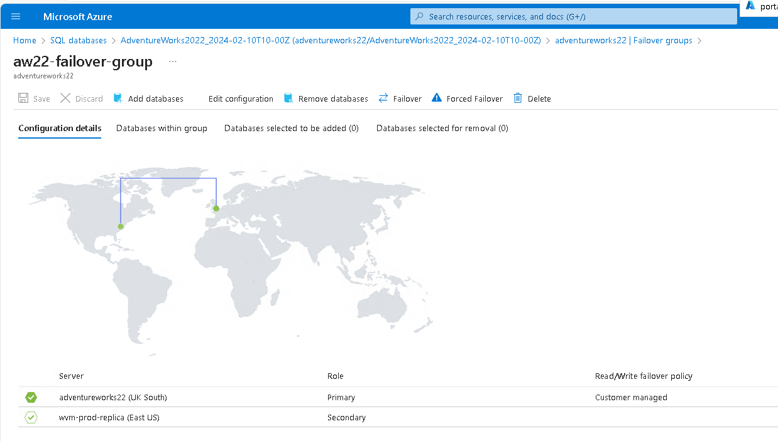
Milestone 7 – screenshot evidence. ms entra id
make sure you click ‘save’

then disconnect from current connection and manage connection. Change to ‘Microsoft entra ID’

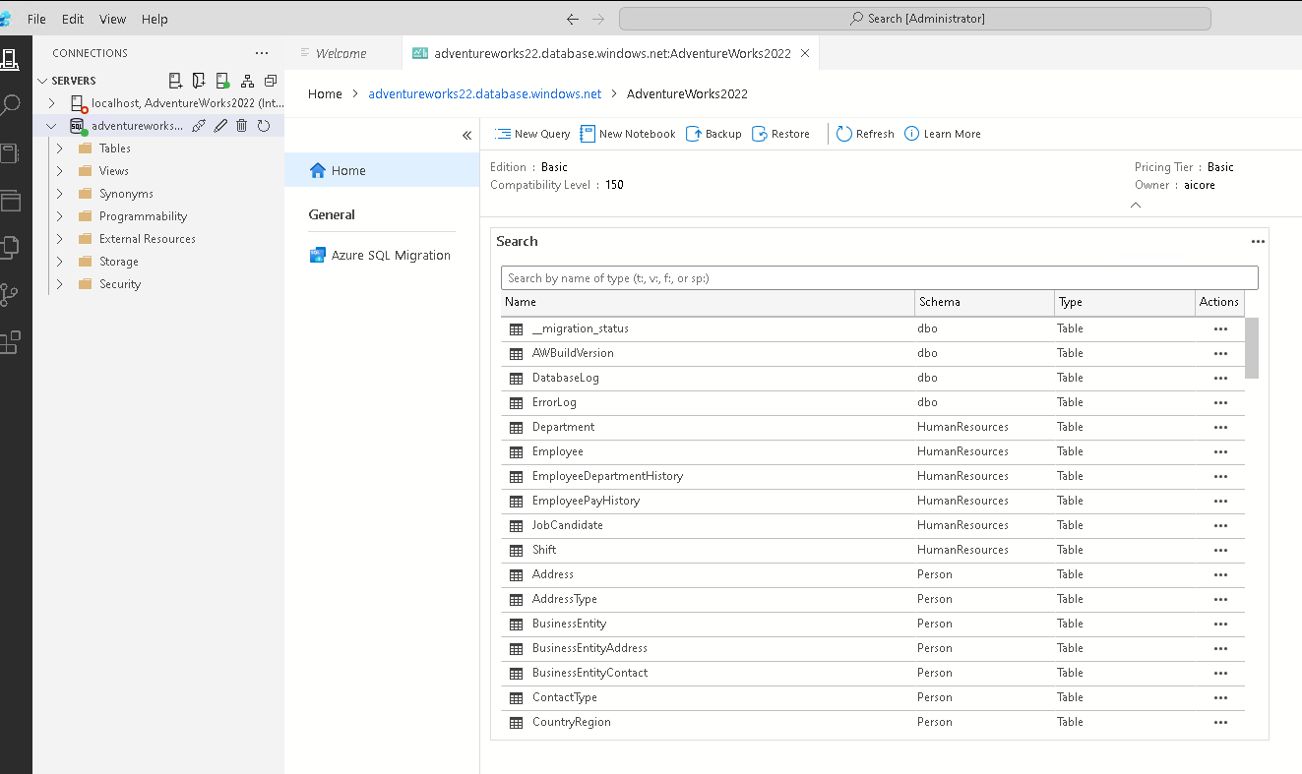
you will be unable to connect vis azure data studio if you fail to save previous action, as I found out:
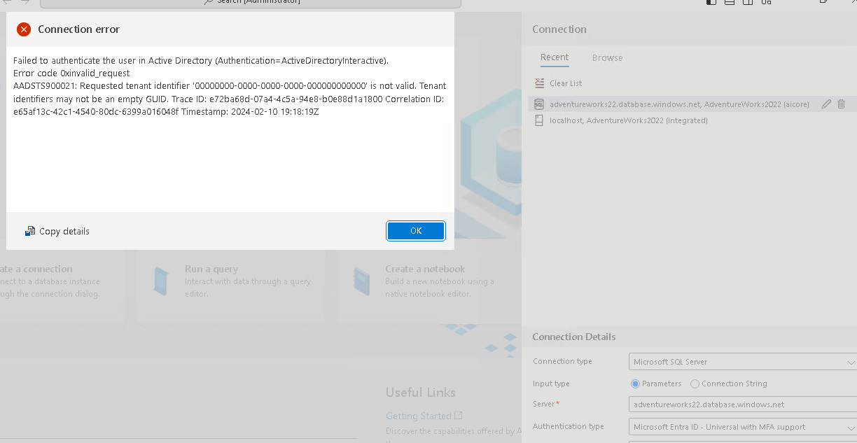

Thus I had to return to the previous screen on azure services (on browser window) and click save. This allowed me to log back in.

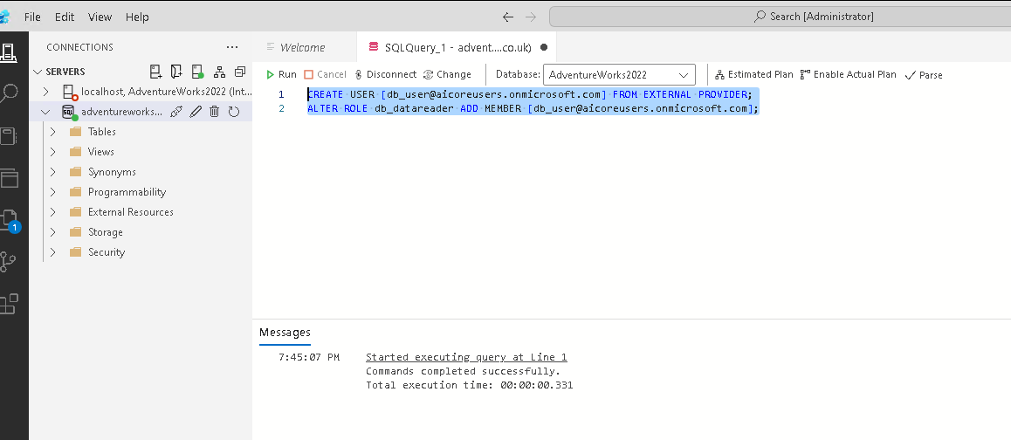
Creating a DB Reader User:
Test the DB Reader's User Access:
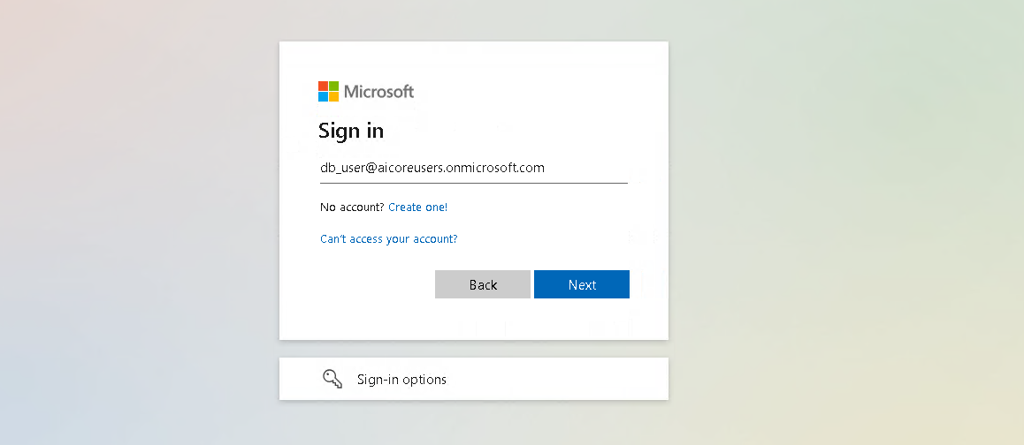
you will be …. prompted to change the password on first login:

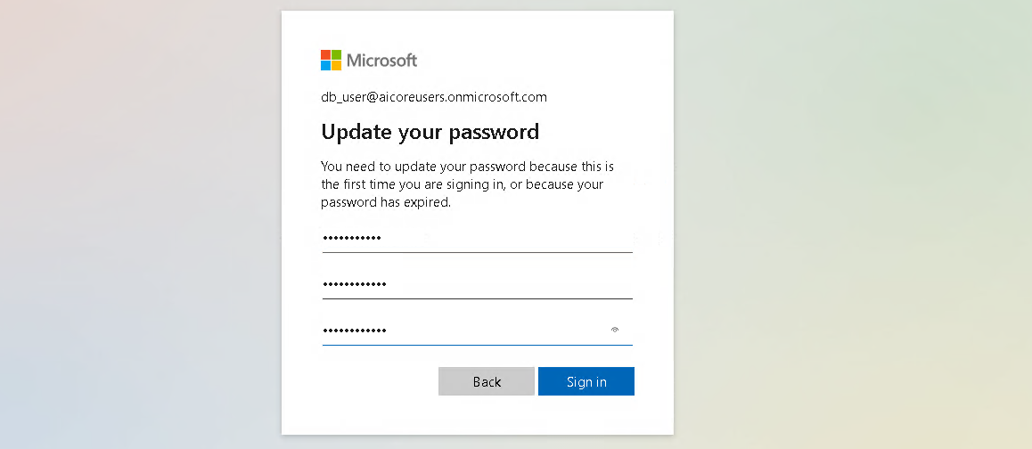
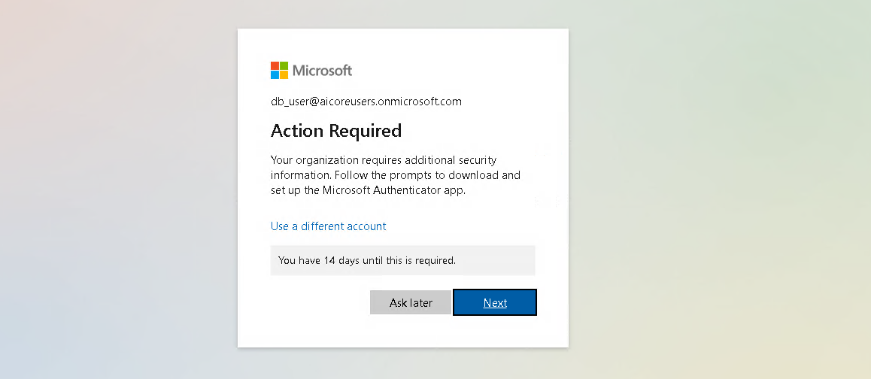

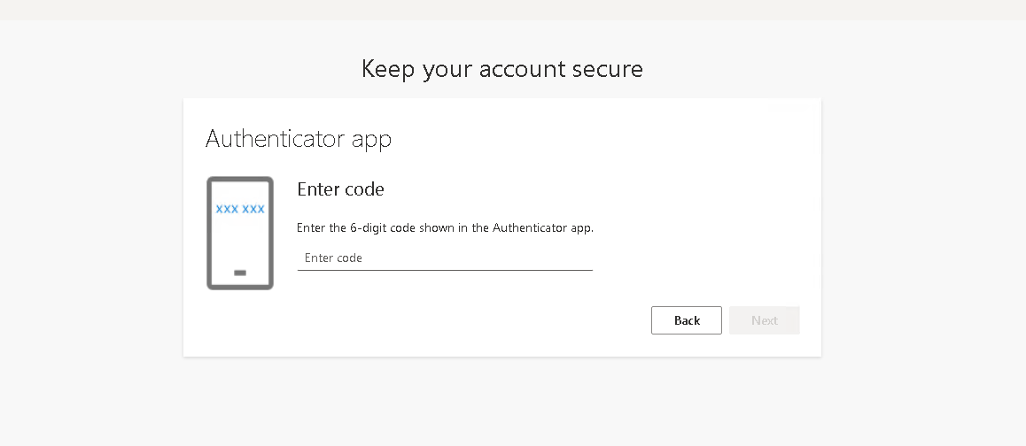
Depending on your companies setup, you may be asked to setup MFA for the new user account. If this is the case, have your preferred MFA app at hand so you can follow the steps to authenticate the new user.

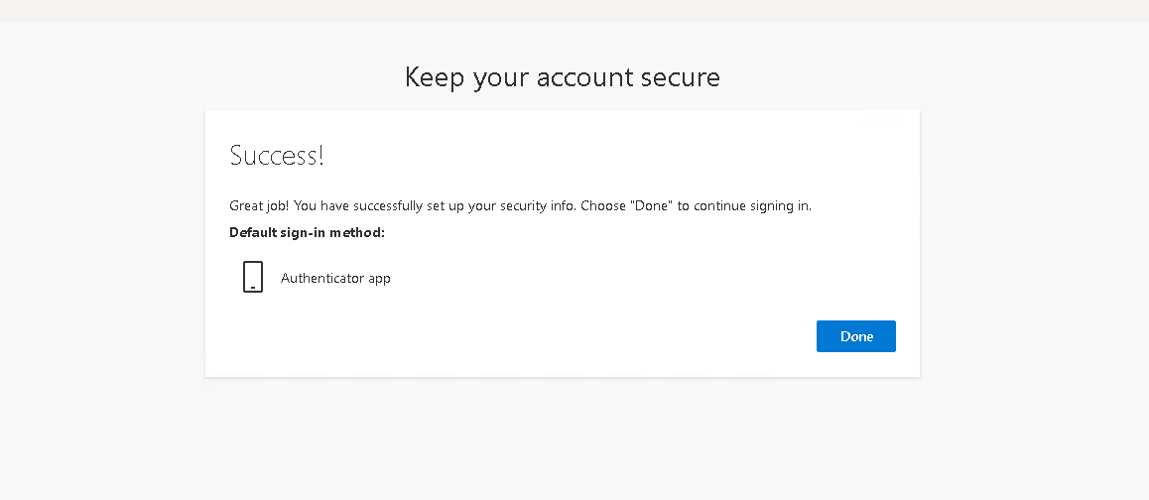
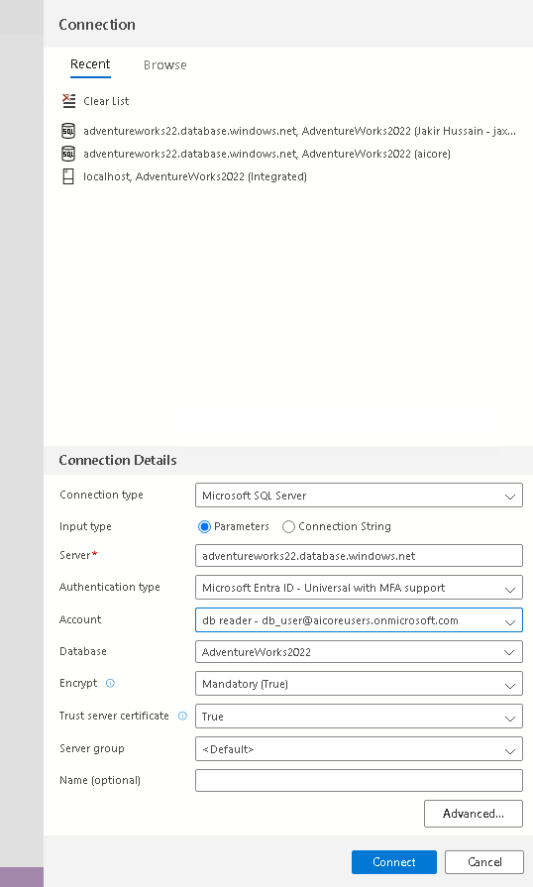
You can then proceed to connecting via azure data studio with the new credentials:
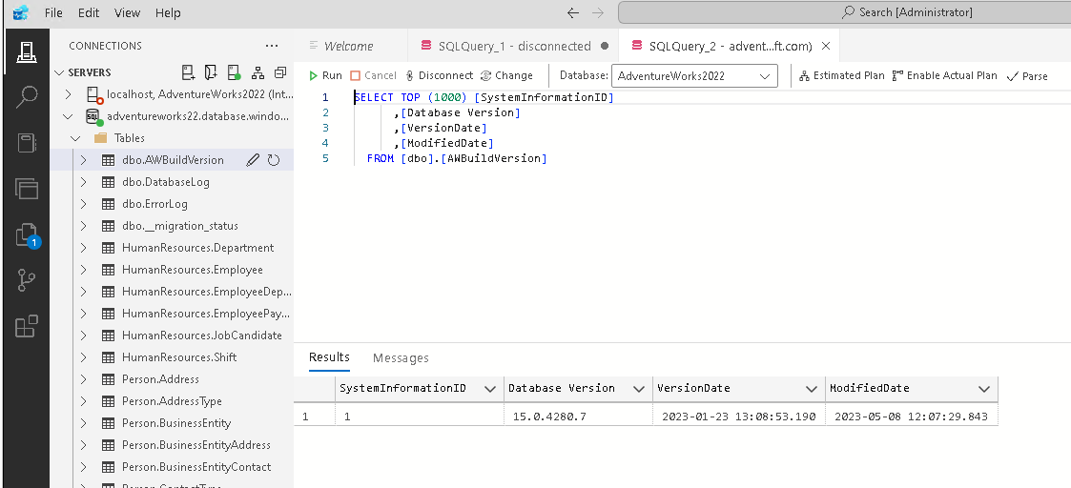
After logging you should check that you have setup the user, testing reading the database with success:
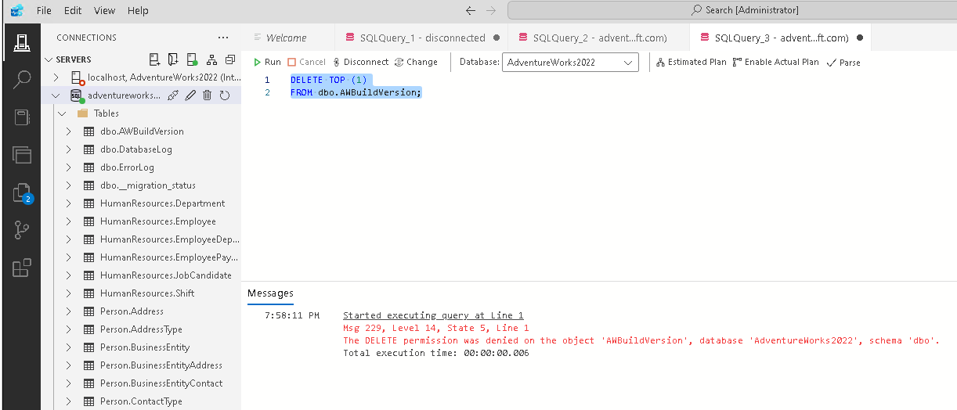
testing access to modify to database which should fail, as this user should correctly only have read access.

